**Abstract : towards a research-oriented Fab Lab in Brussels**

1. **Digital fabrication**

Digital fabrication is the act of turning a numerical design into a physical object, through computer numerically controlled machines such as 3D printers, laser cutters, milling machines among many others. These machines have become significantly cheaper and easy to use over time, allowing newcomers to learn a new process in a matter of days instead of months. Since the fabrication is entirely automated, users can dedicate more energy towards their design, usually through a Computer Assisted Design (CAD) software. Often, the produced parts have tight tolerance that could not be achieved through traditional fabrication methods.

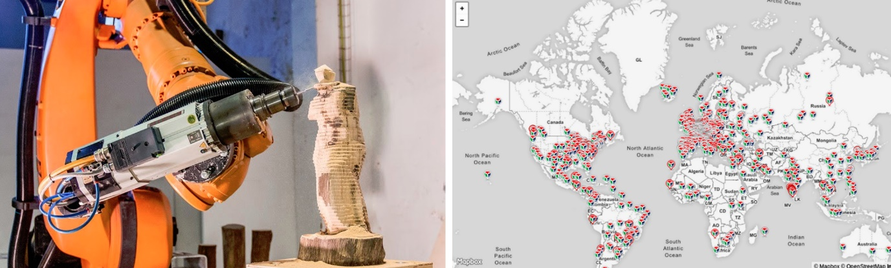

Figure 2: Fab Lab network

Figure 1: CNC carving a statue

One recent development in digital fabrication is its ability to self-replicate, leading to an exponential growth of open-source projects such as machines and design tools. The most well-known example of this is 3D printers producing their own parts, starting in 2007 with the reprap project. A similar effect is now being observed with more diverse digital fabrication equipment and is predicted to bootstrap universal adoption of those technologies.

1. **Fab Labs**

A Fab Lab is an interdisciplinary space in which digital fabrication tools are freely available, with a focus on education and open-source. Members can join workshops and trainings to learn a specific process, after which they can book and use the equipment in exchange of a small fee or paid membership. The first Fab Lab was founded in Boston in 2001 by MIT professor Neil Gershenfeld. The first external Fab Lab was then inaugurated in 2003 at Vigyan Ashram, India, as an experiment to test the viability of the concept in an isolated environment, which proved highly successful even with unskilled new users.

There are now 2000+ fab labs globally, across more than 90 countries. The Fab Foundation is tying this community together by hosting the Fab Conference once a year and providing global courses such as Fab Academy, a distributed online class taught by prof. Gershenfeld with the same material as his MIT class “How to Make (Almost) Anything”.

1. **The current landscape in Brussels**

There are around 7 active Fab Labs in Brussels among which two are related to universities (ULB and VUB). The other labs act mainly as independent workshops where the general public and small companies can use the machines, paying per use and/or monthly membership. Fab Lab ULB is the only one actively following the principles from the Fab Foundation’s [Fab Charter](https://fab.cba.mit.edu/about/charter/), and is also the first Belgian lab to propose Fab Academy since 2018. However, the equipment, personnel and activities proposed by this space are all oriented towards entry-level science and architecture students with very little interactions with researcher university staff. Fab Lab VUB is a great space for bachelor engineering students working on their mechanical design project or the VUB racing team, but research is also very limited there.

Since 2021, Quentin Bolsée is the main instructor for Fab Academy in Brussels. Since graduating from Fab Academy himself, he contributed to several aspects of the class such as the toolchains used for programming microcontrollers or a tool for designing printed circuit boards (PCB) directly in a web browser. He is now collaborating with prof. Gershenfeld on a new type of controller-less machine that could self-replicate its electronics circuit, 3D printed parts and milled parts. Quentin’s position as a FWO fellow at ETRO-VUB give him a unique background in the Fab Lab ecosystem, and he is in contact with the key personnel involved in the Fab Foundation as well as the most notable Fab Labs in neighbouring countries (e.g. in Amsterdam, Paris, Barcelona).

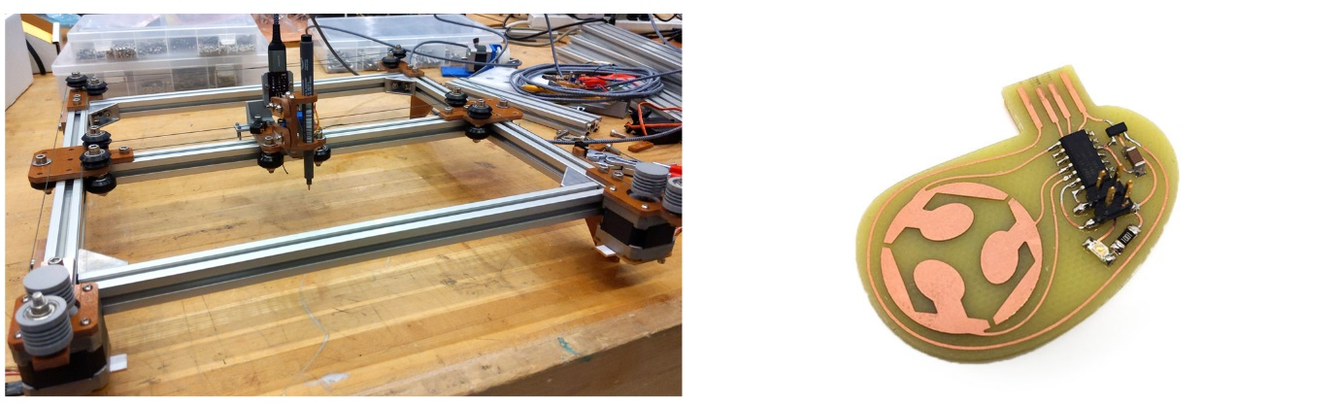

Figure 4: example of Quentin’s PCB designs

Figure 3: Controller-less machine (Urumbu)

1. **What we propose**

We believe setting up a Fab Lab as part of the FARI offices in BeCentral can greatly help its cause in three aspects:

* The demo center would benefit from custom-made prototypes, both in cost and specificity. As seen with the AIXC at VUB Pl9, the most attractive demos often involve robotics, though the robot kits used are very costly and industrial-grade, which is not necessary for demos.
* Digital fabrication can meet the specific needs of researchers affiliated or collaborating with FARI, for instance through novel actuators and sensors, which is particularly relevant in the context of smart cities and IoT applications.
* The Fab Lab itself would act as a technological showcase for visitors, inspiring them to learn more about digital fabrication or even try the machines for themselves when the lab is open.

In conclusion, we envision a new type of Fab Lab that can push the envelope when it comes to research applications of digital fabrication, with close ties to both the unique academic ecosystem of Brussels, and the more global Fab Lab network.