“Design and Implementation of an Order-Tracking System with .NET”
Josh Marquis

April 21, 2005
Abstract

In this project, I built an order-tracking web application using Microsoft’s .NET technology. I learned C# and ASP specifically for the project, but I also used HTML and SQL. The application allows Hands On Originals’ customers and employees to track t-shirt and art-only orders as they move through the creation process. This project focuses on the design and implementation aspects of software engineering.

History and Motivation for the Project

Order-tracking systems can cost thousands of dollars, not counting the necessary maintenance and troubleshooting. In a business domain as specific as screenprinting, software that keeps track of where orders are in the production pipeline and their associated art is nearly always custom-built. Some production companies prefer to know the number of screens a shirt needs to print while others only concern themselves with the number of colors. At times, the only thing a company may care about is the cost of shirts and ink. The varying levels of detail screenprinters may go to in dealing with orders makes the custom-built option necessary since a major piece of software would be financially infeasible and “overkill” for the operation. A few companies do provide applications for screenprinters, but they cost upwards of three thousand dollars for a single user. A number of ways exist to approach the problem of either not enough technology or too much technology; in the past, one solution has always been to rely on knowledge that the business already possesses. Paper orders with physical invoices and documentation are always reliable, if not slightly risky due to the enormous amount of paperwork that can accumulate because of good business. Another possibility lies in using existing software and tailoring that to the business’s purposes. For example, a spreadsheet shared among all the key players in the business serves the purpose of less paperwork – until more than one person wishes to make changes to the document, or someone makes a change while someone else reviews an out-of-date copy.
The solution to all these problems seems to lie in a database system, but databases tend to be difficult to maintain for those not technically adept. The small business owner cannot afford to keep a tech support person on staff all the time, but such a system needs to be available all the time. A database solution is feasible, but still requires a set of skills beyond those of most small business employees.
A database system with a basis in something the inexperienced computer user can comprehend would solve the problem. What is a tool that novice and advanced computer users alike can use with little effort? Such tools do exist! The Internet has brought about a wide range of applications for the home and small business. As the simplest means of accessing information on the Internet, a web browser is a solution that has just the right learning curve for someone to maintain an order-tracking system online. At the same time, that very web browser enables users who have no place altering orders or maintaining the application to simply view order information dynamically. Not only can users understand a web application easily, but the order-tracking system itself benefits from being a web application. Multiple users (one of the problems found in solutions such as sharing a spreadsheet) are inherent in developing anything for the web.
I chose the .NET development environment because it combines all the tools necessary to create such a web application under one roof. Furthermore, .NET is becoming a tool many companies look for in hiring a developer. Personally, I have spoken with a number of companies in my attempts to find a developer position after graduation, and nearly half of them wanted .NET experience. Hence, the secondary motivation in choosing .NET is to learn a suite of tools beyond gcc and the Linux/Unix set taught in my undergraduate and graduate career.
Hands on Originals approached me when I worked for them as a graphic designer to develop some kind of order-tracking system. At the time, the only development tool I knew to use that would provide what they wanted (a graphical user interface) was JAVA. Unfortunately, I lacked the appropriate JAVA skills and doubted my ability to implement such a system in a reasonable amount of time. Since returning to pursue my Master’s Degree, however, I discovered software engineering. After a few projects that sought to teach the design philosophy, it became clear that the implementation is not as important as the design work. The design takes care of all of the work, and then the implementation becomes a side note. To be sure, the end user only cares that it works, not how it works, but to alleviate problems in development, a solid design is fundamental to producing a finished – usable – product.
With this mindset, I decided to tackle an entire order-tracking system in one semester, in a foreign language, and on an entirely alien development environment. Certainly, development required some time to learn the basics of the programming language, and tools available for that language. That amount of time was considerably smaller than I might have expected for a project of this scope. One of the smaller goals of this project is to impress upon those who may read it that software engineering is an important discipline in developing software applications. The “hack it until it works” mentality that gets a student through his or her undergraduate (and sometimes graduate) career is not the only way. Hence, the primary goal of the implementation portion of the project is to produce a working proof-of-concept application that will be moved to a dedicated computer system for permanent use.

Overview

Any web application relies on a number of cooperating software and hardware components. OrderTracker, in its present form, is similar to most web application projects, but there are some differences. This section broadly explores the similarities and differences, but also discusses what the project includes. As expected, the client machine and the web server are the two major parts of the order-tracking system. Traditionally, setup relies on one server to which multiple clients connect. In large-scale projects, there can be multiple web servers where the databases reside on a completely separate set of servers for both security reasons and practical reasons. A web server potentially handles hundreds of thousands of database transactions as well as hundreds of thousands of page accesses and sessions. If the two are separated, the new web server and database server are much more efficient at handling client requests. In this project, financial resources necessitate simplicity because the server is only available on a single computer. Testing on the client side of the application uses the same computer as testing and running the server, although a few tests have used other kinds of computers and various browser brands.
Web applications involve a number of layers, regardless of how the computers behind the scenes are set up. There is a layer for the client to access, a layer for session handling, a layer for the business objects (classes), and a layer for database queries. Generally, the client aspect only deals with rendering the page once it receives a response from the server. However, depending on the application the client side also validates user input. The rest of the functionality occurs at the server side, although various pieces may still apply to the client.
Many companies rely on Microsoft products, although alternatives exist. Hands On Originals uses a number of Windows-based products in their operation, which helped motivate me to develop with .NET. The .NET development platform provides an extensive set of tools for creating a web application. Rather than using a number of different technologies to handle web interaction, database interaction, and order processing, .NET fuses all of these operations into one system. Granted, it is a system with many components. It requires the use of a Windows operating system. In the end, though, the user does not care what the tool “lives” on, as long as it does its job. In this sense, using .NET to develop an order-tracking web application provides all the functionality necessary, while the API and development environment keep development time to a minimum.
What does the web application do, though? In essence, it is a database application for multiple users. Three major kinds of users exist: customer, employee, and administrator. Customers may view orders, but not make any changes. It would not make sense for the customer to be able to change his or her balance due! Employees can create and modify customers and orders, while administrators can the same in addition to being able to modify the list of employees.
These are not the only restrictions, however. Subclasses exist within the employee class of users. For example, an artist should not be able to add orders; that is the salesperson’s job. At the same time, though, the artist needs to be able to update art for the order. The production manager cannot change order totals, but ought to be able to let the salesperson and customer know that the order is finished and ready for pickup. The OrderTracker handles all of these situations, but there are some situations it does not handle. The Statement of Scope describes these circumstances.
A precise discussion of what the application does and how it does it is appropriate at this point. In the area of software engineering, there is a simple way of describing how software works: design. A project’s design serves a twofold purpose. For one, the design organizes a project; it brings together and checks all of the details of the application before implementation starts. When coding begins, the programmer knows about the interaction of software components and how those components are used. This, in principle, ensures fewer defects in the final product. Secondly, design presents a more “user-friendly” picture of how the software works. While diagrams are not necessary in a design, they help the developer understand component interaction. However, they also illustrate for people not involved in creating the application how the finished product works.
I have organized the rest of this document in the style of a software engineering project. The design comes first and the implementation details follow. Finally, the conclusion ties together the two and comments on the finished product. After implementation, from the software engineering perspective, there are usually some extra steps. Verification, refactoring, and metric analysis are examples of these steps, which would help in maintenance and allow me to create future versions as quickly and with as few errors as possible. OrderTracker is only complete up to the first version, so these specific steps have not yet begun.
Analysis/Design

The first half of this project contains details pertinent to its design. No one sat down to start coding at its inception. Rather, most of the work involved my meeting with the customer to decide upon requirements and use-cases. I already knew most of the basic requirements from working with Hands On Originals previously. Requirements and use-cases are fundamental steps in many application design models, but are particularly useful in object-oriented design. Interestingly, although OrderTracker’s design is object-oriented, it does not seem to fall into the OO category upon further investigation. The section entitled “Conceptual Design” develops this idea.

Software Design Process

Popular software design processes include the waterfall method and the spiral method [1]. The waterfall method breaks the process into major phases that follow each other in sequence. The spiral method, on the other hand, involves a repeatable process driven by risk. After each major phase, the engineers take stock of risks for the next phase and begin it with those risks in mind. I used a different design process in developing OrderTracker. Since it is a specialized kind of application, it uses another process similar to the waterfall and spiral methods that engineers developed for software running on the web.
I adapted the Object-Oriented Hypermedia Design Model (OOHDM) to use in this application. In general, this process follows the same structure as most non-web application design models, but its developers modified it to fit the problem of web applications. Details of the model are below [2]:

Requirements Gathering
This step gathers all of the information about what the end users want in the product. The designer develops a statement of scope at this time, but also considers some use-case analysis. The use-cases delineated are in narrative, rather than graphic, form.

Conceptual Design
In the conceptual design stage, the software engineer fleshes out the use cases. This step gives rise to class diagrams. A web application handles classes somewhat differently than a JAVA or C++ application as the classes may involve pages, or categories of pages, that are not actually programming-language classes. However, the focus at this stage is on the domain rather than on implementation issues.

Navigational Design
Navigation design is usually the focus in strict HTML designing. Now, however, the developer takes into account varieties of users, as well as states in which those users might be.

Abstract Interface Design
The designer describes actual classes this point in the design. He or she also defines how those classes interact with pages, databases, or whatever else the system contains. The abstract interface design is a detailed version of the conceptual design and may include artifacts such as pseudo-code or state transition diagrams.

Implementation
This stage is the actual coding of the project. The developer writes the code and tests the application.

Requirements Gathering

Sometimes when a software project is complete, the customers and developers have differing opinions about what the application does versus what it should do. The requirements gathering phase of a project makes all parties involved aware of what will be designed and implemented before anyone begins technical development. The requirements define general use cases, which the software engineer develops later in the process.

Statement of Scope

Hands On Originals, a design and production company based in Lexington, Kentucky, shall use the web application OrderTracker. The purpose of the software is to allow both customers and employees to keep track of orders in various stages of development.
In general, OrderTracker tracks orders. Of course, various other services are asked of it, but at its core, it simply stores all of the information pertaining to an order. I envision a web-based application starting with a completely server-based solution. The client connects to a website, which processes and displays the data to that user in an intuitive way. Intuitive means that the display looks like the forms the employees are used to; it also means common web elements compose those forms.
Initially, there are two kinds of orders: “screenprinting” and “art only”. Each has its own attributes; therefore, OrderTracker handles each differently in terms of data representation. Within Hands On Originals, there are various kinds of entities. Different employees need to have access to different kinds of data. Each kind of user has a specific view of the information. Internal employees and customers are one example. More views are identifiable within the context of internal employees. The artist does not need to know about sales information, like the screenprinting production department should not be concerned with what the shipping department is doing. Each order going through the system has a unique order number that identifies it, and each order ties to a customer as well as (optionally) a contact person. OrderTracker does not restrict the information available to employees, but customer views present additional restrictions. For example, customers only see their orders, and of those orders, they only need to see a limited portion of that information. The scope of this project, in its initial stages, does not allow the developer to fully explore the scalability of such a system.

Business Objects/Process at Hands On Originals

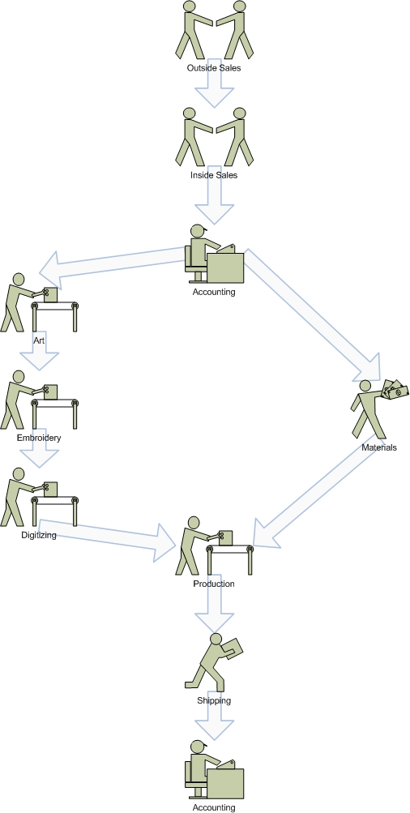
The diagram above shows the current basic flow of control for an order at Hands on Originals. When an outside sales rep places an order, the inside sales rep becomes the “holder” of the order. After the sales reps have each seen the order, the order goes to accounting. Then one copy goes to the art department, while another goes to the materials department for ordering.
The art department works on the art and, optionally, forwards the finished art to another entity for digitizing and embroidery. Once the materials and art are finished, the order goes back through the production department for printing. Production facilities know to start printing the art when a physical piece of artwork arrives at the department. The web application cannot automate this portion of the process because the artwork is necessarily physical for the production department. That is to say, production could look at the art electronically, but could not use that electronic art to print shirts.
Finally, the order goes through shipping if necessary and then to the accounting department again to see the final price of the order. Once all of that is finished, the sales rep contacts the customer to inform him or her that the order is complete.
Each entity knows when to begin his or her specific work when the order – or copy of the order – arrives at his or her desk. The beginning of each process only happens after particular events. For example, the accounting department gets the order after the salesperson writes it up. The digitizer begins after the artwork arrives by email. The accounting department knows to finish the order after it has been printed and shipped. These are just a few of the ideas encompassed by the preceding image.

Business Objects/Process in OrderTracker

In OrderTracker, the process described above is no longer applicable. Orders do not have to traverse a certain path through the system, although certain things need to happen at certain times. With an order-tracking system on the web, the order information is available to all parties involved in the process all the time. Seemingly, this new application redefines the business; however, most of the constraints are still in place. In the following section, I discuss the differences between the web application process and the current business practice.
Instead of passing a sheaf of papers around the office, each entity can check on any order, any time, as appropriate in OrderTracker. For example, when a sales rep places a new order, the art department sees all of the new orders that have no art and orders that need revision when it looks at the list of orders. Thus, the art can be in development while the accounting department is figuring out the payment information. Likewise, when the accounting department looks at the current list of orders, it sees that there is a new order in the system with no “total paid” option and acts on that information accordingly.
Employees no longer know when to deal with an order by the paperwork arriving on the desk, a simple lookup on OrderTracker tells the user where the orders are in the process. When the artwork is finished, the salesperson chooses “art approved” for the revision notes. Then the production division knows to start production of the art because the artwork has arrived on the desk. As noted before, this physical artwork is necessary because when the production department wants to begin printing – or the embroidery department wants to begin sewing – the art needs to be either in physical format from the art department or in a digitized format from the outside digitizer.
The previous ideas break apart the static process the business used before. Each entity has certain requirements to begin his or her part of the process; either the web application fulfills these requirements, or a physical process inherent to the domain (like delivering physical artwork) suffices.

Requirements

A list of requirements, parsed from the statement of scope, effectively ensures the project fulfills the customer’s needs. At the end of this document, I have included a “requirements traceability matrix” (RTM) that matches each requirement with a specific page, piece of code, or specification in the design of OrderTracker. Listed below, however, are the requirements for the order-tracking system from which I extract use cases.

#001.00 OrderTracker SHALL store orders coming into Hands on Originals in a database
#001.01 OrderTracker SHALL keep track of t-shirt screenprinting orders
#001.02 OrderTracker SHALL keep track of art only orders
(these order types are described in the database design)

#002.00 OrderTracker SHALL run on a PC running Windows XP with the .NET framework installed, IIS installed, and ASP installed.

#003.00 OrderTracker SHALL be accessible as a web application using Firefox v1.0 or Internet Explorer 5.0

#004.00 OrderTracker SHALL allow each entity associated with the company to view specific pieces of data
#004.01 Inside Sales reps SHALL be allowed to view: any order
#004.02 Outside Sales reps SHALL be allowed to view: any order
#004.03 Artists SHALL be allowed to view: art specifications for any order
#004.04 Production SHALL be allowed to view: any order
#004.05 Managers SHALL be allowed to view: ANYTHING

#004.06 Customers SHALL be allowed to view: artwork and total balance for their orders only

#004.07 Technical support SHALL be allowed to view: ANYTHING

#005.00 OrderTracker SHALL allow each entity associated with the company to edit specific pieces of data
#005.01 Inside Sales reps SHALL be allowed to edit:
#005.01.1 Insert new orders
#005.01.2 Insert new customers
#005.01.3 Insert new contact people
#005.01.4 Insert new shirt orders (shirt orders define the product to be printed on)
#005.01.5 Change any data associated with his/her order
#005.02 Outside Sales reps SHALL be allowed to edit:
#005.02.1 Insert new orders
#005.02.2 Insert new customers
#005.02.3 Insert new contact people
#005.02.4 Insert new shirt orders (shirt orders define the product to be printed on)
#005.02.5 Change any data associated with his/her order
#005.03 Artists SHALL be allowed to edit:
#005.03.1 Insert new art thumbnails
#005.03.2 Change time the artist finished with the order

#005.04 Production SHALL be allowed to edit:
#005.04.1 Change time production finished with the order
#005.05 Managers SHALL be allowed to edit:
#005.05.1 Insert new customers
#005.05.2 Insert new contact people
#005.05.3 Default order settings

#005.06 Customers SHALL be allowed to edit: NOTHING

#005.07 Technical support SHALL be allowed to edit: ANYTHING

#006.00 OrderTracker SHALL NOT concern itself primarily with security

#007.00 OrderTracker SHALL NOT take care of ASI orders (ad specialty items)

#008.00 OrderTracker SHALL NOT record any account numbers

#009.00 OrderTracker SHALL NOT make any financial transactions

Conceptual Design

The conceptual design, at this stage in the OOHDM process, specifies both the use cases for each kind of user and the general setup for the system. The previous section describes these use cases in a narrative fashion, but they are now more specific. A context diagram follows the use cases. It shows OrderTracker’s general configuration.

Use Cases

I designed OrderTracker to have two major classes of users, employees and customers. While the latter has no more divisions, employees break down further into administrators, salespeople, artists, and production. These divisions categorize the use cases into sections; however, there is one universal login use case. Appendix I gives further detail on the functionality and requirements for each use case.

General Use Cases
Log In to the System

Administrator
  - Create Employee
  - Remove Employee
  - Change Employee Information
  - Backup Order Database Information
- Employee (Sales)
  - Create Customer
  - Create Contact Person
  - Search Customers
  - Create Order
  - Modify Order
  - View Order
  - Search Orders
- Employee (Art)
  - Add/Update Art for an Order
- Employee (Production)
  - Update Production Status

Customer
  - View Order Status/Preview Artwork
  - Search Orders

Each use case sub-item is identifiable as a web page. Granted, the system dynamically generates each web page, so some functions combine into a single page. The idea of a “template” page is common for web applications, and OrderTracker uses that concept for viewing, creating, and modifying orders. “Create Employee”, for example, is just one page. “Search Orders” is another; the list of results differs every time, but OrderTracker uses the same basic page from which to build all pages.
Context Diagram

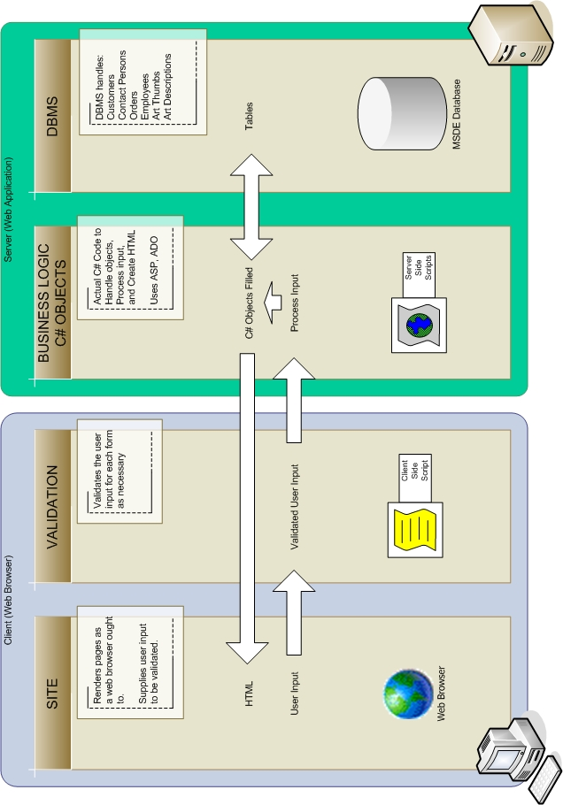
The preceding page illustrates interactions between the client and the server, as well as the pieces inside of each entity. The web browser on the client side handles rendering the page. One particular difficulty in designing a web site is for the developer to ensure that each page rendered on one browser renders the same way in other browsers.
One current problem with .NET involves this rendering. Visual Studio .NET 2003, when it creates a web application, automatically assumes that Internet Explorer 3.0+ and Netscape Navigator 4.0 are the only “good” browsers. It considers every other browser a feeble browser. Thus, when ASP creates a page to send to the browser, if it does not think the browser is capable of handling a specific control or style, it does not send it. For stylistic reasons, not sending a control can be bad because text may not appear the correct size or pictures may have borders when no border should be there. The web application also loses functionality if ASP decides not to send a button or form field to the browser.
The client side or on the server side performs validation; general practice assumes it happens on the client side because that relieves processing time on the server. OrderTracker validates information both at the client side and at the server side. Basic validation, such as ensuring a form has all necessary fields, happens on the client’s browser. The server validates login information, though, since that information does not reside on the client’s computer.
OrderTracker processes all of the page information at the server side. When the browser submits a form or update, all changes happen at the server. The code for business objects revolves around the database management system, at least for this project. Usually the DBMS and business objects reside on two levels as shown in the diagram, and conceptually, this is still true. The database layer is not the same as the C# business object layer. However, .NET fuses the two layers slightly. Connecting to the database and issuing a query gives a result set back, which is automatically a C# object. A distinction still lies in the fact that OrderTracker is not responsible for creating database tables.

Navigational Design

Navigational design, the third phase in the object-oriented hypermedia design model, primarily deals with style and navigability. The Yale Style Manual [3] provides a list of checkpoints to consider in designing a web site. However, this project differs from most sites the style manual applies to in that it is an application rather than a static site. For example, the manual states that web pages ought to be “freestanding.” While true of web sites, this rule gives the web application a feeling of statelessness. If each page should stand alone, then no page depends on other pages in the site. In OrderTracker, every page links to a new page using information pertinent to that new page. Information from other pages in the site restricts each user in what he or she can view or edit.
The use cases in this project aid the design of the navigation. Chiefly, these operations define the hyperlinks the application displays. The following table shows the categories of users and operations allowed to each:

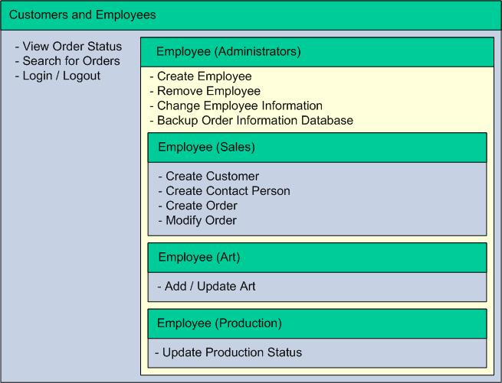

Every entity involved in the interaction has the same basic operations: they can view orders (possibly with editing), they can search for an order, and they can either log in to the application or log out. Hence, it makes sense for these functionalities to form the core navigational links displayed on every page of the application. “Login”, “Logout”, “Search Orders”, and “View Order” are candidate navigational links.
Despite the fact that these three links should be available to any user, some of the links might have different functionality. Customers and Employees do have different methods of searching. A customer can only search his or her orders. Employees can search through any order.
Of the options specific to sales people, two of them have to do with order handling: create order and modify order. There is also the overarching “View Order” command that is applicable to any user. In fact, any employee has some type of order handling capability. Hence, there is a general link for Order Handler from the main menu. Then, depending on the type of employee, there are further specific options.
A similar strategy involves customers and contact people. Functions exist to work on those entities, but they group together to create submenus. For salespeople, a menu item called Customer Handler actually handles customer addition, search, and contact person addition. Although deletion of a customer or contact is possible, it does not make sense to delete a customer associated with an order, even if that customer no longer does business with the company. In the future, an employee may need to reference an old order and if he or she can only remember the customer name, then that information needs to be available.
Certainly, for this same reason, employee information might always be kept, but at the risk of previous employees logging in and creating orders, this option is not considered as of yet. For the current implementation of OrderTracker, the orders of deleted employees are only viewable by others and editable by the administrator. In future implementations, employees might be categorized as “previously employed” and “currently employed”.
After I completed categorization of the use cases, OrderTracker’s users have the Login Menu consisting of login and logout. Then, another menu depicts other options. For customers, this menu consists only of Manage Orders. However, employees have a range of options. The pseudocode for deciding what menu options to provide looks like this:

if the user is logged in
show login and logout
show order handler

if the user is a salesperson or an administrator
show customer handler

if the user is an artist or an administrator
if the user is viewing an order
show add art

if the user is a producer or administrator
if the user is viewing an order
show modify production state

if the user is an administrator
show employee handler
show backup database

.NET provides a useful way to manage menus such as the one described above. The developer can create new controls that load on all pages. Usually there are standard controls such as panels, hyperlinks, buttons, and so on, but with a custom control, every page includes the same menu. These controls are completely programmable using C#. This idea makes the decision to show or hide a menu relatively simple. It also allows the developer to fulfill the recommendation of the Yale Style Manual that encourages no “dead pages”. A dead page is a page with no link to anything but is still reachable. In C# every page derives itself from a common base page. OrderTracker pages all derive from this base page class, but some derive from specialized page classes. Employee pages derive from a page called OrderTrackerEmpBase.cs. This page defines the header and footer (which are likewise defined in their own classes); it also defines the menu options for employees. Since every page draws from a common OrderTracker base page, every page has a menu, and no page is “dead”.
Something outside the scope of this project but still important to consider in navigation is accessibility. Usually, this appears in the form of alternate text for images so that users with poor sight can "hover" their mouse over the image and get a verbal description from third party software. In this application, though, the only useful images are in approving and uploading art. A sales rep or artist would need to write a description of those images, which wastes his or her time.
Final navigation screenshots appear below:

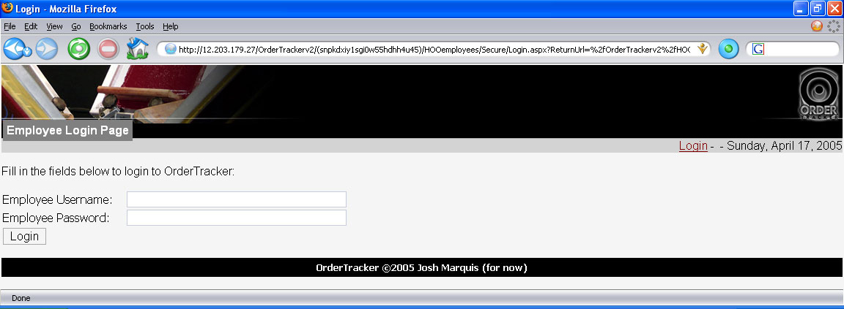
This is an example login page for an employee. The customer login is similar.

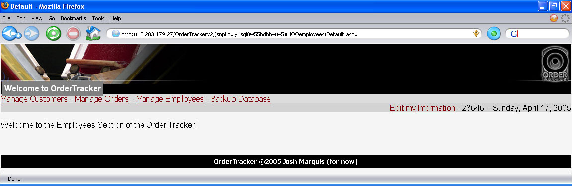
This is the main menu for an administrator. Non-administrators do not have the “Manage Employees” and “Backup Database” options.

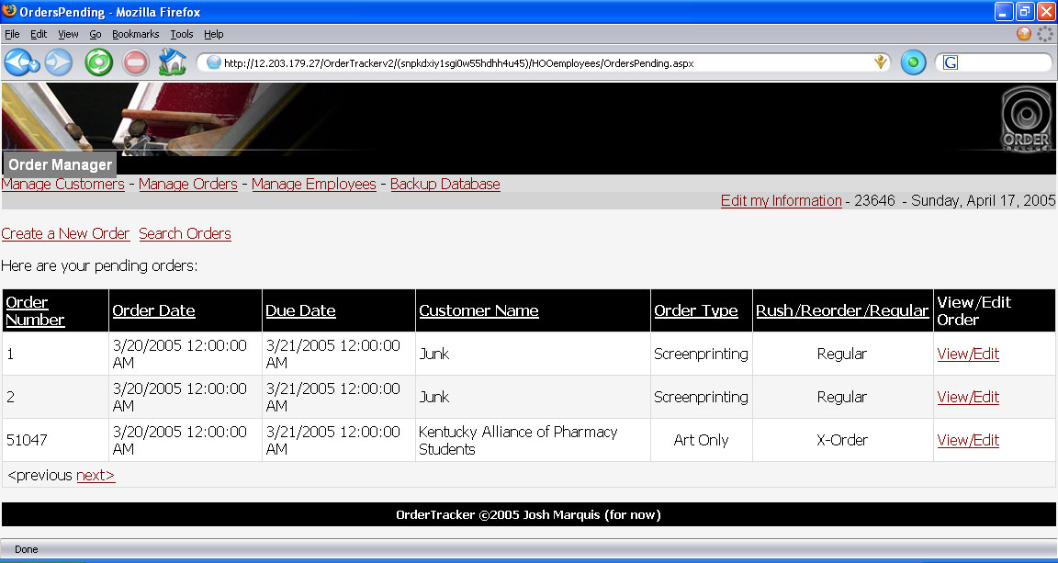
This is the submenu for new orders.
Abstract Interface Design

The final stage before implementation of the project is the abstract interface design. In the OrderTracker design, abstract interface design shows how the pages interact. Each page is a class in a web application using .NET. Every page derives from the generic page, and there are no major differences between how ASP creates generic pages and how ASP creates order-tracking pages. Pages pass messages back and forth between themselves; how this interaction occurs is of particular interest. The picture below illustrates the navigation map of the system. The user can return from any page to the default page and the login screen, so those links are not included.

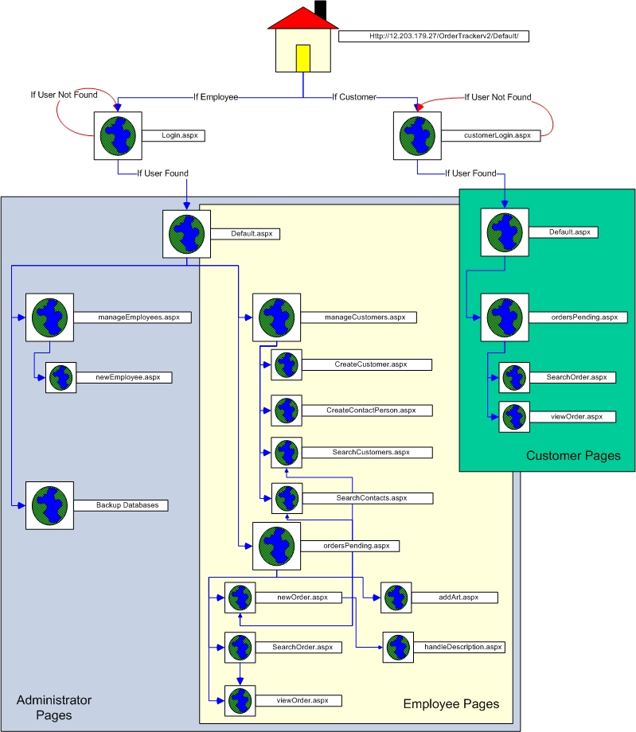

Similar to a control flow diagram in structured programming, this image is a primary page flow diagram. From the main homepage, users choose either employee login or customer login. It is possible to develop two entirely separate websites for this project, but to keep the number of domain names and pages to a minimum, one site combines all functionality for both types of users.
Once an employee logs in, OrderTracker determines their type and all subsequent pages render themselves specifically to that type of user. For example, in OrdersPending.aspx, if the user is a sales rep, the page displays that representative’s current unfinished order list (along with the navigation described above); if the user is an artist, the page will render a list of orders with unfinished art.
Any user may go back to the appropriate default page at any time. OrderTracker automatically redirects any unverified user trying to access any page within the system to the main page to try logging in again.
Below is an example of pseudo-code from OrderTracker to display of each page. Note each page displays the login/logout menu as well as the menu to go back to the main page. Appendix II contains the rest of the pseudo-code.

Homepage:

Same for all users.
Option to login as a customer
Option to login as an employee

Default.aspx for employees and customers:

if the user is not logged in
Redirect to login.aspx

display menu (described above)

Login.aspx and customerLogin.aspx:

display login options
when submit is clicked
query database to ensure username/password combination is valid
if valid
redirect to Default.aspx
else
show user error message
Implementation

The next section details all of the implementation issues involved in coding OrderTracker. First, the platform-specific details are outlined, followed by examples of each piece of technology involved. Each section discusses what the technology is for and how it relates to OrderTracker.

Platform Details

I chose the current platform based on what the company is accustomed to using. All of Hands On Originals’ current technology is Microsoft-based, which means using a product supplied by Microsoft for development purposes eases the integration of the new system to their existing server.
In addition, developing on a Windows XP machine running Visual Studio .Net enabled me to learn a great deal about this particular environment. Unix-like systems seem to be the preferred method for development of these kinds of projects but are certainly not required. Having never developed specifically for Windows as the target system, I chose to use this opportunity to add to my programming language and environment repertoire.
The main technologies I used in the development of the OrderTracker are C#, ASP, and ADO.NET. However, there are a number of “behind the scenes” tools in use, which were chosen mainly because they are free to use. A personal computer running Windows XP Professional as the operating system is hosting the site. Any Windows XP Professional computer has this ability, the owner simply has to set up his or her IIS (internet information server) to allow outside users to connect. (Windows XP Professional is not free, but most tools used are free to its owners.) The process for using IIS is online at http://www.windowsxp.com.

Development Environment:
PC running Windows XP
MSDE (Microsoft SQL Server Desktop Engine)
Visual Studio .NET 2003
IIS (Internet Information Server)
Development Languages/Tools:
C#
ASP
ADO.NET (SQL)
HTML/CSS

An interesting relationship exists between the tools used in developing the project. All Microsoft tools used integrate together, which allows for a simplified development experience. For this project, I found hardships in installing and configuring the .NET tools, but once they were correctly setup, using them was relatively simple.

C#

Programming in C# is not very different from programming in C++. A few options exist that allow for a more accommodating programming experience. For example, when making queries to the database, it is possible to return results in a number of ways. One way to get data is to assign it to a dataset, which is an object, built to hold the results of an SQL query. Secure queries require the developer to use parameters in place of actual variables. In order to fill the parameters with data, a command like this is used:

SqlDataAdapter ad = new SqlDataAdapter( sql, cnOrderTrackerDB );

foreach( DictionaryEntry prm in values )
{
ad.SelectCommand.Parameters.Add( prm.Key.ToString(), prm.Value );
}

Here, ad is a data adapter that fills up a dataset with the results of the query. Sql is the query built with parameters. A foreach command cycles through the values table of parameters and adds each specific value to the query. This specific example comes from the search pages. The person performing the search might use all, a few, or none of the search options, so the page inserts valid options into a hashtable. Finally, before executing the search query, the foreach command adds any hashtable entries to the query.

ASP

Although touted as a technology in its own right, in some ways ASP is simply an enhancement of HTML. Here is a short piece of code used in the login page, which allows the server to tell the user what went wrong in trying to login to the web application:

<asp:Panel ID="pnlError" Runat="server" Visible="False">
<asp:Label id="lblError" Runat="server" ForeColor="Red">
</asp:Label>
</asp:Panel>

The server creates a simple panel called pnlError. This panel is only visible when the server has determined that the login information is not applicable. The advantage of using ASP is that the server can manipulate its controls easily (hence the name Active Server Pages).
Any page with any HTML element on it is likely an ASP control rather than an HTML tag. Some of the simple tables are only tables, but labels, textboxes, hyperlinks, and images are all ASP objects. The following screenshot shows the page used to view orders. With the exception of the tables, everything rendered on this page is an ASP control.

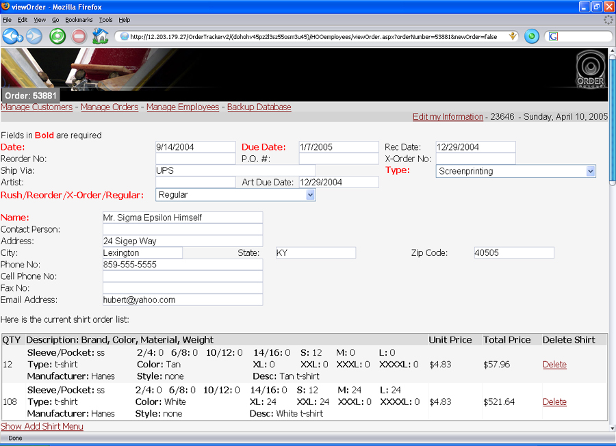

ASP also handles session states for the application. When the user logs in, the server sends a cookie to the client computer’s memory containing that user’s information. If the URL does not reflect the correct cookie when the browser requests a new page, the server redirects that user to the login page. There is a file called web.config where the developer can specify whether cookies are to be in the URL or as a file in memory. None of the cookies in OrderTracker exists on the computer after the session is over or after the browser is closed. Someone attempting to retrieve user information using an OrderTracker cookie would have a difficult time since the browser does not save it on the hard disk of the user’s computer. This is good for security reasons. When an employee is away from his or her computer, there is no chance of an attacker finding the cookie file and reading or altering it. Ad-ware and mal-ware frequently use cookies; if no cookie exists, those malicious programs cannot use the private information.
Since HTML is stateless, as mentioned before, no page has any inherent recall of any other page. However, web applications need to remember data in-between pages. Traditionally there are four methods of passing information between pages. Cookies, as mentioned earlier, are stored on the client’s computer, and are an easy method to use. Hidden fields are another method similar to a cookie. The only difference is that a hidden field in the web page contains the information from the cookie for retrieval later. ASP also provides a Session State and Application State on the server. OrderTracker uses one cookie at login time then relies on session state and query strings to handle the rest of the information pages need.
For each user that logs in to OrderTracker, the server allocates some amount of session space. When pages need to remember information between them, the server saves that information in Session space for when the next page loads. This method requires some space overhead on the server, but this overhead only becomes a problem when massive amounts of data are being stored. OrderTracker only needs a few variables in session space. One such place to use session space is when a customer or employee logs in. The server stores the kind of user in session space so each page knows what to display. OrderTracker also uses session space in searching. When the user searches for something, navigates away from the search page, and navigates back, he or she finds the same search query displayed. The Application State is another option. It is similar to the Session State, but is available to all users. Like a global variable in a program, the potential for “side effects” exists whenever a user changes the value. There are methods for dealing with this potential problem by locking and unlocking the Application State variable, but rather than deal with application states their potential problems, OrderTracker simply does not use this method.
The final method for remembering information between pages is by passing values between those pages as arguments, similar to functions in most high-level languages. OrderTracker uses these extensively to tell pages what to display. For example, if a user searches for an order on one page and clicks on a link to go to that order, the search page tells the order-viewing page which order to show by passing the order number. These passed values are stored in an object called a QueryString.

ADO.NET (SQL)

The structured query language ADO.NET uses is exactly that used in most SQL-based database systems. Since OrderTracker is primarily a database project, it makes sense to devote more time to discussing the options available with Visual Studio .NET for SQL. MSDE (Microsoft SQL Server Desktop Engine) has the ability to act like an SQL server, even though it is not SQL Server 7.0 or some other version.
I built the database and the tables it includes from within the Visual Studio IDE. It contains a server explorer that provides all the necessary functionality to create and connect to databases on the local machine. However, it does not allow user management for those databases. To create a user for the web application, I used the MSDE setup tools from the command line.

c:\osql -S (local) -E -Q "sp_addlogin @loginame='webuser', @passwd='theinternet', @defdb='OrderTrackerDB'"

MSDE saves all of the databases it creates as .mdf files wherever it was installed. The OrderTracker database is located at: C:\Program Files\Microsoft SQL Server\MSSQL\Data\OrderTrackerDB.mdf. Backing up a database on the server uses a simple command, but OrderTracker allows the administrator to backup the database to his or her computer. SQL DMO is the tool from Microsoft that allows C# to manipulate databases within a program; it saves the database on the local machine when a user requests a backup. Restoring the database, on the other hand, currently requires the administrator to be at the server using MSDE’s command line tools to perform the restoration.
The following is an example of how .NET’s Query Builder optimizes queries entered by the developer. Sometimes it makes a small change, but when a number of tables are involved, the Query Builder makes large changes as necessary. For example:

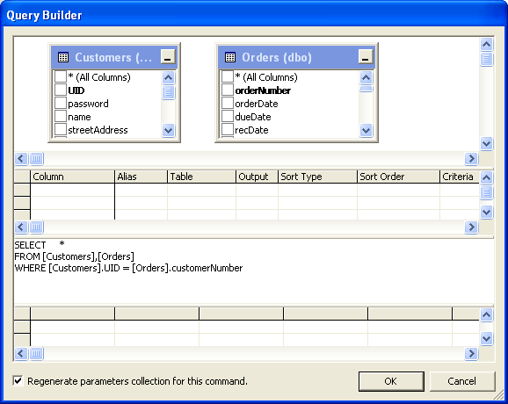

This is a basic query similar to one used in an undergraduate class on databases. When Query Builder gets the query, it generates this:

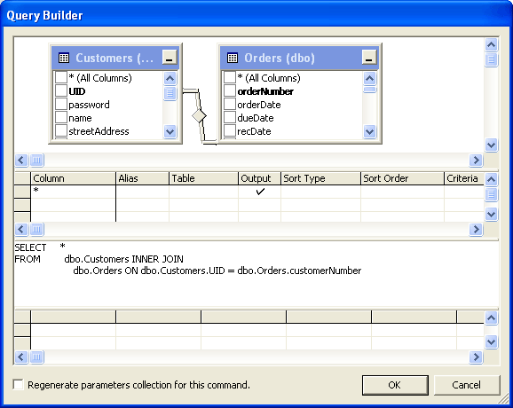

A better example of how Query Builder changes queries is the following query that selects the information pertinent in the Search Order page:

SELECT [Orders].orderNumber,[Orders].orderDate,[Orders].orderType,
[Customers].UID,[Customers].name,[Employees].UID, [Employees].employeename
FROM
[Customers], [Orders], [Employees]
WHERE
[Orders].customerNumber = [Customers].UID
AND
([Orders].insideRepNumber = [Employees].UID
OR
[Orders].outsideRepNumber = [Employees].UID)

Query Builder transforms this query into:

SELECT [Orders].orderNumber,[Orders].orderDate,[Orders].orderType, [Customers].UID,[Customers].name,[Employees].UID AS Expr1,
[Employees].employeename
FROM [Customers] INNER JOIN [Orders]
ON
[Customers].UID = [Orders].customerNumber
CROSS JOIN
[Employees]
WHERE ([Orders].insideRepNumber = [Employees].UID)
OR
([Orders].outsideRepNumber = [Employees].UID)

This new query tells the MSDE how to put the query result together rather than making it decide how to join all of the tables based on the original query. This kind of transformation is one of the benefits of using VS.NET over strict coding of the queries by hand. I wrote the original queries of OrderTracker in simple form, but Query Builder chose how best to implement them. Some queries are still in simple form, but those queries are usually constrained to one-table.
Below is the database design for the system. Constraints on the database are not implemented, and with good reason. Usually a database designer creates the database with a set of rules in mind. I could not create any rules that I was certain employees would adhere to. Sales reps do not handle every order the same way. As with many small businesses, employees stray from the normal order system when something important is at stake. While an art charge might be thirty dollars, a rep may waive that fee for a customer who is a big account holder. The total cost per shirt might be $1.25, but to make a little extra money, the total for the order might be more than the number of shirts multiplied by $1.25. Constraints would certainly make for a more consistent database, but those constraints that make sense may not help the business at this stage of its development.
Nearly everything in the database hinges on the order number, customer username, and employee username. These attributes are the primary keys and foreign keys that relate each table to the others. When OrderTracker creates a new order, it searches the database for the largest order number and uses the following integer as the new order number. In this way, two employees cannot generate the same order number.
Interesting tables include the shirt order table, which defines the kind of shirts that production prints on, and the art/art thumbnail databases. In the shirt order table, the order number, manufacturer, and color of the shirt uniquely identify a shirt order; this table reduces database size for each order. Rather than have a limit of three kinds of shirt orders and wasting server hard drive space by requiring three in the table (which is how Hands On Originals designed the current paper form), the number of shirt orders is now variable. The num variables in the ShirtOrder table give the amount of each particular size of shirt. num_24 is the number of 2/4 size shirts, num_s is the number of small sizes, and so on.
The art table describes how the customer and salesperson want the art to be created, but includes no images. The art thumbnail relates to this table, because it is the actual implementation of that description. The key here is the position, which allows for each position of the shirt in the order to have exactly one piece of artwork. One set of art per order is a problem for Hands On Originals when customers want a number of artistic options for each location and many pieces of artwork are forced into one order with no extra art charge. Perhaps this is a business problem for Hands On Originals to fix on its own, but OrderTracker handles this by making the location and order number the primary keys rather than making the image the key. With this design, each order is required to have only one piece of art per location. Note that the order type and employee type tables have no relationship to the orders. The databases ultimately do not care what kind of string is stored for these values. The web application displays the values from those tables rather than programmatically embedding them in every page used. This way, the addition of a new kind of employee or shirt type is only a matter of a row insert into a table.
In the diagram, PK stands for primary key, and is the attribute that uniquely identifies each entry in the table. FKx, on the other hand, denotes foreign keys. The foreign keys relate the data in a specific column of a table to the data in another table. Bold identifiers indicate required fields, while the rest can be null. In the ArtThumbnail table, the primary keys are the order number and the position of the art. They uniquely identify that thumbnail. The order number is also a foreign key to the Art order and to the order in the Orders table.

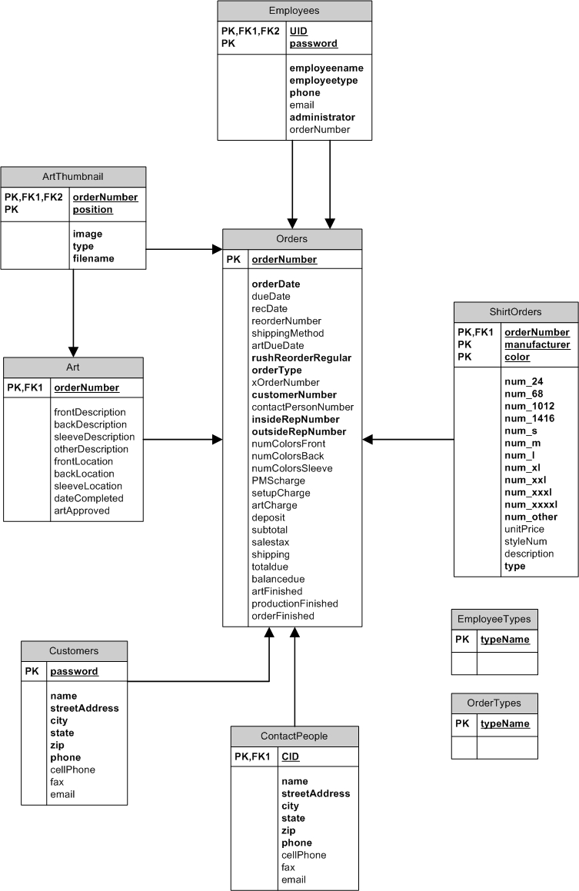

HTML/CSS

A thorough discussion of HTML and cascading style sheets is beyond the scope of this paper, but a background in HTML and CSS is undeniably useful in creating web applications. I already possess a background in both, which saved in development time.
Conclusion

A project like OrderTracker has two conclusions. There is an implementation conclusion in the sense that the project implemented either works or it does not. In addition, there is a learning outcome for the project. Implementation-wise, the project is successful for Hands on Originals. The following requirements traceability matrix shows that OrderTracker meets all requirements elicited.

#001.00
#001.01 fulfilled by viewOrder.aspx
#001.02 fulfilled by viewOrder.aspx
#002.00 fulfilled by Implementation: Platform Details
#003.00 fulfilled by using <browserCaps> in web.config
#004.00
#004.01 fulfilled by viewOrder.aspx, searchOrder.aspx
#004.02 fulfilled by viewOrder.aspx, searchOrder.aspx
#004.03 fulfilled by viewOrder.aspx, searchOrder.aspx
#004.04 fulfilled by viewOrder.aspx, searchOrder.aspx
#004.05 fulfilled by viewOrder.aspx, searchOrder.aspx
#004.06 fulfilled by viewOrder.aspx, searchOrder.aspx
#004.07 fulfilled by viewOrder.aspx, searchOrder.aspx
#005.00
#005.01
#005.01.1 fulfilled by viewOrder.aspx
#005.01.2 fulfilled by ManageCustomers.aspx, CreateCustomer.aspx
#005.01.3 fulfilled by ManageCustomers.aspx, CreateContact.aspx
#005.01.4 fulfilled by viewOrder.aspx
#005.01.5 fulfilled by viewOrder.aspx
#005.02
#005.02.1 fulfilled by viewOrder.aspx
#005.02.2 fulfilled by ManageCustomers.aspx, CreateCustomer.aspx
#005.02.3 fulfilled by ManageCustomers.aspx, CreateContact.aspx
#005.02.4 fulfilled by viewOrder.aspx
#005.02.5 fulfilled by viewOrder.aspx
#005.03
#005.03.1 fulfilled by viewOrder.aspx, addArt.aspx
#005.03.2 fulfilled by addArt.aspx
#005.04
#005.04.1 fulfilled by viewOrder.aspx
#005.05 fulfilled by viewOrder.aspx, searchOrders.aspx
#005.06 fulfilled by viewOrder.aspx, CreateCustomer.aspx,

CreateContact.aspx
#006.00 fulfilled by Login.aspx, web.config
#007.00 fulfilled by viewOrder.aspx
#008.00 fulfilled by viewOrder.aspx
#009.00 fulfilled by all .aspx files

Not only did OrderTracker meet the requirements specification, but the employees at Hands On Originals also agreed it was a tool they would like to use. I demonstrated the application to members of the art department and the sales department. The feedback I received from both was extremely positive, and they even suggested improvements for the next version. Most suggestions, however, were additions rather than changes to the existing application. I outline those suggestions in the section about future work.
Learning outcomes are slightly more difficult to define. My own perspectives bias them. I learned to use C#, ASP, and .NET. I learned about session management and database access using these technologies. However, in addition to these basic skills I learned more about developing software.
Microsoft touts its development products as everything one would need “under one roof.” C#, C++, Visual Basic, ASP, MSSQL, and so on, are all products that Visual Studio .NET 2003 handles. However, the interactions between these components can be difficult to tie together. Nearly a month of development time involved “tinkering” with system settings between Windows XP, IIS, and Visual Studio .NET, in addition to the coding that happened. In that amount of time, a competent programmer could have developed his or her own database API, page-rendering scheme, and session-handling code without worrying if the .NET technology would work when he began implementing the actual application.
Another major lesson I learned involved “cookies”. Even though most browsers can handle cookies and most users are unaware of their presence, some system/browser combinations cannot or will not support them. Mobile devices, for instance, do not usually support cookies. ASP 1.1, the version of ASP OrderTracker uses, cannot function without some kind of cookie use. When a user logs in to OrderTracker, ASP sends a cookie to the browser. The cookie is only valid for the session, but it still exists. The option for “cookieless” sessions supposedly exists. However, this option only means that cookies are not stored as a file on the user’s computer; they are still memory resident. ASP 2.0 purports to solve the no-cookie problem by allowing developers more choices in using a cookie scheme rather than simply saying cookies are or are not allowed [4].
The OrderTracker experience was a good one, however. Web application development is different from standalone application development. Database development for the web is also slightly different from database development for usual applications. I learned some tricks of web application development that point to these differences. For example, changing and searching through thousands of database records takes time. The web is not instantaneous, so delays in database transactions appear to the user as delays caused by bandwidth. These tricks help with finishing the project, but not with its efficiency. Nonetheless, I met both major goals of the project. I completed version one of an order-tracking web application, and I learned to use .NET and C# as a development environment and programming language.
Future Work

A number of options are available for future versions of this application. I would enjoy seeing security fully implemented so that the application can keep track of financial transactions without the risk of having that information stolen. A secure financial module would be more useful to the accountant who, at present, must work with both the OrderTracker system and any previous system.
OrderTracker does not handle ad-specialty items (ASI) or embroidery. ASI orders come with a number of different options and art styles that fall beyond the scope of one semester’s work. There is another database to connect to, which would require more research and perhaps financial backing to access. In addition to the ASI addition, the embroidery department would benefit from a module that allows them to store and use digitized artwork from the digitizer.
A report generator is also an attractive notion. The sales reps, or administrators, might want an option where they can find out statistics on current orders, such as the average order total, the percentage of orders that are rush or reorder, or maybe the most popular ink and shirt colors for a given time range. Each report would require new SQL queries and ASP pages, but the employee might prefer to generate a report “off the top of their heads.” Some kind of report generator that does not require the user to know SQL would fix this problem.
Finally, a customer ought to be able to upload art samples and ideas to the art department when he or she places an order. An online whiteboard for the customer would allow him or her to draw, however crudely, the design they have in mind. Pending future funding, these ideas may come to reality.
The next stage of the process for OrderTracker will involve extensive testing on a dedicated server. Potentially, testing includes adding old orders to the database, but a limit needs to be set since adding all previous orders would require the addition of tens of thousands of orders. Before Hands On Originals begins using it, there will most likely be a trial period where they use their existing method in conjunction with OrderTracker.
Glossary:

ADO.NET – the technology behind connecting to a database and handling disconnected datasets. Originally, ADO stood for Active X Data Object, but is not an acronym anymore. It is simply the “new” .NET technology.

API – application programming interface – this is an interface to a layer of functionality. For example, JAVA has a graphics API that allows programmers to manipulate images in their program without writing the functions themselves.

ASP – active server page - used to render the HTML to send back to the browser

C# – C sharp - the programming language behind ASP. This tells ASP what to render on the page.

CSS – cascading style sheets – used to give basic HTML more flexibility beyond standard HTML tags. Can be used to define text properties, object properties, and page properties.

HTML – hypertext markup language – the basic markup language that defines how objects should be displayed in a browser

IDE – integrated development environment – allows the programmer to manage, edit, and compile source code within the same program. The IDE for OrderTracker is Visual Studio .NET 2003.

IIS – Internet information server – the software that handles web connections to my computer

MSDE – Microsoft SQL server desktop engine – what I'm using in place of Windows Server or SQL server

OOHDM – Object-oriented hyper design model – a series of steps for the analysis and design stages of a web application project

SQL – structured query language – used to create queries to MSDE through ADO.NET

VS.NET – Visual Studio .NET – the package I used to develop OrderTracker. Contains utilities for ASP, HTML, C#, C++, J#, and Basic

References

1. Pressman, Robert S. Software Engineering: A Practitioner’s Approach. 6th Ed. New York: McGraw-Hill, 2005.

2. The OOHDM Wiki. June 18, 2004. Daniel Schwabe. January 23, 2005. <http://www.oohdm.inf.puc-rio.br:8668/space/start>.

3. Yale Style Manual. 2002. Lynch and Horton. March 2, 2005. <http://www.webstyleguide.com/>

4. Brown, Keith. Security Headaches? Take ASP.NET 2.0! MSDN Magazine. June 2004. Microsoft. March 19, 2005. <http://msdn.microsoft.com/msdnmag/

issues/04/06/ASPNET20Security/>

Appendix I – Expanded Use Cases

Log in to the System:

The user is presented the option to login either as an employee or as a customer. When he or she makes a choice, the appropriate login page is displayed. This page contains both a username and a password field. The application takes both fields, when the user clicks “Login” and compares them to the appropriate database. Should a match occur, that user is validated to the application and taken to the default page for that user type.

- Administrator
  - Create Employee
    - A form appears on the screen asking for the user information. Fields that must be filled out include:
      - name
      - employee type {Inside Sales, Outside Sales, Art, Production, Management, Other}
      - phone number
      - email address
      - home address
      - password (might be automatically created)
    - Once the fields are filled out and validated (at the server) the employee is created in the database with a unique employee id number - assuming no prior employee with the same name, id, and address exists.
    - An email is sent to the employee notifying that employee of their information, and login details. (optional)
    - The Administrator is sent to the main administration screen.
  - Remove Employee
    - A form appears on the screen displaying each employee.
    - The Administrator chooses the delete option for the employee to be removed.
    - Upon clicking delete, the system requests the deletion from the database. (Since the information displayed is from the database, there is no need to verify the employee exists.)
    - The administrator is sent to the main administration screen.
  - Change Employee Information
    - A form appears on the screen displaying each employee.
    - The Administrator chooses (with a hyperlink) the employee to be changed.
    - The form displayed in “Create Employee” is given with all the fields filled in – ready to be edited.
    - Once the fields have been validated, the update request is given to the database.
    - An email is sent to the employee notifying that employee of their information and login details. (optional)
    - The administrator is sent to the main administration screen.
  - Backup Order Database Information
    - A form appears on the screen asking where the database should save information.
    - The user either types in the directory, or browses to the directory where the backup should be stored.
    - The system downloads information retrieved from the database (a snapshot) to the folder. While the backup is occurring, no access is given to that particular database.
    - When the backup is finished, the administrator is sent to the main administration screen.
- Employee (Sales)
  - Create Customer
    - A form appears on the screen asking for the customer information. Fields that must be filled out include:
      - Customer ID Number (might be automatically created)
      - Password
      - Name
      - Street Address
      - City
      - State
      - Zip Code
      - Phone Number
    - Once the fields have been filled out and validated (at the server) the customer is created in the database with a unique customer id number - assuming no prior customer with the same name, id, and address exists.
    - If an email address exists, an email is sent to the customer notifying that employee of their information, and login details. (optional)
    - The salesperson is sent to the main screen.
  - Create Contact Person
    - A form appears on the screen asking for contact person information.
    - Once the fields have been validated, they will be added to the database for that particular customer.
    - The salesperson will be taken back to the main sales screen.
  - Search Customers
    - The salesperson is given a list of options to search for
      - Customer Name
      - Customer Username
      - Customer Email
      - Order Numbers
    - Having entered any information, the appropriate database is searched to find orders with those attributes.
    - A list of candidate customers and contact people is presented to the user in order for them to select the appropriate hyperlink and view candidate customer information.
  - Create Order
    - A form appears on the screen asking for order information.
    - The salesperson may search for the customer and contact person.
    - Once all the required order information is entered (detailed in the database design) the “Submit” button is clicked and if the order does not already exist, it is validated and then created in the database.
    - The salesperson is sent to the main screen.
  - Modify Order
    - The salesperson is given a list of their orders currently in the system and not completed.
    - A form is presented similar to Create Order only the fields are already filled in.
    - The rest follows from (ciii) above.
  - View Order
    - The salesperson is given a list of all current orders.
    - By choosing a hyperlink for the order, a form similar to that in Create Order is presented, but without editable fields.
  - Search Orders
    - The salesperson is given a list of options to search for
      - Order Number
      - Customer Name
      - Customer Username
      - Contact Person
      - Contact Name
      - Salesperson Name
      - Salesperson Username
    - Having entered any information, the request is sent to the database to find orders having those attributes.
    - A list of candidate orders is presented on the screen from which the user may select a hyperlink to View an Order (e above)
- Employee (Art)
  - Add/Update Art for an Order
    - The artist is given a list of orders needing art.
    - The artist selects the hyperlink corresponding to the order they want to add to or modify art within.
    - The order information appears on the screen with a list of locations and file input areas.
    - The artist chooses location artwork by browsing to the file.
    - For each location, the database creates an entry detailing the order number, location, and jpg.
    - Should the art already exist, it will be overwritten.
- Employee (Production)
  - Update Production Status
    - The producer is given a list of orders in production
    - The fields pertinent to the producer are editable
      - materials received
      - number of colors for each location
      - date completed
      - date art received
    - Once the fields have been entered and validated, the order is updated.
    - The producer is taken to the list of orders in production
- Customer
  - Preview Artwork/View Order Status
    - The customer is given a list of their current orders
    - From the list, they select the hyperlink corresponding to their order
    - The customer is presented with a screen detailing order information (not editable).
    - The customer can click “OK” to return to the main customer screen.
  - Search Orders
    - The customer is given a list of options to search for
      - Salesperson Name
      - Date
      - Order Number
    - The customer clicks “Search” and is given a list of candidate orders (corresponding to their customer number)
    - From the list, the customer may choose the hyperlink corresponding to the correct order.
    - A page is presented detailing order status and artwork (as in a above)
Appendix II – Example Pseudo-code for each Page in OrderTracker

Homepage

Same for all users.
Option to login as a customer
Option to login as an employee

Default.aspx for employees and customers

if the user is not logged in
Redirect to login.aspx

display menu (described above)

Login.aspx and customerLogin.aspx

display login options
when submit is clicked
query database to ensure username/password combination is valid
if valid
redirect to Default.aspx
else
show user error message

ManageEmployees.aspx

display employee list
display add employee button

if add employee button clicked
redirect to newEmployee.aspx with add option toggled to on

if delete employee hyperlink in list clicked
query database to remove employee

if employee information hyperlink in list is clicked
redirect to newEmployee.aspx with add option toggled to off

BackupDatabase.aspx

display textbox and browse button for entering a path for the backup
display backup button

if backup path button is clicked
use system defined file browser to find directory and filename

if backup button is clicked
save current database to disk specified

ManageCustomers.aspx

display customer handler menu options
display link to create a customer
display link to create a contact person
display link to search for a customer

if link to create customer is clicked
redirect to CreateCustomer.aspx
if link to create contact person
redirect to CreateContactPerson.aspx
if link to search for customers is clicked
redirect to SearchCustomers.aspx

CreateCustomers.aspx and CreateContactPerson.aspx

if the add option is true
display a form with no information inserted
display a button to add a customer

if the add option is false
display a form with customer information inserted
display a button to update a customer

if add button is clicked
if fields are validated
query the database to add the customer
if query fails
change label to reflect error
if fields are not validated
change label to reflect error

if update button is clicked
if fields are validated
query the database to update the customer
if query fails
change label to reflect error
if fields are not validated
change label to reflect error

Search Customers.aspx and Search Orders.aspx
(search for orders shown, search for customers is similar)

if the user is a customer
display options to search for
Salesperson Name
Date
Order Number

if the user is an employee
display options to search for
Order Number
Customer Name
Customer Username
Contact Person
Contact Name
Salesperson Name
Salesperson Username

if search button is clicked
query the database to find orders with fields similar or equal to those entered

if the user is a customer
only display those owned by him or her with hyperlinks
else
display all results with hyperlinks

if hyperlink for an order is clicked
redirect to viewOrder.aspx

OrdersPending.aspx

display a link to search for an order

if the user is a customer
display a table of orders corresponding to that customer username
if the user is a salesperson
display a table of orders corresponding to that sales rep username that are not yet finished
display a link to create an order
if the user is an artist
display a table of orders where the art is not finished

if the user is a production manager
display a table of orders that have not been produced
if the user is an administrator
display a table of current orders

if hyperlink for an order is clicked
redirect user to viewOrder.aspx

if hyperlink for a new order is clicked
redirect user to newOrder.aspx

newOrder.aspx

display all order fields and one shirt order field
display add shirt button
display add order button

if add shirt button is clicked
display a new form in the current form with fields for a new shirt order
display finished adding shirt button

if finished adding shirt button clicked
query database to add shirt
if successful
redisplay data
else
modify label to reflect errors

if add order button clicked
query database to add order
if successful
redisplay data
modify label to show order added
else
modify label to reflect errors

viewOrder.aspx

if the user is a customer
display customer information for that order
display art information for that order
display balance information for that order

if the user is a salesperson or adminstrator
display all order information (editable)
display update button

if the user is an artist
display customer information
display art information
display add/modify art button

if the user is a production manager
display all order information
display finished production button

if update button is clicked
query the database to update the order information
if change valid
redisplay information
else
modify label to show errors

if add/modify art button clicked
redirect to addArt.aspx

if finished production button clicked
query database to add date completed information
if change is valid
redisplay information
else
modify label to show errors

addArt.aspx

display art details for the order
for each location defined
display current art thumbnail
display current art location description
display textbox and browse button for entering a path for the art
display update/add art button

if browse button clicked
use system defined file browser to find directory and filename

if update/add art button clicked
query database to add thumbnail to database
if successful
redisplay information
else
modify label to show errors

Parameterized queries prevent an SQL injection attack where an attacker inserts malicious SQL into the query.
Automating any portion of software implementation involves risks. I had to check all of the transformed queries to ensure the original intent was met.

