Basic OrderTracker User’s Manual*

Customers and Employees follow the same steps to interact with OrderTracker. Some information is not available to Customers, but the same sequence of steps gets them to the desired result.

Log in to the System:

To get to OrderTracker, you need to click a link outside the system to take you to the default customer or default employee page. To login, choose the page you are navigating to and OrderTracker presents this screen:

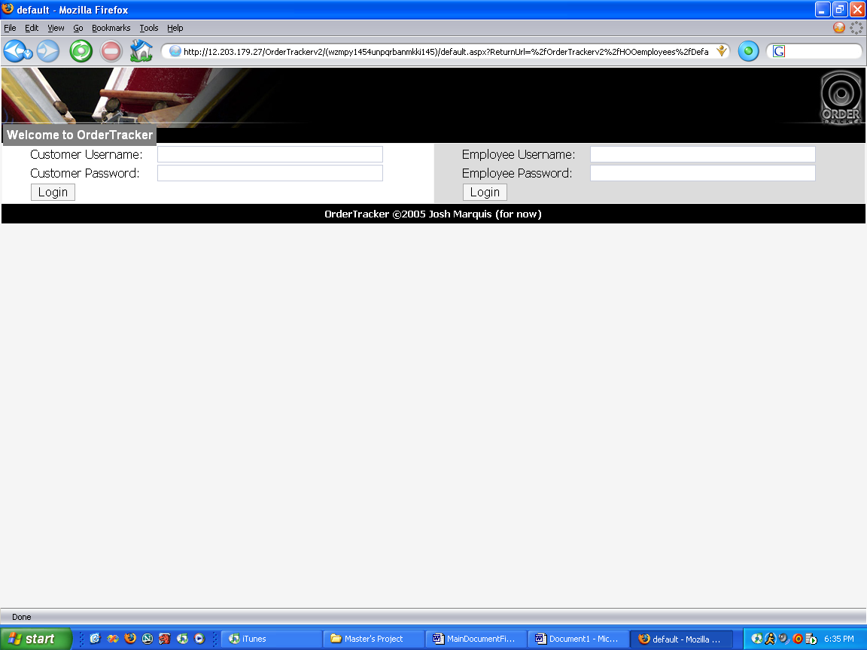

If you are an employee, fill in the employee information, and click “Login”.

If you are a customer, you may do likewise for the customer information and click “Login”.

Administrator

Create Employee

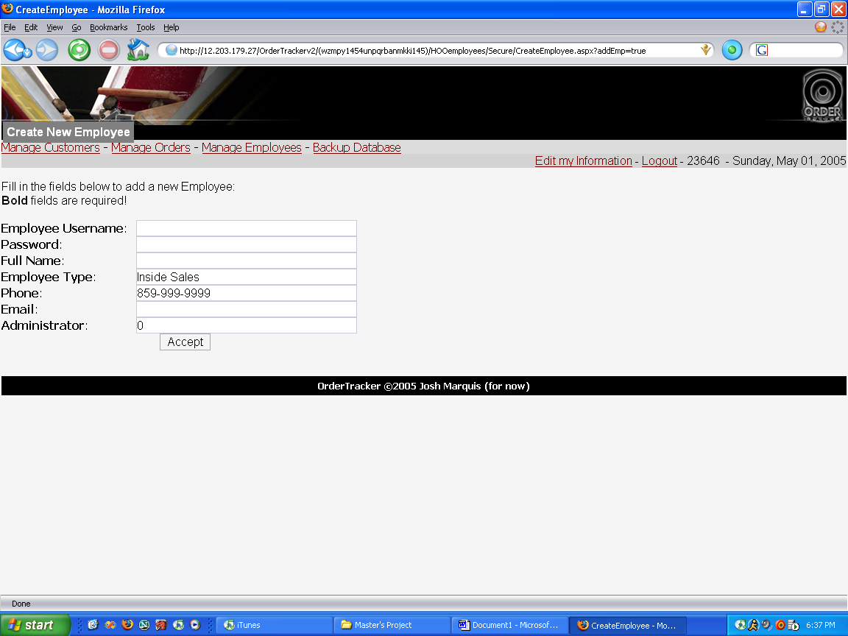

From the main menu, choose “Manage Employees”.

Click “Add Employee”.

Fill out all of the fields for the employee information. Click “Accept” to add the employee to the database. If that employee already exists, you must choose a new username for that employee.

Remove Employee

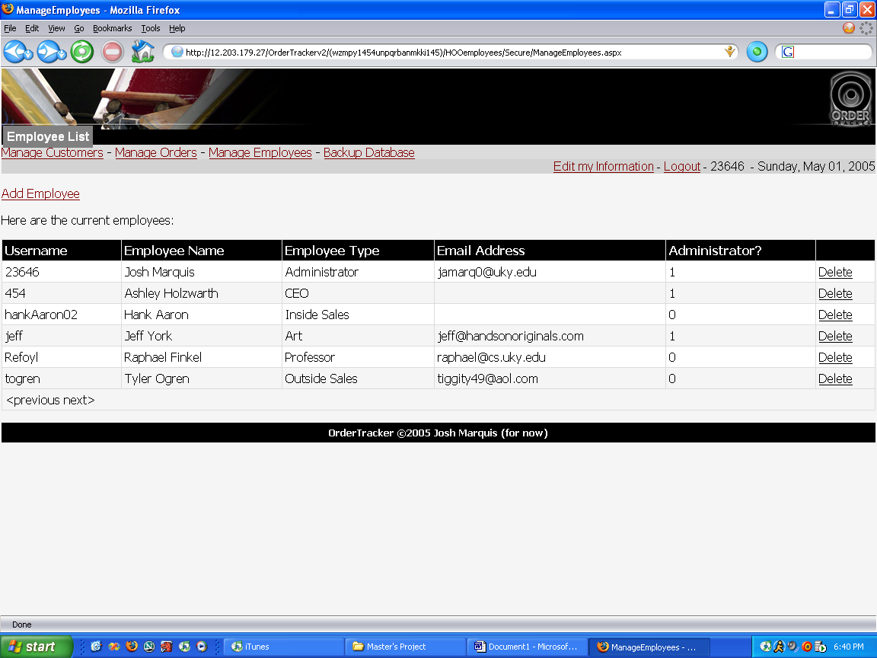

From the main menu, choose “Manage Employees”.

Click “Delete” on the same row as the employee you wish to delete.

Backup Order Database Information

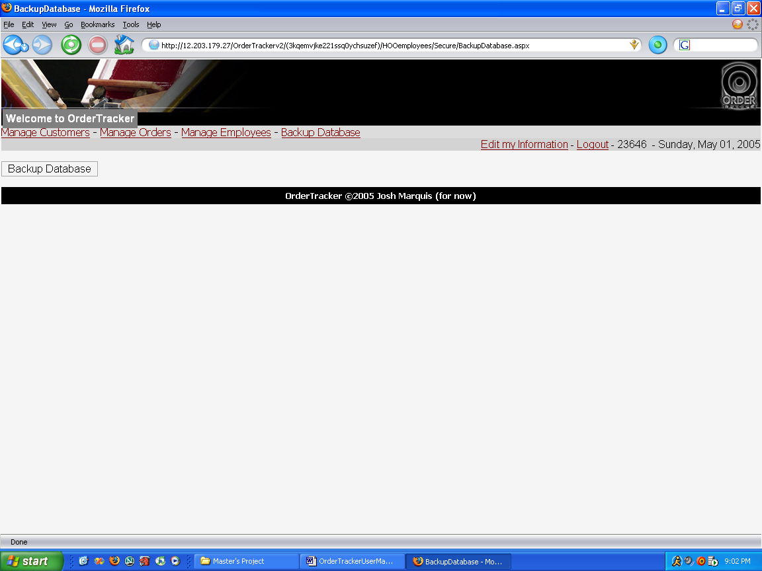

Click “Backup Database”.

From the popup dialog box, choose to save the file.

Choose the directory and filename for the backup file.

Click “Save”.

Sales

Create Customer/Contact Person

(Creating customers and contact people require the same steps)

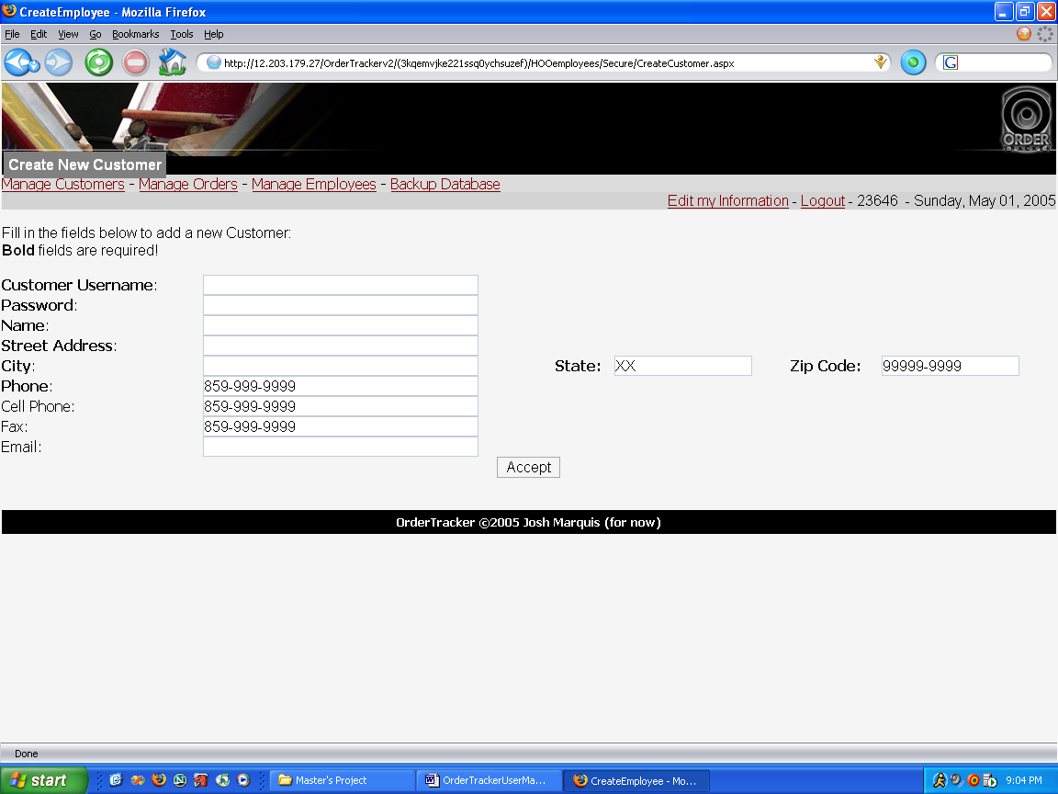

Choose “Manage Customers” from the main menu.

Click “Create a Customer” or “Create a Contact Person”.

Fill in all necessary fields (fields in bold typeface are required).

Click “Accept”. If the customer or contact person already exists, OrderTracker will not insert that customer, and you must choose a new name.
Search Customers/Contact People

(Searching for customers and contact people require the same steps)

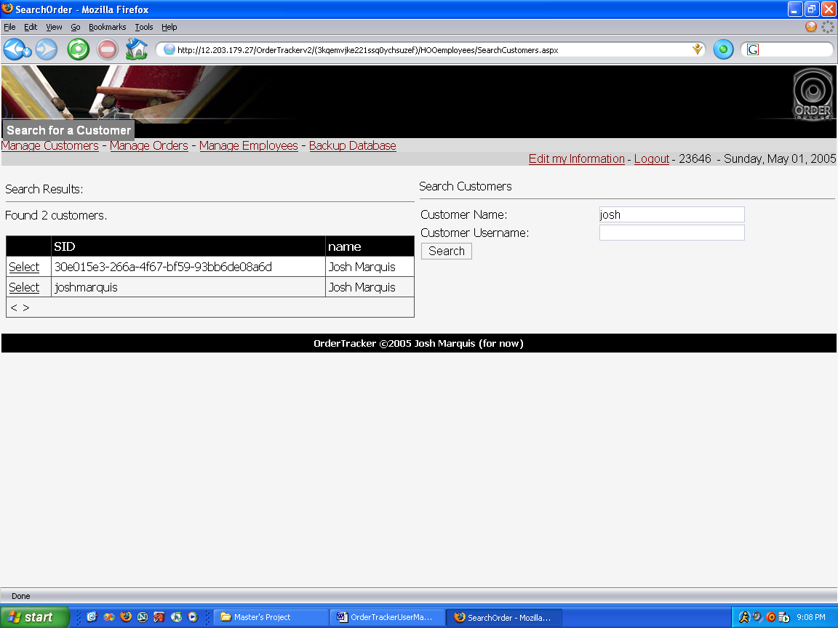

Click “Manage Customers” on the main menu.

Click “Search for a Customer” or “Search for a Contact”.

You must type in all of the information for which you are searching.

Click “Search”.

    - Select the customer you want more information on by clicking, “Select” next to the appropriate name and customer/contact ID.
Create Order

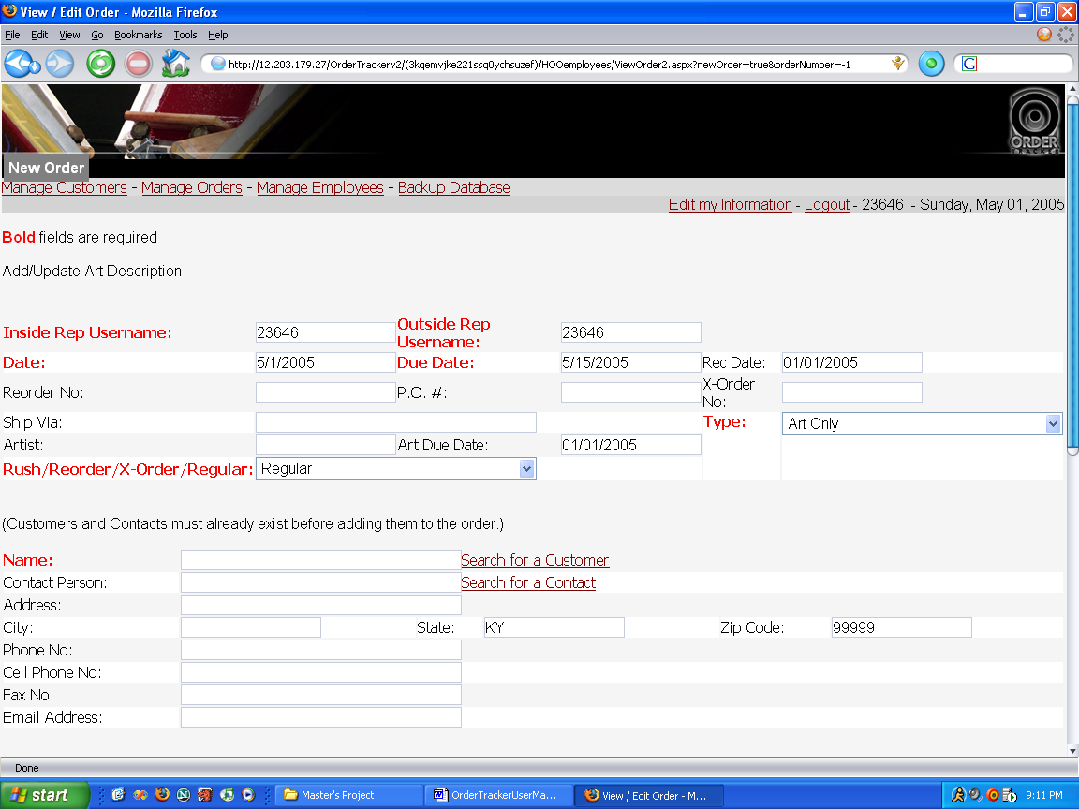

From the main menu, click “Manage Orders”.

Fill in the required fields in the New Order form.

To find a customer or contact person for the order, click the appropriate button. The customer and contact person must already exist, so if it is a new customer, add that person using the steps outlined above for creating customers and contact people.

Click “Accept” at the bottom of the form.

At this point, you can add art descriptions, t-shirt materials, and pricing to the order.

Simply add the information to the form and click “Accept” and OrderTracker updates the information in the database.

Modify/View Order

Click “Manage Orders” on the main menu.

If your order is not yet finished, it may appear in the form that appears. If it is not listed, click “Search Orders” and search for the order (see below for information on how to search for an order).

When you have selected the order, its information appears on the screen.

You can modify and view the order by using the steps outlined in creating an order.

Search Orders

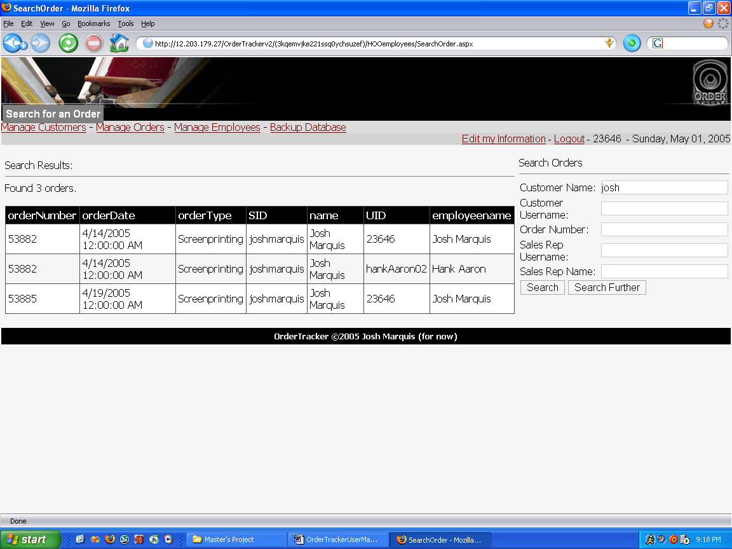

From the main menu, choose “Manage Orders”.

Click “Search Orders”.

Fill in the fields you want to search for in the search menu. Click “Search” and OrderTracker displays a list of orders matching that description.

Art

Add/Update Art for an Order

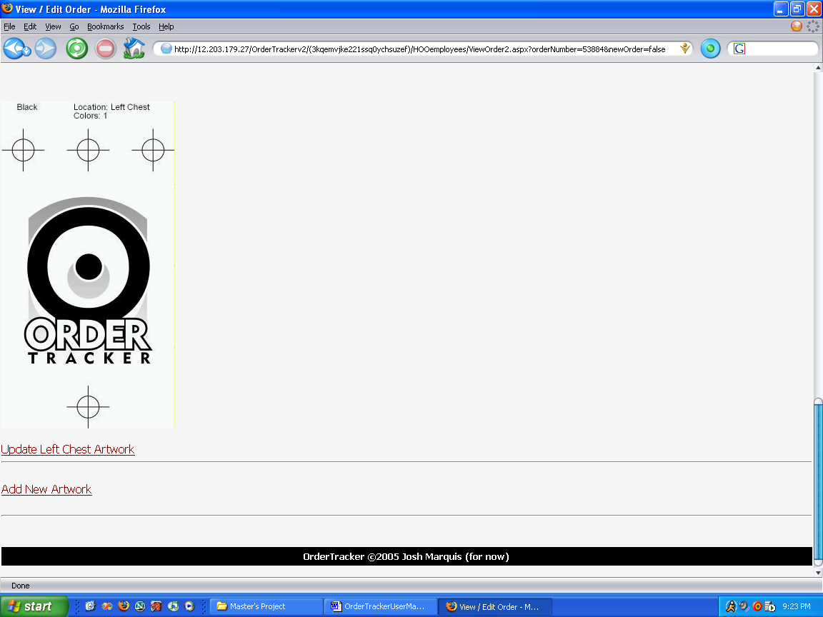

Select the order requiring art using one of the methods described above. If the sales representative has not yet approved the order, it ought to appear in the default list of orders.

Scroll to the bottom of the page and choose to either update the existing artwork using the “Update [Position] Artwork” or “Add New Artwork” links.

You may only add up to six unique pieces of art.

When you decide to change or add artwork, this screen appears:

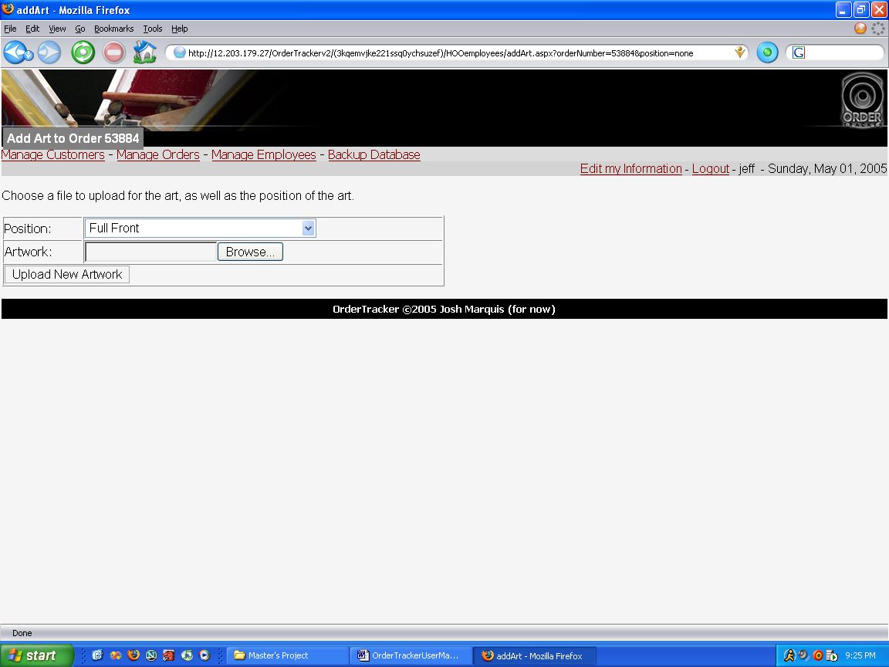

Choose the position desired, and click “Browse” to find the thumbnail corresponding to the artwork for the order.

Click “Upload New Artwork” or “Update Artwork” to change the art.
Production

Update Production Status

View an order using the methods described above.

At the top of the form, click one of the production status checkboxes. For example, when the production department finishes printing the shirts, click “Production Finished”.

Click “Accept” at the bottom of the page to update the order status.

* *I based this manual on the use case descriptions found in the OrderTracker project documentation.

