Final Project Report

Online Auto Mechanic Finder



Project Supervisor
Muhammad Zafar Nazir

Submitted By

F180249CC8

Danish Saleem BC150403476

Software Projects & Research Section,
Department of Computer Sciences,
Virtual University of Pakistan


CERTIFICATE

This is to certify that Danish Saleem (BC150403476), have worked on and completed their Software Project at Software & Research Projects Section, Department of Computer Sciences, Virtual University of Pakistan in partial fulfillment of the requirement for the degree of BS in Computer Sciences under my guidance and supervision.

In our opinion, it is satisfactory and up to the mark and therefore fulfills the requirements of BS in Computer Sciences.

Supervisor / Internal Examiner

Muhammad Zafar Nazir
Supervisor,
Software Projects & Research Section,
Department of Computer Sciences
Virtual University of Pakistan

___________________
(Signature)

External Examiner/Subject Specialist
<<External Supervisor Name>>

___________________
(Signature)

Accepted By:

_____________
(For office use)

EXORDIUM

In the name of Allah, the Compassionate, the Merciful.

Praise be to Allah, Lord of Creation,
The Compassionate, the Merciful,
King of Judgment-day!

You alone we worship, and to You alone we pray for help,
Guide us to the straight path

The path of those who You have favored,

Not of those who have incurred Your wrath,
Nor of those who have gone astray.

DEDICATION

I am sincerely thankful to my parents to encourage me and also my teacher who support me and guide me. Special thanks to my supervisor. Thanks a lot, every who all pray for me.

May Allah bless you all Ameen.

ACKNOWLEDGEMENT

I wish to express my sincere gratitude to my Supervisor Muhammad Zafar Nazir for providing me an opportunity to do my project in Virtual University of Pakistan.
PREFACE

I am glad to present this project to Muhammad Zafar Nazir. This project is about Online Auto Mechanic Finder. This includes functional and nonfunctional requirements and polices about online service finder system.

This project prepared by Danish Saleem as a task of CS619 given by Muhammad Zafar Nazir. Hope so get good remarks in this project compilation.
TABLE OF CONTENTS

CHAPTER NO. 1
gathering & Analyzing info 10

1.1 Introduction

1.2 purpose

1.3 scope

1.4 definitions, acronyms and abbreviations

1.5 Project requirements

1.5.1 Functional Requirements

1.5.2 Non-Functional Requirements

1.6 use cases and usage scenarios

1.6.1 Use Case Diagrams

1.6.2 Usage Scenarios

1.7 Development Methodology

1.7.1 Chosen Methodology

1.7.2 Reasons for Chosen Methodology
1.7.2 Work Plan (Gantt Chart)
1.7.2 Project Schedule (Submission Calendar)

CHAPTER NO. 2
designing the project 19
2.1 Introduction

2.2 purpose

2.3 scope

2.4 definitions, acronyms and abbreviations

2.5 Architectural Representation (Architecture Diagram)

2.6 Dynamic Model: Sequence Diagrams

2.7 Object Model/Logical Model: Class Diagram

2.8 Database Model (Database Diagram)

2.9 Graphical User Interfaces

Chapter no.3
DEvelopment 24
3.1 Development plan (Architecture Diagram)

<<Dear Students, you have to take special care of page numbers, which are written against each Chapter and sub headings. You have to mention your own page numbers and correct one against each document heading. Make proper table of contents. Remember that if there are any new headings or you have included more headings in your documents then you also have to write these in table of contents and modify table of contents according to your documents material>>

<<Dear Students, before starting each chapter the following would be the title page for each chapter on a separate page>>

CHAPTER 1
Gathering & Analyzing Info

  - Introduction
The auto mechanic finder is a web-based application. This is a platform which will allow customers to find the auto-mechanic from different areas. There will be three modules of this platform. One for the admin, second for the customers and third for auto mechanic respectively.
1.2 purpose
The purpose of this project was to develop a web application for finding auto mechanics shops based on your location. This project helped me in gaining valuable information and practical knowledge on several topics like designing web pages using HTML & CSS usage of responsive templates, and management of database using MYSQL and PHP for server-side actions. The entire system is secured. Also, the project helped me understanding about the development phases of a project and software development life cycle. I learned how to test different features of a project. This project has given me great satisfaction in having designed an application which can be implemented to any nearby auto mechanic shops offering various kind of services by simple modifications.

1.3 scope
This Online Auto Mechanic Finder System will allow users to check and send request to different auto mechanics located in their areas. This project will contain complete list of auto mechanics and shop details displayed in several categories and the user can browse through that. User can search for the mechanic shop. User needs to register on the site before sending request to mechanic. He can then login using same user name and password next time. User may pay cash at the spot.

1.4 definitions, acronyms and abbreviations

1.5 PROJECT REQUIREMENTS

    - Functional Requirements
- The application will provide Login interface for admin. Admin can view/add/update/delete Mechanic and User information. Admin can view all the requests sent and feedbacks posted by the users.
- The application will provide Login interface to mechanics. Mechanic can view the requests sent and feedback posted by the users regarding him.
- The application will provide registration interface to unregistered user. User can login to the system after providing registration details. User can search mechanics based on location and see shop address details and posted feedback etc. User can send request to mechanic and post feedback regarding him.
- Unregistered User can search mechanics based on location and see shop address details etc.
- In order to send request to mechanic, user is required to first register.

    - Non-Functional Requirements
- It is a web application, so its run on any browser.
- Usability of application must be easy.
- Application should build up in such a way that classification of errors and maintenance of mechanism become easy.
- Software must be flexible so that it can easily accept all changes at low cost, time and experience.
- Software must be secure.
- Reliability specifies the capability of the application to maintain its performance over time.

1.6 use cases and usage scenarios
1.6.1 Use Case Diagrams
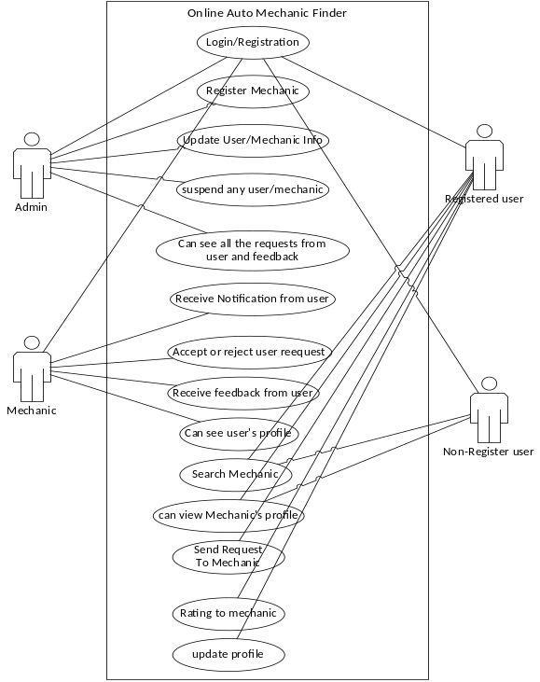

1.6.2 Usage Scenarios

Use Case Title | View Website (User and Guest)
Use Case Id | 001
Actions | Click and view mechanic detail.
Description | Both User and Guest Can View mechanic shop address, but only Registered User Can Send Request to mechanic.
Alternative Paths | None
Pre-conditions | Click on Mechanic Shop details
Post-conditions | Success: Detail of profile will display  Failure: profile is not available
Exceptions | This profile is not available.
Author | BC150403476

Use Case Title | Sign Up (Guest)
Use Case Id | 002
Actions | Click on sign up button  Fill the registration form with a valid email address and password  Click on create account button
Description | By sign up Guest will become a registered User, he will be able to send requests to mechanic.
Pre-conditions | Open website, click on Registration button
Post-conditions | Success: User can Login to his Account and send request to mechanic on the website.  Failure: Error message is displayed
Exceptions | Problem with network connection  Email address already exists in database  Invalid email address  Invalid password
Author | BC150403476

Use Case Title | Sign in/Login (User and Admin)
Use Case Id | 003
Actions | Click sign in button  Enter email & password  Click sign in
Description | User and Admin both enter user id and password to sign in
Alternative Paths | Forgot password  Sign Up
Pre-conditions | User must have an account.
Post-conditions | Success: Signed in to the website.  Failure: User will be prompted again
Exceptions | Invalid email password combination
Author | BC150403476

Use Case Title | Search Mechanic (User and Guest)
Use Case Id | 004
Actions | Click on the search button.
Description | Both User and Guest can search their nearby mechanic over the website using search button.
Alternative Paths | They can view featured mechanics.
Pre-conditions | Click on search button
Post-conditions | Success: searched results will display  Failure: result is not available
Exceptions | This result is not available over the website
Author | BC150403476

Use Case Title | Send Request (User)
Use Case Id | 005
Actions | Click on the mechanic profile, and then click on the send request button.
Description | If user want to send request, he will click on the send request button.
Alternative Paths | View another mechanic profile or go back.
Pre-conditions | Click on the mechanic profile.
Post-conditions | Success: System will send request to mechanic  Failure: product is not available
Exceptions | Request not sent
Author | BC150403476

Use Case Title | Email Confirmation (User)
Use Case Id | 007
Actions | Click book now button  Provide your info  Click submit button
Description | User can provide personal information for pay bill
Pre-conditions | If used has purchased order then he may able to fill the checkout form and submit order
Post-conditions | Success: Email will be sent to user  Failure: Database unchanged
Exceptions | Invalid length or empty string
Author | BC150403476

Use Case Title | Manage Profiles (Admin)
Use Case Id | 008
Actions | Update new Profiles and Modifying Existing Profiles
Description | Admin will manage the user and mechanics, he can add, delete and update information of the users and mechanics.
Alternative Paths | None
Pre-conditions | Click on Update Profile
Post-conditions | Success: A new profile will be display or existing profile will change with new information  Failure: null
Exceptions | Check your internet connection.
Author | BC150403476

Use Case Title | Manage Account (Admin)
Use Case Id | 009
Actions | Adding User ids and Password through automatic system.
Description | Admin will manage the User Account. He will manage different portal, changing password, modifying account info, etc.
Alternative Paths | View as guest,
Pre-conditions | Click on forgot password, Registration button, or change password
Post-conditions | Success: after this your account will manage accordingly  Failure: nil
Exceptions | nil
Author | BC150403476

1.7 Development Methodology

The methodology may include the pre-definition of specific deliverables and artefacts that are created and completed by a project team to develop or maintain an application. Most modern development processes can be vaguely described as agile.

1.7.1 Chosen Methodology
Different methodologies and models are used by the people according to their work and planning. We will use “Vu process model” It is combination of two models Water Fall and Spiral methodologies.

Water Fall Methodology:

The water fall methodology consists on cycle of analysis, design, coding, testing, and maintenance. The simplest version is called "waterfall" methodology.

- The systems goals, services and limits are described by consulting the whole system with Customers
- The requirements are grouped into hardware and software systems. It gives overall design of the system.
- After installation, system is used practically. The system than checks errors correct them and improve them


Project Initiation

Analysis

Requirements Definition

Operation and Maintenance

Testing and Integration

Implementation

Design

1.7.2 Reasons for Chosen Methodology

Spiral Methodology:

- To eliminate the risk that could be faced in development of software the use of spiral methodology is adopted. For example, the risk might be a resignation from the key person
- Spiral Model has two dimensions. One is Radial dimension which represents the cumulative cost to date, and the other is angular dimension which represents the progress through the spiral.
- The spiral model is very sensitive to risks. In this model development and maintenance run in parallel. This method is used for development of large-scale and in-house software.
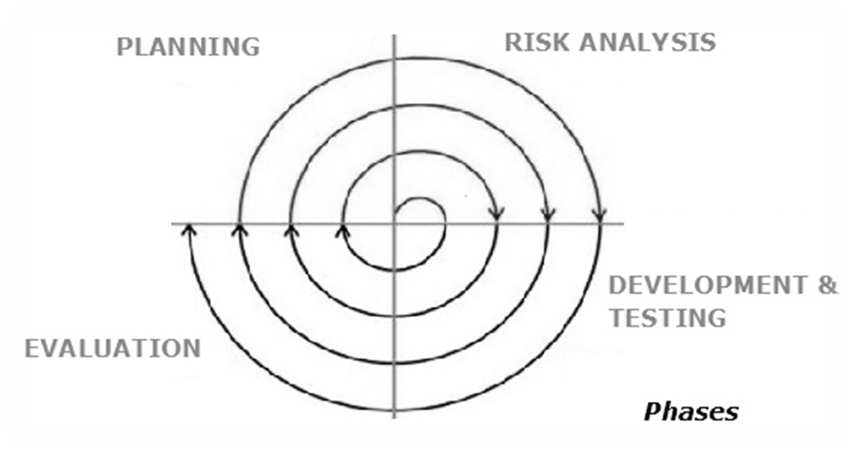

We use the VU Process Model and it contains seven steps or phases.
- First phase is the requirement and verify in which requirement is gathering and for gathering requirement meeting is conduct with the Customer of software.
- Second step is planning and designing of software in which plane the development of software and it complete on given time.
- Third phase is the analyzing and designing phase so it analyzes and designing the all development of software.
- Fourth step is the implementation and testing phases so implement the designing and planning of software and also test.
- Fifth phase is the integration and system testing so in which integrate the development and test every software parts.
- Sixth step is operational phase in which software is sending for operation.
- Seventh step is the maintenance phase in which maintain the operation according to the need.

Requirements

System Analysis

Designing

Coding

Testing

Acceptance

Planning
Software Requirements
Specification and Work

Product Delivery with Quality otherwise Recycle it for further

Risk Analysis:
Cost Effectiveness with Minimum Risk

Design, Coding, Testing & Development

VU PROCESS MODEL

1.7.2 Work Plan (Gantt Chart)
1.7.2 Project Schedule (Submission Calendar)

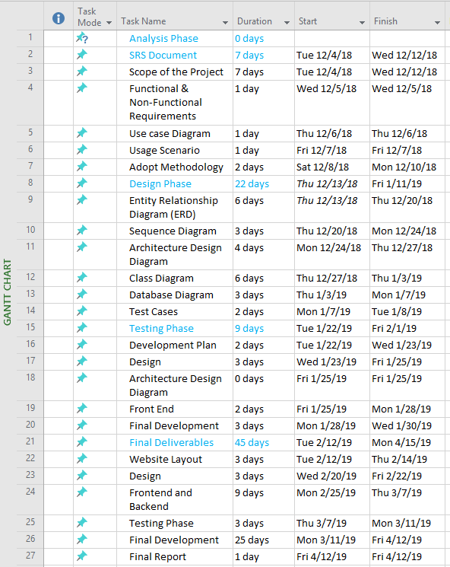

CHAPTER 2
Designing the Project

2.1 Introduction

For students, this document should be used to set goals for their work on the project and to help understand their term and final marks from Lead Engineers. Engineering Design Project – Definition of Engineering Design. “Design: An ability to design solutions for complex, open-ended engineering problems and to design.

2.2 purpose

The purpose of this project was to develop a web application for finding auto mechanics shops based on your location. This project helped me in gaining valuable information and practical knowledge on several topics like designing web pages using HTML & CSS usage of responsive templates, and management of database using MYSQL and PHP for server-side actions. The entire system is secured. Also, the project helped me understanding about the development phases of a project and software development life cycle. I learned how to test different features of a project. This project has given me great satisfaction in having designed an application which can be implemented to any nearby auto mechanic shops offering various kind of services by simple modifications.
2.3 scope
This Online Auto Mechanic Finder System will allow users to check and send request to different auto mechanics located in their areas. This project will contain complete list of auto mechanics and shop details displayed in several categories and the user can browse through that. User can search for the mechanic shop. User needs to register on the site before sending request to mechanic. He can then login using same user name and password next time. User may pay cash at the spot.

2.4 definitions, acronyms and abbreviations

2.5 Architectural Representation (Architecture Diagram)

Admin/Mechanic/Visitor
Web Application
Server/Database

2.6 Dynamic Model: Sequence Diagrams

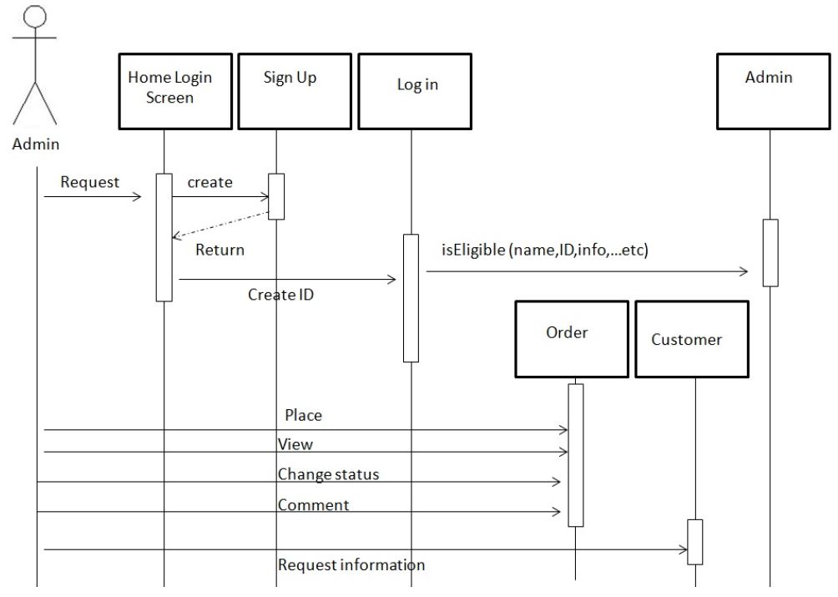

2.7 Object Model/Logical Model: Class Diagram

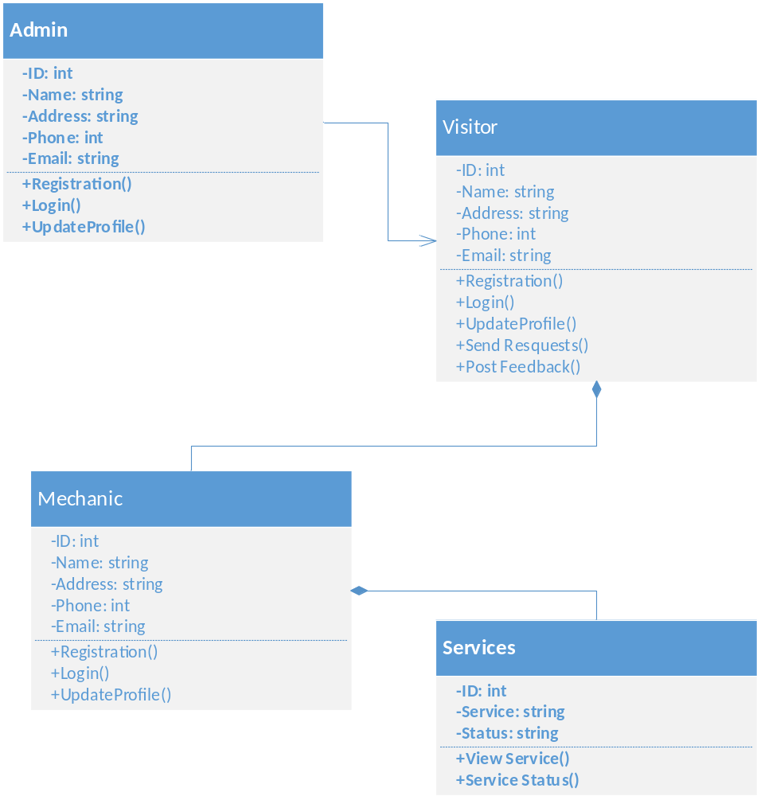

2.8 Database Model (Database Diagram)

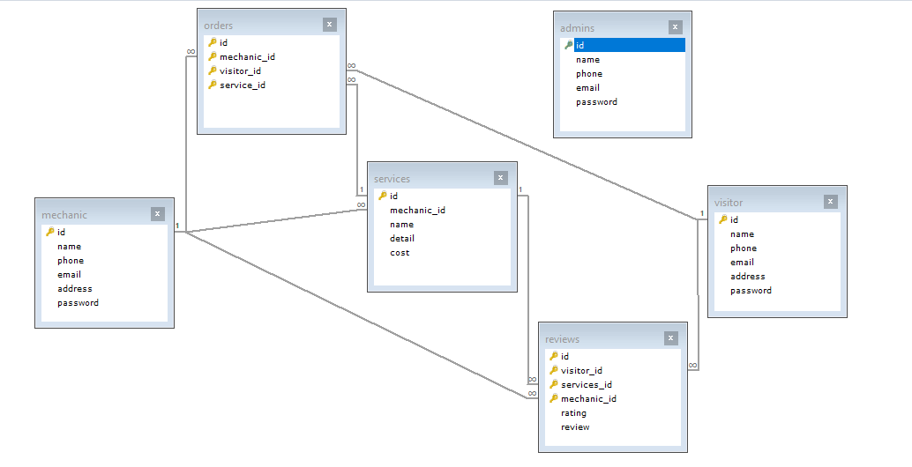

2.9 Graphical User Interfaces

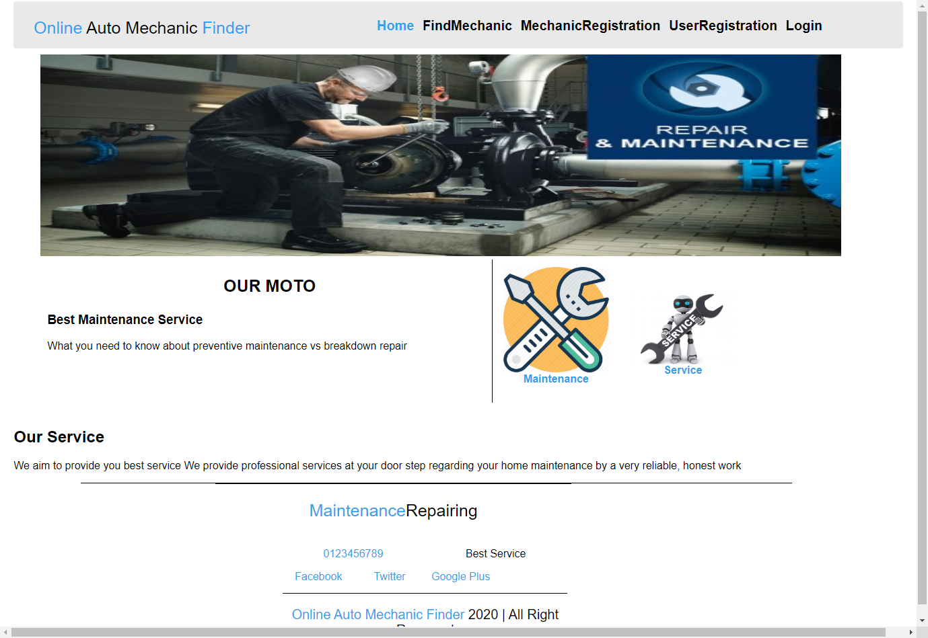

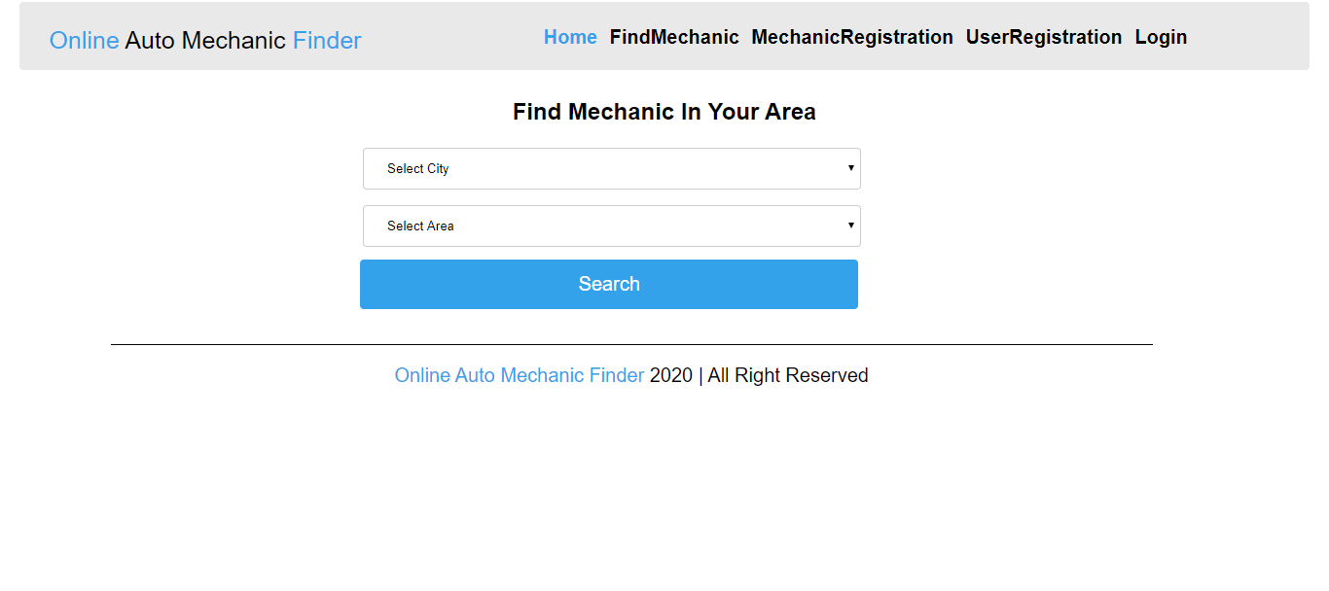
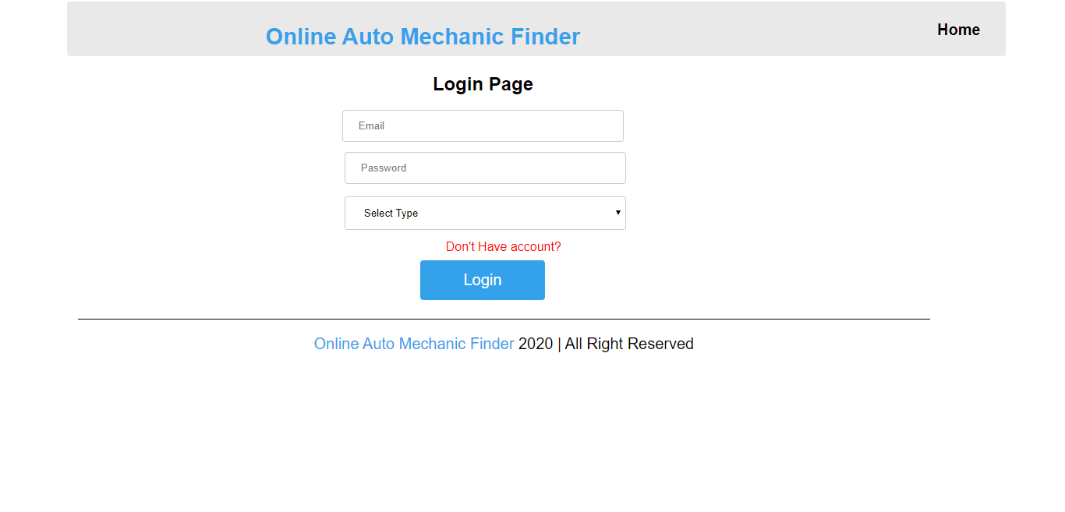
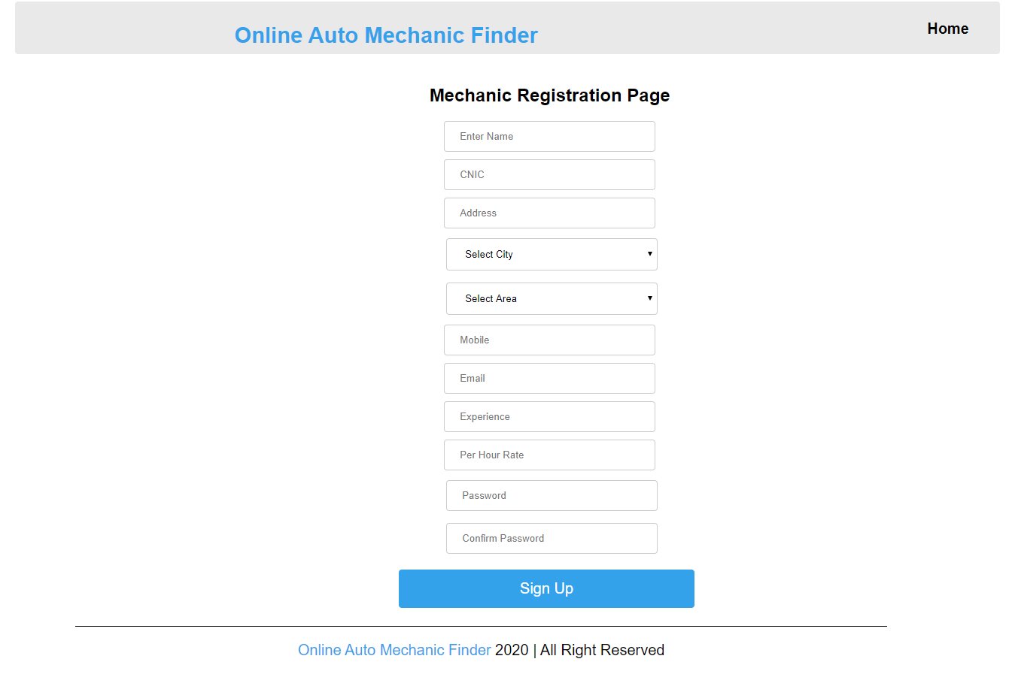

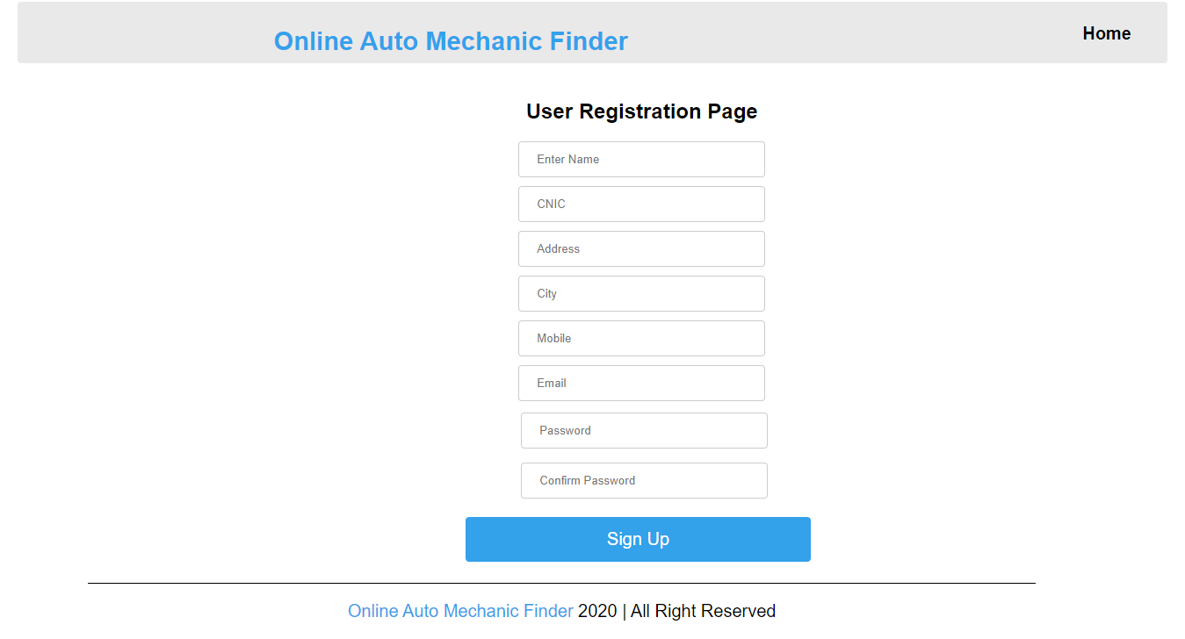

CHAPTER 3
Development

3.1 Development plan (Architecture Diagram)

