**SENTIMENT ANALYSIS FOR MARKETING**

**Phase-2 Document Submission**

Objective:

In this phase, we will apply advanced techniques, specifically fine-tuning pre-trained sentiment analysis models (BERT,RoBERTa), to extract more accurate insights from customer feedback about competitor products.

Step 1: Data Preparation

Ensure that you have collected a comprehensive dataset of customer reviews from various online platforms.Check the quality and coverage of data across competitor products.Split the data into training, validation, and test sets for model training and evaluation.

Step 2: Preprocessing

Clean the text data by removing special characters, punctuation, and irrelevant symbols.Tokenize the text into individual words or phrases.Eliminate common stop words.Apply stemming or lemmatization to reduce words to their base forms.Handle missing or incomplete data.

Step 3: Model Selection

Choose between BERT and RoBERTa based on your specific requirements, available resources, and model performance.

Step 4: Fine-Tuning Pre-trained Models

Load the selected pre-trained model (BERT or RoBERTa).Build a classification layer on top of the pre-trained model to predict sentiment labels (e.g., positive, negative, neutral).Fine-tune the model on the training dataset using techniques like transfer learning.Implement learning rate schedules, early stopping, and gradient clipping for optimization.

Step 5: Model Evaluation

Evaluate the fine-tuned model on the validation dataset.Monitor metrics such as accuracy, precision, recall, F1-score, and ROC-AUC to assess its performance.Make necessary adjustments to hyperparameters to improve results.

Step 6: Model Testing

Assess the model's performance on the test dataset to ensure its generalization to new data.

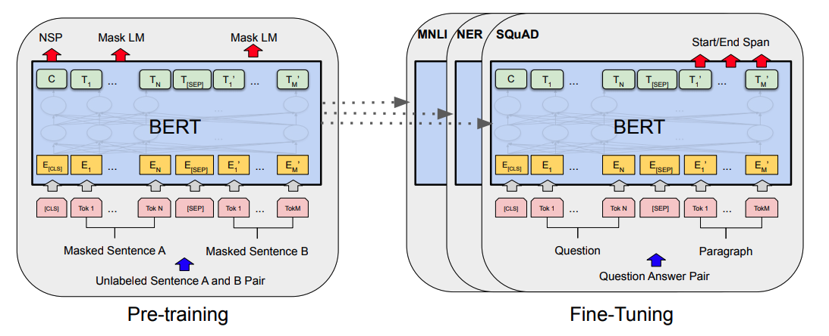

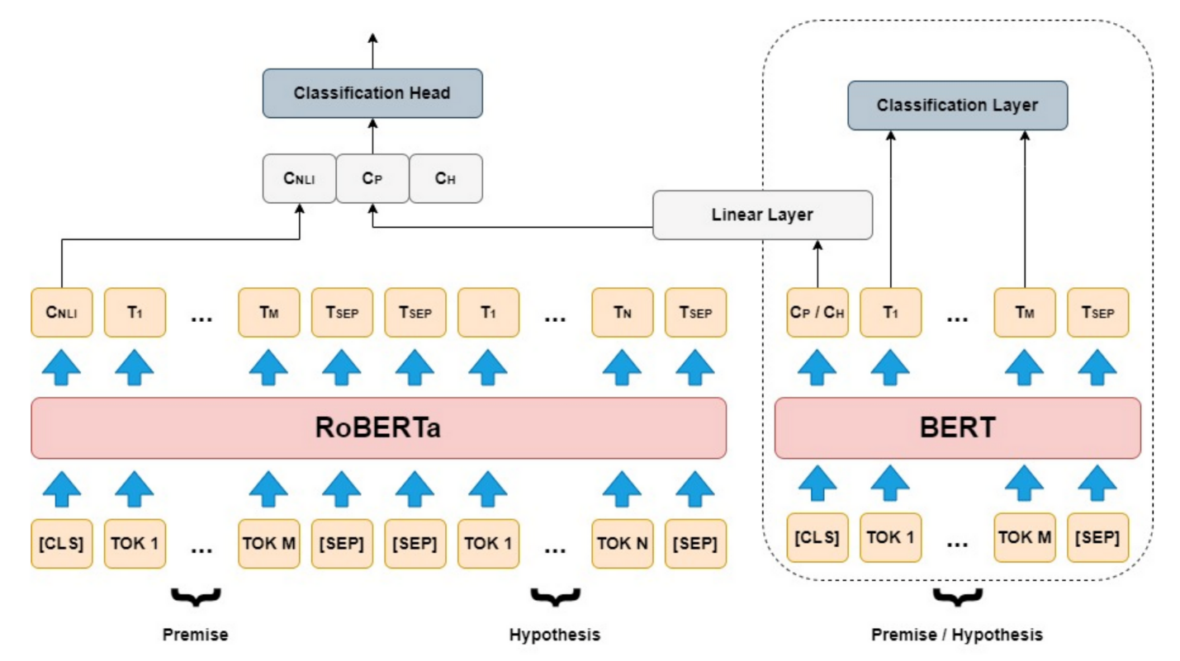

Step 7: Interpretability

Visualize model predictions, attention maps, or saliency maps to understand the reasoning behind sentiment predictions.This step is crucial for explaining why certain sentiments are assigned to specific feedback.

Step 8: Sentiment Scores

Calculate sentiment scores for each feedback text. These scores can indicate the model's confidence in its predictions.

Step 9: Visualization

Create various visualizations (e.g., bar charts, pie charts, word clouds) to illustrate sentiment distribution and trends in feedback.

Step 10: Insights Generation

Analyze sentiment analysis results to identify strengths and weaknesses in competing products.Discover recurring themes or pain points in customer feedback.Provide actionable recommendations for product enhancement and marketing strategies.

Step 11: Continuous Improvement

Establish a feedback loop with customer support and product development teams to ensure that insights from sentiment analysis are integrated into the product improvement process.Regularly update and fine-tune the model with new customer feedback data.

Step 12: Ethical Considerations

Continue to prioritize data privacy and ethical guidelines throughout the project.

This document outlines the complete steps for implementing advanced techniques such as fine-tuning pre-trained sentiment analysis models (BERT and RoBERTa) in my project. By following these steps, you can achieve more accurate sentiment predictions and gain valuable insights into competitor products, ultimately informing your company's product enhancement and business strategies.

Samplecode:

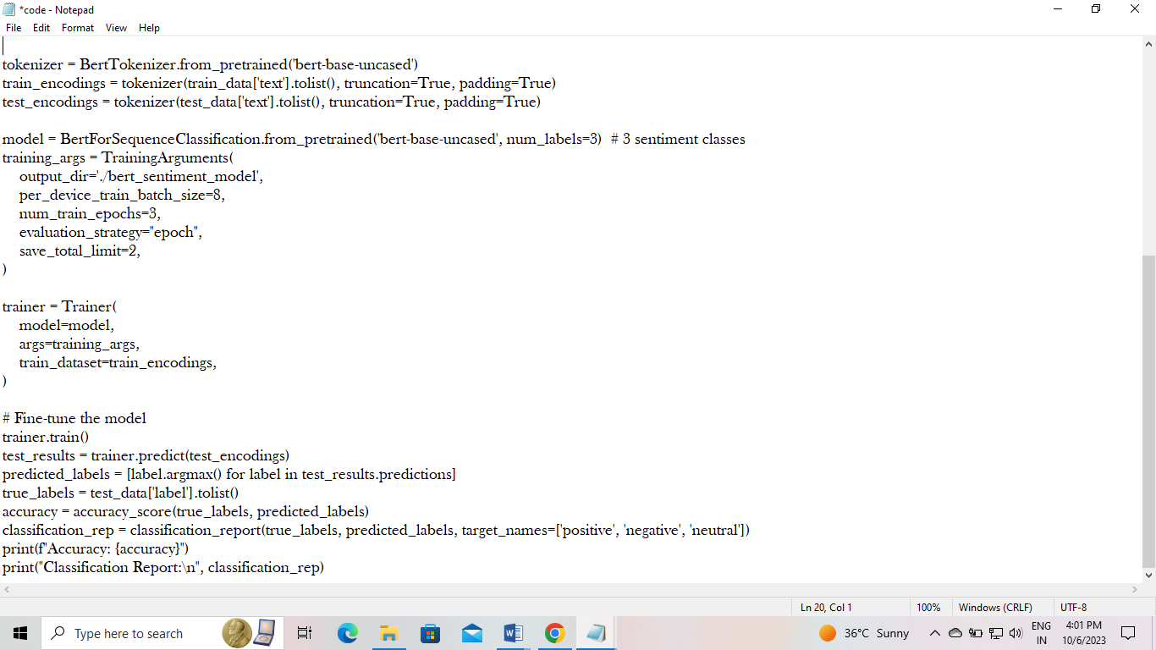

Output:

