## Title: Chatbot With Watson

### Introduction

In this project, we will demonstrate the development of an AI-powered chatbot for data analysis and visualization using IBM Watson for AI and Advanced Data Science (ADS) capabilities. The primary goal of this project is to load, preprocess, and analyze a dataset using Watson, and then create interactive visualizations in IBM Cognos.

### Project Phases

**1. Dataset Selection and Loading**

For this project, we will start by selecting an appropriate dataset. Let's assume we are working with a retail sales dataset containing information about sales transactions. The first step is to load this dataset into Watson Studio.

# sample python code for loading the datasets into watson studio

import pandas as pd

data = pd.read_csv(‘sales_dataset.csv’)

**2. Data Preprocessing**

After loading the dataset, we need to clean and preprocess the data to ensure it's ready for analysis. This may include handling missing values, encoding categorical variables, and normalizing data.

# sample data preprocessing

data.dropna(inplace=True)

Data[‘category’] = pd.get_dummies(data[‘category’])

# More preprocessing teps as needed

**3. Chatbot Development with Watson Assistant**

We'll use IBM Watson Assistant to create a chatbot that can interact with users and assist them in analyzing the data. We'll define intents, entities, and dialog flows for the chatbot.

**4. Data Analysis with Watson Studio**

Watson Studio will be used for performing data analysis. We can leverage various tools and libraries like Pandas, Matplotlib, and scikit-learn.

**5. Integration with IBM Cognos**

We will export the analysis results from Watson Studio and integrate them into IBM Cognos for advanced visualization and reporting.

**6. Chatbot Integration with Cognos**

Enhance the chatbot to retrieve and present Cognos-generated visualizations and reports to the user.

**7. User Testing and Feedback**

To ensure the chatbot's effectiveness and usability, conduct user testing and gather feedback for improvements.

**8. Deployment and Maintenance**

Deploy the chatbot in your chosen environment and ensure that it operates smoothly. Regularly update and maintain the chatbot with new data and features.

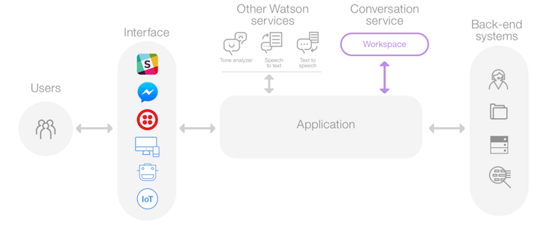

- **Intent**: "Analyze DAC Performance"- **Entity**: DAC Parameter (e.g., input voltage,

## Building an IoT Chatbot with Watson - From Device Deployment to Python Script Development

### Introduction

In this project, we will showcase the development of a chatbot that interacts with IoT devices and IoT data, leveraging IBM Watson for IoT capabilities. The primary goal is to deploy IoT devices, collect data, and then create a Python script on these devices to meet project requirements.

### Project Phases

**1. IoT Device Deployment**

For this project, we will deploy IoT devices suitable for a specific use case. Let's assume we are deploying temperature and humidity sensors to monitor environmental conditions in a warehouse.

* Select IoT devices that are compatible with IBM Watson IoT Platform.
* Physically install these devices in the warehouse to collect data.

**2. IBM Watson IoT Setup**

Set up IBM Watson IoT Platform to manage and monitor the IoT devices. This involves creating device types, adding devices to the platform, and configuring device communication.

* Create a device type for "WarehouseSensors."
* Add each deployed sensor device to the platform.

**3. Python Script Development**

Develop a Python script that runs on the IoT devices to collect data and send it to the Watson IoT Platform. This script should be tailored to the project requirements.

# Sample Python script for IoT device

import ibmiotf.device

import time

import random

# Define the credentials for connecting to Watson IoT Platform

options = {

"org": "your_org_id",

"type": "WarehouseSensors",

"id": "sensor_001",

"auth-method": "token",

"auth-token": "your_auth_token",

}

# Initialize the IoT device client

client = ibmiotf.device.Client(options)

# Simulate data collection and send it to Watson IoT Platform

while True:

temperature = random.uniform(20.0, 30.0)

humidity = random.uniform(40.0, 60.0)

data = {"temperature": temperature, "humidity": humidity}

client.publishEvent("sensor_data", "json", data)

time.sleep(10)

**4. Data Visualization and Analysis**

Utilize the data collected by the IoT devices and feed it into analytics tools or platforms to generate insights. You can use tools like IBM Watson Studio, Python libraries (e.g., pandas, matplotlib), and cloud-based analytics services.

**5. Chatbot Integration with Watson Assistant**

Integrate IBM Watson Assistant to create a chatbot that interacts with users based on IoT data. Define intents, entities, and dialog flows to respond to user queries.

**6. User Testing and Feedback**

Conduct user testing to ensure the chatbot's effectiveness and gather feedback for improvements.

**7. Deployment and Maintenance**

Deploy the chatbot in the chosen environment, and ensure it functions smoothly. Regularly update and maintain both the chatbot and IoT device scripts as needed.

## Building a CAD Chatbot with Watson and Deploying on IBM Cloud Foundry

### Introduction

In this project, we will demonstrate the development of a chatbot that interacts with CAD systems and leverages IBM Watson's AI capabilities. The primary goal is to integrate CAD functionalities with a chatbot and deploy it using IBM Cloud Foundry.

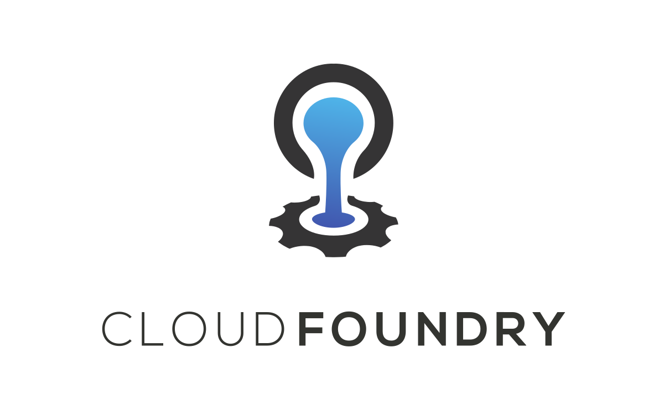

### Project Phases

**1. CAD Integration**

For this project, we will first identify the CAD system to be integrated with the chatbot. Let's assume we are working with a 3D modeling software. Key integration points include:

* **File Upload**: Allowing users to upload 3D CAD files for analysis and manipulation.
* **Model Rendering**: Rendering 3D models for user visualization and analysis.

**Manipulation Commands**: Accepting CAD-specific commands for model modification.

**2. Chatbot Development with Watson Assistant**

Leverage IBM Watson Assistant to create a chatbot capable of interacting with CAD data and users. Define intents, entities, and dialog flows tailored to CAD tasks.

**3. CAD Script Development**

Develop Python or another scripting language code to execute CAD-specific tasks based on user inputs.

# Sample Python script for CAD command execution

import cad_library

def execute_cad_command(model_name, command):

model = cad_library.open(model_name)

if command == "rotate":

model.rotate(45)

elif command == "scale":

model.scale(1.2)

**4. Deployment on IBM Cloud Foundry**

Deploy the chatbot on IBM Cloud Foundry to make it accessible to users. IBM Cloud Foundry is a Platform as a Service (PaaS) solution for hosting applications.

**5. User Interaction and Feedback**

Test the chatbot with users to ensure that it correctly interprets CAD-related commands and provides the desired outputs.

**6. Integration with Visualization Tools**

Consider integrating CAD model visualizations into the chatbot, allowing users to view 3D models directly within the chat interface.

**7. Security and Data Management**

Ensure that the project addresses security concerns, particularly when dealing with CAD files. Implement appropriate access controls and data encryption measures.

**8. Deployment and Maintenance**

Continuously monitor the chatbot and CAD system integration for performance and user feedback. Maintain the chatbot and CAD scripts, addressing any issues or making improvements as needed.

**PHASE OF MY PROJECT:**

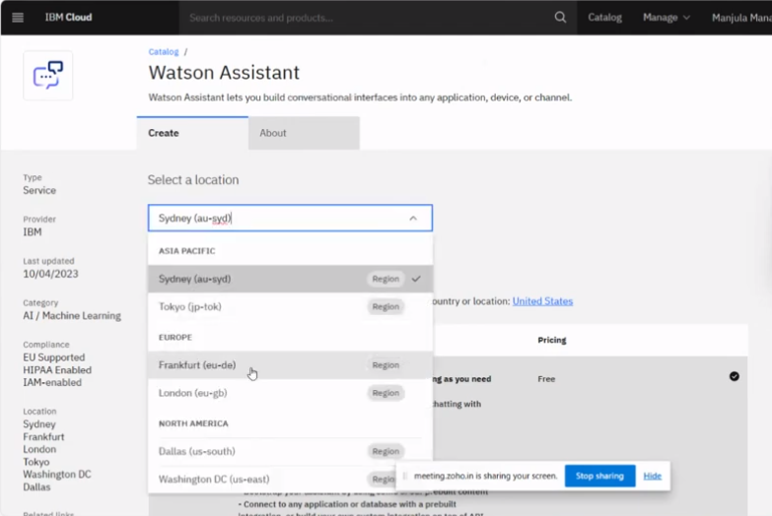**STEP:1 Creation of my project**

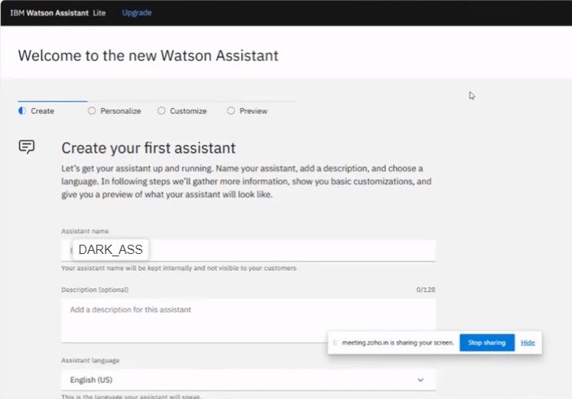**STEP:2 My assistant**

**STEP:3 Where I am doing this project**

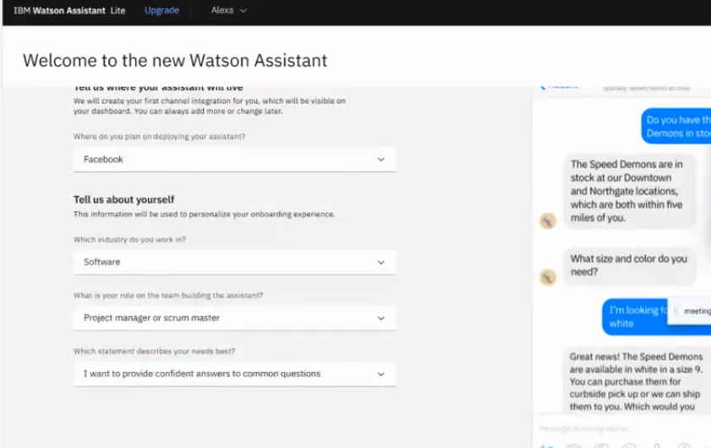

**STEP:4 Creating action for my assistant**

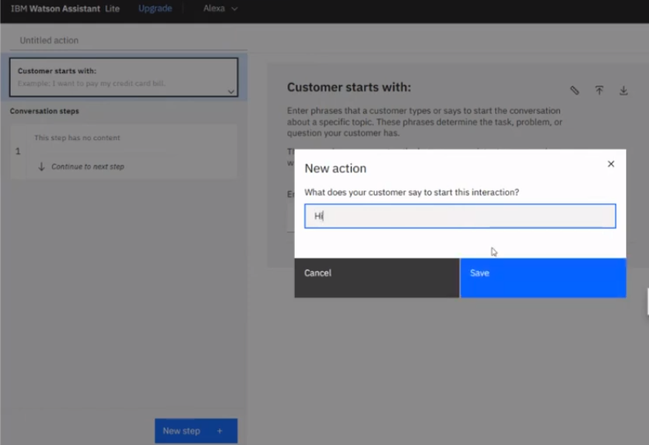

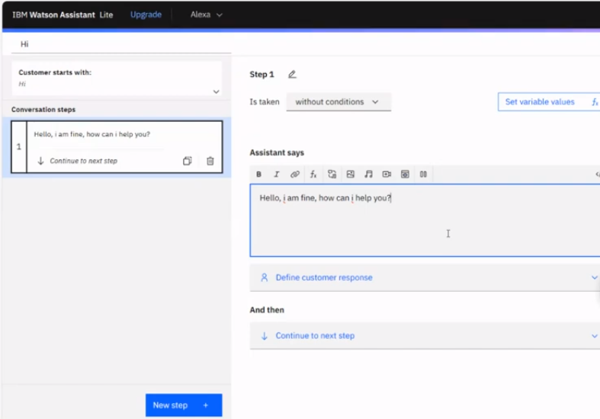**STEP:5 What my assistant says**

**STEP:6 Preview of my assistant**

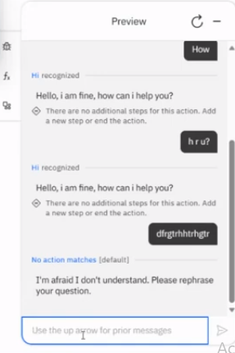

**Conclusion:**

In all four projects, we've demonstrated how AI, analytics, and visualization tools can be integrated to provide efficient and insightful data-driven solutions. Each project emphasizes the importance of harnessing advanced technologies for informed decision-making, regardless of the specific domain or dataset being analyzed.