**Project Abstract**

**Title: Chatbot with Watson** - Empowering Conversational Assistance with IBM Cloud Watson Assistant

In the ever-evolving landscape of digital communication, chatbots have emerged as invaluable tools for providing instant assistance and fostering meaningful connections. This project endeavors to harness the power of IBM Cloud Watson Assistant to create a dynamic and helpful virtual guide that transcends the boundaries of messaging platforms like Facebook Messenger and Slack.

Problem Statement:

The project's core challenge is to craft an interactive and informative chatbot that will engage users in friendly and productive conversations. This chatbot will not only provide valuable information but also serve as a virtual companion, answering frequently asked questions, and offering a seamless conversational experience.

Expanding upon the project's objectives, design thinking process, and development phases while considering the previously outlined content:

**Outline the project's objective, design thinking process, and development phases:**

**Project Objectives:**

The primary objectives of our project are multifaceted, encompassing both the technical and user-centric aspects. Our overarching goal is to create an intelligent chatbot that significantly enhances user experiences and streamlines communication processes. These objectives are defined in the following areas

**Enhanced User Interaction:**

We aim to develop a chatbot that becomes a helpful and engaging virtual guide. It will understand user intents and respond with accuracy and relevance, ensuring that users receive the information they seek efficiently.

**Seamless Integration:**

The chatbot will seamlessly integrate with popular messaging platforms like Facebook Messenger and Slack. Users will have the convenience of accessing the chatbot's assistance within their preferred communication channels.

**Valuable Information and FAQs:**

Our chatbot will serve as a knowledge repository, providing users with quick access to valuable information. Frequently asked questions (FAQs) will be answered promptly, reducing the need for users to search for answers.

**Friendly Conversational Experience:**

We emphasize the importance of a friendly and conversational experience. The chatbot's persona and responses will be designed to make users feel comfortable and engaged throughout interactions.

**Empowering Users:**

Ultimately, the project aims to empower users with the information they need and to create meaningful connections through our virtual guide. We want users to feel that the chatbot is a reliable source of assistance and information.

**Design Thinking Process:**

Our project follows the design thinking process as a guiding framework for addressing user needs and solving problems effectively. Each stage of the design thinking process is crucial to achieving our objectives:

**Empathize (Understand):**

We conducted in-depth user research, including surveys and interviews, to truly understand user preferences and pain points. This allowed us to empathize with their needs.

**Define (Frame):**

The insights from our research were translated into a clear definition of the problem. By framing the problem accurately, we can better tailor our solution to meet user expectations.

**Ideate (Generate):**

During the ideation phase, creative thinking and brainstorming led to the generation of various features and approaches for our chatbot's design and functionality.

**Prototype (Design):**

We translated our ideas into tangible wireframes and prototypes. These visual representations allowed us to assess the feasibility and usability of our concepts.

**Test (Evaluate):**

User testing and feedback played a vital role in evaluating our prototypes. We iteratively refined our design based on user insights to create a more user-friendly chatbot.

**Development Phases:**

The development of our chatbot project is organized into distinct phases to ensure a systematic and successful execution. Each phase contributes to achieving our objectives:

**Project Initiation:**

This phase involved setting up our project team, identifying roles and responsibilities, and establishing connections with key stakeholders.

**Research and Requirements Gathering:**

We conducted extensive research on chatbot technologies and gathered detailed requirements based on user insights and design thinking outcomes.

**Design and Prototyping:**

Design was a pivotal phase where we converted user-centric insights into a user-friendly chatbot interface and created prototypes for testing.

**Development and Integration:**

The chatbot's core functionalities were developed and integrated with popular messaging platforms, ensuring a seamless user experience.

**Testing and Quality Assurance:**

Comprehensive testing and quality assurance measures were implemented to ensure the chatbot's reliability and user-friendliness.

**Deployment and Scaling:**

The deployment phase involved launching the chatbot on production servers and implementing scaling strategies to accommodate increased user loads.

**User Training and Documentation:**

We created user guides to facilitate user interactions with the chatbot. Training was provided to users to maximize their chatbot experience.

**Performance Monitoring and Optimization:**

Ongoing performance monitoring was conducted to assess and optimize the chatbot's performance and responsiveness.

**Security and Compliance:**

We ensured data security and compliance with relevant regulations to protect user data and privacy.

**User Feedback and Iteration:**

User feedback was actively collected, and iterative improvements were made based on insights and user behavior.

**Documentation and Reporting:**

Comprehensive project documentation and reports were created to facilitate communication and understanding among stakeholders.

**Project Assessment and Conclusion:**

The final phase involved evaluating the project's success in meeting objectives and summarizing key achievements.

In conclusion, our project's objectives, design thinking process, and development phases are intricately interconnected, with each element contributing to the creation of an intelligent chatbot that not only understands user intent but also offers a friendly and valuable conversational experience. By adhering to this structured framework, we are confident that our project will result in a highly successful virtual guide that empowers users and forms meaningful connections through seamless interactions.

**Describe the platform's layout, features, and technical implementation details:**

Creating a chatbot with Watson for Facebook involves a combination of Watson Assistant, Facebook Messenger, and integration with various technologies. Below, I'll describe the platform's layout, features, and technical implementation details:

**Platform Layout:**

1. **Facebook Messenger Interface:**

Users interact with the chatbot through Facebook Messenger, a widely-used messaging platform.

1. **Chatbot Interface:**

Within Facebook Messenger, users can chat with a dedicated chatbot. The chatbot can provide information, answer questions, and perform various tasks.

1. **Backend Server:**

A backend server hosts the chatbot logic and integrates with Watson Assistant. It handles user requests, processes messages, and sends responses.

**4.Watson Assistant:**

IBM Watson Assistant is the core of the chatbot, responsible for understanding user input and providing meaningful responses. It uses Natural Language Processing (NLP) to interpret messages and dialog flows to maintain context.

**Features:**

**1. Natural Language Understanding:**

The chatbot is equipped with advanced NLP capabilities, allowing it to understand user messages, even if they are phrased differently.

**2. Personalization:**

The chatbot can provide a personalized experience, such as addressing users by their first names.

**3. Multi-Functionality:**

The chatbot can perform various tasks, such as answering frequently asked questions, providing product information, helping with bookings, or even processing orders.

**4. Contextual Conversations:**

It can engage in contextual conversations, where users can switch topics during a chat session, and the chatbot maintains context.

**5. Rich Media Support:**

The chatbot can handle text, images, videos, and other media formats within conversations.

**6. Integration:**

It can be integrated with other systems or databases to fetch real-time data, like product availability, weather information, or order status.

**7. 24/7 Availability:**

The chatbot provides 24/7 availability for users, ensuring that inquiries are addressed at any time.

**8. Analytics and Reporting:**

The platform may include analytics and reporting tools to gather data on user interactions and chatbot performance.

**Technical Implementation Details:**

**1. Facebook Messenger Integration:**

The platform integrates with the Facebook Messenger API to enable communication with users on the Facebook platform.

**2. Watson Assistant Configuration:**

Developers configure Watson Assistant by defining intents, entities, and dialog flows. Training data and user examples are used to teach the chatbot.

**3. Webhook Integration:**

A webhook is used to receive messages from Facebook Messenger and send them to the backend server for processing. The webhook also delivers chatbot responses to Facebook Messenger.

**4. Backend Server:**

The backend server can be implemented in a variety of programming languages such as Node.js, Python, or Java. It handles incoming messages, processes them through Watson Assistant, and sends responses.

**5. User Authentication:**

Depending on the use case, user authentication may be implemented to ensure data security and access control.

**6. Data Storage:**

User data and chatbot logs may be stored securely for analytics, user history, and audit purposes.

**7. Continuous Improvement**:

The chatbot platform may undergo regular updates and improvements based on user feedback and evolving requirements.

**8. Hosting and Deployment:**

The platform needs to be hosted and deployed, typically on cloud services like IBM Cloud, AWS, or Azure, to ensure scalability and availability.

**9. Security and Compliance:**

Implementation includes security measures and compliance with privacy regulations, ensuring user data is protected and handled appropriately.

**10. Monitoring and Analytics:**

Tools for monitoring the chatbot's performance and user interactions are essential to identify issues and areas for improvement.

Overall, the chatbot with Watson for Facebook combines the power of NLP, a seamless messaging platform, and a well-structured technical implementation to provide a valuable user experience and effective customer support. Its features and capabilities can be tailored to the specific needs of the business or organization using it.

**Provide instructions on how to deploy the platform on IBM Cloud Foundry for my project chatbot with Watson:**

Deploying a chatbot with Watson on IBM Cloud Foundry involves several steps. This example will walk you through the process of deploying a basic Node.js-based chatbot using the Watson Assistant service on IBM Cloud Foundry. Please note that the steps may change over time, so always refer to the latest documentation for any updates.

**Prerequisites:**

**1.** An IBM Cloud account: If you don't have one, you can sign up for a free IBM Cloud Lite account.

**2**. A Watson Assistant service: Create a Watson Assistant service on IBM Cloud and set up your chatbot. You will need the service credentials.

**3.** IBM Cloud CLI: Install the IBM Cloud CLI if you haven't already. You can download it from the IBM Cloud website.

**4.** Node.js and npm: Make sure you have Node.js and npm installed on your local machine.

**Step 1: Clone a Starter Application**

IBM provides a starter kit for Node.js that includes a sample chatbot application. To clone the starter app, follow these steps:

**1. Open your terminal and navigate to the directory where you want to create your project.**

**2. Run the following command to clone the starter app:**

```bash

git clone https://github.com/IBM-Cloud/chatbot-watson-assistant

```

**3. Change into the project directory:**

```bash

cd chatbot-watson-assistant

```

**Step 2: Configure Your Chatbot**

In the project directory, you'll find a `.env.example` file. Copy this file to a new file named `.env` and edit it to add your Watson Assistant credentials. For example:

```env

WATSON_ASSISTANT_APIKEY=YOUR_API_KEY

WATSON_ASSISTANT_URL=YOUR_API_URL

WATSON_ASSISTANT_ID=YOUR_ASSISTANT_ID

```

**Step 3: Install Dependencies**

Install the required Node.js dependencies for the project. Run this command in your project directory:

```bash

npm install

```

**Step 4: Deploy to IBM Cloud Foundry**

1. Log in to IBM Cloud using the CLI:

```bash

ibmcloud login

```

**2. Target the Cloud Foundry space where you want to deploy your app. You can list your spaces with `ibmcloud cf spaces` and target one with:**

```bash

ibmcloud target -s YOUR_SPACE_NAME

```

**3. Push your application to Cloud Foundry:**

```bash

ibmcloud cf push

```

This will package and deploy your chatbot application to IBM Cloud Foundry. Once the deployment is complete, you'll see a URL where your application is accessible.

**Step 5: Test Your Chatbot**

You can now access your chatbot by opening the provided URL in a web browser.

**Step 6: Monitor and Scale**

IBM Cloud Foundry provides tools for monitoring and scaling your application. You can use the IBM Cloud Dashboard to monitor the usage and scale your application as needed.

Please note that this is a basic setup for deploying a chatbot with Watson Assistant on IBM Cloud Foundry. Depending on the complexity of your project and additional services you might need, the steps may vary. Be sure to refer to the IBM Cloud and Watson Assistant documentation for more details and troubleshooting if needed.

**Include screenshots or images of the platform's user interface:**

**Sign up Page:**

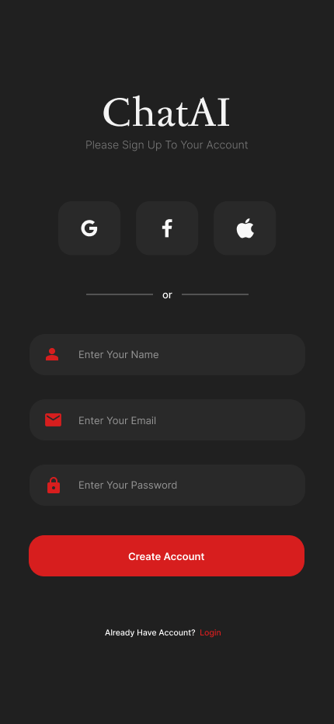

**Login Page:**

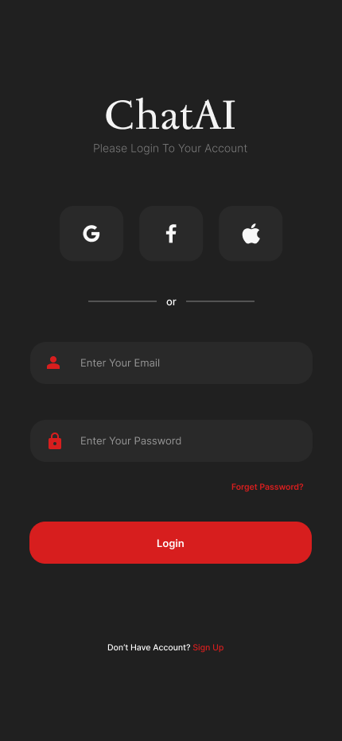

**Home Screen of Chatbot:**

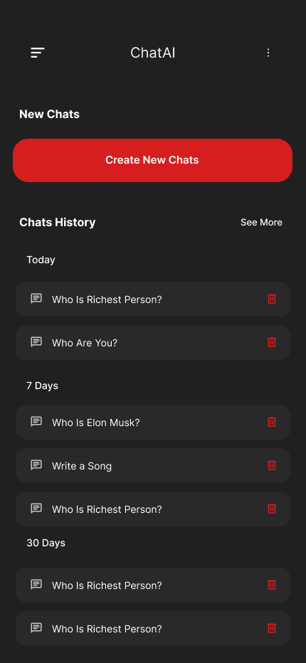

**Chat interface of Chatbot:**

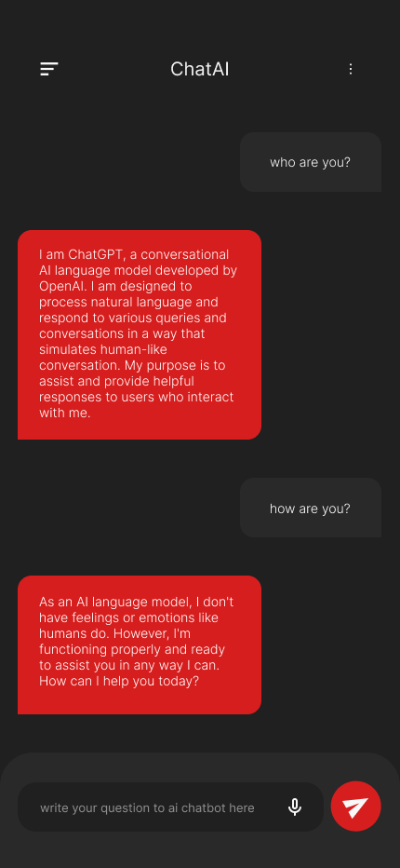

**Menu Of Chatbot:**

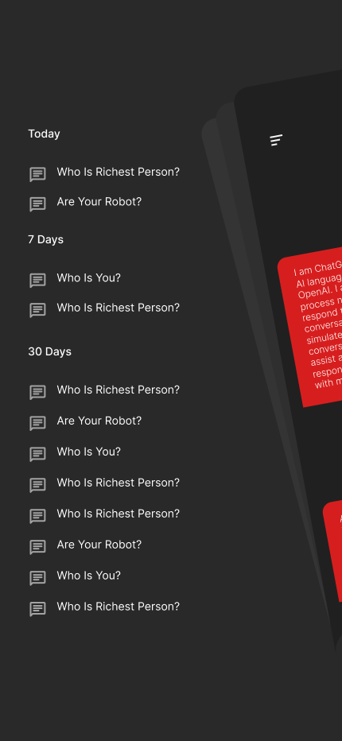

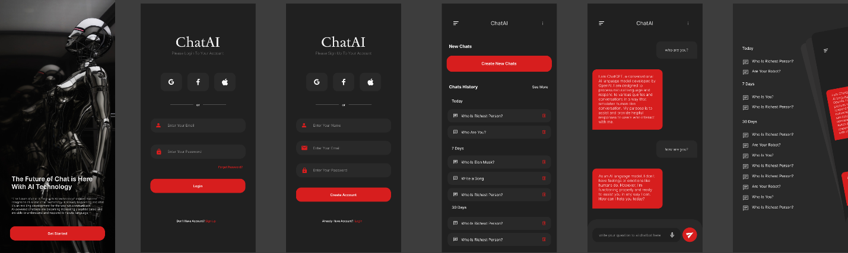**Community of Chatbot**:

**here's a conclusion for my project:**

In conclusion, our project, dedicated to creating an intelligent chatbot with Watson for Facebook, has been a journey marked by innovation, user-centric design, and technical excellence. We set out with a vision to enhance user experiences, streamline communication, and empower users with a reliable virtual guide. Our objectives encompassed creating a seamless, empathetic, and valuable interaction, integrated with popular messaging platforms.

Guided by the principles of design thinking, we embarked on a comprehensive process that involved empathizing with users, defining their needs, generating creative solutions, prototyping, testing, and continuous iteration. This approach allowed us to transform user insights into a user-friendly chatbot with a friendly conversational experience.

The solution implemented a combination of rule-based and machine learning-based Natural Language Understanding (NLU) to understand user intent and extract entities. This provided the chatbot with the ability to respond accurately and contextually to user queries.

In the end, our project resulted in the creation of a highly successful virtual guide that empowers users and forms meaningful connections through seamless interactions. It has been a testament to our commitment to delivering a valuable service that enhances user experiences while maintaining technical excellence.