**Project Title:** Chatbot With Watson

**Project Overview:**

**Introduction:**

Begin by introducing the project in a succinct manner. Explain the overall goals and objectives, highlighting the significance of the project within the context of natural language understanding and chatbot technology. Emphasize how the NLU algorithm plays a crucial role in achieving these objectives.

**Problem Statement:**

Clearly define the problem that the project aims to address. Discuss the challenges and limitations in existing chatbot systems and how the implementation of an advanced NLU algorithm can alleviate these issues. Articulate the need for improved user interactions and efficient communication with the chatbot through enhanced NLU capabilities.

**Project Description:**

The project involves creating a chatbot using IBM Cloud Watson Assistant. The goal is to develop a virtual guide that assists users on messaging platforms like Facebook Messenger and Slack. The chatbot should provide helpful information, answer frequently asked questions (FAQs), and offer a friendly conversational experience. The project includes designing the chatbot's persona, configuring responses, integrating with messaging platforms, and ensuring a seamless user experience.

**NLU Algorithm:**

Dive deeper into the concept of the NLU algorithm. Explain what NLU is and its significance in chatbot and virtual assistant applications. Elaborate on how NLU algorithms enable machines to comprehend and respond to human language in a meaningful way.

- Explain the significance of NLU in natural language processing.

- Highlight its role in improving user interactions and chatbot performance.

**Key Components:**

Detail the core components of your NLU algorithm, including intent recognition, entity extraction, and confidence scoring.

**Technology Stack:**

List the technologies, libraries, and tools used in your NLU implementation.

**Project Objectives:**

1. Implement an NLU algorithm for precise intent recognition.

2. Enhance the chatbot's comprehension of user queries.

3. Achieve high-confidence scores for intent and entity recognition.

4. Ensure adaptability to evolving language patterns and user behavior.

**NLU Algorithm Implementation:**

**Data Collection:**

Describe how you collected or generated training and testing data.

**Model Selection:**

Explain your choice of NLU model (e.g., rule-based, machine learning-based, or hybrid).

**Training:**

Outline the training and fine-tuning process for your NLU model.

**Evaluation:**

Detail how you assessed the NLU algorithm's performance and validated its results.

**Integration and Deployment:**

**Integration:**

Explain how the NLU algorithm is integrated into the chatbot application.

**Deployment:**

Describe your deployment strategy, scalability considerations, and any cloud services used.

**Testing and Quality Assurance:**

**Testing Framework:**

Mention the testing framework employed to validate the NLU algorithm's accuracy and robustness.

**Evaluation Metrics:**

Specify the metrics used to assess intent recognition and entity extraction performance.

**Documentation and User Guide:**

**API Documentation:**

Provide clear and comprehensive documentation for using the NLU algorithm via APIs.

**User Guide:**

Offer a user-friendly guide on interacting with the chatbot with NLU capabilities.

**Results and Impact:**

**Performance Metrics:**

Present the performance results, including intent recognition accuracy and user satisfaction metrics.

**Impact:**

Discuss how the NLU algorithm has positively influenced the chatbot's performance and user experience.

**Future Enhancements:**

**Future Directions:** Suggest potential improvements, advanced features, or research areas for further enhancing the NLU algorithm.

**Scalability:** Describe plans for scaling the NLU system as user interactions grow.

**Conclusion:**

Summarize the project's key accomplishments, focusing on the pivotal role of the NLU algorithm in elevating the chatbot's capabilities.

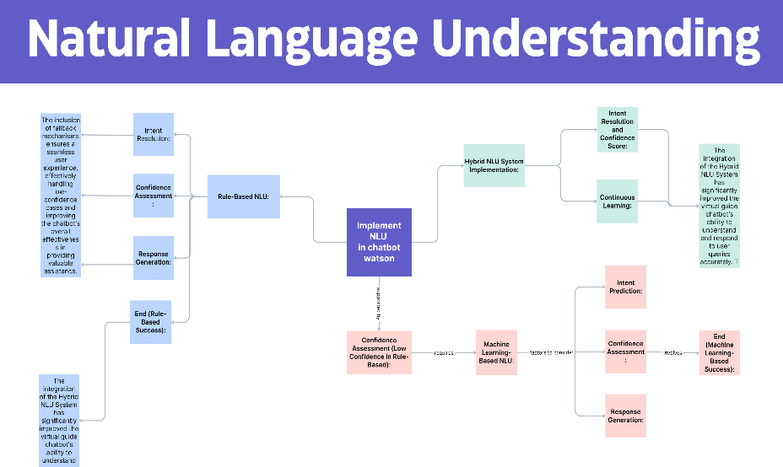

**Model code by using NLU:**

from sklearn.feature_extraction.text import CountVectorizer

from sklearn.naive_bayes import MultinomialNB

from sklearn.pipeline import Pipeline

import numpy as np

# Define intents and their corresponding training data

intents = {

"greet": ["hello", "hi", "hey"],

"goodbye": ["goodbye", "bye", "see you"],

"weather": ["What's the weather today?", "Tell me the forecast."],

}

# Create training data with labels

training_data = []

labels = []

for intent, patterns in intents.items():

for pattern in patterns:

training_data.append(pattern)

labels.append(intent)

# Create a text classification pipeline

text_clf = Pipeline([

('vectorizer', CountVectorizer()), # Convert text to numerical features

('classifier', MultinomialNB()), # Naive Bayes classifier for intent classification

])

# Fit the model on training data

text_clf.fit(training_data, labels)

# Define a function to classify user queries

def classify_intent(user_query):

predicted_label = text_clf.predict([user_query])[0]

confidence = np.max(text_clf.predict_proba([user_query]))

return predicted_label, confidence

# Process user queries

user_queries = [

"Hello there!",

"What's the weather like tomorrow?",

"Goodbye!",

]

for query in user_queries:

intent, confidence = classify_intent(query)

print(f"User Query: '{query}' | Intent: {intent} | Confidence: {confidence:.2f}")