`Demand Analysis
1. Question: Demand (Q) is Q - 110 = - 4P, where P is Price. What is price elasticity at P=Rs. 5? Comment on the result.
Solution:
Given: Q - 110 = - 4P
Or, Q = 110 - 4P
When P=5,
Q = 110- 4x 5 = 90
Further, dQ/dP = -4
Price elasticity of demand ( e_{p})₌ $\frac{dQ}{ dP}*\frac{P}{Q}$

_{or,} e_{p (at p=5 )}= $-4*\frac{5}{90}$
or, e_{p (at p=5 )} = - 20/90
Here, $\left\lfloor e_{P}\right\rfloor =\left\lfloor - 20/9 0\right\rfloor =\frac{2}{9}$ lies between 0 and 1. Hence price demand is inelastic.

2. Question: The accompanying table shows the price and monthly quantity sold of Arrow T-shirts in the town according to the average income of the city newly employed youth.

Price of T-shirt (Rs) | Quantity of T-shirts demanded when the average income of newly employed youth is Rs. 20,000 | Quantity of T-shirts demanded when the average income of newly employed youth is Rs, 30,000
400 | 3,000 | 5,000
5 00 | 2,400 | 4,200
6 00 | 1,600 | 3,000
700 | 800 | 1,800

a. Calculate the price elasticity of demand when the price of a T-shirt rises from Rs. 500 to Rs.600 and the average income is Rs. 20,000. Also calculate it when the average income is Rs. 30,000.
b. Calculate the income elasticity of demand when the price of a T-shirt is Rs. 400 and the average income increases from Rs. 20,000 to Rs. 30,000. Also calculate it when the price is Rs.700.

Solution

- When Income is Rs. 20,000
Initial Price (P1) = Rs. 500
Initial Demand (Q1) = 2400
Final price (P2) = Rs 600
Final Demand (Q2) = 1,600

Price Elasticity (e_{p)}

ep = Proportionate change in quantity demanded ÷ proportionate change in price

Or e_{p=} $\frac{∆Q}{ ∆P}*\frac{P}{Q}$
${or, e}_{P}=\left(\frac{2400-1600}{600-500}\right)*(\frac{500}{2400}$ )
$e_{P}=$-1.66
Here, $\left\lfloor e_{P}\right\rfloor =\left\lfloor -1.66\right\rfloor =1.66$ lies between 1 and ∞. Hence price demand is elastic.

Similarly calculate ep, when income is Rs. 30000

- When price is Rs. 400.

Initial Income (Y1) = Rs. 20000
Initial Demand (Q1) = 3000
Final Income (Y2) = Rs 30000
Final Demand (Q2) = 5000

Income Elasticity (e_{Y)}
ey = Proportionate change in quantity demanded ÷ proportionate change in income of consumers

or, e_{y=} $\frac{dQ}{ dY}*\frac{Y}{Q}$
${or, e}_{Y}=\left(\frac{5000-3000}{3000-2000}\right)*(\frac{2000}{3000}$ )
$e_{y}=$1.33
Here, $e_{y}=$1.33 lies between 1 and ∞. Hence income demand is elastic.
Similarly calculate ey when price is Rs.700

5. Question: The price elasticity of demand for wheat is unit elastic. A household of 8 individuals demands 40 kgs of wheat at price 25 per kg. On what price the household will demand 36 kgs of wheat?

Solution:
Here,
Initial Price (P1) = Rs. 25 per kg of wheat
Initial Demand (Q1) = 40 kg
Final price (P2) =?
Final Demand (Q2) = 36 kg

Further, Price elasticity is unity.
i.e $e_{P}=-1$
Or, $\frac{Q/Q}{ P/P}$ = $-1$ ( as, in normal situation , demand varies inversely with price, ceteris paribus)

, or, $\frac{(36- 40 )}{{(P}_{2}-25)/{(P}_{2}}*\frac{25}{40}$= -1

Or, P₂ = 27.5

Hence, at price Rs 27.5 the household will demand 36 kgs of wheat.

6. FlipKart offers a 10% discount on every book it sells.
Volume of sales before the 10% discount | 1.55 million
Volume of sales after the 10% discount | 1.65 million
Calculate price elasticity of demand.
Solution:
Given
Initial Demand (Q1) = 1.55 million
Final Demand (Q2) =1.65 million

Let Initial Price (P1 ) =x

Final Price (P2 ) = x – 10 percent of X = 0.9x

ep = Proportionate change in quantity demanded ÷ proportionate change in price

Or, e_{p=} $\frac{Q}{ Q} ÷\frac{P}{p}$
e_{p} = $\left(\frac{1.65-1.55}{ 1.55}\right)100\% ÷ \left(\frac{0.9 x -x}{ x}\right)X100 \%)$
e_{p} = - 0.645

Production Function
Important: Formulae and relations:
〖TP=〖L x AP〗_L =∑▒MP〗_L
〖MP〗_L=(d(TP))/dL
〖AP〗_L=TP/L
Where APL, MPL are average productivity or marginal productivity of any factor input say labour.

10. Consider the following production function.

Where:
Y = total real output
L = labour input (the total number of person-hours worked in a year)
K = capital input (the real value of all machinery, equipment, and buildings)
A = total factor productivity
α and β are parameters determined by available technology.

Further, A, α and β >0 and α + β =1

Show that marginal and average productivity of labour and capital are functions of factor ratio.

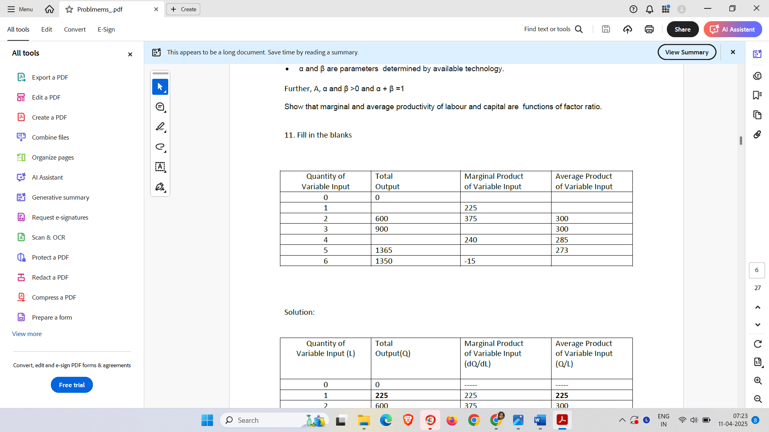
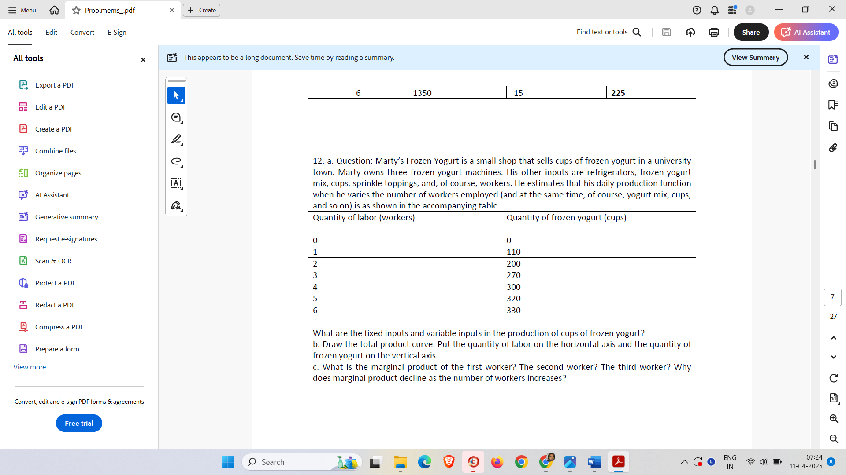

13. Determine the return to scale of the following production function

Q=aL+ bK , where L and k are the inputs.

Determine the return to scale.

14. Suppose that output q is a function of a single input, labour (L). Describe the returns to scale associated with each of the following production functions.
a. q=L/2
b. q = 2L
c. q = log(L)
d. q= f(L)=L

Cost of Production
Important: Formulae and relations:
TC=TVC+TFC = AC X Q
TFC=AFC X Q
TVC=AVC X Q = ∑▒MC
AC= TC/Q= AVC+ AFC
MC=d(TC)/dQ= (d(TVC))/dQ
MC= Minimum AVC
MC =Minimum AC
but Minimum AVC ≠ Minimum AC
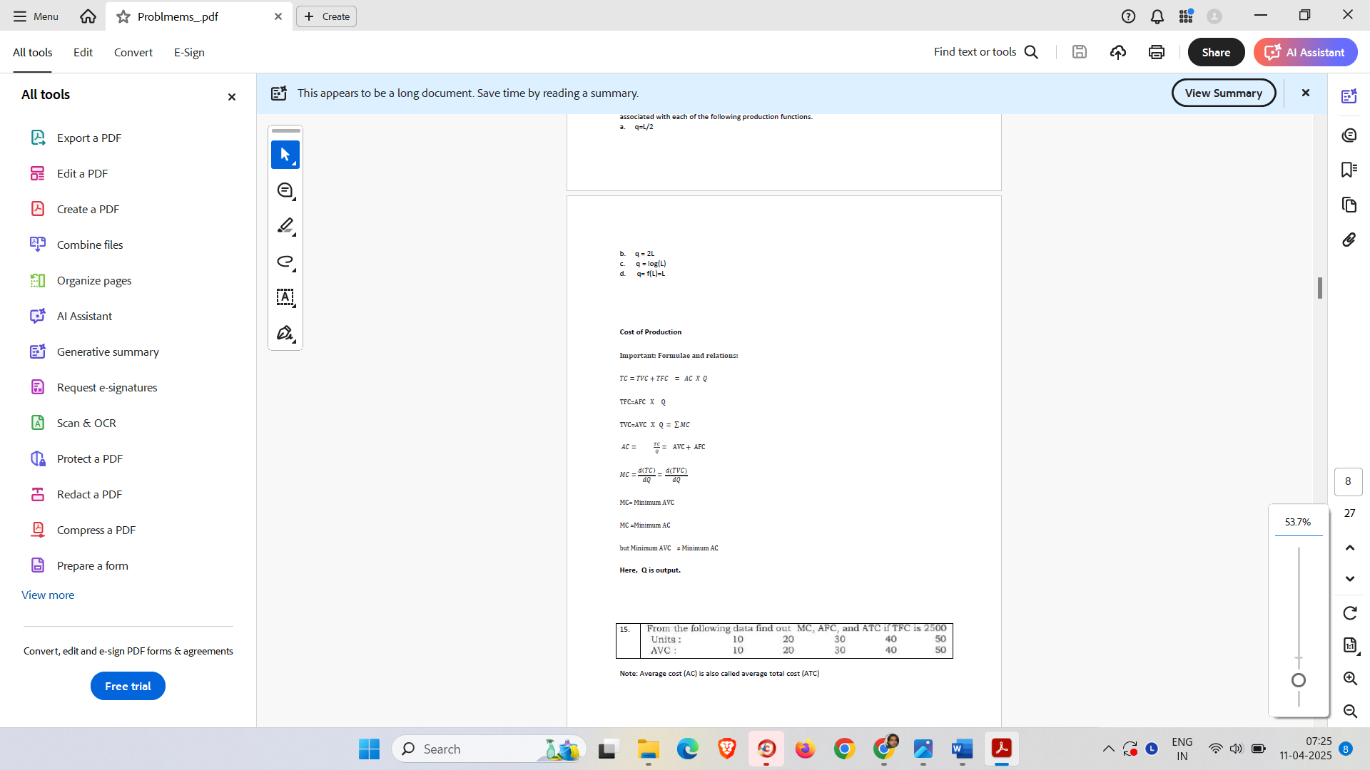

17. The average cost of a firm is given as follows:

C=200 + 100Q-1 - 20Q + 2Q2 , where Q is output.

Determine Total Cost, Total Fixed Cost, Total Variable Cost Function.
Determine Average Fixed Cost, AVC and MC function
Determine level of output when AVC is minimum and also show that MC=Minimum AVC.

18. A firm has the following total cost function
C=Q3 -7Q2 + 2Q + 16, where Q is output produced.

Determine AFC, AVC, AC and MC
Show that when AVC is minimum, AVC=MC.
Derive AC and check that when Q=4, the average cost is minimum.

Revenue, Break-Even and Profit

Important: Formulae and relations:
Profit(∏ ) =Total Revenue – Total Cost
At breakeven point, TR=TC

At maximum profit,
MR= MC and MC must be rising at the point of equilibrium

Or,

19. A monopoly firm has the following average cost function
C = 150 Q-1 + 5
The demand curve facing the firm in the market is
AR= 150 – 0.5Q, where Q is output.
Determine the profit maximizing output and price of the product. Justify your answer by checking the sufficient condition for maximum profit.

20. In a perfectly competitive market, the market price of a commodity is Rs. 3 per unit of output (Q). The total cost function of a firm is C=1/3 Q^(3 ) -4Q2 +10Q +10
Find (a) Profit maximizing output
(b) Maximum profit.

21. Given the demand function and supply function for a market as
P = 80 - 3x and P = 2x + 20 respectively, determine the market equilibrium price and output. Here X is output and P is price.

22. Find the level of output yielding maximum profit by MC and MR approach. Also find the break even output.

Output 1 2 3 4 5
AR 10 9 8 7 6
TC 10 11 14 18 25

National Income
1. From the following data calculate GNP at factor cost by Income Method & Expenditure Method
Items | Rs. in Crores
Net Domestic capital formation | 500
Compensation of employees | 1850
Consumption of fixed capital (Depreciation) | 100
Govt. Final Expenditure | 1100
Private Final consumption Expenditure | 2600
Rent | 400
Dividend | 200
Interest | 500
Net Exports | (-) 100
Undistributed Profits | 900
Net Factor Income From Abroad (=income from abroad – income to abroad) | (-) 50
Net Indirect Taxes (=indirect Tax – Subsidy) | 250

Expenditure Method
GNP at factor cost = GNP at MP - Net Indirect tax
= GDP at MP + NFIA - Net Indirect tax
= Private Final consumption Expenditure + Net Domestic capital formation + Consumption of fixed capital + Govt. Final Expenditure + Net Exports
+ NFIA - Net Indirect tax

Sol :

Income Method

- GNP_{FC} = NDP at factor cost + + Consumption of fixed capital + NFIA

= (Compensation of employees + Rent + Interest + Undistributed Profits + Dividend) + Net Factor Income from Abroad + Consumption of fixed capital

= 1850 + (400 +500 +900 + 200) + (-) 50+ 100
= 3900 CRORE

Note:
- GNP_{FC} = NNP_{FC} + Consumption of fixed capital

- NNP_{FC or} National Income ₌ Compensation of employees + Rent + Interest + Undistributed Profits + Dividend + Net Factor Income from Abroad
- Compensation of employees is income from work which includes wages and salaries in kind and cash, and contribution to social securities

ii. Expenditure Method

GNP_{FC} = GNP_{MP} - Net Indirect Taxes
= GDP_{MP} + NFIA - Net Indirect Taxes

= Private Final consumption Expenditure + (Net Domestic capital formation + consumption of fixed capital) + Govt. Final consumption Expenditure + Net Exports + Net Factor Income from Abroad - Net Indirect Taxes

= 1100 +2600 + (500 +100) + (-) 100 + (-)50 – 250
= 3900 CRORE

Note
- GNP_{MP} = Private Final consumption Expenditure + Gross Domestic capital formation + Govt. Final consumption Expenditure + Net Export + Net Factor Income from Abroad
- Gross Domestic capital formation = Net Domestic capital formation + Consumption of fixed capital)
- Export – Import = Net Export
- Net Factor Income from Abroad = Factor Income from Abroad – Factor Income Paid to Abroad

- GNP_{FC} = GNP_{MP} - Indirect tax + Subsidy
= GNP_{MP} - (Indirect tax – subsidy)
= GNP_{MP} - Net Indirect tax

2. From the following data calculate (a) Gross Domestic Product at Factor Cost, and (b) Gross Domestic Product at Market price

Items | Rupees in Crores
Gross national product at factor cost | 6,1500
Net exports | (-)50
Compensation of employees | 3000
Rent | 800
Interest | 900
Profit | 1,300
Net indirect taxes | 300
Net domestic capital formation | 800
Gross domestic capital formation | 900
Factor income to abroad

Gross Domestic Product at Factor Cost = DI or NDP at FC + D

= DI or NDP at FC + (Gross domestic capital formation
- Net domestic capital formation)
= (Compensation of employees + Rent + Interest + Profit) + (Gross domestic capital formation
- Net domestic capital formation)
- =Rs 3,000crore + Rs 800 crore + Rs 900 crore + Rs 1,300 crore + (Rs 900 crore - Rs 800 crore)

- = Rs 6100 crores

Gross Domestic Product at Market price = Gross Domestic Product at Factor cost + Net Indirect Tax

= 6100 + 300

- GDP at factor cost

= NDP at factor cost + Depreciation

= Compensation of employees+ Rent+ Interest+ Profit +Mixed income+ (Gross domestic capital formation - Net domestic capital formation)

=Rs 3,000crore + Rs 800 crore + Rs 900 crore + Rs 1,300 crore + (Rs 900 crore - Rs 800 crore)

= Rs 6100 crores

- Gross Domestic Product at Market Price

= GDP at factor cost + Net Indirect taxes

=Rs 6100 + Rs300 crore
= Rs 6,400crore

3. An Economy has two firms A & B on the basis of following information find out
a) Value added by firm A & B respectively
b) GDP at Market Price

Items | Rs. in Lakh
Exports by firm A | 20
Imports by firm A | 50
Sales to households by firm A | 90
Sales to firm B by firm A | 40
Sales to firm A by firm B | 30
Sale to household by firm B | 60
Sol: a)
Value added by firm A = value of output of A - intermediate consumption of A

= (Sale to households +Sales to firm B + Exports by firm A ) – ( Imports by firm A + Purchase from firm B)

= Rs 90 + Rs 40+ Rs 20- Rs 50- Rs 30
= Rs 70 Lakh

Value added by firm B
= value of output of B - intermediate consumption of B
= Sales to Firm A + Sales to households – purchase from firm A
= Rs 30+ Rs 60- Rs 40
= Rs 50 Lakh

b) GDP_{MP}
= Value added by firm A + value added by Firm B
= Rs 70+ Rs 50
= Rs 120 Lakh

4. Find out the National Income from the following particulars
Particulars | Amount (crores)
NFIA | (-) 20000
GDP (Market Price) | 4400000
Capital Consumption Expenditure (i.e. Depreciation) | 10000
Output of Primary Sector | 1100000
Output of Secondary Sector | 2100000
Output of Service Sector | 1250000
Intermediate Goods | 50000
Indirect Tax | 35000
Subsidy | 5000

Value added method
National Income or NNP at FC = GDP at MP – D + NFIA - Net Indirect tax

= GDP at MP – D + NFIA - (indirect tax – subsidy)
= (Output of Primary Sector + Output of Secondary Sector Output of Service Sector - Intermediate Goods)
– D + NFIA - (indirect tax – subsidy)

Value added Method

National Income or NNP at FC = GDP (Market Price) – D + NFIA – Net indirect tax
= (Output of Primary Sector + Output of Secondary Sector + Output of Service Sector - Intermediate Goods)
– D + NFIA – Net indirect tax

Hints: Expenditure Method:

National income (or NNP at factor cost)
= NNP at Market price – Net indirect tax

= (GDP at market price – Capital consumption expenditure + NFIA ) – Indirect + subsidy

Or

Value Added Method

National income (or NNP at factor cost)
= (GDP at market price – Capital consumption expenditure) + NFIA – Indirect + subsidy

= (Output of Primary sector + Output of secondary sector + Output of tertiary sector – value of intermediate goods) – Capital consumption expenditure + NFIA – Indirect Tax + subsidy

- Determine the national income from the following information.

Private Consumption Expenditure: Rs.50000 Crore
Public Investment Expenditure Rs. 40000 Crore
Gross Private Investment Expenditure Rs.76000 Crore
Public Consumption Expenditure Rs.56000 Crore
Imports Rs.25000 Crore
Exports Rs.30000 Crore
Capital Consumption Expenditure Rs.5000 Crore
NFIA (-) Rs.12000 Crore
Indirect Tax Rs.50000 Crore
Subsidy Rs.10000 Crore

national income or NNP at FC = GDP at MP - D + NFIA - Net Indirect Tax

= Private Consumption Expenditure + Gross Private Investment Expenditure+ Public Consumption Expenditure + Public Investment Expenditure + Exports – Imports - D + NFIA - ( Indirect Tax – Subsidy)

national income or NNP at FC = NNP at MP – Indirect Tax + Subsidy
= GDP at MP - D + NFIA – Indirect Tax + Subsidy

= Private Consumption Expenditure + Gross Private Investment Expenditure (Public Consumption Expenditure + Public Investment Expenditure) + Export – Import - D + NFIA – Indirect Tax + Subsidy

national income or NNP at Factor cost = GDP at MP – D + NFIA - Indirect tax + subsidy

= Private Consumption Expenditure + Gross Private Investment Expenditure + (Public Consumption Expenditure + Public Investment Expenditure)
+ Export – Import – D + NFIA - Indirect tax + subsidy

national income or NNP at FC = NNP at MP – Net Indirect Tax
= (GDP at MP - D + NFIA) – Net Indirect Tax
= Private Consumption Expenditure + Gross Private Investment Expenditure + (Public Consumption Expenditure + Public Investment Expenditure) + export – Import - D + NFIA – Net Indirect

Hints
National income (or NNP at factor cost)
= NNP at Market Price – Indirect Tax + subsidy
= NDP at Market Price + NFIA – Indirect Tax + subsidy
= (GDP at market price – Capital consumption expenditure) + NFIA – Indirect + subsidy

= {(Private Consumption Expenditure + Gross Private Investment Expenditure + Public Investment Expenditure + Public Consumption Expenditure + (Export – Import)} – Capital consumption expenditure + NFIA – Indirect + subsidy

Note:
Public means government

- Find out the national income of India from the following data
(A) NDP_{fc}: Rs.5000000 Crore ; NFIA(-):Rs 20000 Crore ; Depreciation :Rs.5000 Crore
(B) GDP_{mp}: 40 Lac Crore ; GNP_{fc} :50 Lac Crore,; NFIA (+) 01 Lac Crore; Depreciation : Rs.02 Lac Crore.

Hints
- National income or NNP at factor cost
= NDP_{fc} + NFIA

- National income or NNP at factor cost
= GNP_{fc} - Depriciation

- Find out NNP_{FC} from the following information
GNP _{MP} 500000 (Crores)
NFIA (-) 700 (Crores)
Depreciation 15000 (Crores)
Subsidy 8000 (Crores)
Indirect Tax 12000 (Crores)

Hints: NNP_{FC} = GNP _{MP} – - Depreciation - Indirect tax +

