**CS F320 Foundations of Data Science**

**Assignment-1**

**GROUP DETAILS**

**NAME ID NUMBER**

1. **JEET SHAH 2020A7PS0155H**
2. **LUV GHILOTHIA 2020A7PS1700H**
3. **MOHIT AGARWAL 2020A7PS0189H**

**QUESTION -1A**

**Explanation-1:**

**The initial task is to plot the beta distribution using the initially provided parameters i.e., a=2 and b=2.**

**This is the initial prior distribution with the provided parameters.**

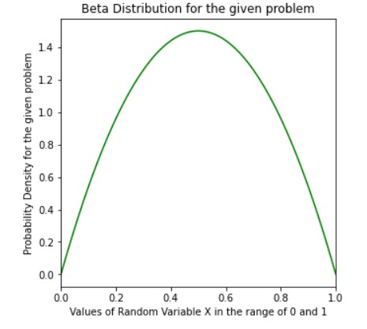

**Explanation-2:**

**The following piece of code deals with the first posterior distribution for the given problem.**

**Since it is explained in the problem statement that 4/5 fraction of people liked the update, this means that if "mu" is the probability that the person likes the update then "1-mu" is the probability that they will not like the update.**

**So, based on this data, it is clear that for the provided prior beta distribution, 40 is the wins and 10 are the losses, this means that the parameters changes in the following manner:**

**a = 2 + 40 (because initially it was initialized to 2)**

**b = 2 + 10 (because initially it was initialized to 2)**

**The change in the parameter is basically:**

**a = initial + wins**

**b = initial + loses**

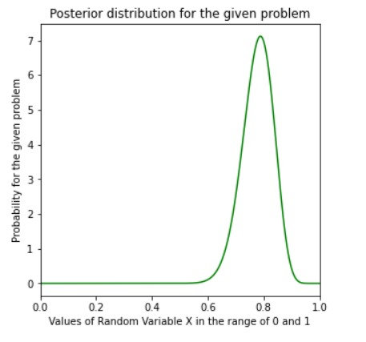

**Explanation-3:**

**Again based on the above details, as per the problem statement, we know that 13/30 liked the update. So, again applying the similar logic to the previous problem that the parameters changes as per the same fashion i.e.,**

**a = updated_a + wins (2 + 40 + 13)**

**b = updated_b + loses (2 + 10 + 17)**

**Explanation-4:**

**Similar, to the logic explained in the previous questions, since the distribution follows the beta distributions, the same thing applies to all the sub-parts of the questions, the changes in the parameters is as follows:**

**a = updated_a + wins (2 + 40 + 13 + 70)**

**b = updated_b + loses (2 + 10 + 17 + 30)**

**It is evident based on the fact that 7/10 is the probability like the update.**

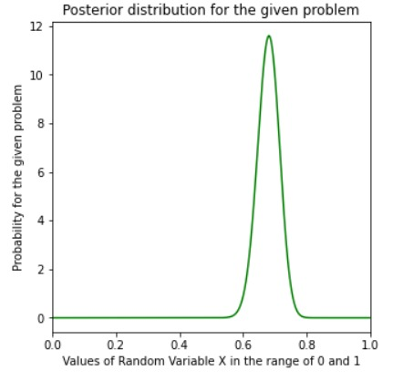

**The likelihood distribution will be your Binomial Distribution (or even a type of Binomial Distribution i.e., Bernoulli Distribution).**

**The reason behind it is that the Beta Distribution is called the conjugate prior for the Binomial Distribution. This means that if the likelihood distribution is Binomial then prior Beta Distribution gives us posterior Beta Distribution. The same applies for the reverse logic as well, that is if we have prior Beta and posterior Beta then we can conclude that Binomial likelihood based on following explanation:**

**The reason they are conjugate is that their densities are proportional to θ α (1−θ)β and when multiplied by a binomial likelihood you get a posterior density from the same beta distribution family though with different α and β.**

**The posterior probability is proportional to the prior probability and the likelihood probability of s. Since this is a beta function, we find posterior probability as -**

**s= probability that a customer likes the update**

**1-s= probability that they don’t like the update**

**Prior is a beta distribution (s:a,b)**

**In a survey of (m+l) people, m people like and l people dislike the update.**

