**Content types:**

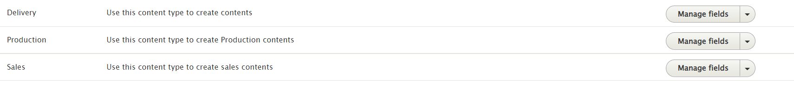

**Production content type:**

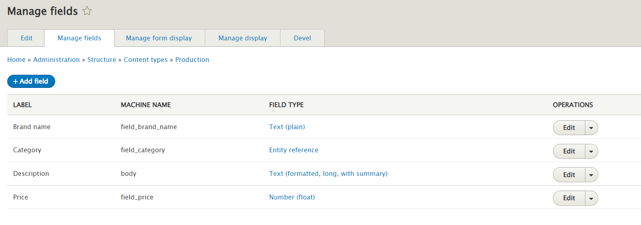

**Delivery content type:**

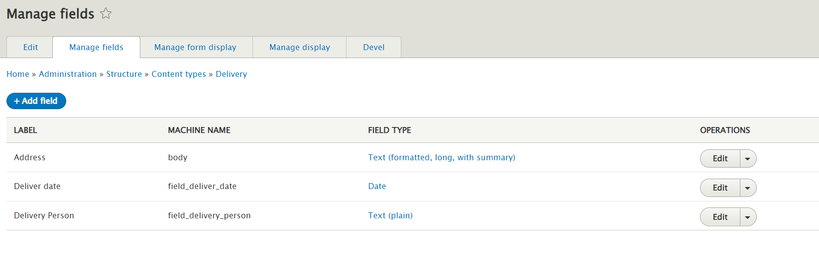

**Sales content type:**

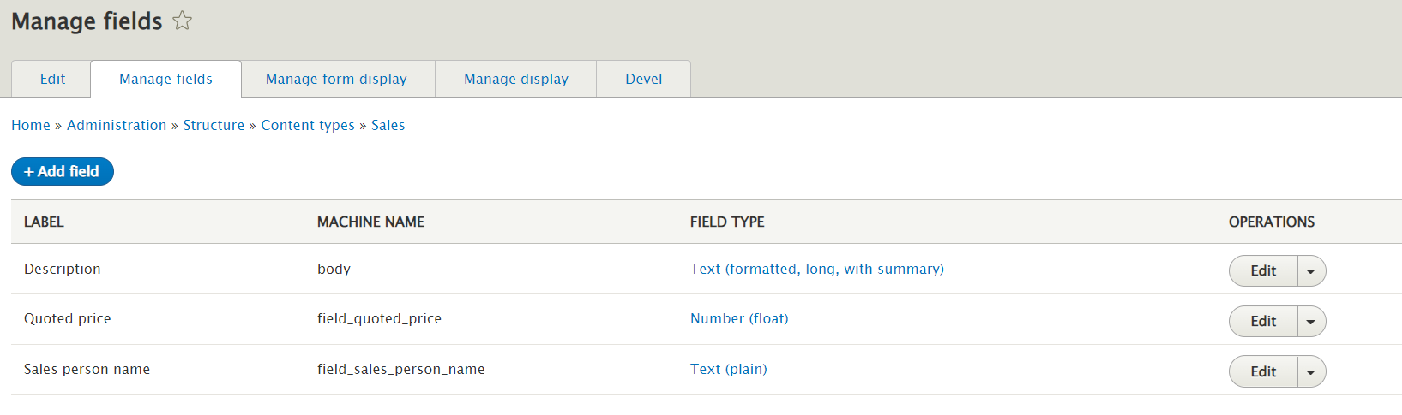

**Delivery listing page (admin view):**

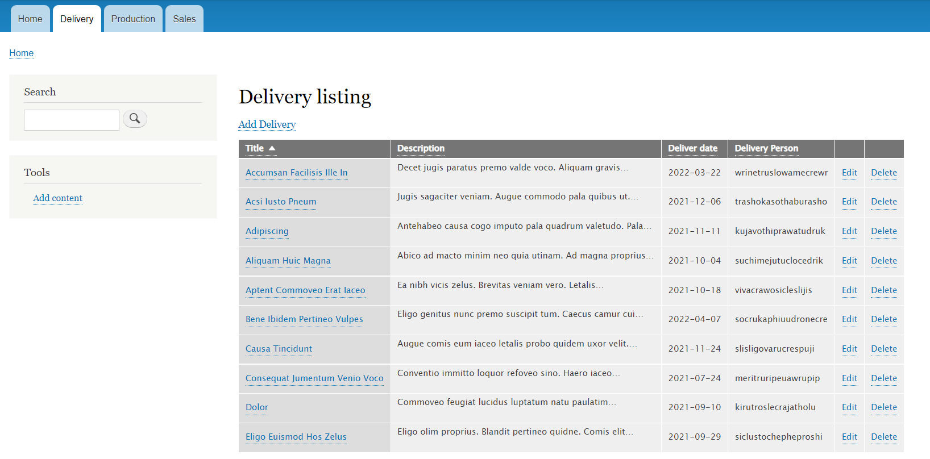

Admin have the full access to add/edit/delete any Delivery content.

**Production listing page (admin view):**

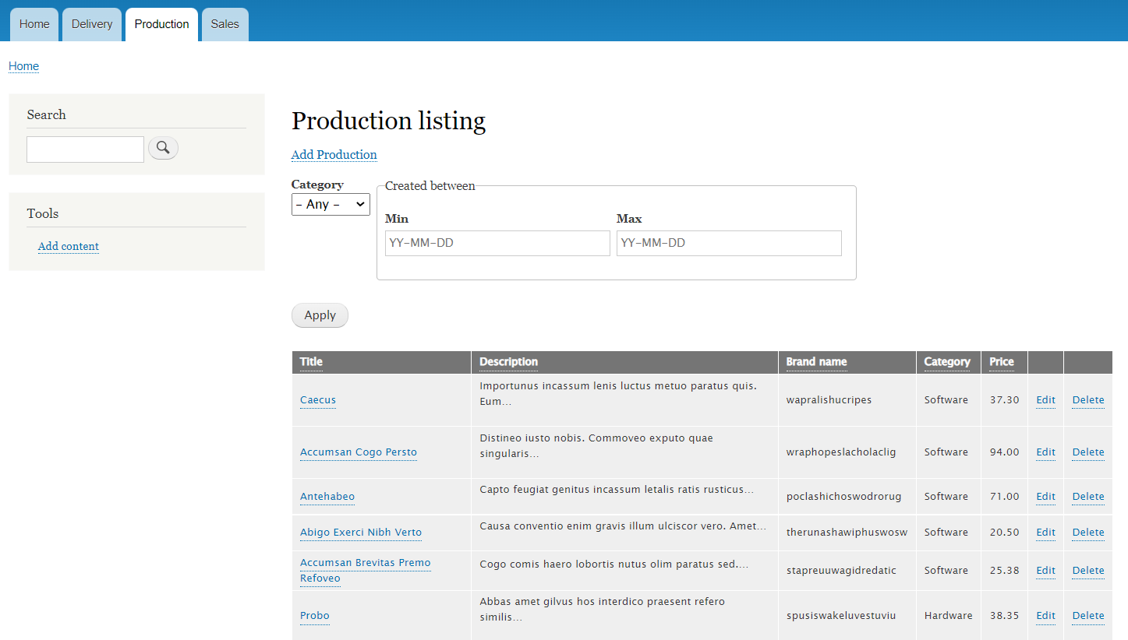

Admin have the full access to add/edit/delete any Production content.

User can sort the listing by Title, Description, Brand name, Category and price.

**Sales listing page (admin view):**

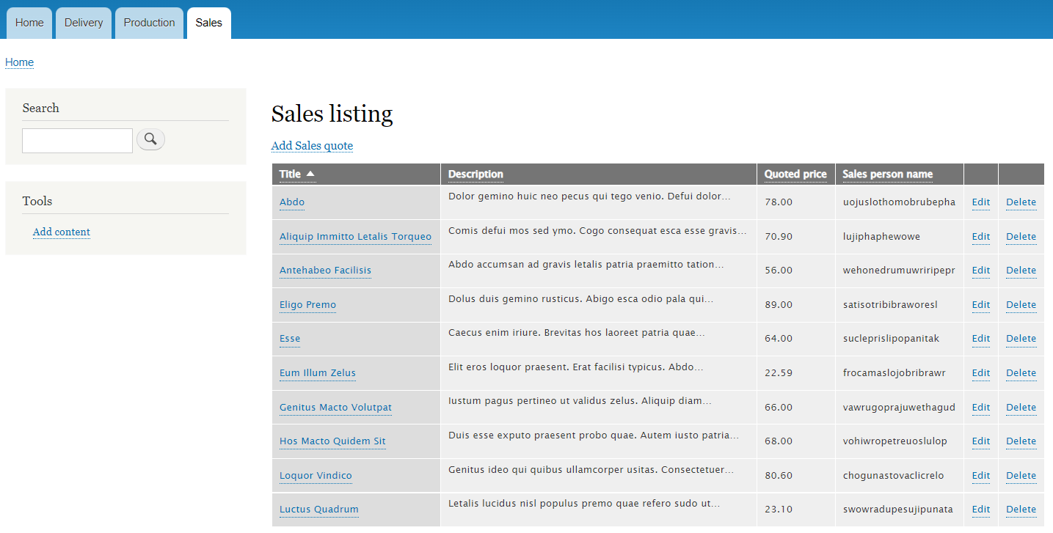

Admin have the full access to add/edit/delete any Sales content.

**Roles:**

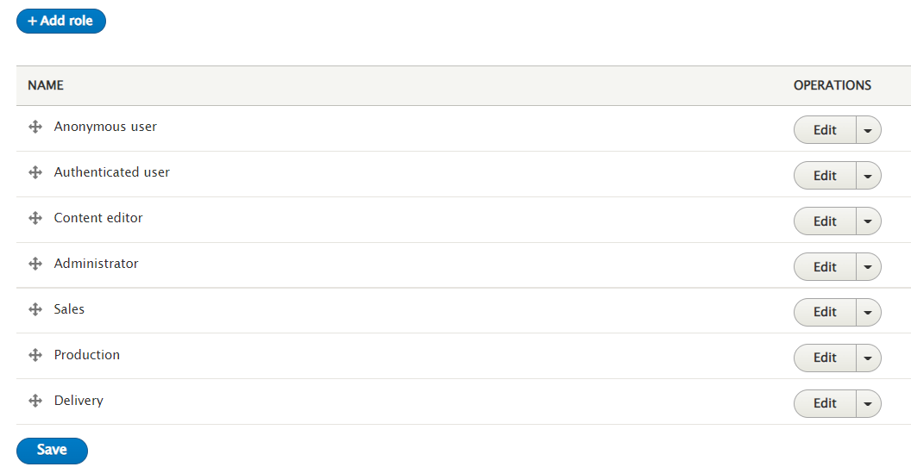

New roles Sales, Production and Delivery are created.

**User accounts:**

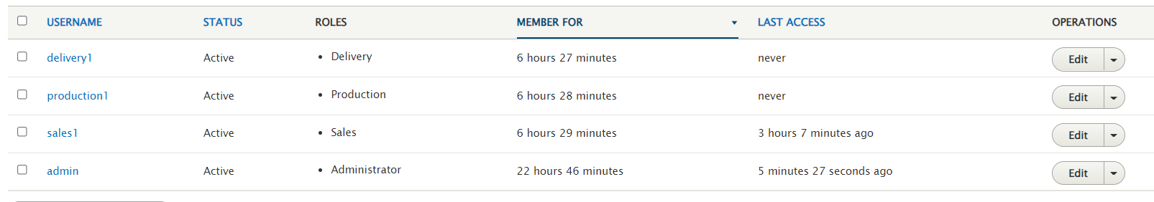

1 user account is created for each role.

**Permissions:**

Permissions are configured in such a way that Sales person will have the full access to Add/edit/delete sales contents.

Production person have the full access to Add/edit/delete production contents.

Delivery person have the full access to Add/edit/delete delivery contents.

Other members have the access ONLY to view the contents.

**Sales login:**

**Sales page:**

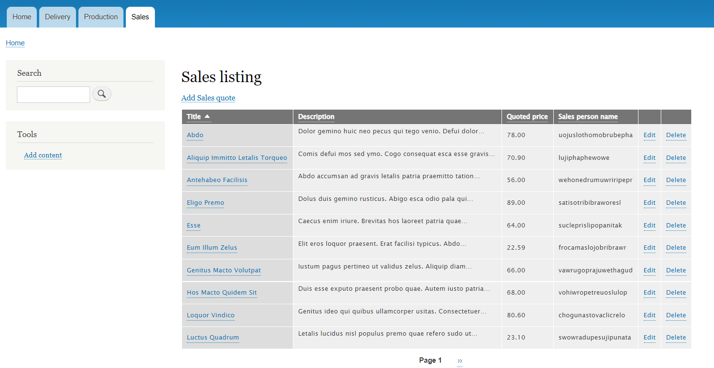

Sales person have the access to add/view/edit/delete sales contents.

**Production listing:**

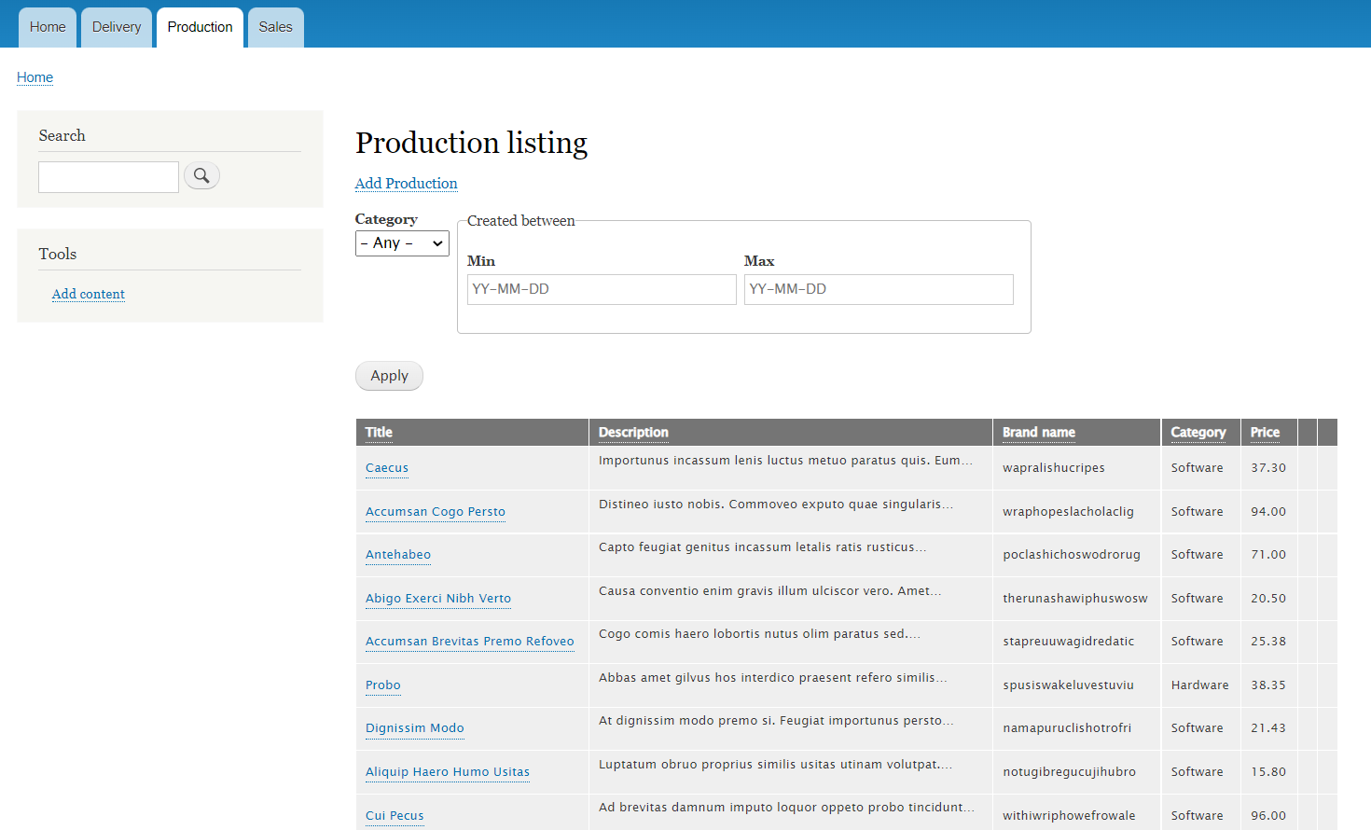

User can ONLY view the production content. Edit and delete options are disabled.

User can filter the content based on category.

User can filter the content between the date ranges based on created date.

**Delivery listing:**

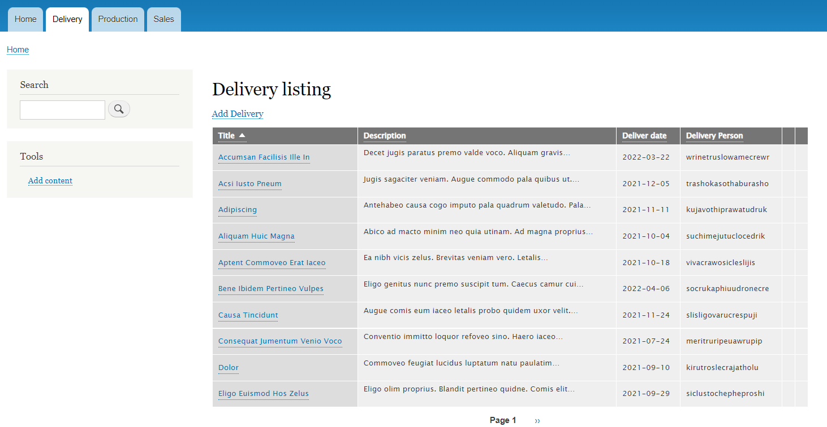

User can only view the content. Edit and delete options are disabled.

**Note:**

**In the same way mentioned above, production team can view/edit/delete/create production contents.**

**But they can’t create/edit/delete sales or delivery contents**

**Delivery team can view/edit/delete/create delivery contents.**

**But they can’t create/edit/delete sales or production contents.**

**Email trigger:**

Installed and configured the ‘Business rules’ module to trigger an email whenever the sales quote is created.

