**Types of Programming Languages**

Python has been gaining popularity since its release in 1991 and is currently the most in-demand language in the world ([TIOBE Index](https://www.tiobe.com/tiobe-index/)).

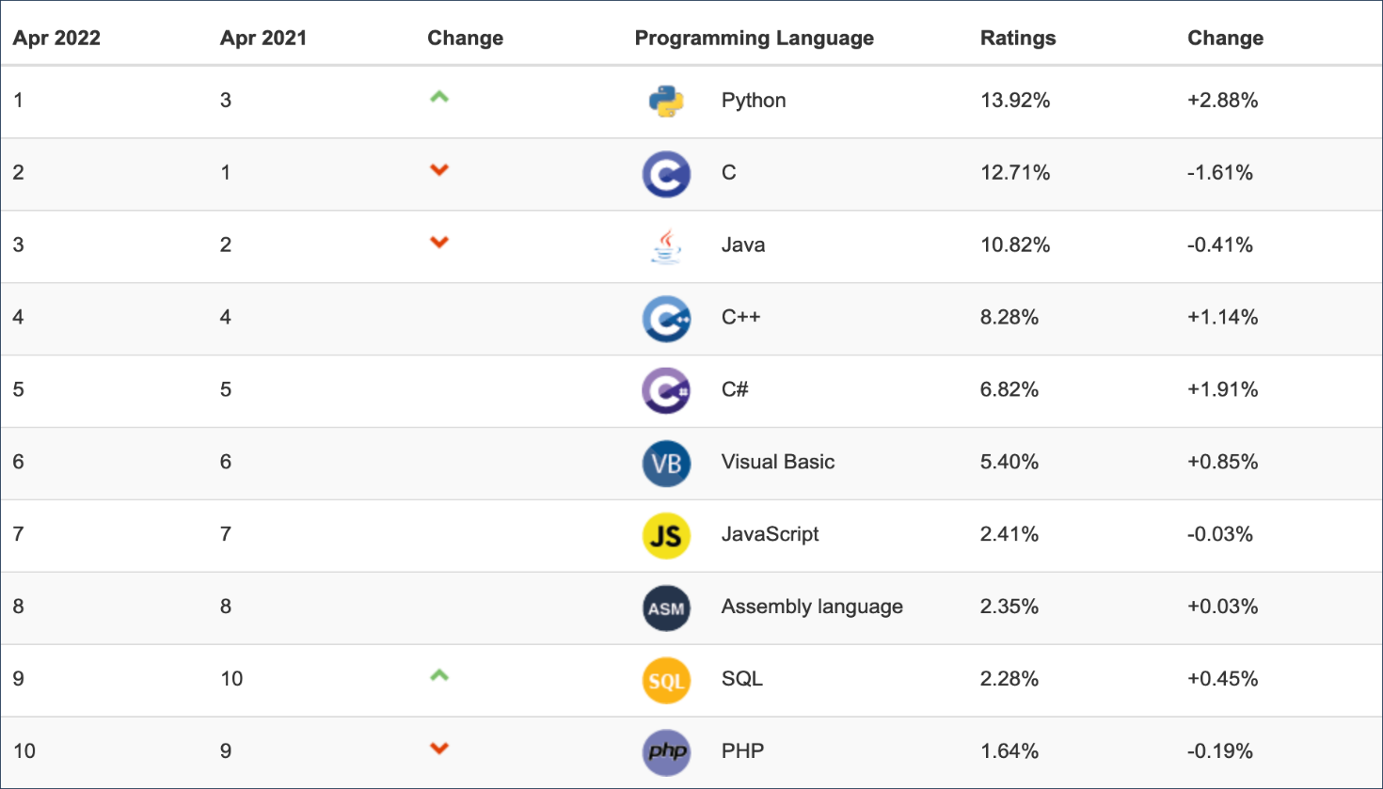

But why is Python so popular? How is it different from other languages, and does it have any limitations? To answer these questions, take a look at the most common characteristics of programming languages.

Each language can be described using the following characteristics:

Now, explore each one in detail.

#### Purpose

Languages can differ in terms of the scope of tasks they perform.

But why is Python so popular? How is it different from other languages, and does it have any limitations? To answer these questions, take a look at the most common characteristics of programming languages.

Each language can be described using the following characteristics:

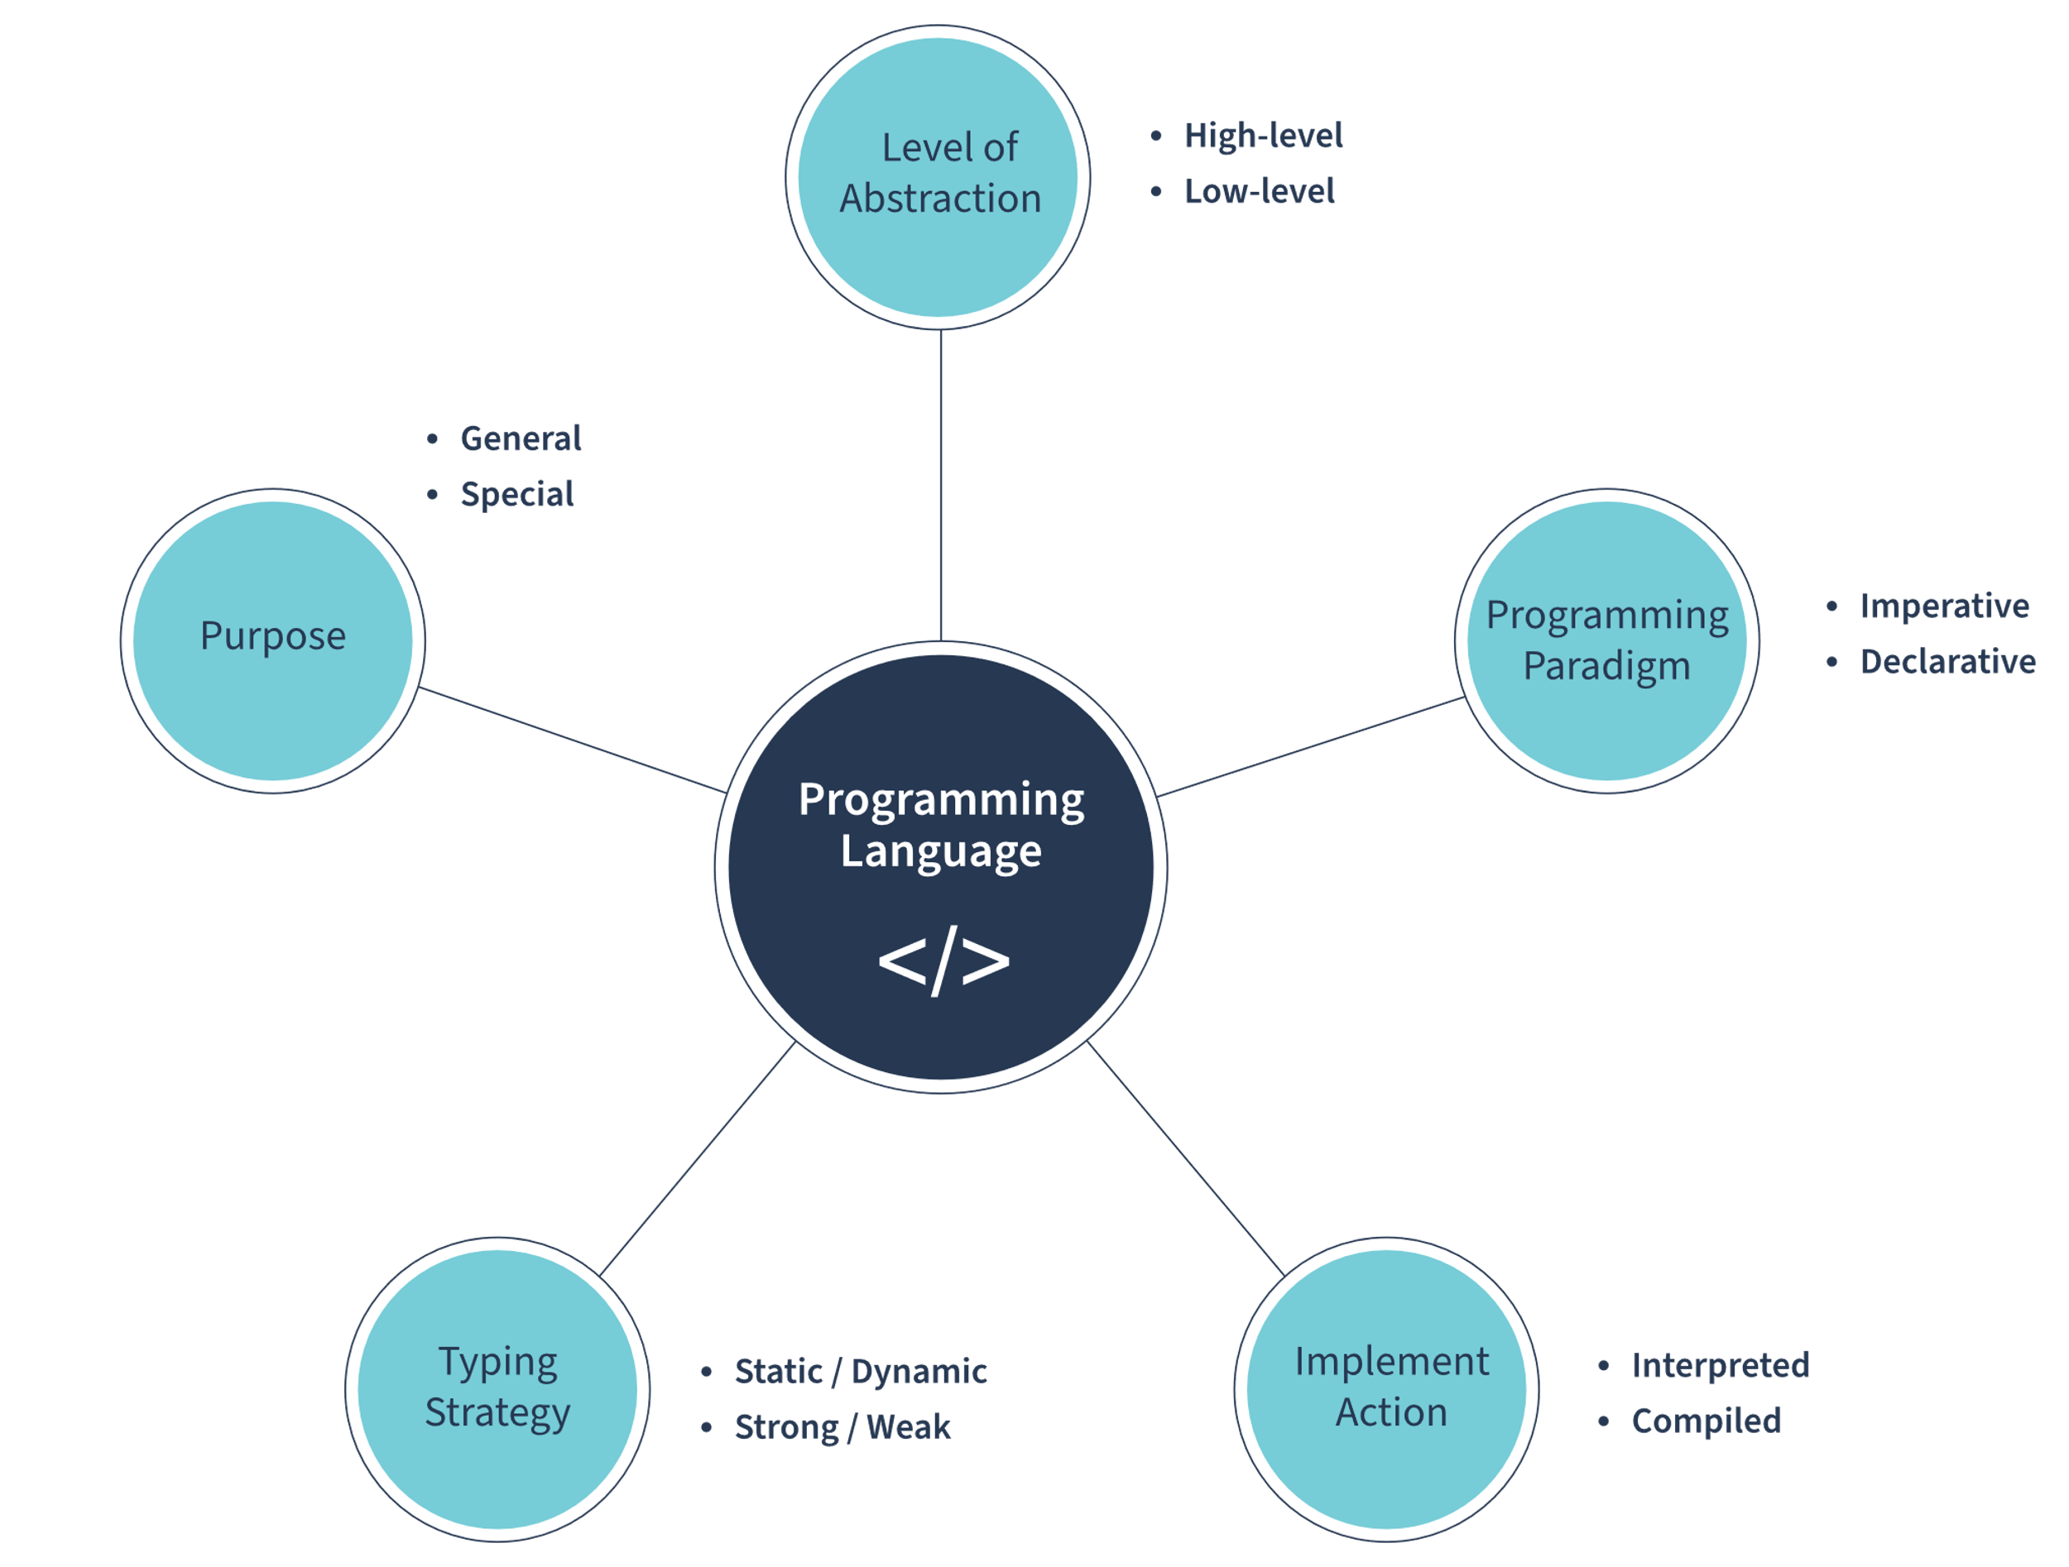

Now, explore each one in detail.

#### Purpose

Languages can differ in terms of the scope of tasks they perform.

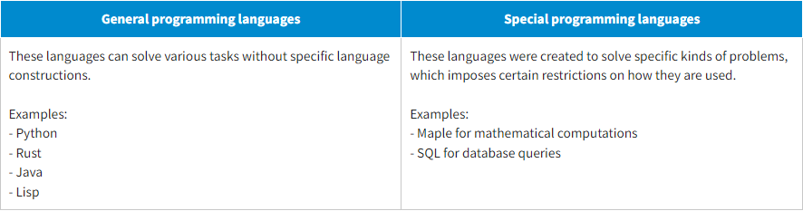

#### Level of Abstraction

Another characteristic is the level of abstraction of the programming language when interacting with hardware.

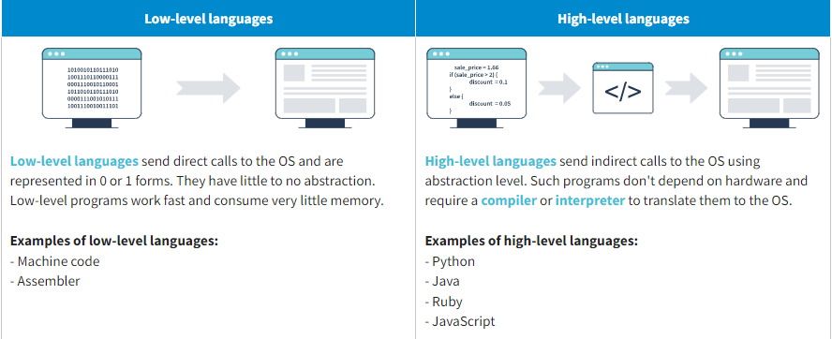

#### Programming Paradigm

Some languages are better suited for a specific way of programming than others.

There are two main programming paradigms: **declarative** and **imperative**. These terms don't refer to specific languages but to the programming styles they employ.

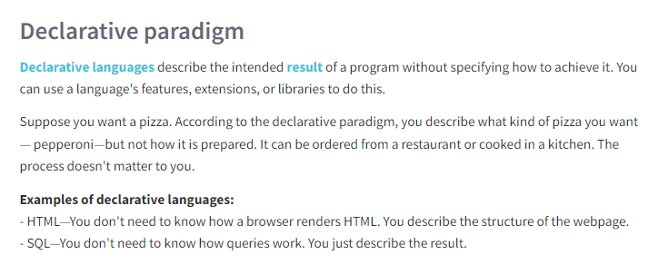

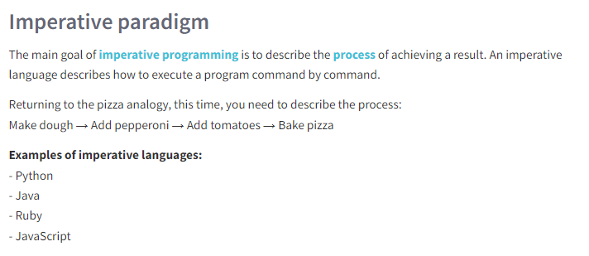

Both declarative and imperative paradigms can be subdivided into even more specific ways of programming:

**Functional paradigm**

* **The functional paradigm** is an example of declarative programming in which programs are executed as a chain of function calls. Such a chain forms a recursion: Functions accept inputs and return outputs that can be used as input by the consecutive functions.
* You can apply standard functions or define new ones. What's more, functional programs don't have a state. Therefore, the data doesn't change; it just gets copied.

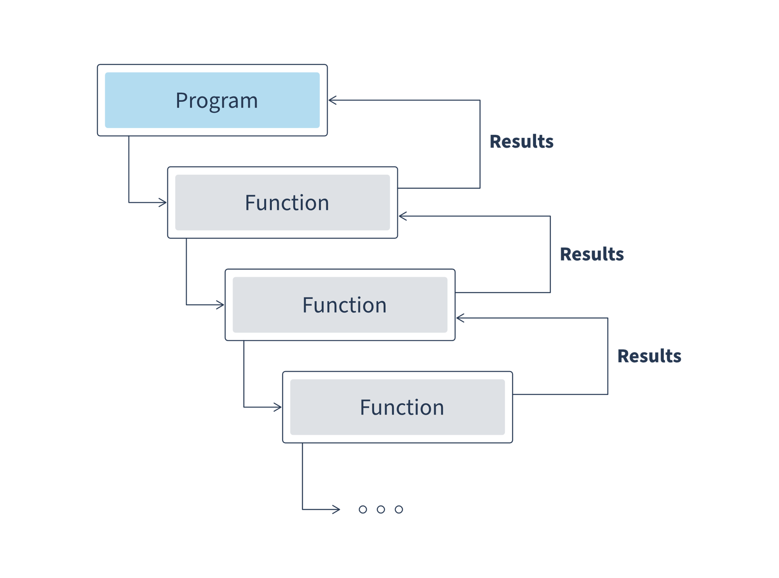

**Advantages:**  
- It is easier to understand, test, debug, and support code because the program doesn't have a state. Functions depend only on input data.  
- Functions can take other functions as arguments and return functions as a result.  
- This enables parallel execution of the same functions because they don't have a state.

**Disadvantages:**  
- Recursion depth is limited in some languages.  
- Code readability can be affected.  
- Immutability of the values can cause problems with performance since you have to copy the values every time.

**Examples of functional languages:**  
- Erlang  
- Haskell  
- F#  
- Wolfram Language

**Object-oriented paradigm**

* **An object-oriented paradigm** is a form of imperative programming.  
  According to this paradigm, a program interacts with a set of *objects* instantiated from *classes*. Classes have *attributes* (data stored in classes) and *methods* (code to manage the data).
* For example, a program has a car class that serves as a template for other car objects within the program. The program should first instantiate it from the class to interact with the object. Objects inherit methods and attributes: New cars can *drive* and *change speed* and have the *same color* as their parental class. At the same time, the car objects have a unique state (*color* and *maxspeed*).

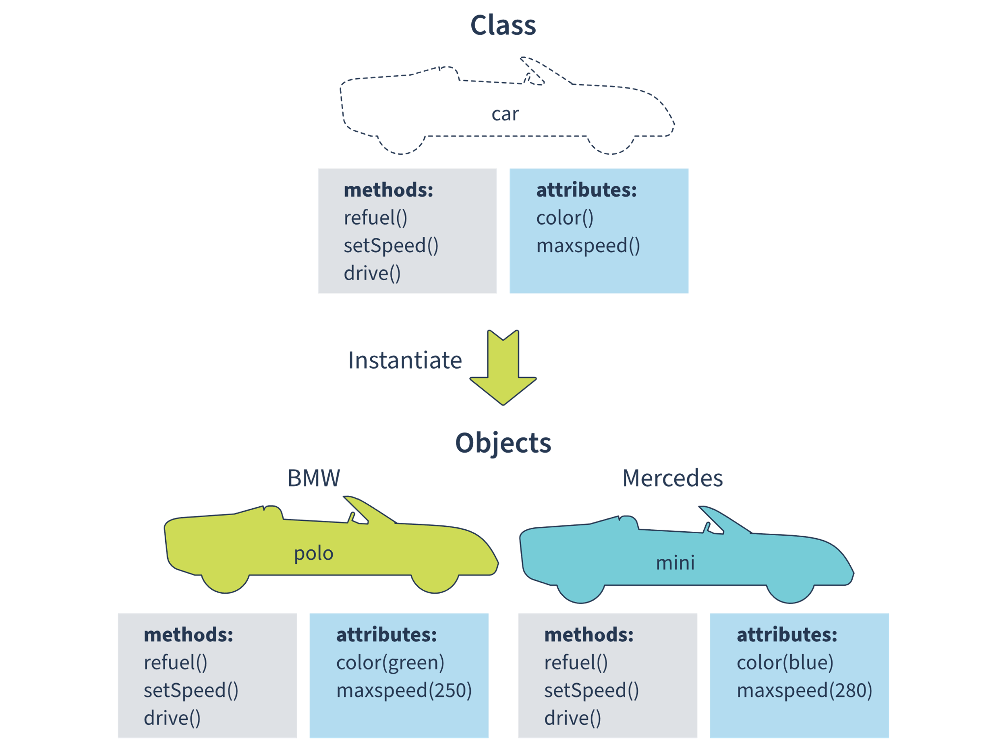

**Advantages:**  
- Parallel development. Each team member can work independently with their own module/classes.  
- Scalable. Very often, classes can be reused.  
- Maintainable. The coding base is centralized, so it is easier to create maintainable code. That makes it easier to keep your data accessible when it becomes necessary to perform an upgrade.

**Disadvantages:**  
- Can be inefficient. Using an OOP can increase CPU usage.  
- Unnecessary classes. An insufficiently well-designed and thought-out inheritance structure can lead to quite a large number of unnecessary classes.  
- Duplication. OOP projects are quite easy to develop but sometimes quite difficult to implement. You can get up new projects and run them at a greater speed. But sometimes projects look like they've been cloned.

**Examples of object-oriented languages:**  
- Python  
- Ruby  
- C++

**Procedural paradigm**

**The procedural paradigm** is yet another form of imperative programming. It requires grouping sequences of instructions into procedures. A procedure can store data that is accessed only from within the procedure. You can call any procedure at any part of the code.

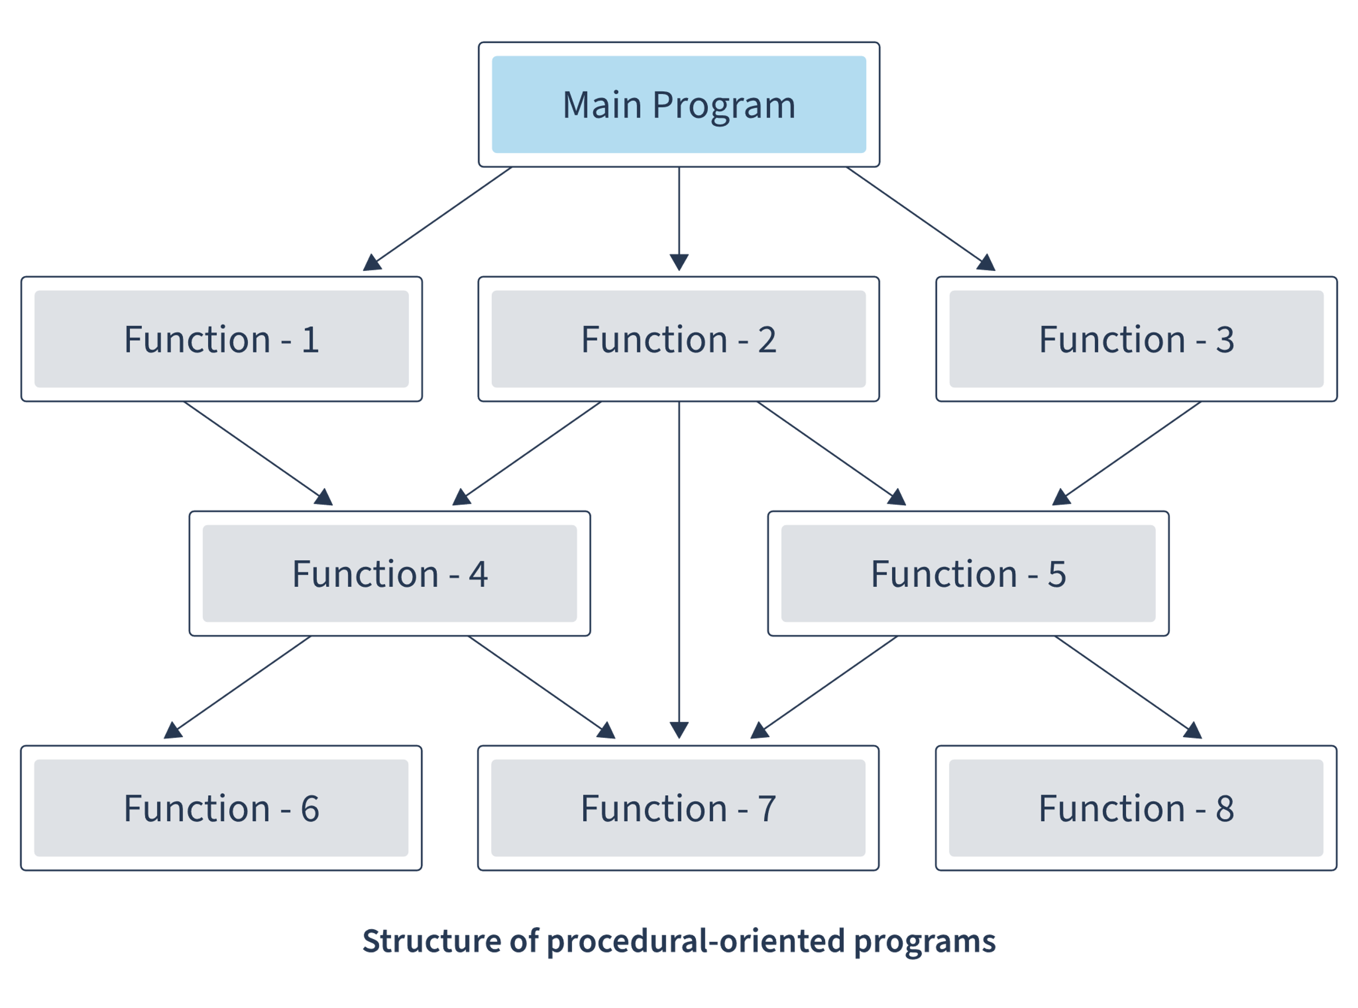

**Advantages:**  
- Easy to reuse procedures  
- Consumes less memory than other paradigms

**Disadvantages:**  
- No data protection, unlike in other paradigms  
- Harder to write a procedural program  
- Difficult to handle errors

**Examples of procedural languages:**  
- С  
- Pascal  
- Ada

#### Implementation

High-level languages make developing a program easier and faster than low-level languages. However, the OS doesn’t directly understand source code written using some high-level language. The special programs, which are called compiler and interpreter, allow transforming source code to code understandable by the OS. Based on this, there are two large groups of languages:

**Compiled languages**

**Compilation** is the process of translating source code from high-level programming language to lower-level language (e.g., assembly code, object code, or machine code) to create an executable program (["Compiler" (2022) Wikipedia](https://en.wikipedia.org/wiki/Compiler)).

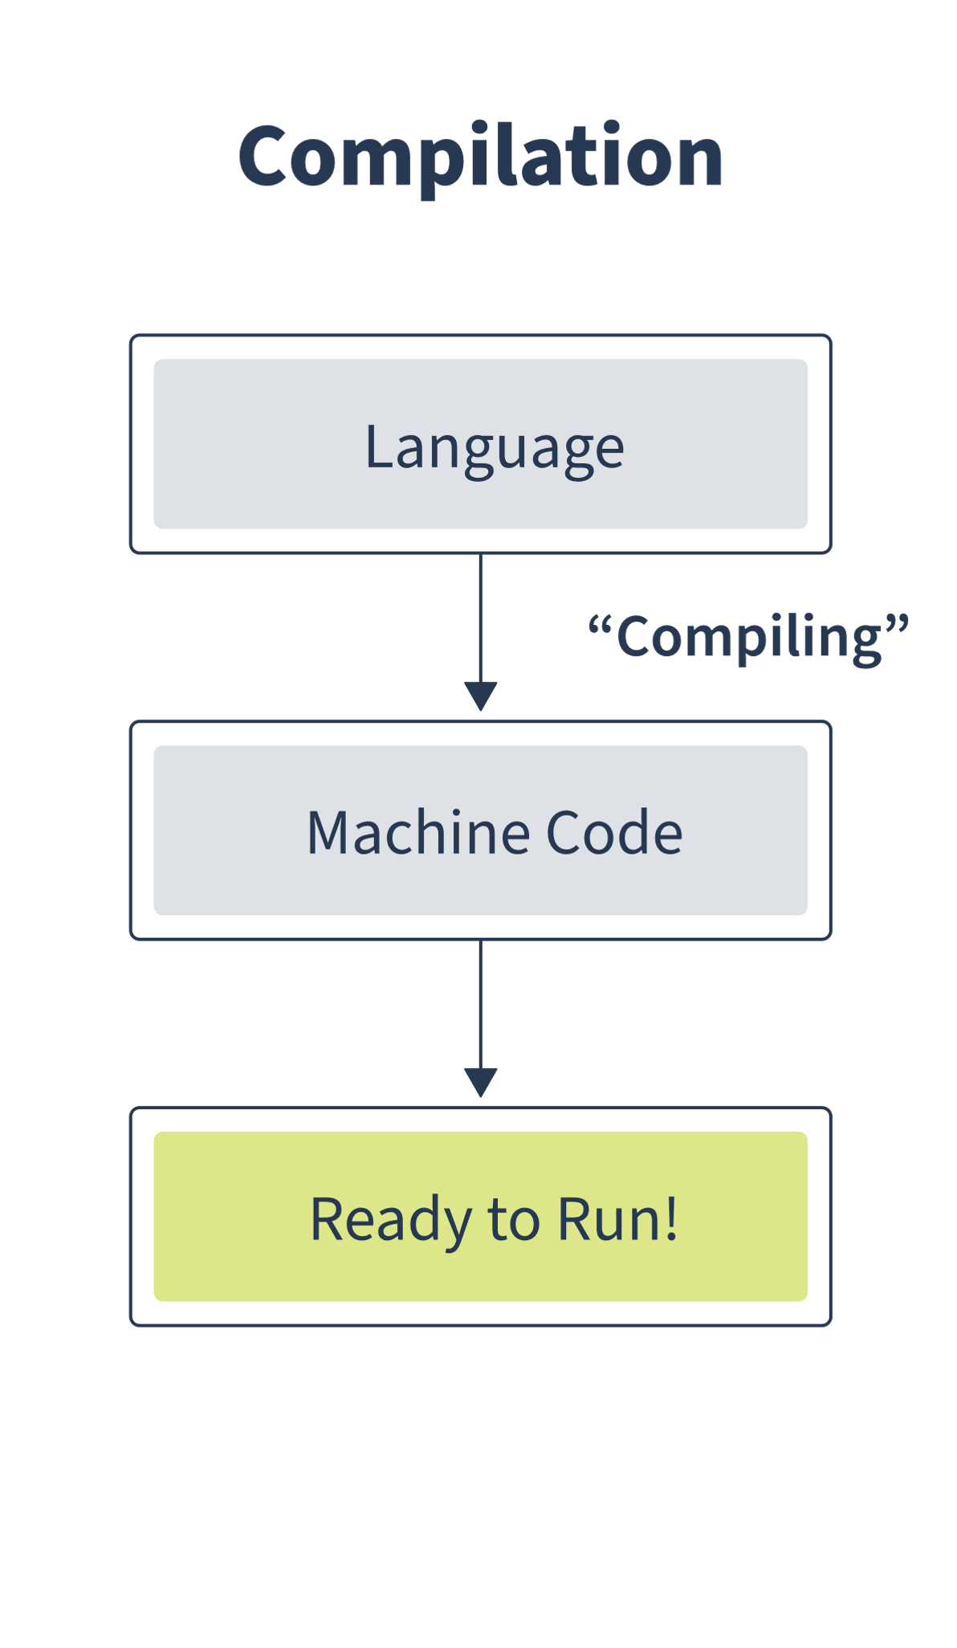

**Advantages:**  
- Faster execution than interpreted language

**Disadvantages:**  
- It takes time to compile the program before its execution  
- Compiled code depends on the compilation platform

**Examples of compiled languages:**  
- C  
- Go  
- Pascal

**Interpreted languages**

**Interpretation** transforms source code to bytecode (an intermediate representation language), which is then executed by the [interpreter](https://en.wikipedia.org/wiki/Interpreter_(computing)) step by step. Interpreted languages are cross-platform but take longer to execute than compiled languages.

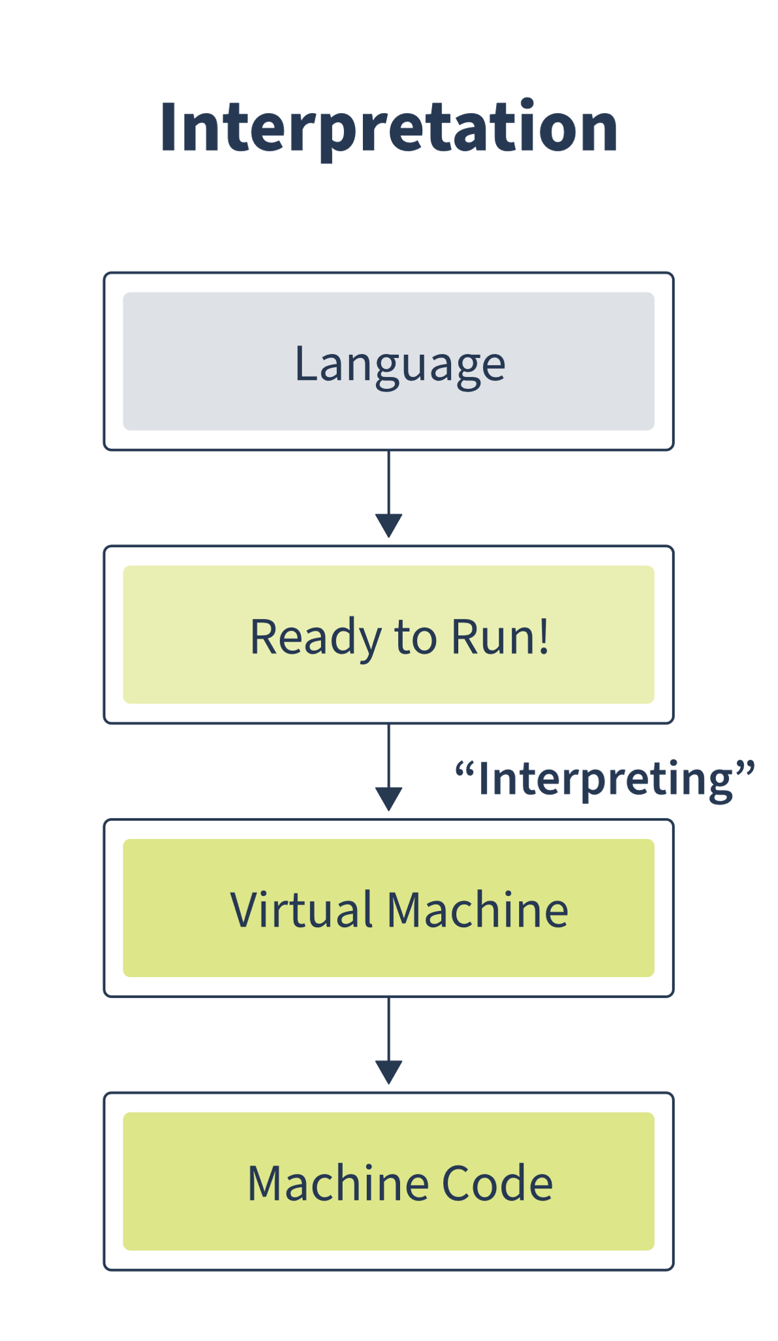

**Advantages:**  
- Platform-independent code  
- Smaller programs than compiled languages

**Disadvantages:**  
- Slower execution

**Examples of interpreted languages:**  
- Python  
- Lisp  
- PHP

#### Typing Strategy

Type-checking is the process of verifying the type of construct and its usage context. This helps to minimize the possibility of type errors in the program.

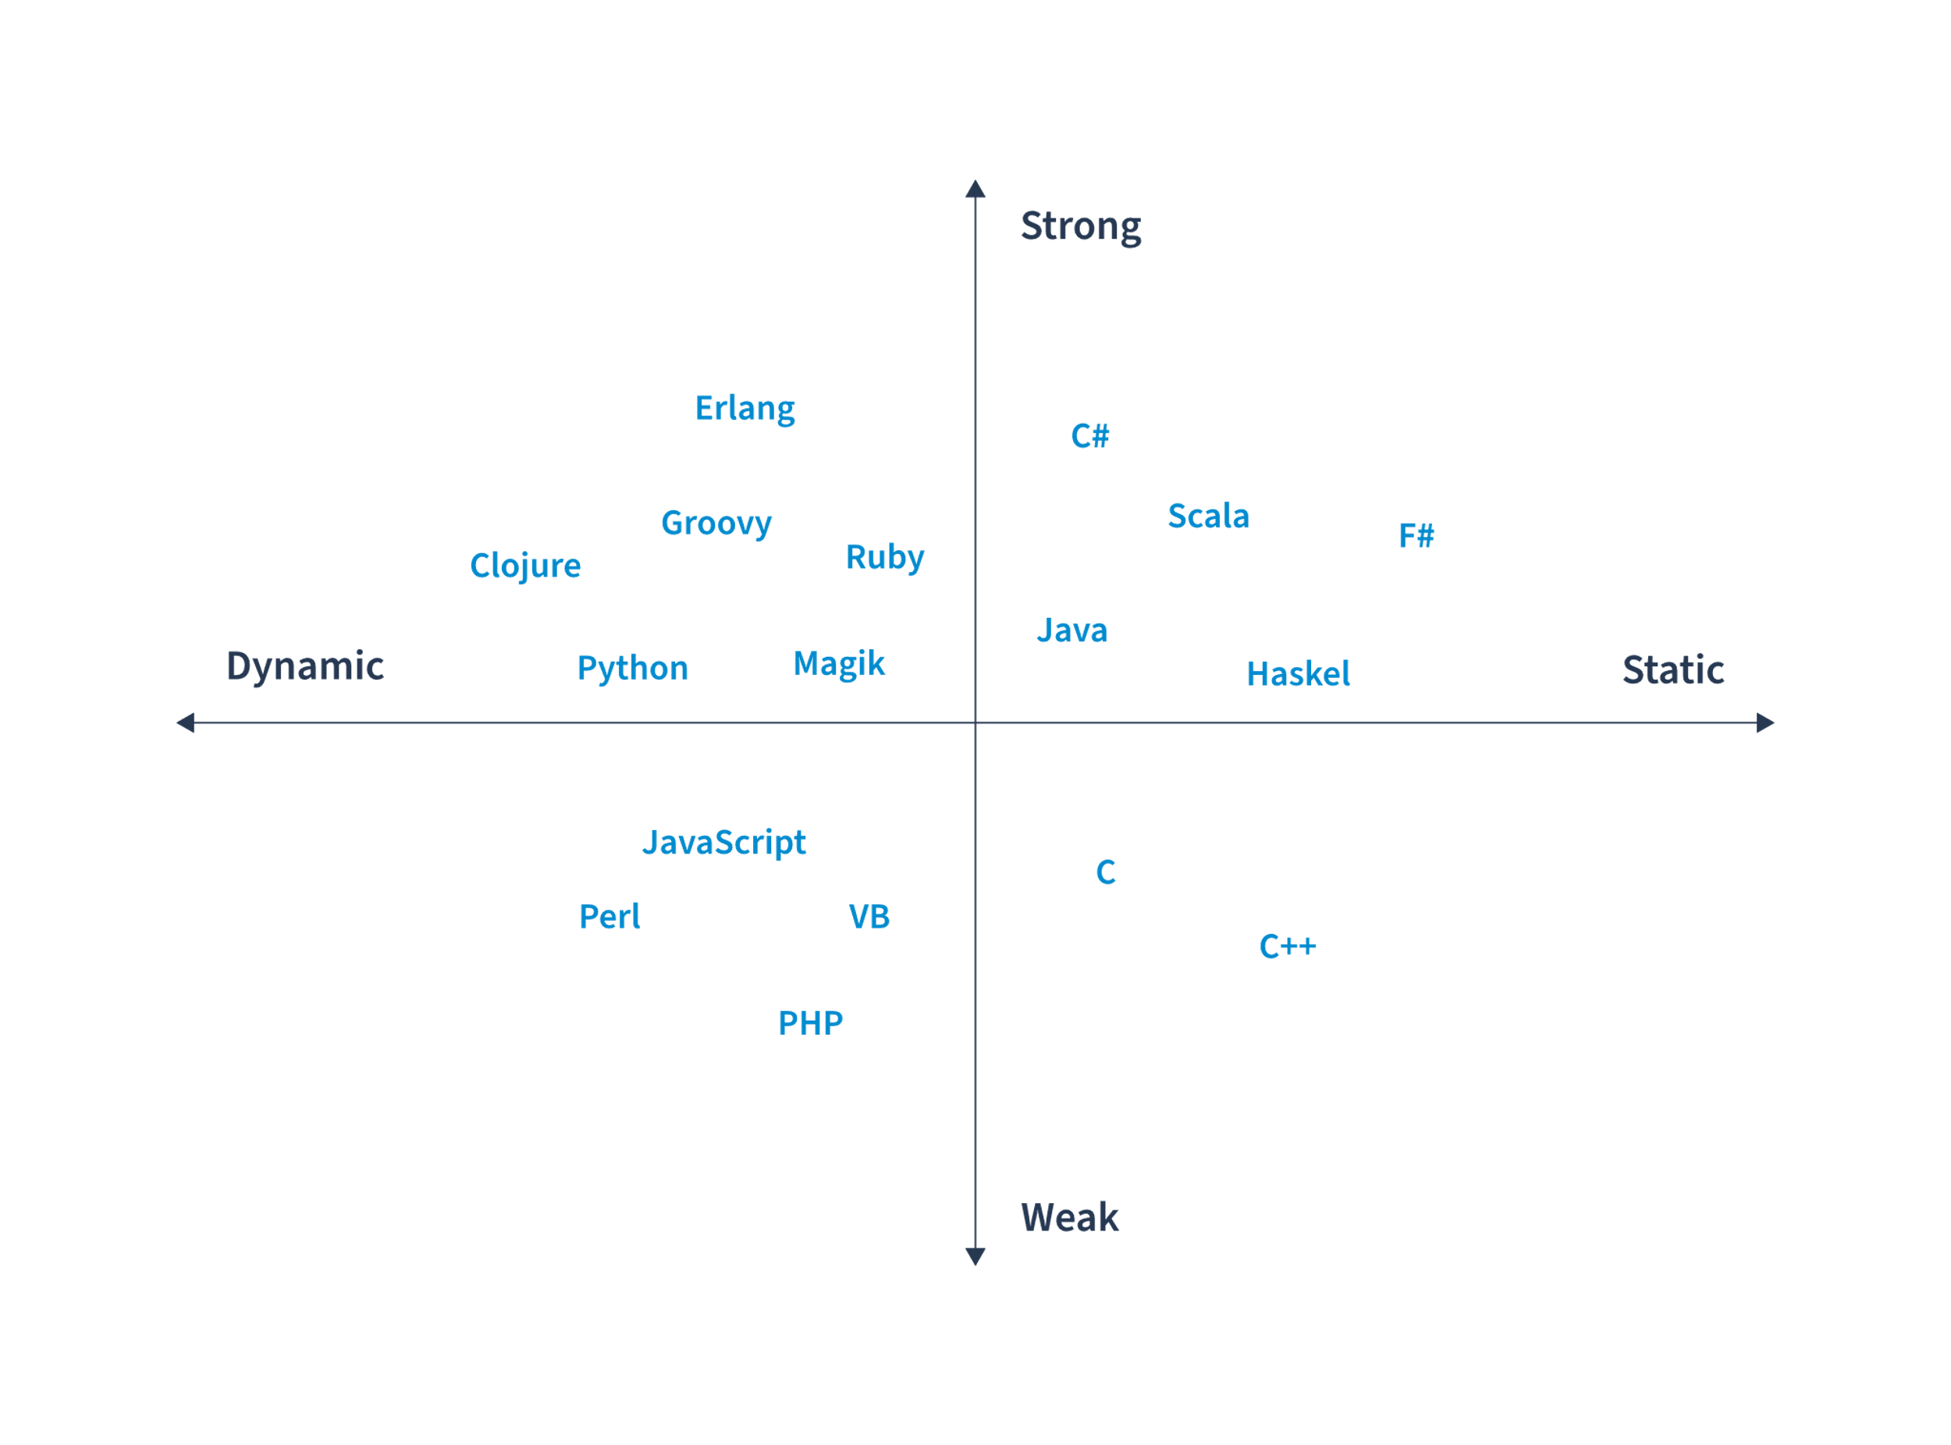

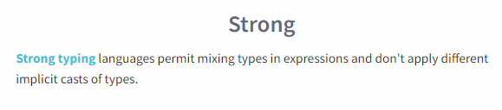

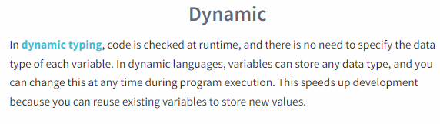

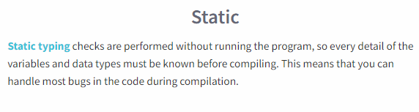 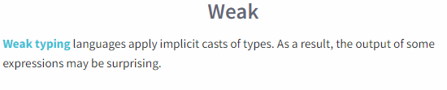

Take a look at some examples of code:

### Dynamic vs. Static

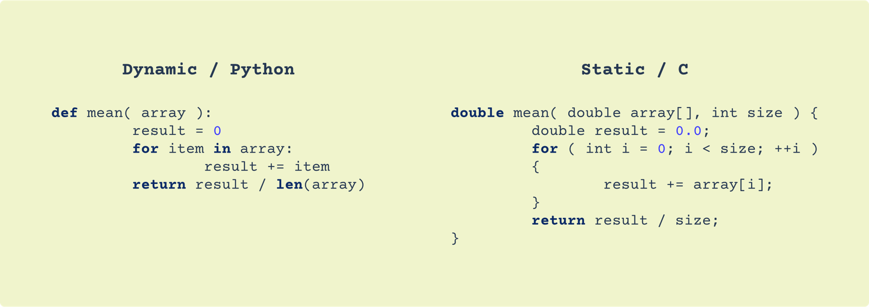

### Strong vs. Weak

