**L2: Introduction to Python**

**Lesson Introduction**

Python is currently the number-one language in the world. But what makes it so popular? In this lesson, you will find the answer to this question. First, you will take a quick look at the history of Python and the philosophy behind the language. Then, you will explore the main characteristics of Python, its pros and cons, and how it is different from other languages. In the final section, you will find out in which industries Python is commonly used.

Duration: **20 minutes**

### The Founding of Python

Python originated within the walls of a research institute in Amsterdam called [CWI](https://www.cwi.nl/).

[Guido van Rossum](https://en.wikipedia.org/wiki/Guido_van_Rossum)joined CWI in late 1982 as a programmer in an ABC group. ABC was conceived as a programming language and development environment for improving and eventually replacing BASIC. A few years later, Guido started working on another project—Amoeba, a kernel-based distributed system.

The idea for the Python language came to Guido during his time on the Amoeba project. Every application on this project was either a shell script or a C program. Guido could see the downsides of both. He was looking for a third language that would unite the strengths of both C and shell but that would be interpreted, easier to use, and more concise.

Work on Python was started **in late December 1989**, and the first version was released early in 1990. The new language was named Python in honor of Guido's favorite comedy show, [Monty Python's Flying Circus](https://en.wikipedia.org/wiki/Monty_Python%27s_Flying_Circus).

On **February 20, 1991**, it was released as an [open-source](https://github.com/python) project. It immediately received a lot of feedback from the community, which soon began to grow. These people spread the word about Python and started contributing.

The community has inspired and motivated developers to constantly update and refine the language. To this day, Python remains a dynamic language that strives to address the developing needs of the industry.

The following versions of Python have been released over the years:

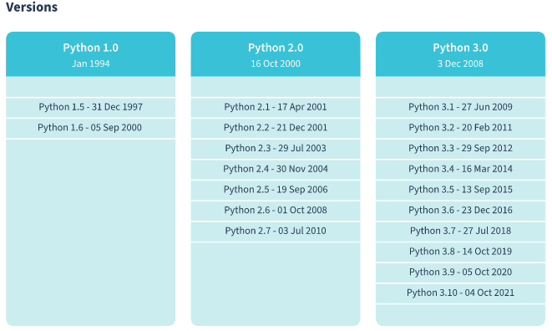

#### What is Python?

Python is an easy-to-learn, powerful programming language that is perfect for scripting and rapid development. Below you can see how Python fits into the family of programming languages:

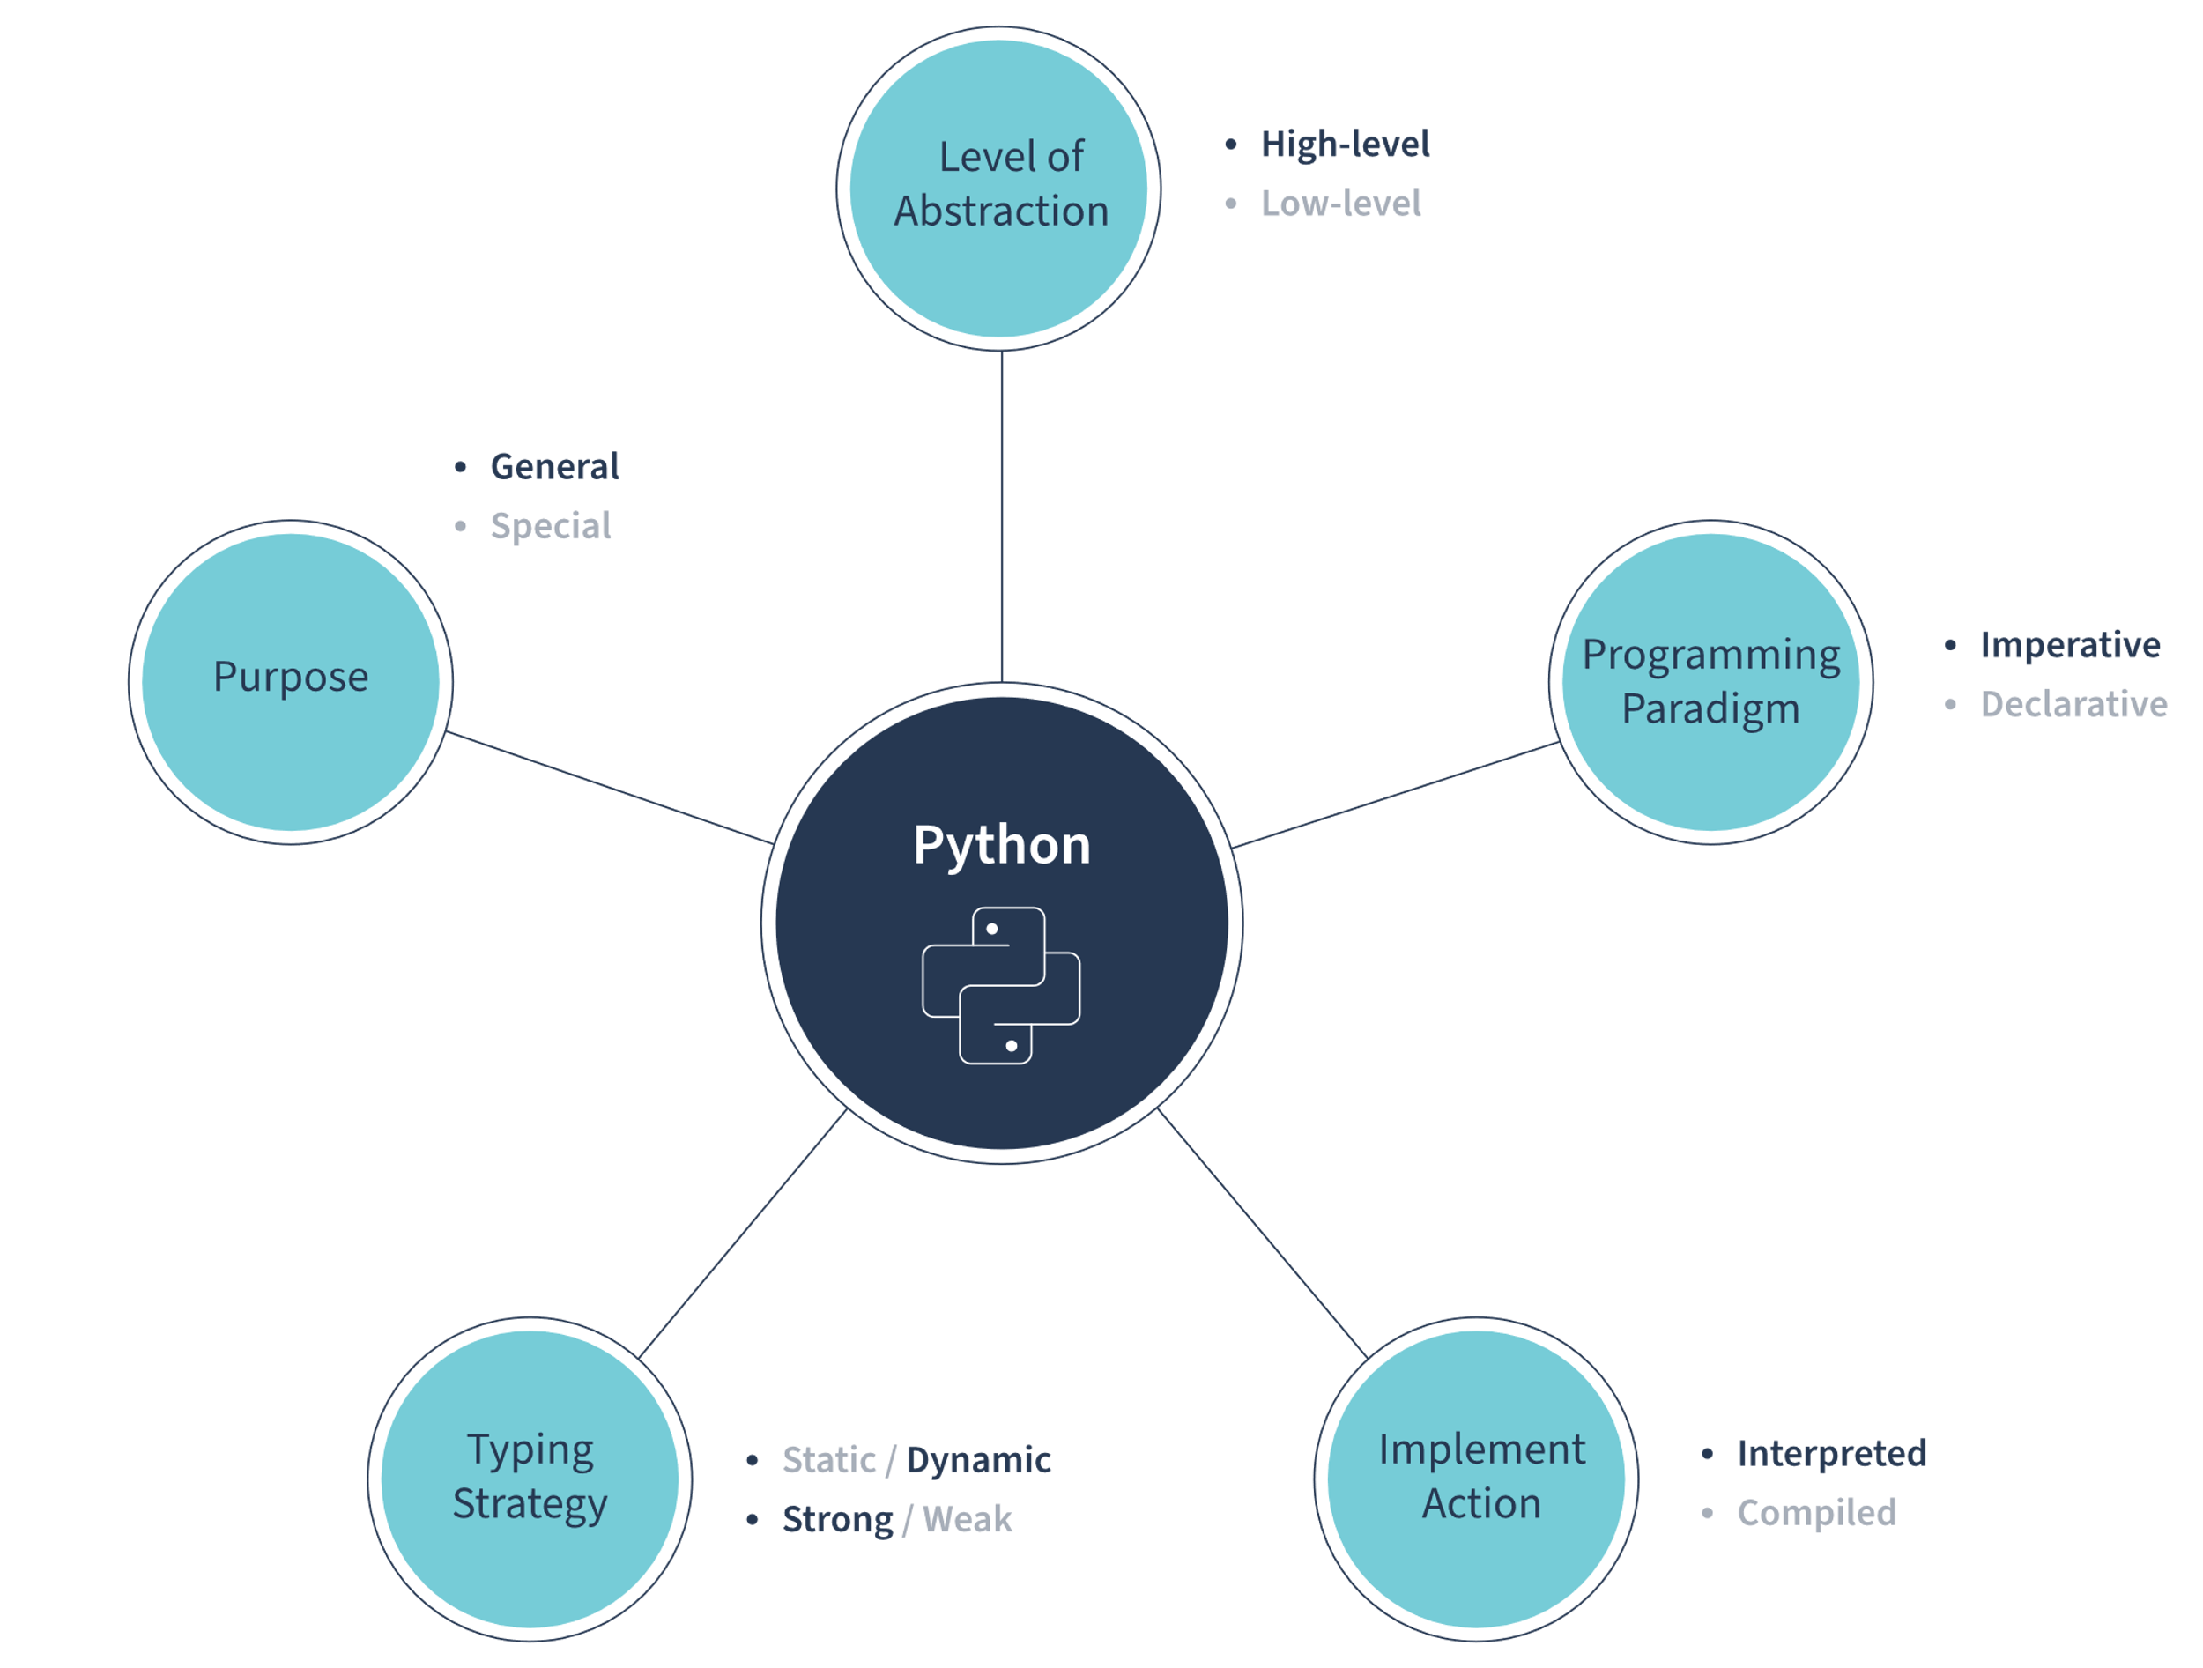

You're probably already familiar with these classifications, but it would be good to explore them in more detail.

**General-purpose**

Python is an industry-independent language, so it is used in many different domains, including:

* Scripting
* Web development
* Data analysis
* Machine learning and AI
* DevOps and system administration
* Tests automation
* Prototyping

**High-level**

Python is a high-level programming language. It has a strong abstraction from the computer characteristics and resembles natural human language.

**Interpreted**

Even though Python is generally considered an interpreted language, this is not completely true. The source code of the program is first compiled into an intermediate format called bytecode. Then, this low-level instruction runs on a Python virtual machine (PVM). The PVM is software for converting bytecode line by line into machine code so that the computer can execute the instructions and display the final output.

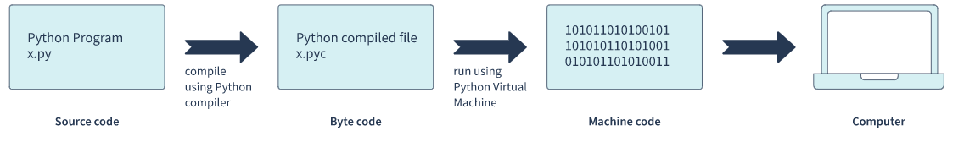

**Object-oriented**

Python is a member of the family of an object-oriented languages (OOLs).An OOL is a high-level computer programming language that devises objects with their associated methods to create software programs. Therefore, Python supports OOP. It employs objects with clearly defined inter-connections and interactions. However, though it is an OOP, Python can also be used for functional programming.

**Dynamic typing**

Python performs type checking at runtime. That means developers don't have to declare a variable's type explicitly. It will be automatically recognized at runtime based on the value assigned to the variable. For example:

In the example below, **x** has an integer value and **y** – string.

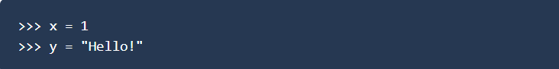

The same variable can change its type as many times as necessary during program execution.

Just like with any language, you should consider Python's advantages and disadvantages before deciding to use it.

### Pros

Python's benefits have made it the most widely used language in the industry. Here are just a few of them:

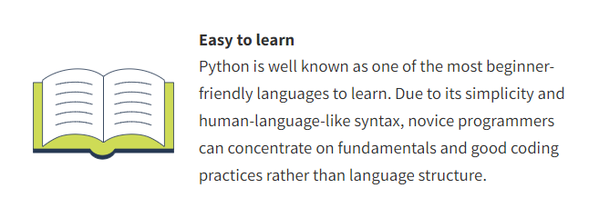

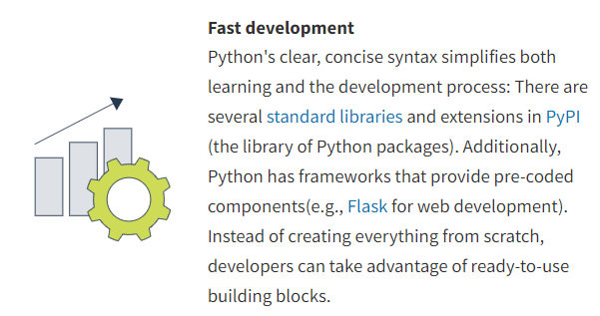

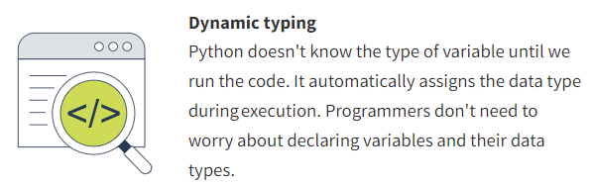

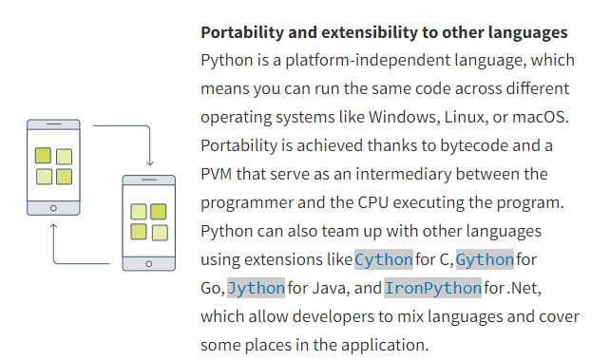

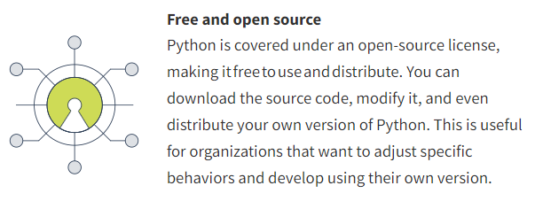

### Cons

