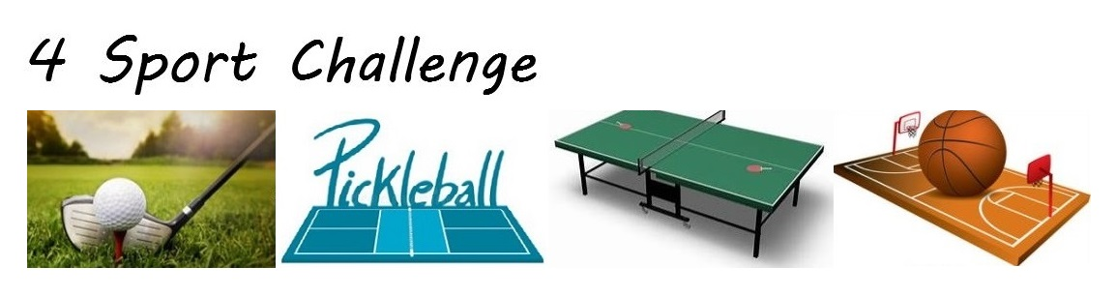  
**Coming soon**

A highly inclusive athletic competition which places a premium on skill, while minimizing physical attributes like height, strength, speed and endurance. And because 4 Sport Challenge is a green field, participation won't be limited to only professional athletes. But in the spirit of inclusiveness, they too are welcome.

**Athletic disciplines**

* **Basketball skills** - 3 separate timed activities: free throw shooting – competitor must self-rebound, 3-point shooting, and obstacle course.
* **Golf -** Traditional outdoor courses at first, with indoor driving range and synthetic chipping and putting greens expected in the future.
* **Pickleball** – Selected over tennis because of inclusiveness considerations (e.g., smaller court size, under hand service rule which prohibits serve and volley).
* **Table tennis**

**Competitive events** – open division (for both men and women), and coed team events. If desired, team events may also include open division and women’s only division.

**Business and technology**

* Site management - not only is there a need for physical sites to host 4 Sport Challenge events, it is expected that hospitality, health and fitness, broadcast and media centers, technology hubs and retail sales will be bundled within sites.
* Robotics, video parsing, analytics and A.I. will be used in conjunction with 4 Sport Challenge events. Vendors which offer such technology are good candidates for advertising revenue and as business partners.
* Professional athletes may want to participate as competitors in 4 Sport Challenge events, but also may make good business partners, including investing in, or owning, 4 Sport Challenge sites.
* Colleges (and NCAA) are also good candidates for business partners - they already manage stadiums and arenas, so they likely will see this as an additional revenue stream with minimal investment (a 4 Sport Challenge site would be a fraction of the cost to build as compared to a typical basketball arena).
* Traditional broadcast networks - reasons should be self-evident. Plus, there are numerous reality show spins-offs that can be easily imagined.
* Imagine 4 Sport Challenge / 4 League Challenge (NFL, NBA, NHL, and MLB) Superbowl the day before and after Baseball's All-Star game. That would be must see TV.
* International interest - hard to say? Table tennis is more popular outside the United States, and since 4 Sport Challenge is a green field, it might attract quite a bit of international interest. With existing professional sport leagues in the U.S., if a foreign athlete is highly skilled, they come to the U.S. to complete. This benefits the foreign athlete and the U.S. team owners, but does little or nothing for the athlete's home country. And the cost of entry for a 4 Sport Challenge site would be a fraction of that for a franchise in any of the big 4 U.S. sports leagues (plus, opportunities to buy an existing franchise are few and far between).
* 4 Sport Challenge as an Olympic event - if 4 Sport Challenge were to take off, then this would actually make a lot of sense.

[darrellmadison.wordpress.com](https://darrellmadison.wordpress.com/)