


Electrical and Electronics Engineering Department
EE301-Signals and Systems
PROJECT PHASE – 1

Group Number: 18
Group Members:
Taha DOĞAN ID: 2093672
Emre DOĞAN ID: 2093656

CONTENTS
1. Q1 3
2. Q2 3
3. Q3 4
4. Q4 & Q5 4
Instruction 1 4
Instruction 2 5
Instruction 3 5
5. Conclusion 17

clear all
close all
clc

Q1
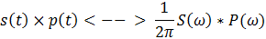
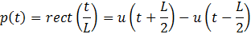
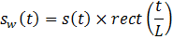
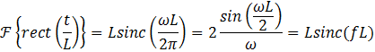

Q2
Note that
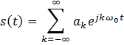
Fourier Transform of the expression above is an impulse train.
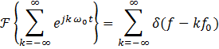
And note that ’s are constant and can be multiplied without transformation.
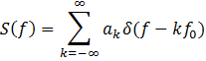
From Part 1
And insert the term inside this equation.
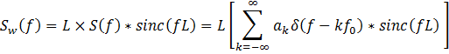
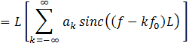

Q3
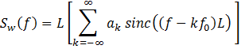
And assume that
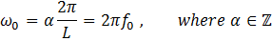
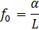
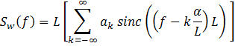
Using Nyquist Sampling frequency
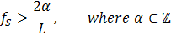
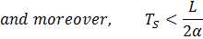
We can obtain a_{k}’s by looking train of sinc function’s peak values.

Q4 & Q5
Yes they should be be equal to a constant multiple of the magnitude of the Fourier series coefficients for the audio signals. Because We know that, Fourier transform of any function is definitely related to its Fourier series coefficients. Actually, by using the fft operation, we get the Fourier series coefficients, but in the normalized edition. So the peak values of our graphes from Figure 4, 6 and 8 are equal to a constant multiple of the magnitude of the Fourier series coefficients for 3 different audio signals.

Instruction 1
Instruction 1: Read the audio file using "audioread" command (read violin_A4.wav for violin, flute_A4.wav for flute and singer_A4.wav for voice signal) and store its outputs. The audio signal should be stored in the vector with name "audio_signal" and the sampling rate in the variable "Fs")
[audio_signal_flute, Fs_flute] = audioread('flute_A4.wav');
[audio_signal_singer, Fs_singer] = audioread('singer_A4.wav');
[audio_signal_violin, Fs_violin] = audioread('violin_A4.wav');
[a b] = size(audio_signal_flute);
time_flute = a / Fs_flute;
[a b] = size(audio_signal_singer);
time_singer = a / Fs_singer;
[a b] = size(audio_signal_violin);
time_violin = a / Fs_violin;

Instruction 2
Instruction 2: Find the index array corresponding to the time intervals between 1.8<t<1.84 seconds for violin 0.1<t<0.12 seconds for flute 0.17<t<0.21 seconds for singer Store the index array in an array called "time_index" Hint: There are Fs samples in 1 seconds.
time_index_violin = 1.8*Fs_violin : 1.84*Fs_violin;
time_index_flute = 0.1*Fs_flute : 0.12*Fs_flute;
time_index_singer = round(0.17*Fs_singer) : round(0.21*Fs_singer);

Instruction 3
Instruction 3: Plot the time domain waveform for the time intervals specified for violin, flute and singer
figure
plot(1.8 : 1/Fs_violin : 1.84, audio_signal_violin(time_index_violin));
xlabel('Time (Seconds)');
ylabel('Amplitude');
title('Amplitude vs Time Graph of Violin');
figure
plot(0.1 : 1/Fs_flute : 0.12, audio_signal_flute(time_index_flute));
xlabel('Time (Seconds)');
ylabel('Amplitude');
title('Amplitude vs Time Graph of Flute');
figure
plot(0.17 : 1/Fs_singer : 0.21, audio_signal_singer(time_index_singer));
xlabel('Time (Seconds)');
ylabel('Amplitude');
title('Amplitude vs Time Graph of Singer');
% The samples of CTFT for -Fs/2<f<Fs/2 when Fs is larger than the audio
% signal bandwidth is found with the below code segment
%fft analysis for singer
N=2^12;
CTFT_sampled = fft(audio_signal_singer(time_index_singer),N)/N; % This finds the samples of CTFT
CTFT_sampled_abs = abs(CTFT_sampled(2:N/2));
freq = (1:N/2-1)*Fs_singer/N; % observed frequency interval
CTFT_sampled_abs=CTFT_sampled_abs/max(CTFT_sampled_abs); % normalization of the spectrum with its maximum value.
figure;
semilogy(freq,CTFT_sampled_abs) % Plot the magnitude of the samples of CTFT of the audio signal
xlabel('Frequency (Hz)');
ylabel('Magnitude');
title('Normalized Magnitude of the Audio Signals obtained from "The Singer"');
[c, d] = find(CTFT_sampled_abs == 1);
CTFT_sampled_abs(c);
dummy = freq(c);
if dummy < 500
for i = 1 : 9
f_singer(1, i) = freq(c * i);
location_singer(1, i) = c * i;
end
elseif dummy > 500 && dummy < 1100
for i = 1 : 9
f_singer(1, i) = freq(c / 2 * i);
location_singer(1, i) = c / 2 * i;
end
end
magnitude_singer_peak = CTFT_sampled_abs(location_singer(1, :));
phase_singer = phase(CTFT_sampled(2:N/2));
phase_singer_peak = phase_singer(location_singer(1, :));
freq_singer_peak = [freq(location_singer(1, :))]';
figure;
plot(freq,phase(CTFT_sampled(2:N/2))) % Plot the phase of the samples of CTFT of the audio signal
ylabel('Phase (radians)');
xlabel('Frequency (Hz)');
title('Phase of the Audio Signals obtained from "The Singer"');
% axis([0 4000 10^-4 1])
table_singer = table(freq_singer_peak, magnitude_singer_peak, phase_singer_peak);
%fft analysis for violin
N=2^12;
CTFT_sampled = fft(audio_signal_violin(time_index_violin),N)/N; % This finds the samples of CTFT
CTFT_sampled_abs = abs(CTFT_sampled(2:N/2));
freq = (1:N/2-1)*Fs_violin/N; % observed frequency interval
CTFT_sampled_abs=CTFT_sampled_abs/max(CTFT_sampled_abs); % normalization of the spectrum with its maximum value.
figure;
semilogy(freq,CTFT_sampled_abs) % Plot the magnitude of the samples of CTFT of the audio signal
xlabel('Frequency (Hz)');
ylabel('Magnitude');
title('Normalized Magnitude of the Audio Signals obtained from "The Violin"');
[c, d] = find(CTFT_sampled_abs == 1);
CTFT_sampled_abs(c);
dummy = freq(c);
if dummy < 500
for i = 1 : 19
f_violin(1, i) = freq(c * i);
location_violin(1, i) = c * i;
end
elseif dummy > 500 && dummy < 1100
for i = 1 : 19
f_violin(1, i) = freq(c / 2 * i);
location_violin(1, i) = c / 2 * i;
end
end
magnitude_violin_peak = CTFT_sampled_abs(location_violin(1, :));
phase_violin = phase(CTFT_sampled(2:N/2));
phase_violin_peak = phase_violin(location_violin(1, :));
freq_violin_peak = [freq(location_violin(1, :))]';
figure;
plot(freq,phase(CTFT_sampled(2:N/2))) % Plot the phase of the samples of CTFT of the audio signal
ylabel('Phase (radians)');
xlabel('Frequency (Hz)');
title('Phase of the Audio Signals obtained from "The Violin"');
% axis([0 4000 10^-4 1])
table_violin = table(freq_violin_peak, magnitude_violin_peak, phase_violin_peak);
%fft analysis for flute
N=2^12;
CTFT_sampled = fft(audio_signal_flute(time_index_flute),N)/N; % This finds the samples of CTFT
CTFT_sampled_abs = abs(CTFT_sampled(2:N/2));
freq = (1:N/2-1)*Fs_flute/N; % observed frequency interval
CTFT_sampled_abs=CTFT_sampled_abs/max(CTFT_sampled_abs); % normalization of the spectrum with its maximum value.
figure;
semilogy(freq,CTFT_sampled_abs) % Plot the magnitude of the samples of CTFT of the audio signal
xlabel('Frequency (Hz)');
ylabel('Magnitude');
title('Normalized Magnitude of the Audio Signals obtained from "The Flute"');
[c, d] = find(CTFT_sampled_abs == 1);
CTFT_sampled_abs(c);
dummy = freq(c);
if dummy < 500
for i = 1 : 10
f_flute(1, i) = freq(c * i);
end
elseif dummy > 500 && dummy < 1100
for i = 1 : 10
f_flute(1, i) = freq(c / 2 * i);
location_flute(1, i) = c / 2 * i;
end
end
magnitude_flute_peak = CTFT_sampled_abs(location_flute(1, :));
phase_flute = phase(CTFT_sampled(2:N/2));
phase_flute_peak = phase_flute(location_flute(1, :));
freq_flute_peak = [freq(location_flute(1, :))]';
figure;
plot(freq,phase(CTFT_sampled(2:N/2))) % Plot the phase of the samples of CTFT of the audio signal
ylabel('Phase (radians)');
xlabel('Frequency (Hz)');
title('Phase of the Audio Signals obtained from "The Flute"');
% axis([0 4000 10^-4 1])
table_flute = table(freq_flute_peak, magnitude_flute_peak, phase_flute_peak);

table_singer =
freq_singer_peak magnitude_singer_peak phase_singer_peak
_______(Hz)_____ _____________________ _______(Deg)_____
462.96 0.45955 -34.348
925.93 1 -70.044
1388.9 0.44461 -183.38
1851.9 0.054122 -200.02
2314.8 0.013264 -240.93
2777.8 0.0088402 -296.83
3240.7 0.26512 -385.72
3703.7 0.14141 -443
4166.7 0.013546 -498.41
table_violin =
freq_violin_peak magnitude_violin_peak phase_violin_peak
_____(Hz)_______ _____________________ _____(Deg)_______
446.81 1 -62.525
893.63 0.004386 -89.605
1340.4 0.20206 -89.779
1787.3 0.11033 -96.892
2234.1 0.1523 -186.92
2680.9 0.032504 -190.25
3127.7 0.062369 -281.05
3574.5 0.13481 -296.13
4021.3 0.047027 -365.32
4468.1 0.1123 -444.63
4915 0.022126 -484.99
5361.8 0.026426 -551.57
5808.6 0.035434 -612.87
6255.4 0.025019 -655.64
6702.2 0.0024736 -692.92
7149 0.0026579 -720.8
7595.8 0.0019664 -771.52
8042.7 0.00062946 -809.27
8489.5 0.00047507 -843.89

table_flute =
freq_flute_peak magnitude_flute_peak phase_flute_peak
______(Hz)_____ ____________________ ______(Deg)_____
436.05 0.77714 1.1421
872.09 1 -44.666
1308.1 0.55626 -62.499
1744.2 0.1817 -71.533
2180.2 0.076023 -89.787
2616.3 0.031185 -118.41
3052.3 0.053572 -126.19
3488.4 0.020074 -135.68
3924.4 0.044996 -138.25
4360.5 0.021184 -139.68

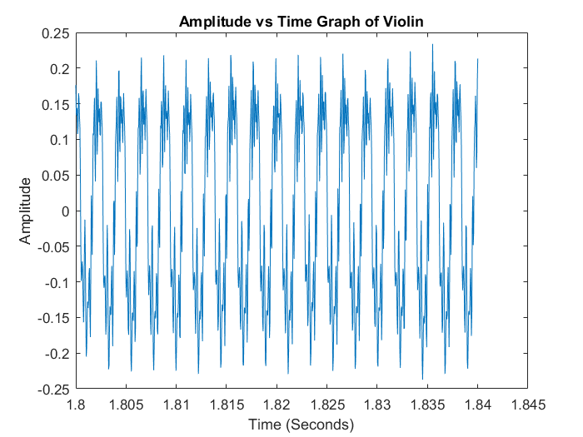
Figure 1. Amplitude vs Time Graph of “violin_A4” between t=1.80sec and t=1.84sec
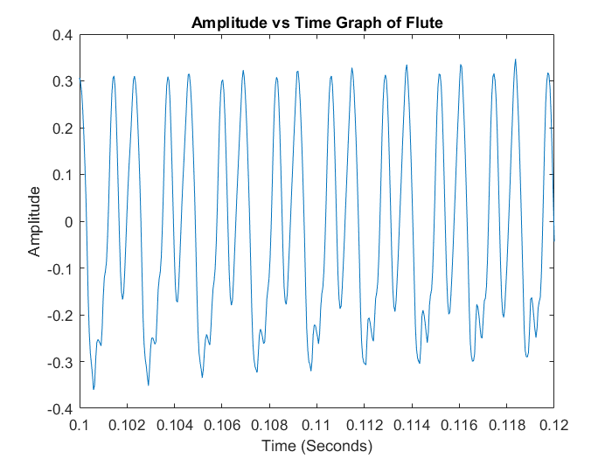
Figure 2. Amplitude vs Time Graph of “flute_A4” between t=0.10sec and t=0.12sec

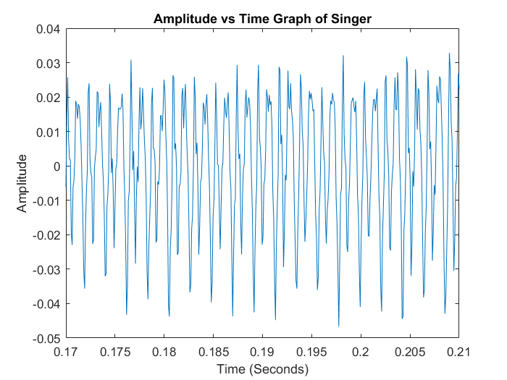
Figure 3. Amplitude vs Time Graph of “singer_A4” between t=0.17sec and t=0.21sec

As It can be seen from the Figures 1,2 and 3, these signals are periodic. We expect this result because, we are working on the regular A note. So these waveforms must be periodic over the time domain.
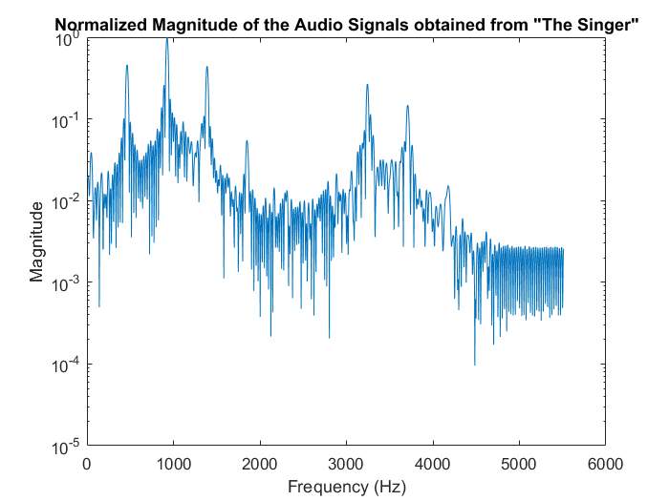
Figure 4. Normalized Magnitude of the Signals from “The Singer” Over Changing Frequency

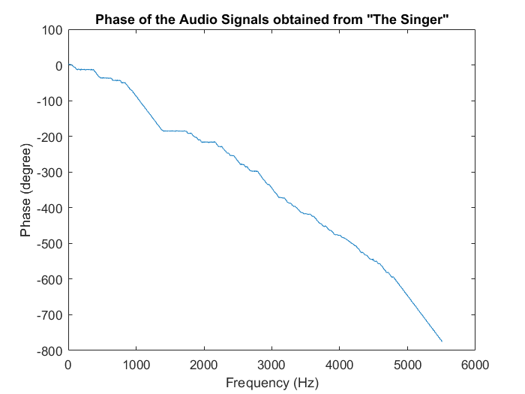
Figure 5. Phase Angle of the Signals from “The Singer” Over Changing Frequency
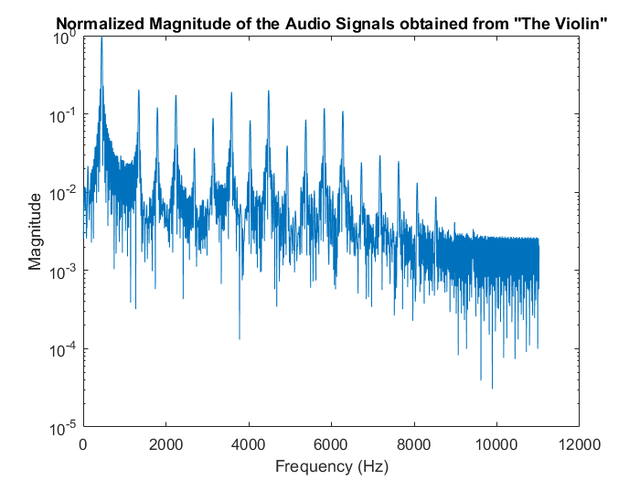
Figure 6. Normalized Magnitude of the Signals from “The Violin” Over Changing Frequency
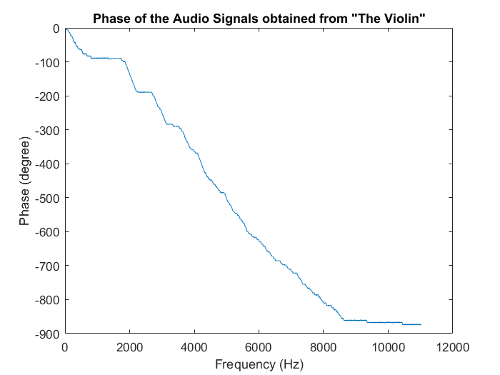
Figure 7. Phase Angle of the Signals from “The Violin” Over Changing Frequency
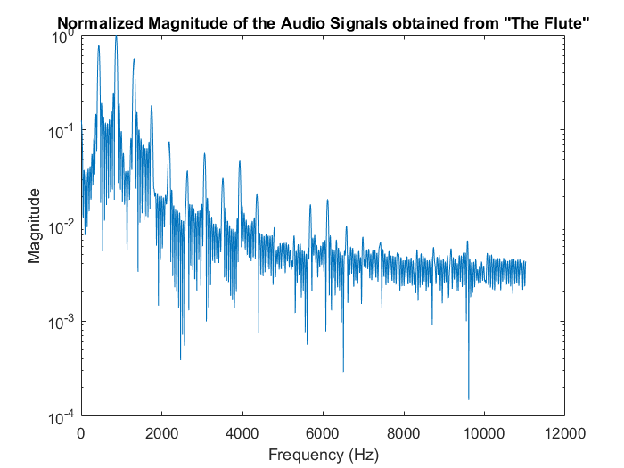
Figure 8. Normalized Magnitude of the Signals from “The Flute” Over Changing Frequency

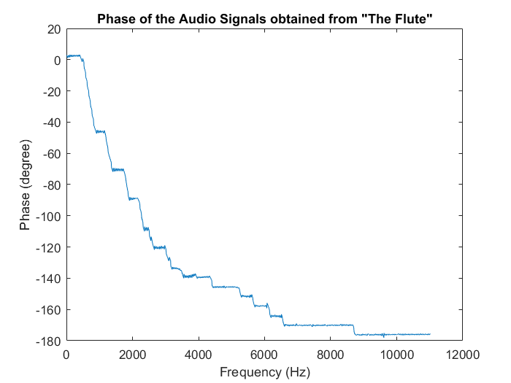
Figure 9. Phase Angle of the Signals from “The Flute” Over Changing Frequency

Conclusion
To conclude, in this very first part of the project we conducted a work to examine the “A_Note” for different instruments and for a human voices. During these parts we observed that, the sound signals are not formed of one frequency On the contrary, these signals consist many harmonic sound waves. These harmonics can be found by Fourier Transform or FFT. From these results, we saw that generally the first or the second harmonic is the dominant one and as frequency is increased magnitude of harmonics decreases.
Published with MATLAB® R2015b

