MedBroker
Technical Specification & Architecture
System architecture, data model, security design, and POPIA/FAIS compliance — the complete technical reference
Author: Mark du Toit, with Claude
Date: 20 August 2026
Version 2.0
INTERNAL — Technical Reference

Document Control
Field | Value
Version | 2.0
Status | Current — reflects the live application as at 20 August 2026
Author | Solution Architecture (Mark du Toit, with Claude)
Date | 20 August 2026
Distribution | Internal delivery team; suitable for a technically-authorised customer IT contact on request
Supersedes | v1.0 (9 August 2026). That version was built in a working session and never reached the GitHub repository or this project's document set — this version replaces it entirely rather than patching it, both because the source file was not recoverable and because ten days of substantial work (POPIA/FAIS compliance build, field-level encryption extension, security header hardening) made a patch insufficient regardless.
Companion documents | MedBroker-GlobalAdmin-Guide.docx (deployment configuration and provisioning); MedBroker-User-Guide.docx (end-user reference); MedBroker_Security_Code_Review_Findings.docx (security audit history); Status_Vercel.md (full build history); Project_Context_Vercel.md (architecture decisions and standing conventions — this document's primary source)
Methodology note | Every table name, column, and relationship in this document's diagrams was extracted programmatically from the live schema.postgres.sql (32 tables, 75 foreign-key relationships), not drawn from memory of the design intent. Diagram tooling note: the solution-architecture skill specifies Draw.io XML with UML stencils for component/deployment diagrams — no Draw.io renderer was available in the build environment, so Mermaid was used for all six diagrams instead, flowchart notation standing in for the missing UML tooling. Flagged here rather than silently substituted.

Table of Contents
1. Introduction
2. System Overview
3. Architecture Overview
4. Data Model
5. Security Architecture
6. POPIA & FAIS Compliance
7. Integration Architecture
8. Key Architecture Decisions
9. Deployment & Operations
Appendix A: Full Table List
Appendix B: Related Documents

1. Introduction
This document is the technical reference for MedBroker’s architecture: how the system is put together, how its major components interact, how data is modelled, and — new in this version — how POPIA and FAIS compliance requirements are actually implemented in code, not only stated as intent. It is written for a technical audience: a developer picking up this codebase for the first time, a customer’s technical contact evaluating the system, or Mark himself returning to a part of the system not touched in some time.
It is deliberately not a duplicate of Status_Vercel.md (the session-by-session build log) or the GlobalAdmin Guide (a task-oriented runbook for configuring and provisioning a deployment). This document answers "how does it work and why was it built this way," not "what happened when" or "how do I click through setup."

1.1 Scope
MedBroker is a FAIS/POPIA-conscious lead management and broker-matching SaaS platform for a South African medical insurance brokerage, built for approximately 50 users across five roles (GlobalAdmin, Admin, Supervisor, Agent, Broker). The active, in-scope codebase is the Vercel + Neon Postgres deployment under medbroker-v1/frontend/. A separate Azure Functions codebase exists in this repository (api/, infra/) and is frozen — out of scope for this document except where explicitly noted for historical context.

1.2 Audience
- A developer joining or returning to this codebase, who needs the data model and the "why" behind non-obvious decisions without re-deriving them from the code alone.
- A customer’s technical or compliance contact evaluating MedBroker before or during a deployment, particularly Section 6 (POPIA & FAIS Compliance).
- Mark, as the record of decisions made and the reasoning behind them, for a system he did not write every line of personally.

2. System Overview
MedBroker manages the lifecycle of a medical insurance lead from first contact through to a claimed, closed appointment: capture (manual entry, CSV import, event registration, or a public self-service portal), qualification and contact (Agents), booking (Appointments), broker matching via a token-based claim economy (Brokers spend tokens to claim appointments from a shared pool), and outcome tracking (ClosedWon/ClosedLost). Running alongside the pipeline is a compliance layer: an audit trail on every state-changing action, and — since this version’s predecessor was written — a full Subject Access Request workflow covering both the POPIA right of access and the right to request deletion.

2.1 Roles
Role | Scope
GlobalAdmin | Full access across the organisation, including system configuration, feature flags, and integration credentials.
Admin | Operational administration: users, leads, appointments, POPIA Subject Access Requests, data export, reporting.
Supervisor | Visibility and management scoped to themselves and their direct reports.
Agent | Own leads and call activity — capture, contact, and book appointments.
Broker | Claims appointments from the shared pool using tokens; own appointment and token history.

2.2 Core Workflow
- A Lead enters the pipeline (manual entry, CSV import, event registration, or the public portal) and is assigned to an Agent.
- The Agent makes contact (CallAttempt records) and books an Appointment when the Lead is ready.
- Unclaimed Appointments sit in a claim pool; Brokers spend tokens (TokenLedger/TokenTransaction) to claim one.
- The Broker records the meeting outcome (MeetingAttempt) and the Appointment closes ClosedWon or ClosedLost — the point at which, as Section 6 covers, a FAIS record-keeping obligation begins running on the underlying Lead.
- Throughout, every state-changing action writes to AuditLog, and a Lead can be the subject of a POPIA access or deletion request via the Subject Access Request workflow.

3. Architecture Overview

3.1 Technology Stack
Layer | Technology
Frontend | React (Vite build), role-gated client-side routing, five-theme design system (Linen/Terra/Midnight/Ember via CSS variables)
API | Vercel Functions (Node.js) — one router per domain (leads, appointments, users, reports, auth, notifications, flags), dispatching to api-lib/handlers/
Business logic | api-lib/services/ — one service module per domain, called from handlers, never called directly from routers
Database | Neon Postgres, accessed exclusively via @neondatabase/serverless’s neon() HTTP driver — not a persistent TCP pool, required by Vercel’s freeze/thaw execution model
Authentication | Local (bcrypt, 12 rounds) or Microsoft Entra ID SSO (loginPopup + server-side JWKS verification via jose); both issue the same httpOnly, SameSite=Strict session cookie
Encryption | AES-256-GCM envelope encryption (idNumber and, since this version, five medical/insurance fields), KMS- or DEMO_ENCRYPTION_KEY-wrapped depending on the security.kmsEncryption.enabled feature flag
Payments | Paystack, redirect-based hosted checkout (Stripe is integrated but inert for this deployment — Stripe does not support South Africa as a merchant country)
Deployment | Vercel Pro (stated production target — Hobby-plan constraints such as the 10-second function timeout do not apply), auto-deploying from GitHub main

3.2 Component & Deployment View
The diagram below shows the request path from browser to database and the external services the API layer talks to. See the Document Control methodology note regarding the diagram tooling used.
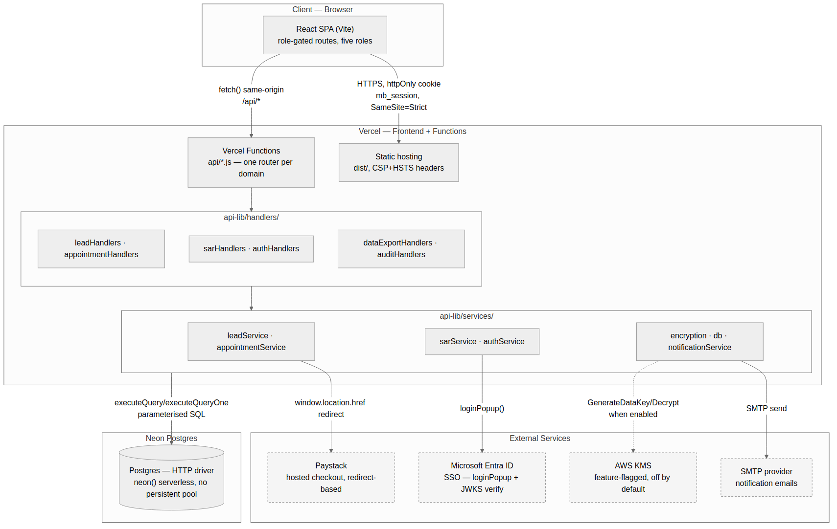
Figure 1 — System architecture and component view.

3.3 Multi-Tenancy
Every domain table carries an organisationId column, and resolveOrganisationId() is the single chokepoint every service function calls to scope its queries — there is no code path that queries across organisations. This is what makes the cosmetic-rebrand-vs-cross-vertical-productisation distinction discussed elsewhere in this project’s planning meaningful: the multi-tenant foundation already exists; what would need to change for a genuinely different vertical is the fixed shape of the Lead table’s own columns, not the tenancy model.

3.4 Request Authentication
Every authenticated request carries the mb_session httpOnly cookie (SameSite=Strict, set on login). The API layer validates the JWT, checks sessionsRevokedAt (so a password change or an Admin-forced sign-out invalidates existing sessions without needing a server-side session store), and every handler calls requireRole() with an explicit allow-list before touching data — there is no implicit "logged in is enough" path anywhere in api-lib/handlers/.

4. Data Model
32 tables, 75 foreign-key relationships, grouped below into four domains for readability. The full table list is in Appendix A. Every diagram in this section was generated from a fresh read of the live schema.postgres.sql, not approximated from documentation — see the Document Control methodology note.

4.1 Identity, Access & Configuration
Organisation is the tenancy root; every other table in this domain, and indirectly every table in the other three domains, traces back to it. Region/Portfolio/Product model the brokerage’s own structure (which regions and insurance products it covers); User carries role and authentication state; the Broker* junction tables model which regions and products a given Broker covers.
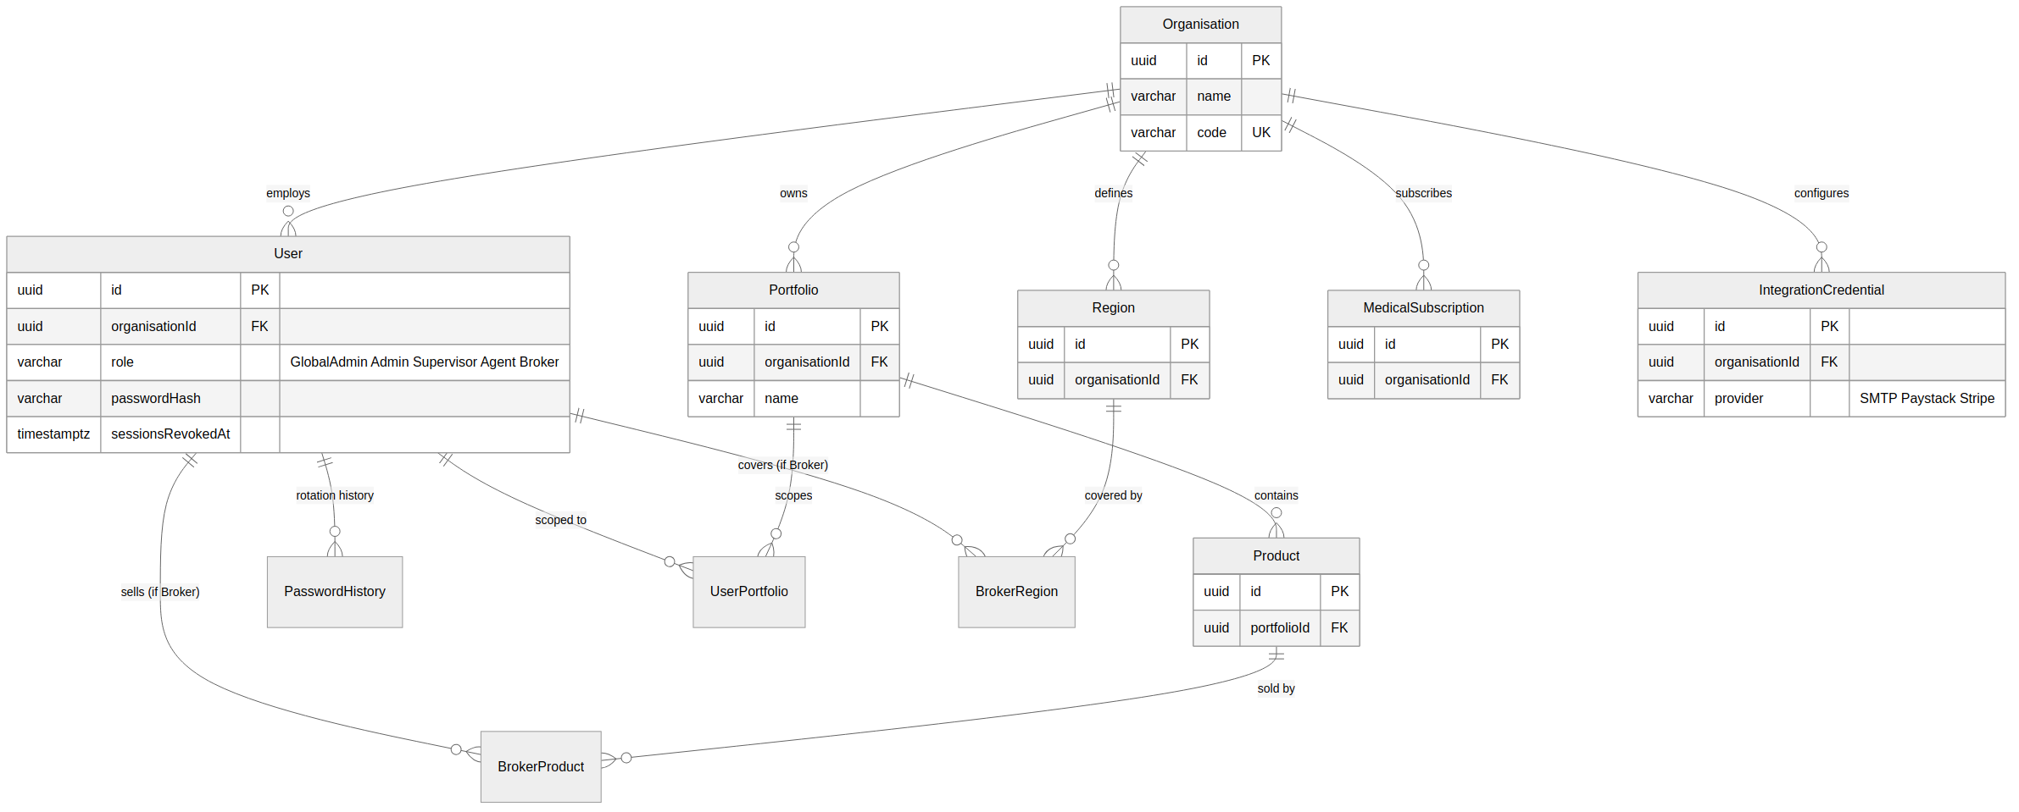
Figure 2 — Identity, Access & Configuration domain.

4.2 Lead Pipeline
Lead is the busiest table in the schema and the one this document’s Section 6 (POPIA & FAIS Compliance) concerns itself with most. Note the four columns called out on the diagram below: deletedAt is the general-purpose "hidden from active views" mechanism every soft-delete in this schema uses; erasedAt/restrictedAt/retentionExpiresAt are new since v1.0 of this document, added specifically to implement the POPIA erasure and FAIS restrict-and-retain paths covered in full in Section 6.
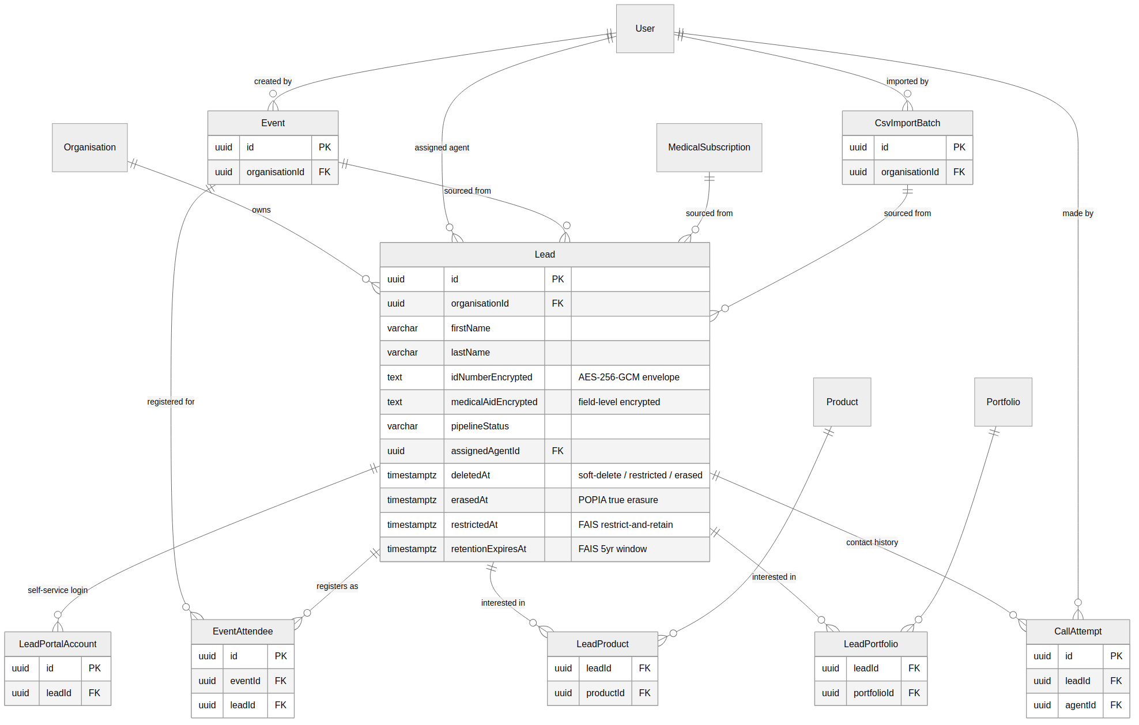
Figure 3 — Lead Pipeline domain.

4.3 Appointments & Token Economy
An Appointment converts from a Lead and is either worked directly by an Agent or picked up from the shared claim pool by a Broker spending tokens. status is the field most of the application’s business logic keys off — note that ReturnedToLeads is deliberately excluded from every "Lost" calculation in reporting and, since this version, from the FAIS retention-trigger logic in Section 6: an appointment returned to the pool without a real outcome never rendered a financial service.
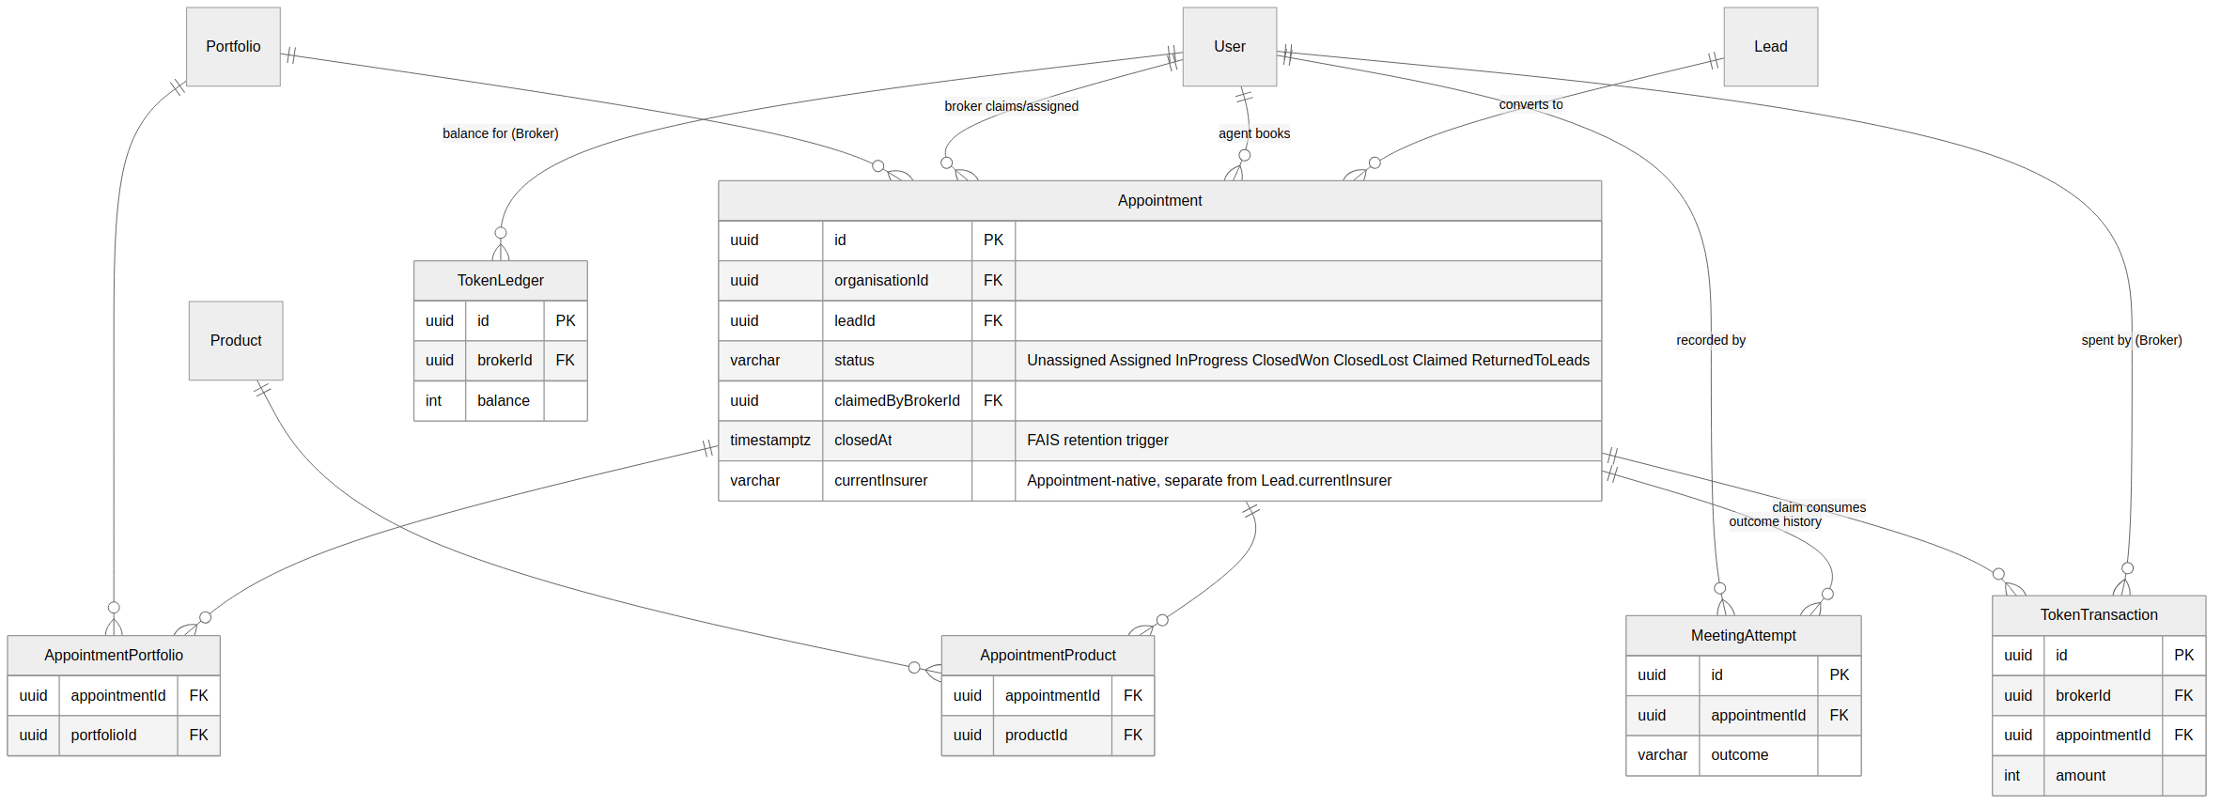
Figure 4 — Appointments & Token Economy domain.

4.4 Compliance & Workflow
SubjectAccessRequest models both POPIA rights this system implements — requestType distinguishes Access (s23, "what do you hold on me") from Deletion (s24(1)(b), "delete it") — covered in full in Section 6. AuditLog and Task/Notification are both polymorphic (entityType + entityId, no foreign-key constraint on entityId since it can point at a Lead, Appointment, User, or SubjectAccessRequest depending on entityType) — this is a deliberate trade-off: referential integrity at the database level is given up in exchange for one shared audit/task mechanism instead of one per entity type.
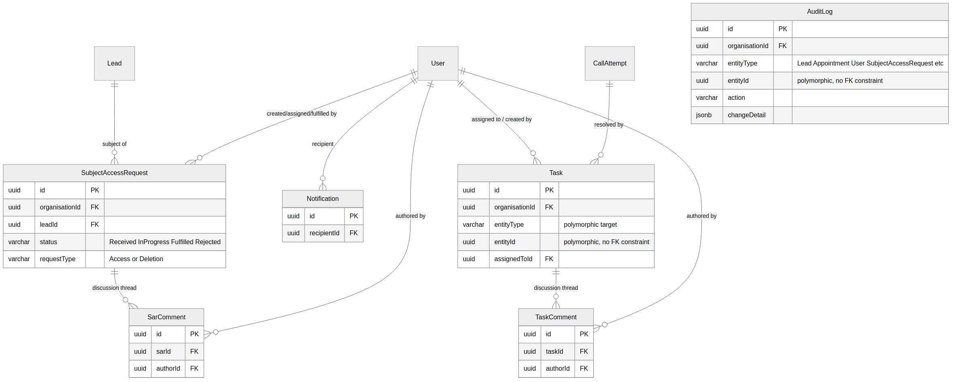
Figure 5 — Compliance & Workflow domain.

5. Security Architecture
This section summarises the controls verified in the most recent full security sweep (MedBroker_Security_Code_Review_Findings.docx, v2.1, 20 August 2026) — that document is the authoritative, continuously-updated record; this section is a snapshot for readers of this specification who don’t need the full finding-by-finding detail.

5.1 Authentication & Session Management
- Local passwords: bcrypt, 12 rounds.
- Session: HMAC-signed JWT, 8-hour expiry, carried in an httpOnly, SameSite=Strict cookie (mb_session) — never accessible to client-side JavaScript, and never sent on a cross-site request.
- Microsoft Entra ID SSO: a genuine popup window (loginPopup()), not an iframe; server-side JWKS verification via jose. After initial SSO login, the app issues its own session cookie — SSO is not re-checked on every request.
- Session revocation: sessionsRevokedAt checked per request. A password change or an Admin-forced "sign out everywhere" invalidates every existing session immediately, without a server-side session store to maintain.

5.2 Authorisation
- Every handler in api-lib/handlers/ calls requireRole() with an explicit allow-list before touching data.
- Object-level authorisation (IDOR protection) is enforced server-side, not just hidden in the UI: Agents/Brokers see only their own records; Supervisors see themselves and direct reports; Admin/GlobalAdmin are unrestricted.

5.3 Encryption
- Field-level: idNumber (since the system was built) and, since 20 August 2026, five medical/insurance fields (medicalAid, medicalAidProvider, existingCover, currentInsurer, policies) — AES-256-GCM envelope encryption, a random per-value data key, wrapped by either AWS KMS or an environment-variable DEMO key depending on the security.kmsEncryption.enabled feature flag (off by default; a client production deployment must enable it and configure AWS before go-live).
- Platform-level: Neon provides disk-level encryption at rest by default, covering physical-storage theft — a materially different threat than the field-level encryption above, which protects against a compromised database credential or a SQL injection foothold reading the table directly.
- Transport: HTTPS everywhere (Vercel auto-provisions TLS); the Neon connection itself goes over HTTPS via the neon() HTTP driver, with certificate validation on by default and no override present.

5.4 Browser Security Headers
Configured in vercel.json as of 20 August 2026: Content-Security-Policy, Strict-Transport-Security, X-Content-Type-Options, X-Frame-Options, Referrer-Policy, and Permissions-Policy, applied to every route. The CSP was built against the actual production build output and every external-navigation path in the codebase (Paystack’s redirect-based checkout, Entra’s popup-based SSO) rather than a generic template — full reasoning in Project_Context_Vercel.md §12.

5.5 Audit Trail
writeAuditLog() is called from every state-changing route across Leads, Appointments, Users, Tasks, and Subject Access Requests — an enforced convention, not an opt-in. A Lead’s own change log surfaces both Lead-scoped entries and SAR-scoped entries that reference it (a UNION query, not a duplicate write), so a POPIA deletion action shows up in the same place as every other change to that record.

5.6 Known Open Items
Not live exposure today — go-live gates, consistent with how these are tracked in Project_Context_Vercel.md §12/§12a:
- AWS KMS encryption not yet enabled for a production deployment (currently DEMO_ENCRYPTION_KEY, an unrotated environment variable).
- Rate limiting deferred to Vercel Pro’s WAF Custom Rules by design — not yet configured against a real production Vercel account.
- No CI, dependency scanning, or SAST/DAST configured — dependency vulnerabilities (e.g. the react-router and xlsx CVEs closed earlier this build) have been caught via manual npm audit review.
- Operator agreements (Vercel, Neon, Paystack, SMTP provider), a formal breach-notification process, and Information Officer registration with the Information Regulator are all still outstanding — see Section 6.4.

6. POPIA & FAIS Compliance
New in this version of the document, at Mark’s explicit request. This section covers how MedBroker implements the Protection of Personal Information Act (POPIA) and the Financial Advisory and Intermediary Services Act (FAIS) in code — not as a policy statement, but as a description of the actual mechanisms, cross-referenced to the specific functions and files that implement them. Where a gap remains, it is stated plainly rather than glossed over; where a control has genuinely closed, its closure is dated and cross-referenced to how it was verified.
This section describes the current build’s technical implementation. It is not a legal opinion, and does not substitute for sign-off from compliance counsel before real client personal information flows through a production deployment.

6.1 Regulatory Context
MedBroker sits at the intersection of two South African regulatory regimes:
- POPIA (Protection of Personal Information Act) governs how any personal information is processed — lawfulness, purpose limitation, data subject rights (access, correction, deletion/restriction), retention, and security safeguards.
- FAIS (Financial Advisory and Intermediary Services Act) governs the brokerage’s conduct as a financial services provider, including a General Code of Conduct record-keeping obligation: client records relating to advice and transactions must be kept for a minimum of five years from the termination of the financial service.
These two regimes are frequently in tension in exactly the way this system has to resolve programmatically: a data subject’s POPIA right to request deletion runs up against FAIS’s legal requirement to retain certain records. Section 6.3 below covers how MedBroker resolves this — POPIA itself provides the mechanism (s14(6), restriction of processing in place of destruction, where retention is otherwise required by law).

6.2 Lawful Processing & Consent
- Portal self-service registration and manual/CSV-imported leads both capture the lawful basis for processing at the point of entry.
- Special personal information (POPIA s26 — health-related data, which MedBroker’s medical aid and existing-cover fields fall closest to) is processed under the insurance-related exclusion typically available for this kind of brokerage activity — a determination for compliance counsel to confirm in writing before go-live, not one this document makes on the business’s behalf.

6.3 Data Subject Rights

6.3.1 Right of Access (POPIA s23–s25)
Implemented via the Subject Access Request (SAR) workflow (SubjectAccessRequest table; sarService.js; the "Data Requests" tab in the Admin area). An Access-type request tracks through Received → InProgress → Fulfilled/Rejected (locked once terminal), can be assigned to a specific Admin/GlobalAdmin, carries a comment thread for internal discussion, and compileSubjectData() produces a genuine full export of everything MedBroker holds on the Lead: profile (including the decrypted ID number and medical/insurance fields), call attempts, appointments and meeting history, tasks, and the Lead’s own audit trail.

6.3.2 Right to Erasure / Restriction (POPIA s14, s24(1)(b))
Built 20 August 2026, in direct response to a gap identified in this document’s own compliance review: the general-purpose deleteLead() function (used for routine data cleanup, e.g. removing a duplicate lead) was soft-delete only — it hid a record from active views but left every column, including the encrypted ID number, fully intact. That function’s own code comment called this "POPIA right to erasure," which was true in label only; POPIA s14(5) requires destruction "in a manner that prevents its reconstruction in an intelligible form," and a soft-delete flag is the opposite of that by design.
A dedicated deletion path now exists, distinct from the general-purpose soft-delete, and it makes exactly the erase-vs-restrict decision FAIS and POPIA require of each other:
- requestType on SubjectAccessRequest distinguishes Access from Deletion — a Deletion request is fulfilled via executeSarDeletion() (sarService.js), not the ordinary status-update path.
- getLeadRetentionPosition() (leadService.js) checks whether the Lead has at least one Appointment that reached a genuine outcome (ClosedWon or ClosedLost) — ReturnedToLeads is deliberately excluded, since an appointment returned to the pool without a real meeting outcome never constituted a financial service being rendered, consistent with the standing reporting rule that ReturnedToLeads is never counted as Lost.
- If no such Appointment exists: eraseLeadPII() runs. Every PII/special-personal-information column is anonymised in place (name replaced with a placeholder, ID number and medical/insurance data nulled, email replaced with a synthetic non-reversible value) — de-identification is an explicitly valid alternative to physical deletion under POPIA s14(4), and was chosen over a hard/cascading DELETE specifically to preserve referential integrity (CallAttempt, Appointment, Task, and AuditLog rows that reference the Lead) and historical reporting counts, which a cascading delete would silently corrupt.
- If such an Appointment exists: restrictLead() runs instead. The record is excluded from every active view (the same deletedAt mechanism every other soft-delete in this schema already uses — no additional query changes were needed to make restriction actually stop active processing), but no PII is touched. retentionExpiresAt is set to five years from the most recent qualifying Appointment’s closedAt — the FAIS floor. A partial database index (IX_Lead_RetentionExpiry) exists specifically to support a future scheduled job that will erase these records once that window lapses; that job is not yet built — see Section 6.7.
The distinction matters and is deliberate: a soft-delete flag and a genuine erasure are not the same operation, even though both make a record disappear from the same screens.

6.4 Security Safeguards (POPIA s19)
Covered in full in Section 5. In brief: authentication and authorisation controls are enforced server-side (not only hidden in the UI), the ID number and five medical/insurance fields are field-level encrypted independent of the platform’s disk-level encryption, and every state-changing action is written to an audit trail. The gap this section exists to be honest about: dateOfBirth and contact fields (email, mobile, WhatsApp number) remain application-layer plaintext, relying on Neon’s platform-level encryption alone — a deliberate scope decision (these fields carry genuine search/matching value and lower risk in isolation than health/insurance data), not an oversight, and one Mark made explicitly rather than the system drifting into it by default.

6.5 Special Personal Information (POPIA s26)
The fields closest to POPIA’s definition of special personal information (health) are medicalAid, medicalAidProvider, existingCover, currentInsurer, and policies. All five are field-level encrypted as of 20 August 2026 (migration 036) — the same envelope-encryption scheme the ID number already used. A pre-existing, unrelated bug was found and fixed in the same piece of work: Lead.currentInsurer had a working input field on the Lead detail page that had silently never saved, on any Lead, since that page was built, because the field was missing from the request-validation schema.

6.6 Data Retention
No single retention period applies uniformly — this is itself one of the two regimes’ tension points. FAIS sets a five-year floor for records of transactions and advice rendered; POPIA’s default is "no longer than necessary for the purpose it was collected for," with no fixed period. Section 6.3.2’s erase-vs-restrict logic implements a working approximation of this today (has a financial service actually been rendered, yes or no), but a fully formalised, per-record-type retention schedule — covering every entity, not only Lead — remains an open item; see Section 6.7.

6.7 Compliance Status Summary
Item | Status | Detail
SAR — right of access | Built | Full compileSubjectData() export, s23–s25.
SAR — right to erasure/restriction | Built | True-erasure and restrict-and-retain paths, s14/s24(1)(b). 20 Aug 2026.
Field-level encryption — idNumber | Built | AES-256-GCM envelope, since system inception.
Field-level encryption — medical/insurance fields | Built | 5 fields, migration 036, 20 Aug 2026.
Browser security headers | Built | CSP/HSTS/etc., 20 Aug 2026.
Scheduled purge (restricted → erased once FAIS window lapses) | Open | Manual today; index exists to support the future job.
Formal per-record-type retention schedule | Open | Beyond the Lead-level erase-vs-restrict rule.
AWS KMS encryption enabled for production | Open | Off by default; DEMO key protects idNumber/medical fields until enabled.
Cross-border transfer assessment | Open | Neon’s actual provisioning region not yet confirmed.
Operator agreements (Vercel/Neon/Paystack/SMTP) | Open
Breach-notification process; Information Officer registration | Open
Legal sign-off on s26 processing basis | Open | Compliance counsel determination, not a technical build item.

6.8 Full Backlog
The complete, current backlog for the items marked Open above is maintained in Project_Context_Vercel.md §12a and Status_Vercel.md’s Outstanding Items list, not duplicated verbatim here to avoid two copies drifting out of sync — this section is the compliance narrative; those files are the working tracker.

7. Integration Architecture

7.1 Microsoft Entra ID (SSO)
A popup-based login flow (loginPopup(), @azure/msal-browser) with server-side JWKS verification (jose, entraAuthService.js). After the initial SSO handshake, MedBroker issues its own session cookie — Entra is not re-checked on every subsequent request, and there is no silent-iframe token refresh anywhere in this codebase (confirmed by direct search when the browser security headers were built, since a hidden iframe would have had implications for the Content-Security-Policy).

7.2 Paystack (Payments)
Hosted checkout, redirect-based: the browser performs a genuine top-level page navigation (window.location.href) to Paystack’s hosted page, not an embedded iframe or a form POST. The sequence below shows a Broker’s token top-up, triggered when they attempt to claim an Appointment without a sufficient token balance.
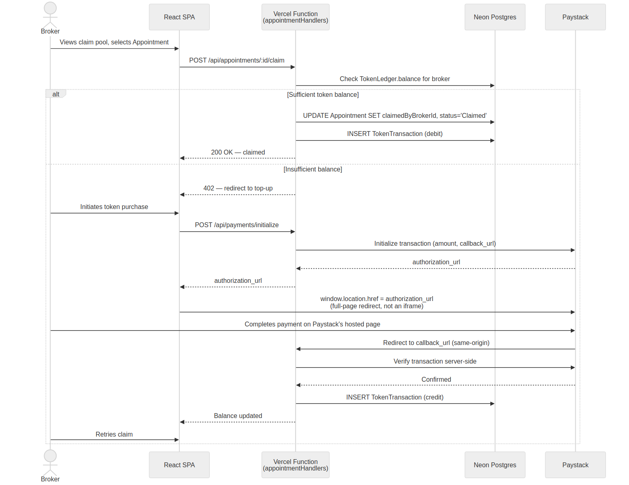
Figure 6 — Appointment claim and token top-up sequence.

7.3 Stripe
Integrated in the codebase but inert for this deployment: Stripe does not support South Africa as a merchant country. Retained for a future deployment in a market where it is supported, not currently reachable from any live user flow.

7.4 SMTP (Notifications)
Outbound notification emails (task assignments, POPIA request updates, appointment reminders) via a configured SMTP provider, credentials stored in IntegrationCredential, DB-backed configuration on the Integrations page (GlobalAdmin only).

7.5 AWS KMS
Feature-flagged (security.kmsEncryption.enabled, off by default). When enabled, encryption.js’s envelope-encryption calls (idNumber and the five medical/insurance fields) use KMS GenerateDataKey/Decrypt instead of the DEMO_ENCRYPTION_KEY environment variable. A client production deployment should enable this and configure AWS before real client personal information flows through the system — see Section 6.7.

8. Key Architecture Decisions
Selected decisions with real trade-offs, in the order they matter for a new reader — not exhaustive; the complete, continuously-updated record is Project_Context_Vercel.md.

ADR-1: Neon’s HTTP driver over a persistent connection pool
Decision: use @neondatabase/serverless’s neon() function exclusively, never pg.Pool. Rationale: Vercel Functions freeze and thaw between invocations; a persistent TCP connection pool doesn’t survive that model reliably, while an HTTP-based driver has no connection state to lose. Trade-off: every query is a fresh HTTP round-trip rather than a pooled connection — accepted, since it also happens to be what makes this codebase’s architecture-review scripts unable to talk to a local Postgres instance for live testing, a real, documented constraint (Status_Vercel.md, multiple sessions) rather than a hidden one.

ADR-2: Anonymise-in-place over hard delete for POPIA erasure
Decision: eraseLeadPII() nulls/replaces PII columns and keeps the row, rather than a cascading DELETE. Rationale: POPIA s14(4) explicitly treats de-identification as equivalent to physical destruction; a cascading delete across CallAttempt/Appointment/Task/AuditLog would corrupt historical reporting counts and orphan audit trail entries that exist specifically to prove compliance actions happened. Trade-off: the database retains rows that no longer represent a real person — mitigated by the same deletedAt exclusion mechanism already used throughout the schema, so an erased Lead is invisible everywhere an active Lead would be visible.

ADR-3: Mermaid over the skill-specified Draw.io for the component diagram
Decision, this document: use Mermaid flowchart notation for the system architecture diagram in Section 3.2, despite the solution-architecture skill specifying Draw.io XML with UML stencils for component/deployment views. Rationale: no Draw.io renderer was available in the build environment for this document, and a raw, unrendered XML file is a worse deliverable than a rendered, if not perfectly notation-compliant, diagram. Flagged explicitly in the Document Control section rather than silently substituted — a genuine tooling gap to close for a future revision, not a preference.

ADR-4: Field-level encryption scoped by data sensitivity, not applied uniformly
Decision: idNumber and five medical/insurance fields are field-level encrypted; dateOfBirth and contact fields are not. Rationale: the encrypted fields are the ones closest to POPIA s26 special personal information and to FAIS advice-record sensitivity; dateOfBirth/contact fields carry genuine operational value in plaintext (search, matching, contact) and lower risk in isolation. Trade-off: not every PII field gets the strongest available protection — a deliberate, documented scope decision rather than a default drifted into.

9. Deployment & Operations

9.1 Environments
A single Vercel project auto-deploys from GitHub main. Feature flags (SystemConfig-backed, managed via the FeatureFlags admin page) gate functionality independent of code deployment — a flag can be toggled without a new deploy.

9.2 Delivery Workflow
Mark applies deliveries via github.dev’s drag-and-drop upload (no CLI on his work machine); Vercel auto-deploys on push to main. Database migrations are applied manually against Neon; once run, migration files are removed from the repository (schema.postgres.sql remains the single canonical current-state reference).

9.3 Observability
Vercel’s own function logs and the application-level AuditLog table are the current observability surface. No dedicated APM or structured logging pipeline is configured — an open item for a production-scale deployment, not currently blocking the pre-launch stage this project is at.

Appendix A: Full Table List
All 32 tables, grouped by the same domains as Section 4’s ERDs, for quick lookup.
Domain | Tables
Identity, Access & Configuration | SystemConfig, Organisation, Region, Portfolio, Product, MedicalSubscription, User, PasswordHistory, UserPortfolio, BrokerRegion, BrokerProduct, IntegrationCredential
Lead Pipeline | Event, CsvImportBatch, Lead, LeadPortfolio, LeadProduct, CallAttempt, LeadPortalAccount, EventAttendee
Appointments & Token Economy | Appointment, AppointmentPortfolio, AppointmentProduct, MeetingAttempt, TokenLedger, TokenTransaction
Compliance & Workflow | SubjectAccessRequest, SarComment, AuditLog, Notification, Task, TaskComment

Appendix B: Related Documents
- MedBroker_Security_Code_Review_Findings.docx — the full, continuously-updated security audit history and finding-by-finding detail behind Section 5.
- MedBroker-GlobalAdmin-Guide.docx — deployment configuration and new-instance provisioning.
- MedBroker-User-Guide.docx — end-user reference for all five roles.
- Project_Context_Vercel.md — architecture decisions and standing conventions; this document’s primary source and the place to look for anything not covered here in full.
- Status_Vercel.md — the complete, session-by-session build history this document distils.

