Ra=1; % armaature resistance [Ohms]  
Kt=.5; % motor torque constant [Nm/A]  
Ke=.5; % back emf constant [Vs/rad]  
J=.05; % Load inertia [Nm^2]  
b=.5; % damping [Nm/s]  
K = (6.1);  
sig = 6.667;  
open_system('motorsim4')  
out=sim('motorsim4');

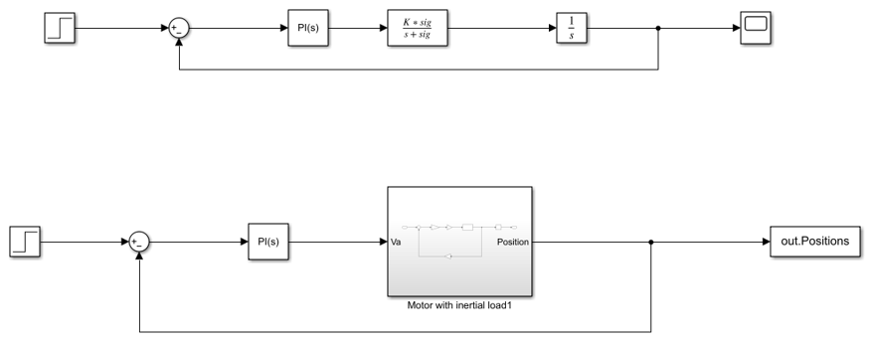

figure  
plot(out.Positions)  
title('Positions');

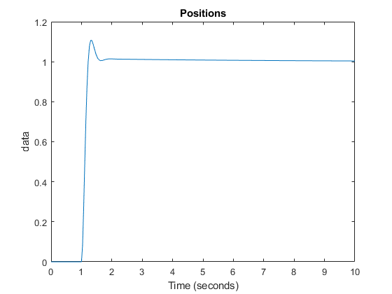

[*Published with MATLAB® R2022a*](https://www.mathworks.com/products/matlab)