4330 Data Wangling Part 1:

UPDATE USUStudent_Class
SET Grade = UPPER(Grade);
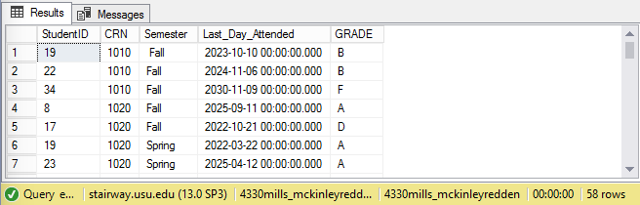

ALTER TABLE SocialMediaMetrics
DROP COLUMN Shares;
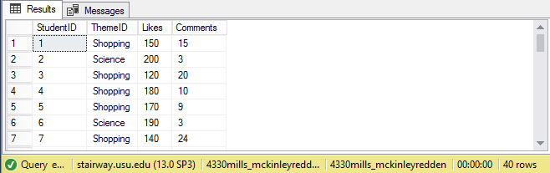

UPDATE USUStudent_Class
SET Semester = LTRIM(Semester);
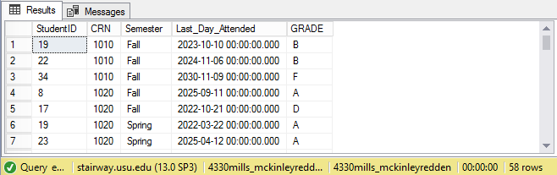

UPDATE USUStudent
SET Major = 'DAIS'
WHERE Major = 'MIS';
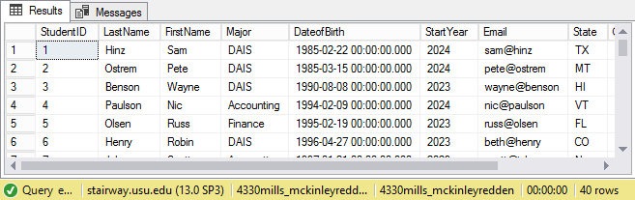

ALTER TABLE USUStudent_Class
ADD LastDayAttended DATE;
UPDATE USUStudent_Class
SET LastDayAttended = Last_Day_Attended;
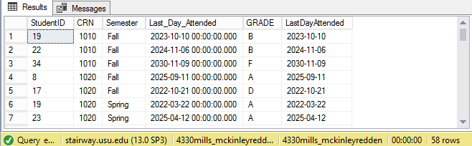

ALTER TABLE USUStudent_Class
DROP COLUMN Last_Day_Attended;
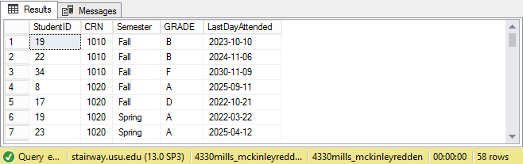

ALTER TABLE USUStudent
ADD Fav INT;
UPDATE USUStudent
SET Fav =
CASE FavIceCream
WHEN 'Birthday Cake' THEN 1
WHEN 'Blue Mint' THEN 2
WHEN 'Bull Tracks' THEN 3
END
FROM USUStudent;
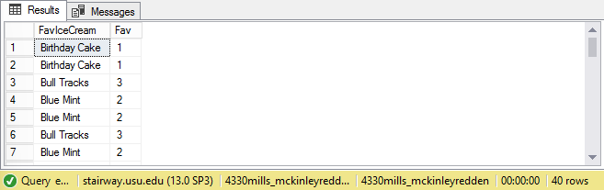

ALTER TABLE USUStudent_Class
ADD Ngrade INT;
UPDATE USUStudent_Class
SET Ngrade =
CASE Grade
WHEN 'A' THEN 4
WHEN 'B' THEN 3
WHEN 'C' THEN 2
WHEN 'D' THEN 1
WHEN 'F' THEN 0
END
FROM USUStudent_Class;
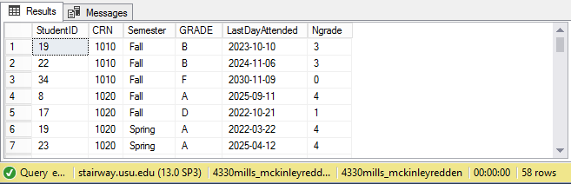

UPDATE SocialMediaMetrics
SET Comments = 0
WHERE Comments IS NULL;
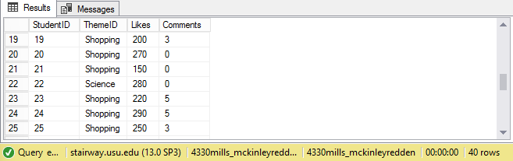

ALTER TABLE USUSTUDENT_CLASS
ADD GPA FLOAT;
WITH GPA AS (
SELECT StudentID, SUM(Ngrade) / COUNT(Ngrade) AS AvgGrade
FROM USUSTUDENT_CLASS
GROUP BY StudentID
)
UPDATE USUSTUDENT_CLASS
SET GPA = GPA.AvgGrade
FROM GPA
WHERE USUSTUDENT_CLASS.StudentID = GPA.StudentID;
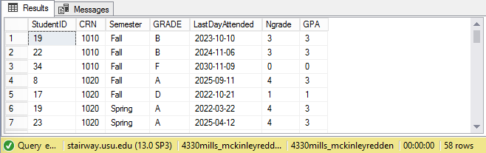

SELECT COUNT(*) AS DuplicateCount, StudentID, LastName, FirstName, Email
FROM USUSTUDENT
GROUP BY Email, StudentID, LastName, FirstName
HAVING COUNT(*) > 1;
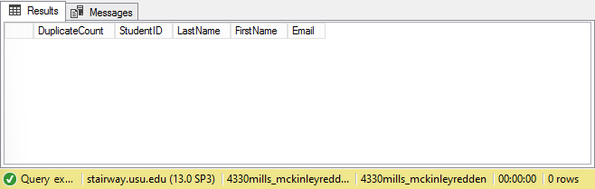

SELECT *
FROM SocialMediaMetrics
WHERE LIKES > (SELECT TOP 1 PERCENTILE_CONT(0.95) WITHIN GROUP
(ORDER BY Likes)
OVER() as percentile_value FROM SocialMediaMetrics);
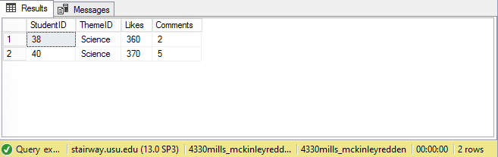

Initial Data Analysis:

SELECT
ThemeID,
REPLICATE('*', SUM(Comments)) AS Histogram
FROM
SocialMediaMetrics
GROUP BY
ThemeID;
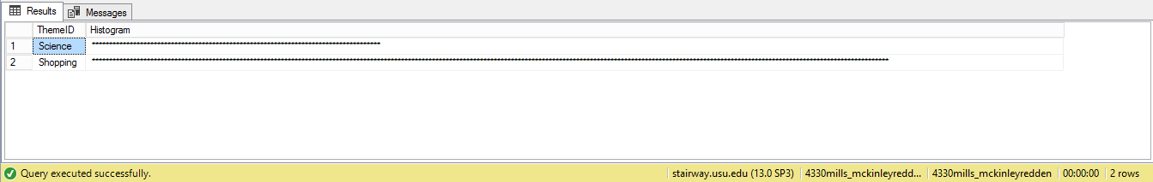

SELECT Fav,
REPLICATE('*', SUM(Fav)) AS Histogram
FROM USUStudent
WHERE Fav IS NOT NULL
GROUP BY Fav;
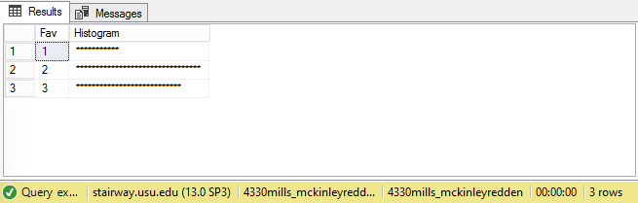

SELECT StudentID, GPA,
DENSE_RANK() OVER(ORDER BY GPA DESC) as 'DenseRank'
FROM USUSTUDENT_CLASS;
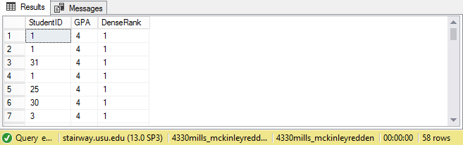

SELECT s.studentID, GPA, Fav,
DENSE_RANK() OVER(PARTITION BY sc.Fav ORDER BY GPA DESC) as
'DenseRank'
FROM USUstudent_Class as s join USUstudent as sc
on s.studentID = sc.studentID
WHERE Fav IS NOT NULL;
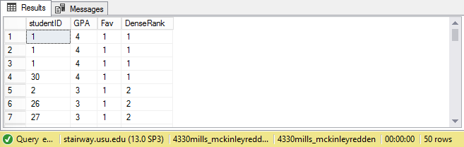
- I decided to drop the time off of the date of birth column similar to questions 5 and 6 above.
ALTER TABLE USUStudent
ADD Date_Of_Birth DATE;

UPDATE USUStudent
SET Date_Of_Birth = DateOfBirth;

ALTER TABLE USUStudent
DROP COLUMN DateofBirth;
