The Information Placebo:

How Fake Wellness Dashboard Feedback Influences Self-Reported Well-Being
Authors: Mitch Brammer, Laney Rasband, McKinley Redden, Maleah Yee
Information Systems Management
Brigham Young University

ABSTRACT

Aim

This study investigates how fake health data from wearable wellness trackers influences users’ self-reported well-being. As these devices become more common, their metrics are often treated as objective indicators of health, despite known measurement limitations.

Method

To isolate the psychological effect of displayed data, we used a placebo-controlled design. Participants, consisting of college-aged students at a large private university in the US, wore a non-functional “placebo ring” for two weeks and were presented with a fabricated health dashboard that mimicked real tracking interfaces.
Results
The results showed no statistically significant relationship between the fabricated health data and participants’ reported well-being. This can suggest that perceived well-being may be less susceptible to manipulation by wellness feedback than previously assumed. However, the study is limited by its sample and design. College students may be more focused on external stressors such as academic performance and job search pressures, which could reduce the influence of biometric feedback. Interestingly, participants who rated the placebo system as more credible also reported lower overall wellness.
Conclusion
Despite the lack of significant effects, the study highlights important ethical considerations. The participants with lower wellness having more trust in the placebo may suggest that individuals experiencing poorer well-being were more likely to perceive the system as believable or potentially helpful. This pattern may reflect greater health concern or increased openness to external feedback. Wellness technology companies should be more transparent about the accuracy and error margins of their metrics, as even small perceived influences could impact user trust and decision-making in broader populations.

INTRODUCTION
Wearable wellness tech has taken off in the last decade [1]. Fitness trackers, smartwatches, and even smart rings are everywhere, giving people updates on their sleep, heart rate, stress, and daily activity. This uptick is part of a bigger trend. People want numbers, charts, and scores to tell them how they are doing, and they are starting to trust those numbers to guide their choices about when to rest, work out, or slow down [2].
But as people start to lean on these metrics more, the devices’ potential impact on psychology increases. Health apps reduce complicated body signals into simple tags and numbers: “good,” “poor,” “high stress.” Those labels can potentially impact stress and personal well-being [3][4]. Imagine feeling great in the morning but seeing “poor sleep” on your wearable’s wellness dashboard. It’s easy to start second-guessing how you feel.
Even though wearables are everywhere, hardly anyone has studied how this constant feedback affects user perceptions, separate from what’s actually happening in the body. Most research looks at whether the devices are accurate [5][6], how they might change behavior [6][7], or if they lead to better health [8].
Not many are asking whether the information displayed can affect how the user feels. By using a placebo device and dashboard, our study examines how feedback alone shapes someone’s sense of well-being, separate from any real data about their body. Although this study is exploratory, we do suppose one overarching hypothesis:

wellness feedback has a positive association with self-reported well-being.

LITERATURE REVIEW

Wearable devices have become a regular part of how people track health today. Our health data is no longer limited to a scheduled doctor's appointment; we are getting constant feedback about our health.

The studies reviewed below show that wearable devices affect users in at least three key ways. First, they support continuous monitoring, giving a fuller, more nuanced picture over time. Second, they shape how people manage their own health, how they perceive it, and how they practice self-care. And third, wearables raise questions about accuracy, interpretation, and ethical use. The articles cover a broad scope in focus, some focus on practical feasibility and clinical monitoring, while others take a broader look at psychological outcomes and the implications for everyday living.
Feasibility: Wearables as tools for continuous monitoring of mood, cognition, and sleep
A major theme across the literature is that wearables make it possible to monitor mental and behavioral health continuously in real-world settings. Wearables are part of a broader medical transition toward out-of-clinic, longitudinal monitoring, with applications in sleep and mental health alongside other domains of medicine (Dunn et al. 2018). Their review frames wearable technology as infrastructure for ongoing health observation.

Cormack et al. (2019) provide direct evidence for this monitoring function in a mental health context. In their longitudinal observational study, 30 adults with mild-to-moderate major depressive disorder used an Apple Watch app for six weeks to complete repeated mood and cognitive assessments. The study found excellent adherence for mood and cognitive assessments, and the daily wearable-based measures showed moderate correspondence with validated depression questionnaires and cognitive tests. These findings support the feasibility and accuracy of using wearables for repeated, high-frequency assessment of mental status over an extended timeframe.
Continuous monitoring matters because mental health is not static. Depression, anxiety, burnout, stress, and sleep disruption change across days and contexts. A one-time appointment can miss those fluctuations. Cormack specifically notes that mobile technologies allow sampling in home and work environments, and that high-frequency assessment helps capture the course of illness and treatment response more accurately than retrospective recall alone. The paper also points out that recall can be distorted, especially in depression, where memory is shaped by negative bias.
Czeisler et al. (2022) extend this monitoring role to sleep-related mental health outcomes. Using longitudinal WHOOP data from 4,912 adult users in the United States, they found changes in sleep duration, sleep consistency, and sleep timing during the early COVID-19 period. Another finding was that persistently short sleep and inconsistent sleep timing were associated with higher odds of anxiety or depression symptoms, burnout, and substance use. This study shows that wearable-derived sleep data can reveal behavioral patterns linked to mental health outcomes.
Effects: Positive psychological effects may come indirectly through self-care, health perception, and behavior
A second theme from the literature is that wearables may affect mental health indirectly rather than through simple exposure to data alone. Choudhury and Asan (2021) explicitly argue that the psychological effect of wearables is mediated by factors such as workout duration, body mass index, self-care, and health perception. Using HINTS 2019 and 2020 data, they found significant negative indirect effects of wearable use on psychological distress, with self-care and health perception serving as especially important mediators in the parallel mediation models. Their sequential model further suggests that wearables may influence workout duration, BMI, self-care, and health perception in a chain that ultimately relates to lower psychological distress.
This emphasis on indirect influence is consistent with a broader synthesis presented by Alipio et al. (2022). In their integrative review of 10 studies, the authors conclude that wearable devices support clinicians in detection and treatment-related work through improved real-time cognitive assessment. This in turn, promotes mental wellness and quality of life. While this review is not original research, it supports the idea that wearable technologies could help with mental health by improving how we monitor health, increase user involvement, and make healthcare more efficient.
Together, these papers suggest that wearables may matter psychologically because they record the body, and they shape how users understand and manage their health. This is important for studies of perceived well-being because it implies that interpretation of feedback may be central to any effect.
Warnings: Accuracy, misinterpretation, and ethical concerns
A third recurring theme is caution. Wearable data is not automatically beneficial. Choudhury and Asan (2021) note that self-tracking can produce opposing consequences. It can improve self-care when users receive meaningful information, but it can also create anxiety when data are misinterpreted or flawed. It is also of note that wearables may induce obsessive tendencies, rumination, and self-worth tied to numbers, particularly when users fail to meet predefined targets.
Similar concerns are raised by Dunn et al. (2018). Their review warns that companies often make unsubstantiated claims about testing accuracy and indications for use. They argue that stronger regulation is needed to prevent harm from overdiagnosis or inappropriate intervention. Usability, interpretation, privacy, compatibility, and the lack of standards for data collection and analytics are also challenges that the industry needs to tackle (Dunn et al., 2018).
Cormack et al. (2019) add a more specific methodological caution. While their study supports the feasibility of wearable-based mood and cognition assessment, they also report concerns about the reliability of some sensor data, especially heart rate data from the Apple Watch, and state that caution is required when such equipment is used in scientific research.
Alipio et al. (2022) also emphasize some unresolved issues with privacy, data storage, user acceptance, and ethics. Their review concludes that further research is needed to improve the usability and practical mental health application of these devices.
Research Gap
Although the articles show that wearables can monitor mental health-relevant variables and may be associated with improved self-care, health perception, or lower distress, an important gap remains. Most of the evidence does not isolate the effect of displayed health feedback itself. Choudhury and Asan (2021) rely on cross-sectional survey data, which supports overarching patterns but does not experimentally test whether the presentation of wearable data causes changes in perceived well-being.
Similarly, Czeisler et al. (2022) show associations between wearable-derived sleep patterns and mental health outcomes, but their study examines naturally occurring sleep behavior rather than manipulated health feedback.
Cormack et al. (2019) show that wearables can gather reliable mood and cognitive info, especially for patients with depression. Despite this, it was more assessment rather than exploring how wellness data itself affects someone psychologically.
As a result, the existing literature supports the importance of wearable technologies in mental health monitoring, but it leaves open a narrower question of whether perceived well-being can change in response to controlled health information. That gap justifies experimental work using placebo devices or fabricated dashboards to separate the influence of feedback from the influence of actual physiological status.

METHODOLOGY

Research Design
This study employed a placebo-controlled, longitudinal design to examine how individuals respond to daily wellness feedback delivered through wearable technology. Participants were assigned a non-functional wellness ring and companion mobile application that displayed pre-programmed, fabricated biometric data over a 14-day period. All study procedures were reviewed and approved by the Institutional Review Board (IRB).
A total of 96 participants were recruited and compensated with extra credit upon completion. Participants were primarily drawn from the university’s business school population and were required to be adults capable of using the study device and mobile application. Figure 1 illustrates the demographics of our sample.
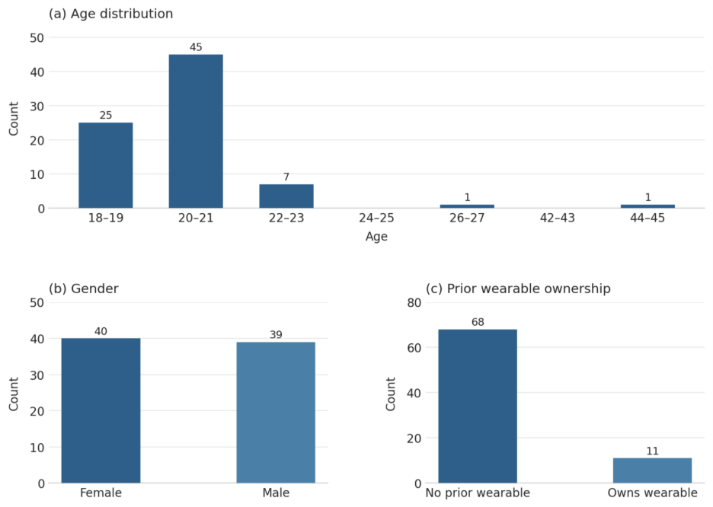

Figure 1: Sample Demographics
Prior to participation, all individuals completed a written informed consent process. Participants were informed that the study examined responses to wellness information generated by wearable technology and that the device would track physiological indicators such as sleep, stress, and energy levels. Consistent with the approved deception protocol, participants were not informed that the device was non-functional or that the displayed metrics were fabricated. Participation was voluntary, and individuals were informed of their right to withdraw at any time without penalty.
Participants were provided with a ring-form wearable device and instructed to install a companion mobile application on their personal smartphones. The application displayed four daily wellness metrics: Sleep Rest Sufficiency, Stress Index, Energy Index, and Overall Wellness Score, each ranging from 50 to 100. Scores were visually categorized using color cues (yellow indicating average values and green indicating higher values). Based on these values, each day was classified into one of two sentiment conditions: positive (all metrics between 71 and 100) or neutral (all metrics between 50 and 70). This daily sentiment classification served as the primary independent variable.
The sequence of metric values was fixed across participants and designed to alternate between sentiment conditions, resulting in seven positive and seven neutral days over the study period. A preview of this sequence is shown in Table 1 and a preview of the app interface is shown in Figure 2.
Date | Sentiment | Sleep Score | Stress Score | Energy Score | Overall Score
2026-02-10 | Positive | 88 | 82 | 91 | 87
2026-02-11 | Neutral | 63 | 57 | 65 | 61
2026-02-12 | Positive | 79 | 85 | 77 | 80
2026-02-13 | Neutral | 55 | 62 | 58 | 58
2026-02-14 | Positive | 93 | 76 | 89 | 86
2026-02-15 | Neutral | 68 | 54 | 61 | 61

Table 1: Pre-Programmed 14-Day Metric Sequence

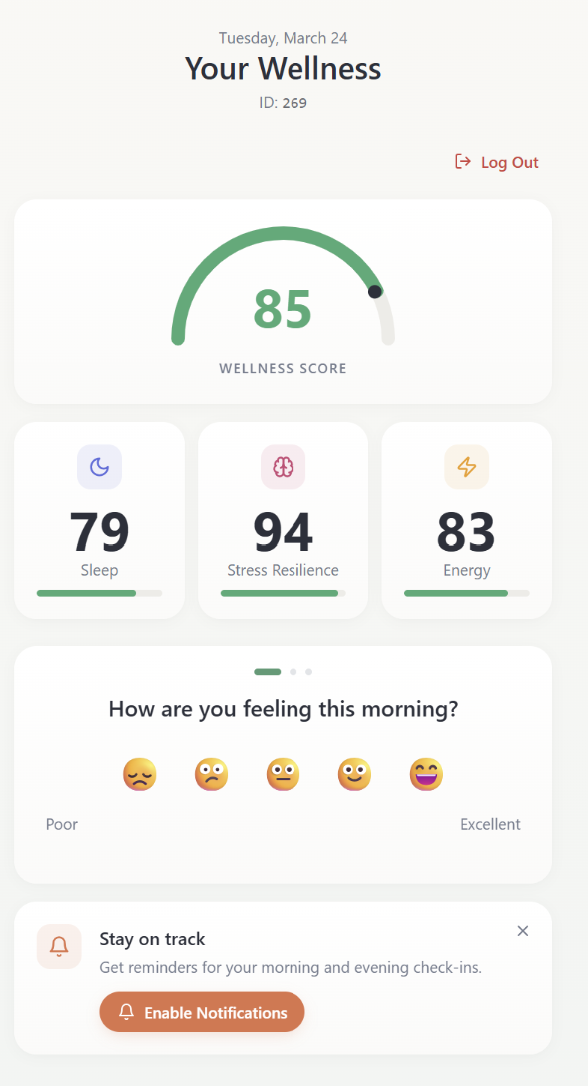

Figure 2: Representative Interface of the Dashboard
Participants attended a 15-minute in-person orientation to initiate the study, during which they received their assigned device, installed the application, and completed a baseline survey capturing demographics and prior wearable device usage. Each participant was assigned a unique identifier to link survey responses with application data.
During the 14-day study period, participants received two daily prompts: a morning check-in (7:00–10:00 AM) and an evening check-in (8:00–10:00 PM). Each check-in included three self-report measures—mood, productivity, and energy level—rated on a 5-point Likert scale (1 = Poor, 5 = Excellent).
At the conclusion of the study, participants completed an exit survey assessing perceived accuracy, reliance on results, behavioral influence, and overall confidence in the system. Mean responses indicated low-to-moderate perceived credibility (perceived accuracy: M = 2.37, SD = 0.90; result reliance: M = 2.57, SD = 1.21; result influence: M = 2.37, SD = 1.06; ring confidence: M = 2.38, SD = 1.27). Participants were then fully debriefed regarding the deception protocol, and no participants elected to withdraw their data.

Measures

The primary independent variable was the daily sentiment condition (positive or neutral), derived from the pre-programmed metric values and merged with participant responses by date.

Dependent variables consisted of three self-reported wellness measures collected during daily check-ins: overall mood, perceived productivity, and perceived energy level. These measures were analyzed both individually and as aggregated indicators of participant well-being.

A composite measure of perceived system credibility was constructed from four post-study survey items: perceived accuracy, result reliance, behavioral influence, and system confidence. Internal consistency of the composite measure was assessed using Cronbach’s alpha.

Statistical analyses included ordinary least squares (OLS) regression, Pearson correlation analysis, paired t-tests, and mixed-effects modeling. These approaches were used to evaluate relationships between sentiment condition, perceived system credibility, and self-reported wellness outcomes across both cross-sectional and longitudinal dimensions.

Data Analysis
Quantitative and qualitative analyses were used to evaluate whether fabricated wellness feedback influenced self-reported well-being, both directly through day-level sentiment manipulations and indirectly through participants’ broader perceptions of the placebo wearable system. Response timestamps were converted into study dates and, when relevant, categorized into morning (before 2:00 PM MST) and evening (2:00 PM MST or later) check-ins. Participant-level and daily aggregates were created where appropriate to support between-period, within-day, and longitudinal analyses. A total of 1,806 response records were included in the primary daily-response dataset, with 1,068 observations in the early half of the study and 738 in the late half.
Several statistical techniques were used. First, descriptive statistics and correlation analyses were used to summarize the structure of the repeated wellness responses and the relationships among response measures, sentiment, and post-study perception variables. Second, OLS regression was used to test whether sentiment, perceived system credibility, and related predictors explained variation in average response levels or within-day differences. Third, paired t-tests compared morning and evening response values separately for neutral and positive sentiment days. Finally, a mixed-effects model with participant random intercepts was estimated to account for repeated observations nested within participants and to test whether perceived system credibility predicted response trajectories over time.
Because each day’s sentiment condition was held constant across participants, within-day sentiment-response correlations were not identifiable. To address this design feature, sentiment analyses were also conducted using daily aggregated response values, as well as lagged, rolling, and response-change specifications.
The qualitative data consisted of open-ended responses to the question asking participants what they believed was the main purpose of the study. These responses were reviewed inductively and synthesized into recurring themes to contextualize the quantitative findings. The qualitative analysis was not intended as a formal coding study, but rather as a thematic aggregation of participant interpretations of the ring, dashboard, and feedback process. Participants’ responses clustered around themes of placebo-like influence, behavioral and decision influence, skepticism about accuracy, and heightened awareness of health information. For example, many participants said the study seemed designed to test whether “being told how [they] should feel” would affect how they actually felt, whether the ring would influence decisions or behavior, and whether they would “believe what the app tells [them], even if it’s inaccurate.”

RESULTS

Response Consistency Over Time
The first major pattern in the data was increasing internal consistency among the three repeated response measures. In the early period, correlations ranged from .53 to .67, with response_value correlating .53 with response_value2 and .67 with response_value3. In the late period, these associations strengthened, ranging from .70 to .74, with response_value correlating .70 with response_value2 and .74 with response_value3. The largest increase was observed between response_value and response_value2, which rose by .165 from early to late study periods.
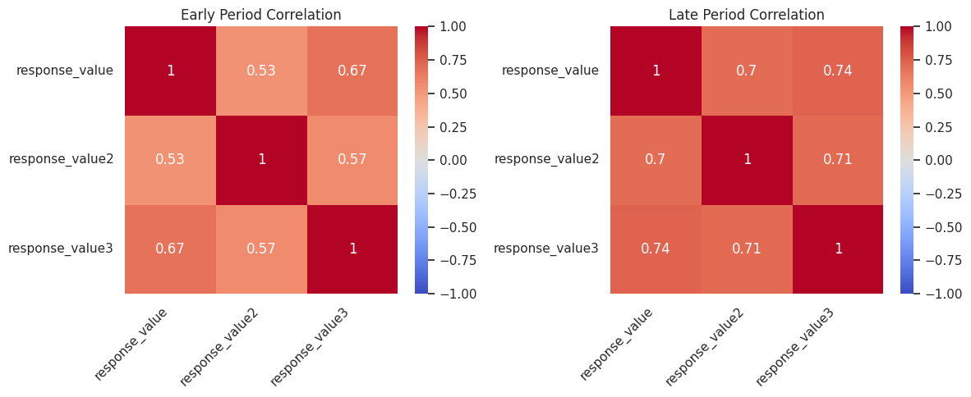

Figure 3: Early vs. Late Period Correlation Heatmaps
This increase in coherence was also evident in the daily time-series of inter-response correlations. The correlation trend rose from approximately .27 at the beginning of the study to approximately .88 by the end, despite a temporary decline around the thirteenth day of the study. Overall, these results suggest that participant responding became more internally consistent over time, consistent with a calibration or familiarization effect.
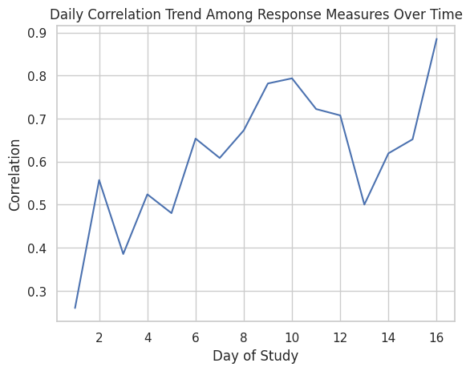

Figure 4: Correlation Over Time

Sentiment and Participant Wellness Responses
Daily sentiment showed little to no meaningful relationship with participant wellness responses. Correlations between sentiment_numeric and the three response measures were negligible: .019 for response_value, .016 for response_value2, and .006 for response_value3. In contrast, the response variables themselves remained moderately to strongly intercorrelated, ranging from .61 to .70.
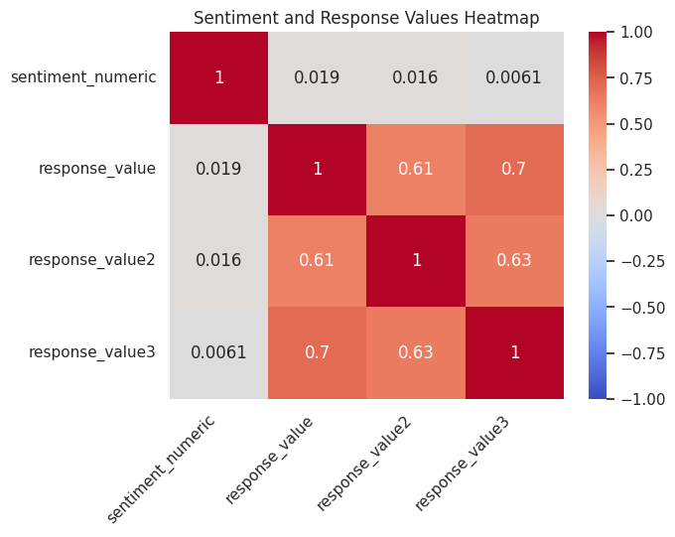

Figure 5: Correlation Matrix for Sentiment and Response Values
At the daily aggregate level, the relationship between sentiment and average response remained weak. Although the correlation between sentiment_numeric and daily average response_value was .215, the corresponding regression model was not statistically significant, b = 0.062, t = 0.852, p = .408, with R² = .046 across 17 daily observations. The scatterplot of sentiment versus average response showed only a slight positive slope with substantial uncertainty, indicating that sentiment explained little of the variation in average response levels.
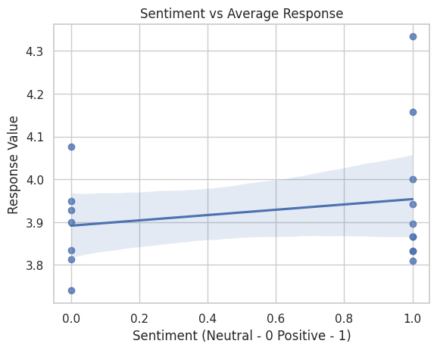

Figure 6: Sentiment vs. Average Response
The time-series comparison of sentiment and average response values likewise showed that participant responses remained relatively stable, clustering around roughly 3.8 to 4.1, even as sentiment alternated across days. Thus, there was little visual or statistical evidence that daily sentiment systematically shifted participant self-reports.
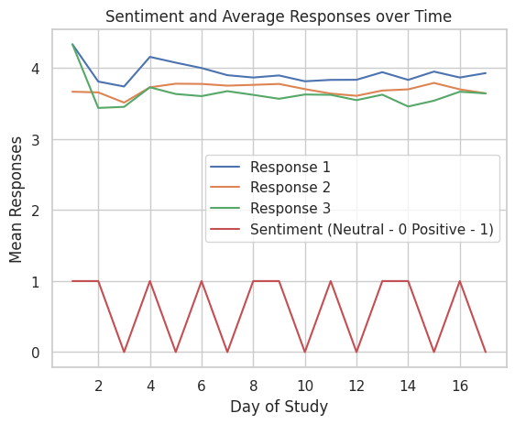

Figure 7: Sentiment vs. Response Over Time

Lagged, Rolling, and Response-Change Analyses
Additional analyses examined whether sentiment might exert delayed or cumulative effects. A rolling three-day average of sentiment did not show a meaningful relationship with response values, and the fitted trend line was essentially flat to slightly negative. Similarly, day-to-day changes in responses showed no systematic association with sentiment condition. Together, these results provide no evidence that sentiment influenced participant responses through immediate, lagged, cumulative, or directional change mechanisms.
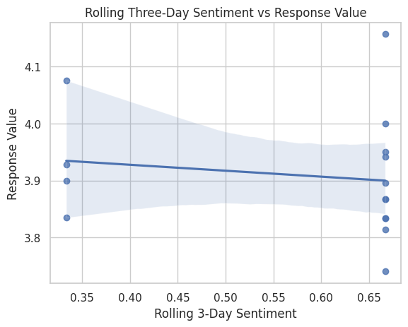

Figure 8: Rolling Three-Day Sentiment vs. Response Value
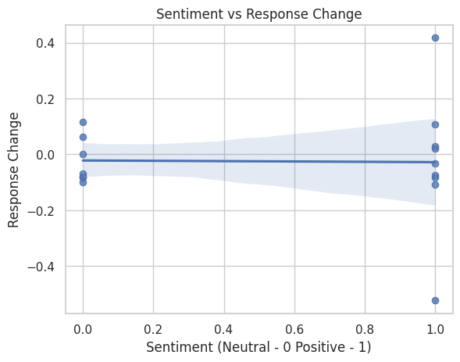

Figure 9: Sentiment vs. Response Change

Morning Versus Evening Comparisons
To assess within-day variation, responses were categorized as morning if submitted before 2:00 PM MST and evening if submitted at or after 2:00 PM MST. Paired t tests were then conducted separately for neutral and positive sentiment days. For neutral sentiment days, the difference between morning and evening responses was marginal but not statistically significant, t(284) = 1.73, p = .086. For positive sentiment days, there was no significant difference, t(384) = 0.95, p = .341. These findings indicate that participant responses were stable across the day regardless of sentiment condition.
A regression predicting the within-day difference score (evening_minus_morning) from sentiment also produced a non-significant result, b = 0.057, t = 0.673, p = .501, with R² = .001, reinforcing the conclusion that sentiment did not significantly alter within-day shifts in participant responses.

Final Survey Perceptions and Perceived System Credibility
Descriptive distributions of the final survey items indicated that participants generally evaluated the placebo system in the low-to-moderate range rather than at the highest levels of endorsement. Perceived accuracy responses were concentrated primarily around the middle of the scale, with relatively few participants selecting the highest accuracy category. Similar patterns were observed for result reliance, result influence, and ring confidence, where responses were spread across lower and mid-range categories rather than clustering strongly at the top end. Overall, these distributions suggest that the ring and dashboard were viewed as somewhat credible, but not uniformly convincing, providing useful context for the subsequent credibility analyses.
The post-study survey revealed that participants formed a coherent impression of the placebo wearable system. Perceived accuracy, result reliance, result influence, and ring confidence were all moderately to strongly positively correlated. The composite measure perceived_system_credibility was strongly associated with its components, including perceived accuracy (r = .80), result reliance (r = .87), result influence (r = .72), and ring confidence (r = .83). These associations support the use of perceived_system_credibility as an integrated post-study perception measure.
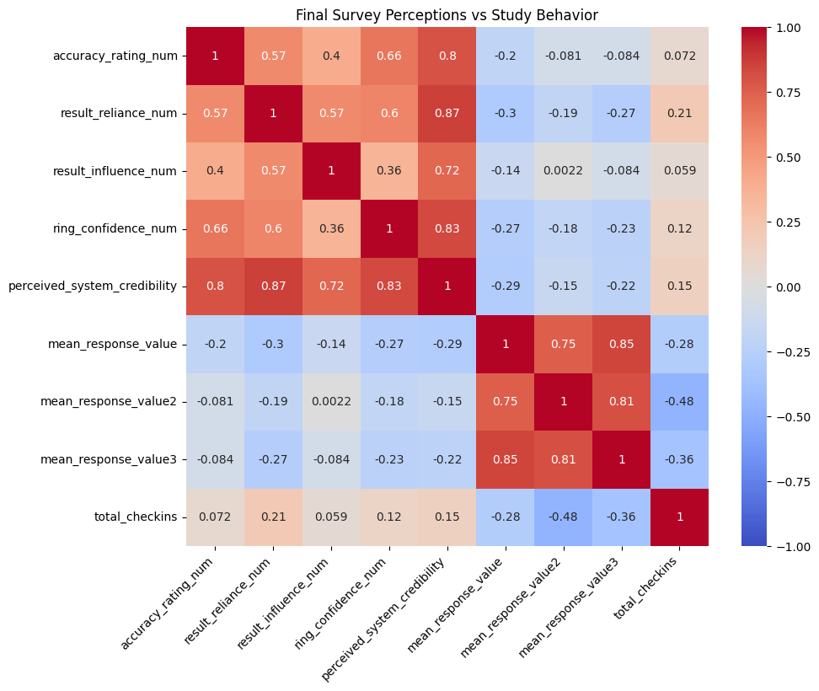

Figure 10: Final Survey Perceptions vs. Study Behavior Heatmap
Perceived system credibility was negatively associated with participant-level average wellness responses. Correlations between perceived_system_credibility and the participant-level mean response measures were -.29 for mean_response_value, -.15 for mean_response_value2, and -.22 for mean_response_value3. At the same time, credibility was only weakly related to overall engagement, as measured by total check-ins (r = .15). This suggests that belief in the system was more strongly associated with self-assessment than with participation volume.
An OLS regression predicting mean_response_value from perceived system credibility showed a significant negative relationship, b = -0.153, t(61) = -2.36, p = .022, with R² = .083. Thus, participants who viewed the ring and dashboard as more credible tended to report lower average wellness values.
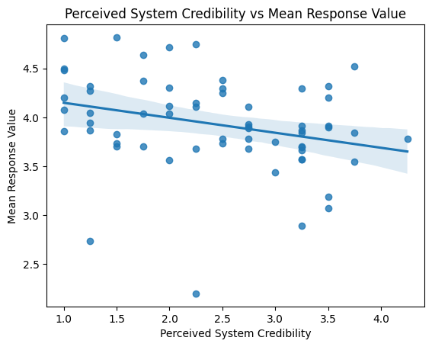

Figure 11: Perceived System Credibility vs. Mean Response Value

Credibility and Response Trajectories Over Time
A mixed-effects model with participant random intercepts was estimated to test whether perceived system credibility predicted response trajectories over time. There was no significant main effect of study day, b = -0.017, p = .359, indicating no overall linear change in response values across the study period. However, perceived system credibility significantly predicted lower response values overall, b = -0.184, p = .033. The interaction between study day and perceived system credibility was not significant, b = 0.007, p = .338, indicating that credibility did not significantly alter the slope of responses over time. In other words, participants who found the system more credible reported lower wellness overall, but they did not systematically decline or improve more over time than lower-credibility participants.
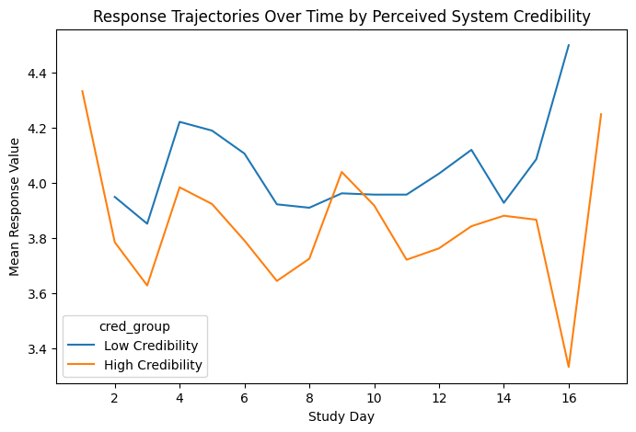

Figure 12: Response Trajectories Over Time by Perceived System Credibility Group

Qualitative Findings
The open-ended responses provided a clear qualitative complement to the quantitative results. The strongest recurring theme was a placebo-like interpretation of the study. Many participants explicitly said they believed the purpose was to see whether being told how they should feel would influence how they actually felt, and several directly used terms such as “placebo,” “fake ring,” or “inaccurate data.” Others described the study as testing whether dashboard feedback would influence behavior, mood, motivation, or health-related choices, while another group emphasized accuracy and skepticism, noting mismatches between the dashboard scores and their lived experience. These responses indicate that many participants recognized the study as an investigation into whether wearable-provided wellness information can shape self-perception and behavior, even when its validity is uncertain.

DISCUSSION
The most consistent finding across the study was not a strong direct effect of sentiment, but rather a pattern of response stability combined with the importance of perceived system credibility. Daily sentiment manipulations showed little effect on self-reported wellness. Same-day correlations with sentiment were near zero, aggregate regressions were non-significant, rolling and response-change analyses were null, and within-day morning-evening comparisons did not reveal reliable differences. Taken together, these findings suggest that short-term variation in dashboard sentiment was not sufficient to substantially alter participants’ reported well-being (possibly while taking into account that many participants hypothesis-guessed this study early on).
At the same time, the placebo system did appear to matter in a different way: participants who perceived the ring and dashboard as more credible reported lower average wellness values. This pattern was observed in both the participant-level OLS regression and the mixed-effects model. Importantly, credibility predicted the overall level of responses rather than their trajectory over time. Participants with higher credibility scores did not become progressively more influenced as the study continued; instead, they appeared to adopt a generally lower self-assessment baseline from the outset. This suggests that belief in the system may have shaped participants’ interpretive frame more than it changed their responses dynamically over repeated exposures. Or, it may suggest that participants who generally have lower wellness tend to also be hesitant to question authority (i.e., we told them it was real, so they believed us).
In the qualitative data, many participants described the study as testing whether health information from the ring would affect how they felt, how they thought about themselves, or how they acted during the day. Several explicitly commented that the ring seemed fake or that the scores felt random, yet still described the dashboard as something that could influence self-perception and behavior. Participants’ comments about “believing the scores,” “being told how [they] should feel,” or using the data as a reason to feel tired, stressed, or productive suggest that the dashboard functioned as a psychological cue rather than merely a neutral display of information.
These findings are consistent with placebo-effect theory, which suggests that inert devices can shape subjective experience when they are perceived as credible or authoritative. In the present study, the day-level sentiment manipulation itself did not appear strong enough to change self-reported wellness, but the broader credibility of the system was associated with participants’ reported well-being. Thus, the placebo effect may have operated not through isolated dashboard messages, but through the more general authority and believability of the wearable interface.
From a behavioral psychology perspective, the results suggest that expectation and interpretive framing may matter more than short-term shifts in message tone. Participants who trusted the dashboard more may have incorporated its feedback into their self-assessments in a more conservative or self-critical way, leading to lower average wellness ratings. This aligns with the idea that external cues can shape internal judgments, especially when those cues are delivered by a system perceived as data-driven and objective.
The results also have important implications for digital health design. Even when the day-level sentiment valence did not significantly alter participant responses, the apparent authority of the system still mattered. This suggests that digital health interfaces can shape self-assessment not only through what they say, but through how credible, confident, and diagnostic they appear to be. Designers of wearable dashboards should therefore be cautious about projecting certainty, precision, or implied biometric authority when the underlying measurements are limited, uncertain, or potentially misleading. Transparency, calibration, and ethical communication of uncertainty are critical design concerns in consumer wellness technologies.
Several limitations should be acknowledged. First, daily sentiment was uniform across participants on a given day, limiting within-day inferential leverage and reducing the amount of variation available for sentiment-based analyses. Second, for ethical reasons, the sentiment manipulation was relatively narrow, primarily spanning neutral and positive conditions, which may have limited the strength of the experimental contrast. Third, the qualitative analysis was thematic and interpretive rather than based on a formal multi-coder qualitative framework. Nonetheless, the open-ended responses were highly informative and converged strongly around the same conceptual issues that motivated the study.
Overall, the combined quantitative and qualitative evidence points to a nuanced conclusion. The direct sentiment manipulation embedded in the dashboard did not strongly influence reported wellness. However, participants who perceived the placebo system as more credible reported lower wellness overall, and many participants explicitly understood the study as testing whether wearable feedback could shape self-perception, behavior, and mood. Thus, in this context, it appears that the perceived authority of the system may matter more than the specific valence of the daily feedback it delivers.

LIMITATIONS
The following limitations should be considered when interpreting our findings, as they provide necessary context for the validity of the research.

Sample Characteristics and Generalizability
Our sample of business students introduces demographic and psychographic constraints. This population provides a focused look at high-achieving, tech-literate young adults; it limits the generalizability of the results to broader populations. Also, despite screening efforts, a small subset of participants used other personal health trackers (e.g., Apple Watch, Garmin, Oura) during the study. This concurrent use of multiple devices may have introduced confounding variables, as conflicting data points could have diminished the psychological impact of the metrics in our app.

Range Restriction and "Wellness Floor" Constraints
To comply with IRB ethical guidelines regarding the psychological well-being of participants, the app’s data generation was restricted to a score range of 50 to 100. This "wellness floor" ensured that no participant was led to believe they were in a state of clinical or physiological crisis. However, from a research perspective, this limits our understanding of how participants react to genuinely "poor" metrics (scores <50). The absence of low-tier data may have softened the negative psychological correlations typically associated with poor sleep or health indicators, potentially skewing the results toward a more optimistic baseline.

Study Duration and Longer Adaptation
The two-week observation period was sufficient to capture responses to biometric feedback but may not reflect long-term behavioral changes. In a lengthier setting, users often develop a "feedback loop" where they learn to ignore metrics that do not align with their physical sensations. A 14-day window represents the "honeymoon phase" of wearable adoption, where the perceived authority of the device is at its peak, potentially overstating the influence of the metrics compared to long-term usage.

Subjectivity and Self-Reported Metrics
The primary dependent variables, mood, productivity, and energy level, are inherently subjective and susceptible to internal biases. Participants’ responses could have been influenced by academic stressors, social dynamics, or environmental factors (e.g. midterm exams) that occurred during the 14-day study period, which were not controlled for.

Verification and Deception Resilience
The study relied on the continued belief that the provided rings had functional sensors. The lack of a full debriefing regarding the placebo nature of the study means that any subconscious skepticism remains unmeasured. If a participant observed their generated "85 Sleep Score" after a night of objectively poor sleep, the resulting cognitive dissonance may have altered their subsequent self-reports without being explicitly captured by the study’s design.

FUTURE RESEARCH
To build upon the current research, the following areas are recommended for further investigation.

Comparative Studies of Objective vs. Perceived Biometrics
Future research should employ a dual-cohort design that compares participants receiving accurate, sensor-derived biometrics against another group receiving randomized placebo data. By benchmarking the psychological response of both groups, researchers can isolate the degree to which a user’s knowledge of a device’s technical validity enhances or diminishes the data's impact on their perceived well-being. This would help clarify whether the effect of a low sleep score is driven by the data’s perceived authority or by its alignment with the user's physical sensations. Objectively comparable measures like sleep score could also simply be omitted from future studies to avoid triggering suspicion.

Clinical and High-Stakes Health Contexts
This study focused on a generally healthy student population. Future work should explore these dynamics within clinical contexts, such as among patients with chronic insomnia, anxiety disorders, or cardiovascular conditions. In these populations, the psychological weight of a "low" health score may be significantly higher, potentially triggering acute stress responses. Investigating the ethical threshold for data transparency in clinical wearables is a necessary step for the next generation of medical-grade health trackers.

Cross-Demographic and Cultural Replications
Replicating this study across diverse age groups and cultural and educational backgrounds would enhance the generalizability of the study’s findings. Different cultures may place varying levels of trust in quantitative data versus intuitive physical feeling. Expanding the participant pool beyond university settings will ensure that the effects are understood across the full spectrum of human experience.

CONCLUSION
This study investigated the psychological weight of wellness wearables and their metrics by isolating the dashboard sentiments from actual physiological data. While the initial hypothesis suggested that daily fluctuations in fabricated metrics (positive vs. neutral) would directly mirror fluctuations in user well-being, the quantitative data revealed a more nuanced reality. For this sample of business students, fake daily scores did not significantly shift self-reported mood or productivity on a day-to-day basis. However, the study uncovered a significant relationship between system credibility and self-assessment: participants who perceived the wearable as more authoritative and accurate tended to report a lower baseline of wellness.

Summary of Contributions
The primary contribution of our research is the distinction between transactional influence (daily scores) and institutional influence (system trust). Our findings suggest that users are not necessarily influenced by a daily number; instead, the presence of a credible tracking system may act as a diagnostic frame that leads users to be more self-critical or conservative in their wellness self-reports. The qualitative feedback reinforced this, as participants explicitly recognized the placebo potential of being told how they feel.

Implications for Design and Ethics
The lack of a direct correlation between sentiment (imposed) and mood (reported) in this study does not absolve technology manufacturers of ethical responsibility; rather, it highlights a deeper concern regarding authority. If the perceived credibility of a device is associated with a lower self-assessment baseline, designers must prioritize transparency. We propose that wellness technology should evolve beyond binary scores toward a more human-centric interface by:
- Communicating Uncertainty: Integrating confidence intervals to signal that biophysiological tracking is an estimation, not an absolute value.
- Contextualizing Feedback: Moving from descriptive metrics ("Your sleep was 60") to prescriptive, empathetic support ("You may feel less alert today; consider a lighter schedule") to mitigate the negative self-framing observed in high-credibility users.
- Ethical Guardrails: Recognizing that for high-achieving populations, such as business students, the pressure to "optimize" metrics can lead to a decreased sense of well-being when the device is viewed as an objective judge—we should therefore signal healthy bands, rather than optimal targets.

Final Remarks
In conclusion, wellness dashboards influence perception independent of real health data, but they do so through the lens of authority rather than mere daily feedback. As wearable technology moves closer to clinical integration, the industry must account for these psychological feedback loops. By designing for the "human in the loop", rather than just the data in the cloud, we can ensure that health trackers serve as tools for genuine empowerment rather than unintentional sources of self-diminishment.

REFERENCES
- Arnold, B. (2025, September 18). Spending on fitness trackers grows 88% in 2025, Circana reports. Circana. https://www.circana.com/post/spending-on-fitness-trackers-grows-88-in-2025-circana-reports
- Feng, S., Mäntymäki, M., Dhir, A., & Salmela, H. (2021). How self-tracking and the quantified self promote health and well-being: Systematic review. Journal of Medical Internet Research, 23(9), e25171.
- de Vries, H. J., Balt, M., Bos, M. G. N., et al. (2025). The effects of self-monitoring using a smartwatch and app on stress- and well-being–related outcomes. JMIR mHealth and uHealth, 13, e60708. https://www.jmir.org/2023/1/e40529/
- Zahrt, O. H., Crum, A. J., & Hekler, E. B. (2023). Effects of wearable fitness trackers and activity adequacy mindsets on affect, behavior, and health. Journal of Medical Internet Research, 25, e40529. https://pubmed.ncbi.nlm.nih.gov/36696172/
- Huhn, S., Axt, M., Gunga, H.-C., et al. (2022). The impact of wearable technologies in health research: Scoping review. JMIR mHealth and uHealth, 10(1), e34384. https://mhealth.jmir.org/2022/1/e34384
- Germini, F., Noronha, N., Borg Debono, V., et al. (2022). Accuracy and acceptability of wrist-wearable activity-tracking devices: Systematic review of the literature. Journal of Medical Internet Research, 24(1), e30791. https://www.jmir.org/2022/1/e30791/
- Singh, B., et al. (2024). Real-world accuracy of wearable activity trackers for diagnosis and detection of disease: Systematic review and meta-analysis. https://pubmed.ncbi.nlm.nih.gov/39213525/
- Ferguson, T., Olds, T., Curtis, R., et al. (2022). Effectiveness of wearable activity trackers to increase physical activity and improve health: A systematic review and meta-analysis. The Lancet Digital Health, 4(8), e615–e626. https://pubmed.ncbi.nlm.nih.gov/35868813/

- Alipio, J. S., Bautista, M. C., Mendoza, G., Narvaez, R. A., Sudaypan, M., & Peco, R. A. (2022). Impact of wearable devices in mental health and quality of life. Canadian Journal of Nursing Informatics. https://cjni.net/journal/?p=10472

- Cormack, F., McCue, M., Taptiklis, N., Skirrow, C., Glazer, E., Panagopoulos, E., van Schaik, T. A., Fehnert, B., King, J., & Barnett, J. H. (2019). Wearable technology for high-frequency cognitive and mood assessment in major depressive disorder: Longitudinal observational study. JMIR Mental Health. https://doi.org/10.2196/12814

- Choudhury, A., & Asan, O. (2021). Impact of using wearable devices on psychological distress: Analysis of the health information national trends survey. https://www.sciencedirect.com/science/article/abs/pii/S1386505621002380

- Czeisler, M. É., Capodilupo, E. R., Weaver, M. D., Czeisler, C. A., Howard, M. E., & Rajaratnam, S. M. W. (2022). Prior sleep-wake behaviors are associated with mental health outcomes during the COVID-19 pandemic among adult users of a wearable device in the United States. Sleep Health. https://doi.org/10.1016/j.sleh.2022.03.001

- Dunn, J., Runge, R., & Snyder, M. (2018). Wearables and the medical revolution. Personalized Medicine. https://doi.org/10.2217/pme-2018-0044

