**Hive Activity 1**

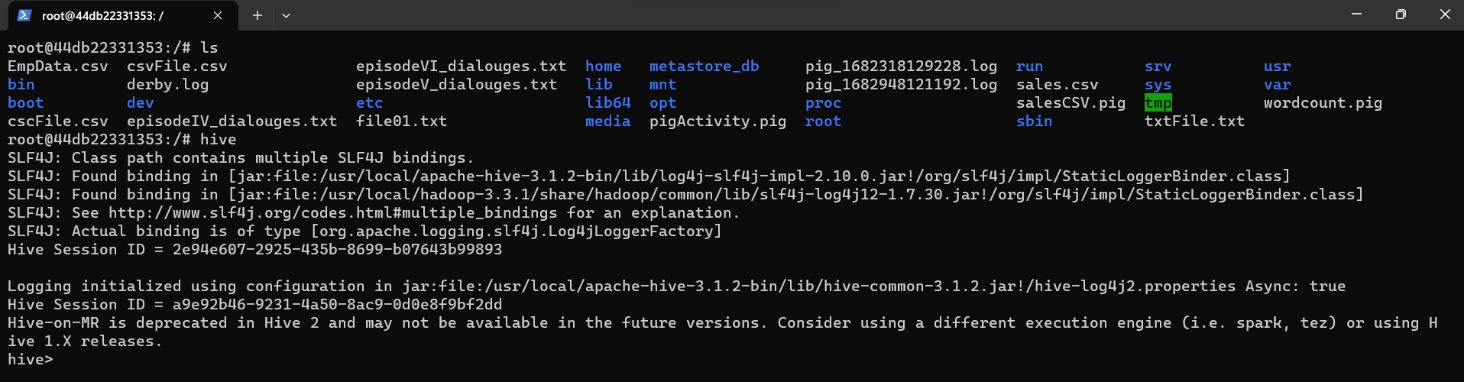

Episode IV:

Episode V:

Episode VI:

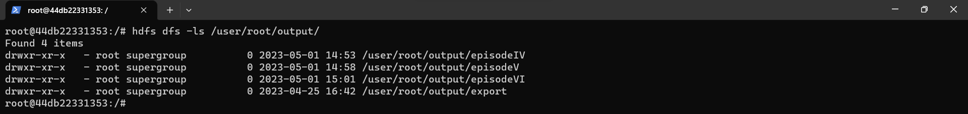

Results Episode IV:

Results Episode V:

Results Episode VI:

