**OSU_CS361_partner_microservice**

PROJECT TITLE: Implementation of Microservice for Partner

PROJECT DESCRIPTION: Random number generator microservice using python sockets

INSTALLATION/REQUIREMENTS:

* Python
* Program/Client and the Microservice/Server running on the same computer.
* Microservice/Server MUST be started first to avoid connection error.
* PORT may need be changed if the computer is already using the PORT.
* Firewalls may need to be disabled to allow for python sockets to run properly
* Program/Client must contain the following code to connect to the server.

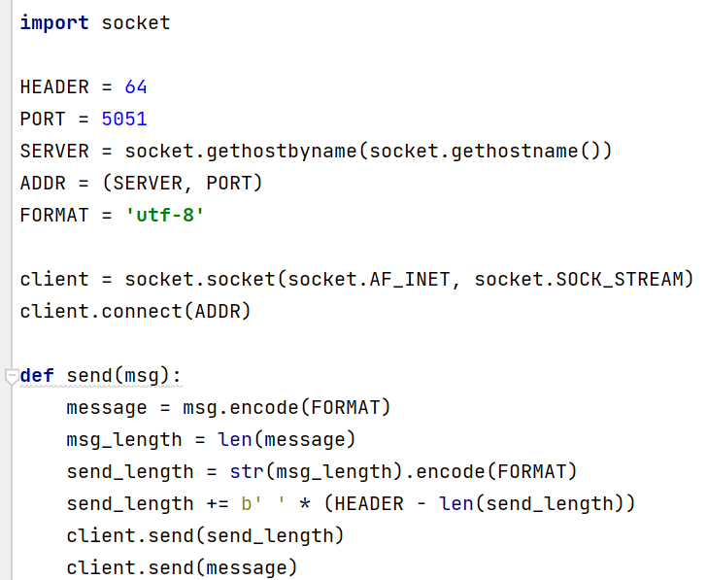

USAGE INSTRUCTIONS TO REQUEST DATA FROM THE MICROSERVICE:

* Using the send() function as embedded/defined in the Program/Client to request data from the microservice.
* Example call **send(“Hello”)**: Using the example call **send(“Hello”)** of the send() function with the text message “Hello” will cause the Microservice/Service to generate a random number.
* In the template Program/Client code, an input() function is added prior to the send() so that the User can determine when the random number is being generated. This input() function can be deleted/modified in the final Program/Client code as necessary.

USAGE INSTRUCTIONS TO RECIEVE DATA:

* The data received is the code “client.recv(64).decode(FORMAT)).”
* In the template Program/Client code, a print statement was used to show the received data. Delete the print() statement, but utilized the code “client.recv(64).decode(FORMAT)” to use the received data.

UML SEQUENCE DIAGRAM

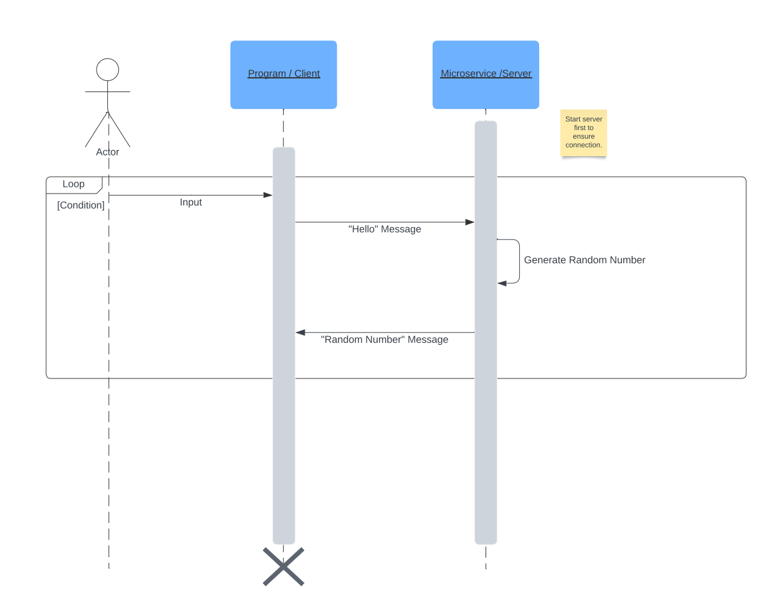

COMMUNICATION CONTRACT: Jointly-Developed by Makenna and Eddy:

* Preference for how we should be communicating: First option, communicating over Microsoft Teams Chat/Video. Second option, communicating over the phone.
* Expectations for responsiveness: Response target of around one day. If no response after one day, reminder text or phone call to the partner's mobile phone.
* Work synchronously vs asynchronously: Preference for working synchronously over Microsoft Teams or over the phone.
* Method of sharing code: Over GitHub.
* Struggles with course: Discuss together and brainstorm solutions.