Enabling 3DS IC manufacturing through SEMI Standards

By James Amano [SEMI]

As the industry pushes current boundaries and explores new solutions to enable commercialization of 3D ICs, cost-effective high-volume manufacturing will be difficult to achieve without standardized equipment, materials, and processes, especially because 3D ICs' design and mechanical complexity can lead to increased manufacturing defects, as well as thermal management issues and signal interference.
Focusing on 3D IC technology and the manufacturing process will help reduce costs through increased throughput, improved product quality, better yields, and lower maintenance and operational expenses. No single company can fully realize these benefits without working closely with their suppliers and their competitors. Highly-automated and advanced manufacturing systems comprise multiple equipment types, technologies and supporting products from best-in-class suppliers from around the world. Enabling these different processes, products and technologies to work seamlessly and cost-effectively together requires diverse, well-informed and effective industry standards.
Understanding the essential role of standards in enabling low-cost, high-quality manufacturing, SEMI first charged its International Standards group with exploring the challenges of 3D IC manufacturing issues in spring 2010. The first 3DS-IC (“S” stands for “stacked”) SEMI Standards Technical Committee was formed in North America in late 2010, with a counterpart in Taiwan created in July 2011. In early fall 2012, the Japan Packaging Committee authorized the formation of a 3D-IC Study Group with plans to explore and ultimately engage in the activities in North America and Taiwan.

TSV geometrical metrology
The SEMI 3DS-IC Standards committee’s first accomplishment was SEMI 3D1, “Terminology for Through Silicon Via Geometrical Metrology.” SEMI 3D1 provided a starting point for standardization of geometrical metrology for selected dimensions of through-silicon vias (TSVs). Although different technologies measured various geometrical parameters of an individual TSV, or of an array of TSVs — such as pitch, top diameter, top area, depth, taper (or sidewall angle), bottom area, and bottom diameter — it was difficult to compare results from the various measurement technologies because parameters are often described by similar names, but actually represent different aspects of the TSV geometry. The Inspection & Metrology Task Force recognized the need for such a standard. SEMI 3D1 is an important first step in promoting common understanding and precise communication between stakeholders in the 3D IC manufacturing supply chain.

Glass carrier wafer specs
Publication of SEMI 3D2, “Specification for Glass Carrier Wafers for 3DS-IC Applications” was approved in Fall 2012. Developed by the Bonded Wafer Stacks Task Force, this specification addresses the needs of the industry by providing the tools needed to procure pristine glass carrier wafers for use in 3DS IC processes.
SEMI 3D2 describes dimensional, thermal, and wafer preparation characteristics for the glass starting material that will be used as carrier wafers in a temporary bonded state. This specification also describes glass carrier wafers with nominal diameters of 200 and 300mm, and a thickness of 700µm, although the wafer diameter and thickness required may vary due to process and functional variation. Such variations need clarification in the purchasing order or in the contract. Methods of measurements suitable for determining the characteristics in the specifications are also indicated (Table 1).

Thin wafer transport and storage
In June 2013, SEMI published the 3D3 standard: “Guide for Multiwafer Transport and Storage Containers for 300mm, Thin Silicon Wafers on Tape Frames.” Developed by the Thin Wafer Handling Task Force, SEMI 3D3 is intended to address the needs for choosing a method for shipping thin wafers on tape frames in such a way that they arrive undamaged at their final destination. It describes various methods of shipping thin wafers on tape frames. Examples of methods for shipping thin wafers on dicing frames are provided in Figure 1.

Bonded wafer stacks and TSV metrology
At the heels of SEMI 3D3 publication, both SEMI 3D4 - “Guide for Metrology for Measuring Thickness, Total Thickness Variation (TTV), Bow, Warp/Sori, and Flatness of Bonded Wafer Stacks” and SEMI 3D5 - “Guide for Metrology Techniques to be used in Measurement of Geometrical Parameters of Through-Silicon Vias (TSVs) in 3DS-IC Structures” were released in mid-2013. Control of parameters, such as bonded wafer stack (BWS) thickness, total thickness variation (TTV), bow, warp/sori, and flatness metrology, is essential to successful implementation of a wafer bonding process. These parameters provide meaningful information about the quality of the wafer thinning process (if used), the uniformity of the bonding process, and the amount of deformation induced to the wafer stack by the bonding process. Developed by the Inspection & Metrology Task Force, SEMI 3D4 provides a description of tools that can be used to determine these key parameters before, during, and after the process steps involved in wafer bonding.
On the other hand, TSVs are critical elements in three-dimensional stacked integrated circuit (3DS-IC) packaging. Advanced TSV designs with higher aspect ratios and smaller diameters may challenge TSV metrology techniques. SEMI 3D5 aims to assist in the selection and use of tools for performing measurements of geometrical parameters of an individual TSV, or of an array of TSVs.

The middle-end process
While the North America 3DS-IC Technical Committee (TC) led the first charge of SEMI 3DS-IC standards development (see the sidebar for a summary of its activities), the Taiwan TC Chapter’s efforts came to fruition with Middle End Process Task Force publishing SEMI 3D6, “Guide for CMP and Micro-Bump Processes for Frontside TSV Integration” (Fall 2013) and SEMI 3D7, “Guide for Alignment Mark for 3DS-IC Process.”

Biography
James Amano received his BA from the U. of Colorado at Boulder and is a Senior Director of International Standards at SEMI (www.semi.org); email jamano@semi.org

List of figures and tables:

Table 1: Requirements for standardized glass carrier wafers for temporary bonding.

Figure 1: Methods for shipping thin wafers on dicing frames bonded wafer stacks and TSV metrology.

Table 1.
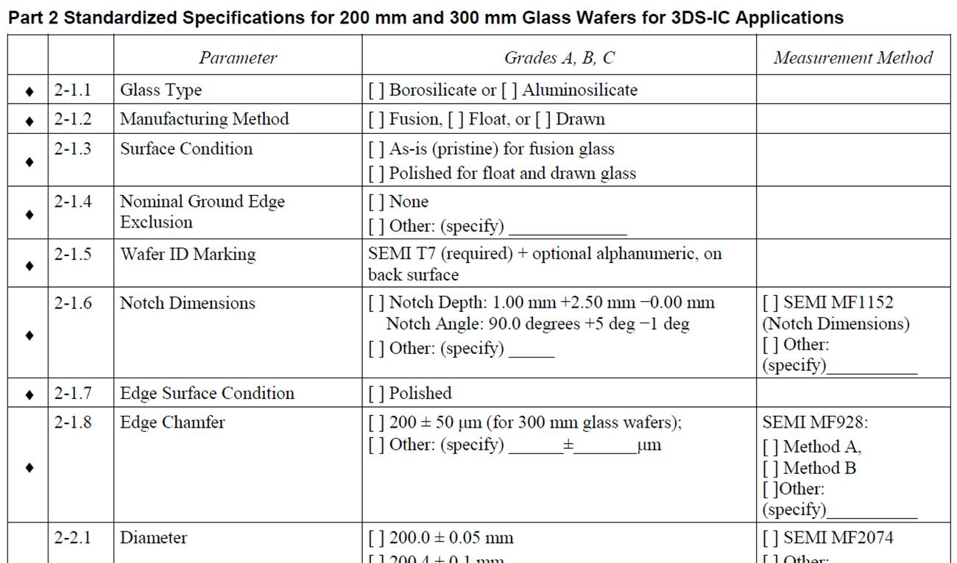

[Todd: THIS SECTION IS A SIDEBAR.]

SIDEBAR

SEMI 3DS-IC standardization activities continue
North America 3DS-IC Committee
- Bonded Wafer Stacks Task Force has divided the existing 5173 activity (New Standard: Guide for Describing Silicon Wafers for Use in a 300 mm 3DS-IC Wafer Stack) into smaller document development efforts:
  - New Standard: Guide for Describing Glass Wafers for Use as 300mm Carrier Wafers in a 3DS-IC Temporary Bond-Debond (TBDB) Process [Doc. 5692]
  - New Standard: Guide for Describing Silicon Wafers for Use as 300mm Carrier Wafers in a 3DS-IC Temporary Bond-Debond (TBDB) Process [Doc. 5693]
  - New Standard: Guide to Describing Materials Properties for 300mm Wafer Stacks [Doc. 5694]
  - New Standard: Guide to Describing Materials Properties for Intermediate Wafers for Use in a 300mm 3DS-IC Wafer Stack [Doc. 5695]. The task force submitted Documents 5173D, 5693, 5694, and 5695 for the Cycle 2, 2014 voting period.
  - The task force is also continuing its work on SEMI Draft Document 5174, New Standard: Specification for Identification and Marking for Bonded Wafer Stacks.
- Inspection & Metrology Task Force is continuing its work on the following activities:
  - New Standard: Guide for Measuring Voids in Bonded Wafer Stacks [Doc. 5270]
  - New Standard: Terminology for Measured Geometrical Parameters of Through-Glass Vias (TGVs) in 3DS-IC Structures [Doc. 5447]
  - New Standard: Guide for Measuring Warp, Bow and TTV on Silicon and Glass Wafers Mounted on Wire Grids by Automated Non-Contact Scanning using Laser Scanning Interferometry [Doc. 5506]
  - Revisions to SEMI 3D4 [Doc. 5616] for clarification and additional improvements
  - The task force submitted Document 5447 for the Cycle 2, 2014 voting period.
- Thin Wafer Handling Task Force is considering possible standardization on dicing tape characterization and performance as well as unsupported thin wafer handling.
For more information about North America 3DS-IC activities, please contact Paul Trio (ptrio@semi.org) at SEMI.
Taiwan 3DS-IC Activities
- Middle End Process Task Force recently initiated a new standards activity focused on overlay performance via Standards New Activity Report Form (SNARF) 5688: New Standard: Guide for Overlay Performance Assessment for 3DS-IC Process.
- Testing Task Force is continuing its work on Draft Document 5485, New Standard: Guide for Incoming/Outgoing Quality Control and Testing Flow for 3DS-IC Products.
For more information about Taiwan 3DS-IC activities, please contact Ms. Catherine Chang (cchang@semi.org) at SEMI.
Japan 3DS-IC Activities (under the Japan Packaging Committee)
- Thin Chip (Die) Bending Strength Measurement Task Force was chartered to develop a new test method for bending strength measurement under SNARF 5691: New Standard: Test Method for Measurement of Chip (Die) Strength by Mean of Cantilever Bending.
- 3D-IC Study Group. The 3D-IC Study Group is considering possible standardization on bonded wafer handling, stacked wafer handling, and diced stacked dies handling.
For more information about Japan 3DS-IC activities, please contact Ms. Naoko Tejima (ntejima@semi.org) at SEMI.

Ballots for the above activities will be issued throughout 2014, and are reflective of the continued global, industry-wide effort. Over 100 technologists from industry, research institutes, and academia around the world have already joined the SEMI 3DS-IC Standards Committee and are at work on these critical standards.
Pre-competitive collaboration is difficult, and involves hard work by industry experts, but it creates significant benefits for the industry as a whole, for companies participating, and for individuals involved in the process. If you or your company is not yet involved in these efforts to shape the future of 3D-IC, learn more about SEMI Standards by visiting www.semi.org/en/Standards. Note that participation in the SEMI Standards Program is free, but requires registration. To learn more, contact jamano@semi.org or register at: www.semi.org/standardsmembership.

