

3

Edito11ial amd 0w Calendar *4*



Ad Bates alild Speciticatiom 6

W/eb *aJ* Ema·1 Advertisrng 7

CSR's Team of Experts 8

Sa1les Contacts 8

CHIP SCALE REVIEW

Expanding your Reach. Connect. Deliver.

Chip Scale Review expands your reach, connects with leading industry contacts, delivers your company message. Plan now for your company's advertising campaign in 2014.

[ads@chipscalereview.com](mailto:ads@chipscalereview.com)

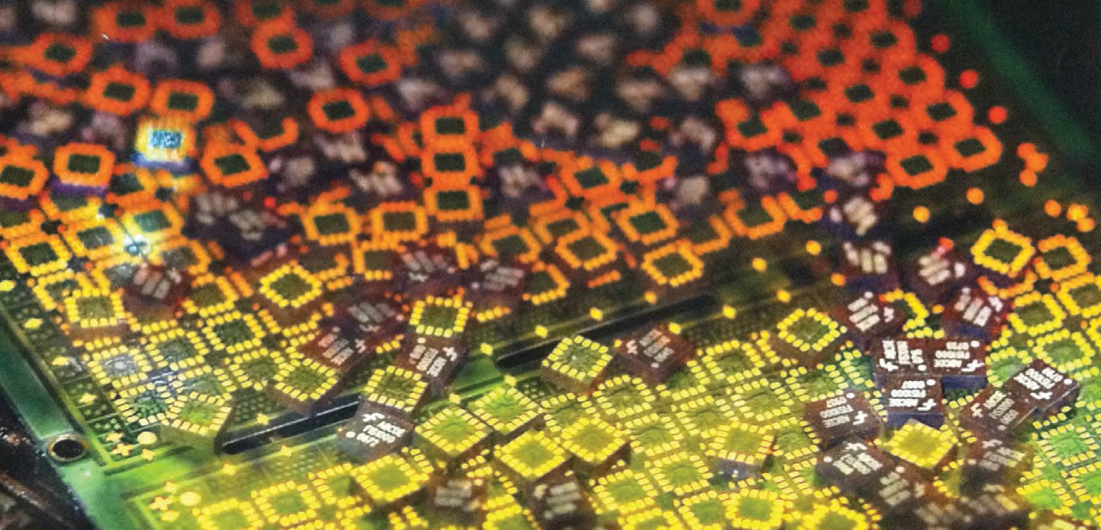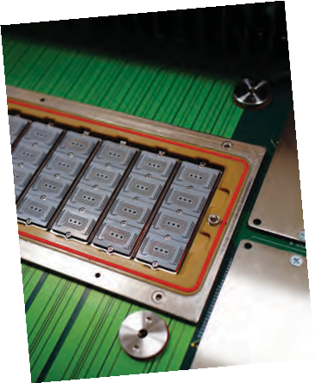

***Chip Scale Review*** *is the first word in middle-end and back-end technologies for advanced semiconductors. Whether it’s TSV and associated processes,*

September Volume 17, Number 5

- October

2013

V

olume

17,

Number Packaging Innovations:

5 Graphene for Next-Gener

P. 20

• Acoustic Imaging & Inspection

• Metrology for Bumping Processe

• Wafer-to-Wafer Bonding for 3D IC

• Thermocompression Bonding (TC

• Wafer-Level Fan-Out Packaging (

INTERNATIONAL DIRECTORY OF BOND

**ChipScaleReview**

**.com**

*wafer-level packaging, semiconductor packaging and final test advances – CSR showcases the industry leaders with exclusive editorial content.*

Chip Scale Review Sets the Standard for

Semiconductor Packaging Publications

Founded in 1997, **Chip Scale Review** is the leading international publication serving the semiconductor packaging industry today, bringing you the most up-to- date technology advancements in both contemporary and advanced assembly, test, and packaging processes and technologies for ICs, MEMS, RF/Wireless, optoelectronic, and emerging areas such as nanotechnology and LED packaging. From cover

to cover, **Chip Scale Review** is packed with technology features, market trends, industry news, industry events, expert perspective, and international directories that can’t

be found elsewhere.

audience

DEMOGRAPHICS

**The Chip Scale Review** brand encompasses the flagship publication now entering its 17th year which

is published six times per year in print and digital. The monthly technical enewsletter ***CSR Tech Monthly*** is an

extension of the publication and is produced 12x per year on the third Tuesday of every month.

**Chip Scale Review** audience comprises 24,000 subscribers that consist of test & assembly packaging engineers, engineering management, general and corporate management at OEMs, device manufacturers, contract manufacturers and IC Packaging Foundries plus R&D research

institutes, educational institutions, and government who are involved in the advanced packaging

industry.

**DISTRIBUTION\***

**PRINT:** 14,250

**DIGITAL:** 9,929

**TRADE SHOW:** 700

**TOTAL**

**DISTRIBUTION*:** 24,879

*\*Data taken from Sept./Oct. 2013 Edition*

**JOB FUNCTION**

**CORPORATE & GENERAL MANAGEMENT:**

21%

**ENGINEERING MANAGEMENT:**

**ASSEMBLY PACK AGING ENGINEER:**

17%

**R&D:**

17%

**TEST ENGINEERING**

8%

**IC DESIGN ENGINEER:**

5%

**RELIABILITY QA:**

4%

**PURCHASING:**

4%

18%

**SUBSCRIBERS**

**USA:** 14,400

**ASIA-PACIFIC:** 6,000

**EUROPE:** 3,600

*Data Sources based on print run, shipping receipts, and email marketing statistics provided by Con- stantComment.com. All records and documents on file with CSR.*

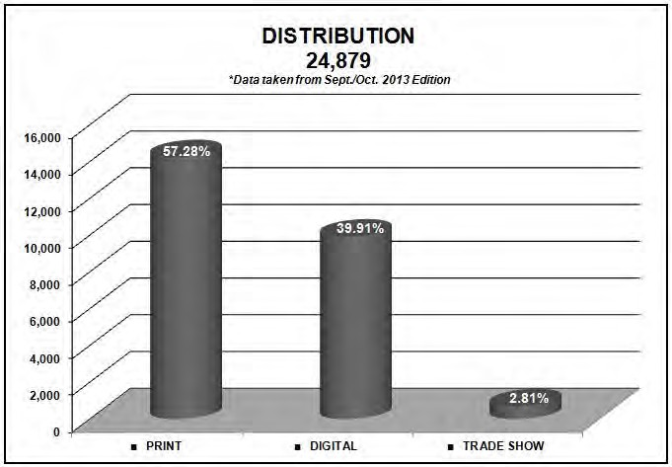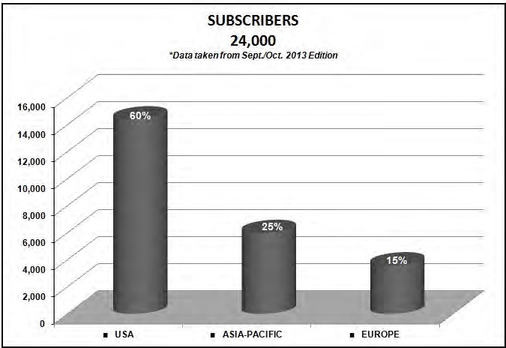

**OTHER:**

3%

**UNIVERSITY, INSTITUTES, STUDENTS – OTHER:**

3%

January  February

3D - Wafer-Level Packaging - MEMS

Columns Technical Features Trade Show /Conferences

Semiconductor Industry Forecast Probe Technology Advances • BiTS Workshop

Mesa, AZ (March 9-12)

Competitive Strategies and Tactics for the

Packaging Industry

Probing µ-bumps for wide I/O 3D SICs

• IMAPS Device Packaging (DPC)

Fountain Hills, AZ (March 10-13)

Putting 2.5D in Perspective MEMS Mobile Devices

Bringing New Electronic Materials to Market 3D IC Stacking

BGA Socket Systems for Test and Verification Next-generation TSV Filling by

Electroplating

R&D Institute Profile Ad Space Close Jan 21 - Ad Materials Deadline Jan 24

March  April

OSATS – Packaging & Assembly – 3D TSVs

OSATS Market Update European Assembly and Test • SEMICON China

Shanghai China (March 18-20)

IC Packaging Technologies & Trends

How the OSATs Stack Up

3D TSV & Heterogeneous Integration

• APEX Expo

Las Vegas, NV (March 25-27)

High-density 2.5D Interposer Market Update Dispensing Trends

TSV Reliability Challenges Glass as a Future Packaging Platform

Die & Flip-chip Bonding

Semiconductor Packaging Materials

Advancements in PoP Technology

R&D Institute Profile Ad Space Close Feb 11 - Materials Close Feb 14

International Directory of IC Packaging Foundries

May  June

Materials - Test & Burn-in Sockets - 3D IC Integration

Advanced Packaging Materials Market Update 3DIC & TSV Interconnects • MEPTEC

Symposium on Polymers

Standards Update Enabling Technologies for 2.5D IC/ Si

Integration

Patents Update 3D Integration of SiP

High Performance Test Sockets

Bond Testing Metrology Trends TSV Interposers

Laser Ablation Technology

Wilmington, DE (May 6-8) MEMS Tech Symposium San Jose, CA (May 22)

• ECTC

Lake Buena Vista, FL (May 27-30)

• IEEE/SW Test Workshop (SWTW)

San Diego, CA (June 6-11)

• SEMICON West

San Francisco, CA (July 8-10)

Special Feature: R&D Institute Profile Ad Space Close March 28 - Ad Materials Close April 2



Special Feature: Executive Profile & Perspective

For ad inquiries: [ads@chipscalereview.com](mailto:ads@chipscalereview.com) - For editorial inquiries [editor@chipscalereview.com](mailto:editor@chipscalereview.com)

July  August

Copper Pillar Bumping - Dicing & Singulation - Assembly & Test

Columns Technical Features Trade Show /Conferences

Assembly & Test Market Update Copper Pillar Bumping • SEMICON Taiwan

Taipei, Taiwan (Sept 3-5)

• MEPTEC

Burn in and Test Market Update Scalable Approaches for 2.5D IC

Assembly

Medical Microelectronics Conference

Portland, OR (Sept 18-19)

Cost Reduction of MEMS

Bonding/De-Bonding/Wafer-thinning

Handling

Dicing & Singulation

Spring Contact Probes in Wafer Test

Applications

Solder Trends

International Directory of Test and Burn-in Sockets Ad Space Close May 30 - Ad Materials Close Jun 4

September  October

Thermocompression Bonding – Wafer Probing – Wire Bonding

Test Trends TCB for 2.5D/3D Assembly • SMTA International

Rosemont, IL (Sept 28-Oct 2)

• SEMICON Europa

• Grenoble, France (Oct 7-9)

Patents 3D Packaging Through-glass Vias (TGV)

Wafer Probers & Probe Cards

High-reliability Wire Bonding

Cleaning Processes

• IMAPS Microelectronics Symposium

San Diego, CA (Oct 13-16 )

• T-Sensors Summit

San Diego, CA (Oct 15-16)

• International Test Conference (ITC)

Seattle WA (Oct 21-24)

• MEMS Executive Congress

Scottsdale, AZ (Nov 5-7)

• IWLPC-International Wafer-Level

Packaging Conference & Exhibition

San Jose, CA (Nov 11 -13)

Automotive Electronic Packaging

International Directory of Bonding Equipment for 2.5D and 3D Assembly Ad Space Close Aug 8 - Ad Materials Close Aug 13

Special Feature: Executive Profile & Perspective

November  December

3D TSVs – Package Test – Inspection

Advances in Burn-in & Test Sockets Heterogeneous Integration Through-die

Stacking

Green Electronics 3D TSVs

MEMS Industry Report HVM of 3D ICs

Solder Ball Placement

Reliable Flip-chip Interconnection

Package Inspection

• MEPTEC

Packaging, Assembly & Test Conf.

Santa Clara, CA (Nov TBD)

• SEMICON Japan

Tokyo, Japan (Dec 3-5)

• RTI 3D ASIP Conference

Burlingame, CA (Dec 10-12)

• SEMI European 3D TSV Summit

Grenoble France (Jan 2015)

Failure Analysis

Ad Space Close Oct 10 - Materials Close Oct 15

For ad inquiries: [ads@chipscalereview.com](mailto:ads@chipscalereview.com) - For editorial inquiries [editor@chipscalereview.com](mailto:editor@chipscalereview.com)



advertising

RATES & SPECIFICATIONS

ADVERTISING SPECIFICATIONS

**2 PAGE SPREAD**

**Trim Size Bleed Size**

15.75" x 10.875" .125" beyond all sides

FULL COLOR ADVERTISING RATES

**2 PAGE SPREAD** (Bleed or Non-Bleed)

**1 - 2x 3 - 4x 5 - 6x**

$7,020 $6,545 $6,240

**1 PAGE**

**Trim Size Bleed Size**

7.875" x 10.875" 8.125" x 11.125"

**1 PAGE** (Bleed or Non-Bleed)

**1 - 2x 3 - 4x 5 - 6x**

$4,500 $4,200 $3,800

**2/3 PAGE**

**Ad Size Bleed Size**

4.5" x 10" This type of ad does not bleed

**2/3 PAGE**

**1 - 2x 3 - 4x 5 - 6x**

$3,690 $3,385 $3,170

**1/2 PAGE ISLAND**

**Ad Size Bleed Size**

4.5" x 7.375" This type of ad does not bleed

**1/2 PAGE ISLAND, HORIZONTAL** or **VERTICAL**

**1 - 2x 3 - 4x 5 - 6x**

$2,900 $2,750 $2,530

**1/2 PAGE HORIZONTAL**

**Ad Size Bleed Size**

7" x 4.875" This type of ad does not bleed

**1/3 PAGE HORIZONTAL** or **VERTICAL**

**1 - 2x 3 - 4x 5 - 6x**

$2,470 $2,335 $2,145

**1/2 PAGE VERTICAL**

**Ad Size Bleed Size**

3.375" x 10" This type of ad does not bleed

**1/4 PAGE VERTICAL**

**1 - 2x 3 - 4x 5 - 6x**

$2,160 $2,025 $1,855

**1/3 PAGE HORIZONTAL**

**Ad Size Bleed Size**

4.625" x 4.875" This type of ad does not bleed

**COVER POSITIONS** (Frequency discounts available)

**Inside Front Cover Inside Back Cover Outside Back Cover**

$5,500 $4,800 $6,500

**1/3 PAGE VERTICAL**



**Ad Size Bleed Size**

2.1875" x 10" This type of ad does not bleed

**1/4 PAGE VERTICAL**

**Ad Size Bleed Size**

3.5" x 4.875" This type of ad does not bleed

**NOTE ON ADVERTISING SIZES All Ads Must be Submitted to Correct Size** Please contact the Chip Scale Review Publisher or Sales Representative

for mechanical requirements

and specifications.

Rates are gross.

Ad placements that require special positioning or a guaranteed page or editorial placement are subject to a 10% premium fee in addition to the earn rate.

Rates are based on the total number of insertions of any size within the contract year. Rates are subject to a 15% advertising agency commission. Agency commission will be disallowed if payment has not been received at the Publisher’s office by the 35th day following the invoice date. Ads cancelled after the materials close date will subject the advertiser to a

100% penalty at the Publisher’s discretion.

**GENERAL CONTRACT AND RATE POLICY**

All advertising is accepted at the Publisher’s discretion. The advertising insertion order is an official and legally binding contract between the advertiser and/or agency and Chip Scale Review magazine. Neither the advertiser nor agency may amend our advertising policies by notation to the insertion order, verbally or through any other document whether it is part of the insertion order or separate.

Rate & specifications are effective 12/01/2013

*Advertising Rates and Specifications are subject to change without notice and are contingent on logistics*

*and magazine production.*

**CSR Tech Monthly eNewsletter**

***CSR Tech Monthly*** brings the latest in technology features,

key industry news, event coverage, and significant new product information right to your in-box. Ask your sales person about sponsoring dedicated special issues of CSRTM.

CSRTM RATE CARD CSRTM CALENDAR

|  |  |
| --- | --- |
| **ISSUE BROADCAST SPACE CLOSE MATERIALS CLOSE** |  |
| **JANUARY** January 21 January 14 January 17 |
| **FEBRUARY** February 18 February 11 February 14 |
| **MARCH** March 18 March 11 March 14 |
| **APRIL** April 15 April 8 April 11 |
| **MAY** May 20 May 13 May 16 |
| **JUNE** June 17 June 10 June 13 |
| **JULY** July 15 July 8 July 11 |
| **AUGUST** August 19 August 12 August 15 |
| **SEPTEMBER** September 16 September 9 September 12 |
| **OCTOBER** October 21 October 14 October 17 |
| **NOVEMBER** November 18 November 11 November 14 |
| **DECEMBER** December 16 December 9 December 12 |
|  | |

**TOP BANNER** (625 x 80)

|  |  |  |  |
| --- | --- | --- | --- |
| **1x**  $1025 | **3x**  $925 | **6x**  $850 | **12x**  $775 |
| **SMALL BANNER** (485 x 90) | | | |
| **1x**  $775 | **3x**  $700 | **6x**  $625 | **12x**  $550 |
| **SKYSCRAPER** (120 x 240) | | | |
| **1x**  $775 | **3x**  $700 | **6x**  $625 | **12x**  $550 |
| **TEXT/ TILE** (120 x 120) | | | |
| **1x 3x**  $625 $575 | | **6x**  $525 | **12x**  $475 |
| *Measurements are in pixels* | |  |  |
| **Chip Scale** | | **Review** | **Website** |

***CSR Tech Monthly***

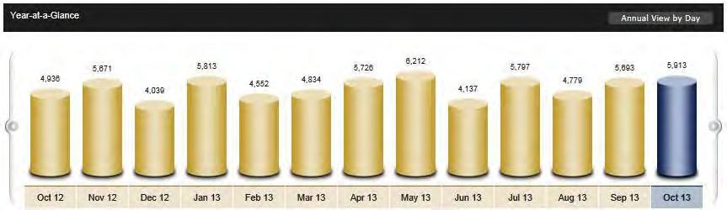

Chipscalereview.com Web Traffic*

October 2012 - October 2013

**\* source:** 3rd party data analytical services

**CSRTM AD SPACE FILE SPECIFICATIONS**

**Material Format:** gif, jpg, png or swf

**Max. Animation Time:** 30 sec., 3 loops max

**Max. File Size:** 35Kb

**Supply the click through url with your material**

***Chip Scale Review*** teaM OF eXPerts

***The editors, writers, and contributors who provide our editorial are industry experts with real time experience in semiconductor packaging, engineering, design and test.***

**KIM NEWMAN,** Publisher, A 14 year veteran at CSR, she joined the magazine’s sales and marketing team in 1999. Kim assumed the Publisher role in 2007 and manages the public relations strategy and execution of programs for semiconductor packaging sector industry firms. Her overall responsibilities includes publication of all CSR generated media, oversight of technical content generation for contributed editorial and development of client and agency projects including marketing collateral in support of sustaining positive client relationships. Additional and significant efforts are channeled to industry trade shows and industry events and are evidenced by the success of the International Wafer-level Packaging Conference (IWLPC) with additional acknowledgements by the leading trade venues. She is synonymous with the packaging industry. Her previous positions include sales operations management at Memorex Corporation. Kim graduated with a BS from the University of California at Davis.

**LAWRENCE MICHAELS,** Managing Director, became associated with Chip Scale Review initially

as a business and operations advisor in 2008 and joined fulltime in 2012. He brings with him a 20+ years of experience in senior systems engineering and a technical program management background from the Enterprise Business System and software industry. Additionally, he has held significant manufacturing and management positions in the avionics & aerospace industry. Lawrence holds a BS from University of Colorado and an MBA from California Lutheran University.

**DEBRA VOGLER,** Sr. Technical Editor, joined the CSR team in 2012. She is responsible for technical content selection, author coordination, editing and editorial Advisory Board representation. Having served as the Sr. Technical Editor for Solid State Technology in excess of 10 years, Debra is well-known in the advanced packaging community as a technical editor, industry media commentator covering symposiums and conferences. Debra holds a graduate degree in physics from Marquette University.

**RONALD J. MOLNAR** is an industry veteran who has enjoyed a distinguished career in the fields of Optoelectronics, ASIC, Bipolar Logic & Memory, Contract IC Assembly, Package Design and Test, Equipment Automation, Sales Representation, and consulting. He’s held VP of Engineering positions with Amkor Technology, Abpac, and Tiros. He is currently Executive Director of Az Tech Direct, LLC. University of California, Berkeley BSEE, Semiconductor Physics.

**THOMAS H. Di STEFANO, Ph.D.** was the founding president of Tessera Technologies and helped build Tessera into a world leader in miniaturized packaging. Royalties from U.S. Patents coauthored by

Di Stefano produced well above $1Billion revenue for Tessera. In 2011, SEMI names Thomas Di Stefano as one of the recipients of the SEMI Award for North America for contributions to the development and commercialization of Micro Ball Grid Array (µBGA) technology. Tom is also a co-founder of Chip Scale Review.

**JASON MIRABITO,** Contributing Editor on Patent Legislation, is a member of the Mintz, Levin, Cohn, Ferris, Glovsky and Popeo Law Firm and is contributing editor of the Patents column. LLM, Georgetown Law Center Juris Doctor, American University BSEE, Engineering Physics : New York University

EDITORIAL ADVISORY BOARD MEMBERS

**• Rolf Aschenbrenner**

Deputy Head, Fraunhofer Institute

**• Thomas Di Stefano PhD**

President & CEO, Centipede Systems

**• Joseph Fjelstad** President & Founder, Verdant Electronics

**• Arun Gowda PhD**

Manager, Electronics Packaging & Miniaturization Lab.

GE Global Research

**• John Lau PhD**

Fellow, Industrial Technology

Research Institute (ITRI)

**• Andy Mackie PhD** Global Product Manager, Indium Corporation

**• Venky Sundaram PhD**

Research Director,

3D Systems PackagingResearch Center (PRC) Georgia Institute of Technology

**• Fred Taber** General Chairman, BiTS Workshop

**• Lin Tingyu PhD**

Director of Strategic Partnership,

National Center for Advanced Packaging

(NCAP China)

**• Francoise von Trapp**

Editorial Director, 3D InCites

***Chip Scale Review*** saLes cOntacts

**USA WEST,**

**USA-NORTH CENTRAL**

**KIM NEWMAN**

P.O. Box 9522

San Jose, CA 95157-0522

T: 408.429.8585

F: 408.429.8605 [ads@chipscalereview.com](mailto:ads@chipscalereview.com)

**USA-EAST,**

**USA-SOUTH CENTRAL**

**RON MOLNAR**

13801 S. 32nd Place

Phoenix, AZ 85044

T: 480.215.2654

F: 480.496.9451 [rmolnar@chipscalereview.com](mailto:rmolnar@chipscalereview.com)

**INTERNATIONAL & DIRECTORIES**

**LAWRENCE MICHAELS**

2259 Putter Court

Brentwood, CA 94513

T: 408.800.9243

F: 408.429.8605 [lxm@chipscalereview.com](mailto:lxm@chipscalereview.com)

**KOREA**

**YOUNG J. BAEK**

Young Media Inc.

407, Jinyang Sangga,

120-3 Chungmuro

4ga, Chung-Ku, Seoul, Korea T: +82.2.2273.4819 [ymedia@ymedia.co.kr](mailto:ymedia@ymedia.co.kr)



P.O. Box 9522, San Jose, CA 95157-0522  **PHONE:** 408.429.8585  **FAX:** 408.429.8605  **ChipScaleReview.com**