Radio Packet Structure:
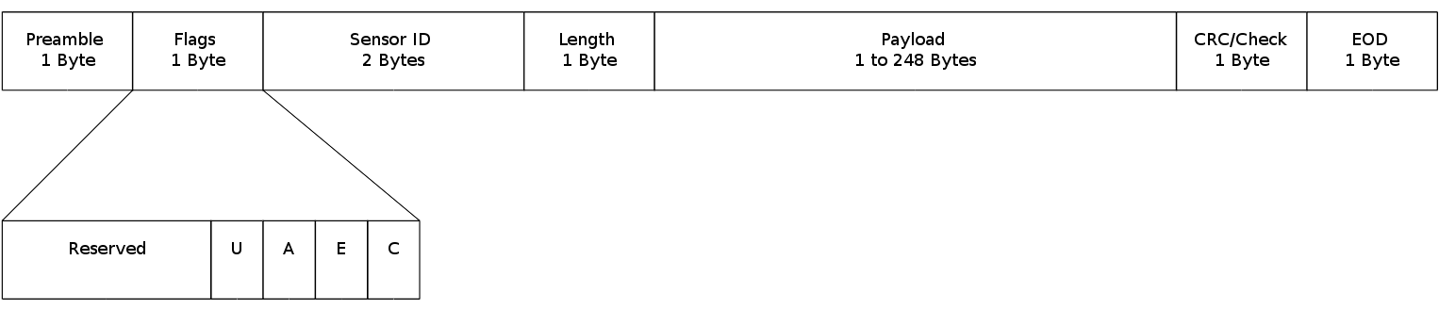
*(Potentially add 4 bytes for source and destination addresses (2 bytes each) for bidirectional communication. This changes the Payload limit to 244 bytes.)

Flag Descriptions:
C – Continuation – The Next Packet with the same Sensor ID has a the next part of a multi- datagram message

E – End – This Packet is the end of a multi-datagram message (C and E are mutually exclusive)

A – Armored – The start of the payload field contains integrity information about SensorID and
Length. Also, the end of payload contains integrity information about the payload data
itself. To be implemented.

U – Urgent – Will be set for syslog/onboard system management/onboard sensor messages from
sensor multiplexer (server). This should only be used for abnormal operating conditions,
such as kernel messages/syslog warnings, system monitoring sensors are outside their
normal operating range, or other important system management information. These
messages will depend on what module the sensor multiplexer is implemented on.

