**StemmedList**

Holds a list of FreqList objects that have read and write methods

* read(string filename)
  + reading the lists of lists from a file
* write()
  + writing the lists of lists to a file

|  |  |  |  |
| --- | --- | --- | --- |
| **Name** | **Signature(Parameters)** | **Signature(Return)** | **Description** |
| read | string | n/a | Reads the list of lists from a file |
| write | n/a | n/a | Writes a list of lists to the file |
| addStemAndWord | string, string | n/a | Update StemmedList by inserting stem if needed, incrementing the stem count, inserting word if needed and incrementing the word count |

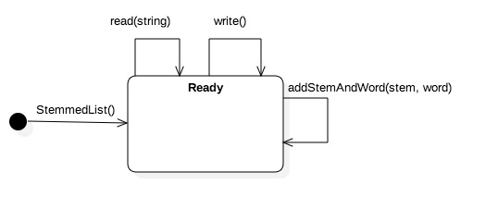

**Name**

WordMap

**Description**

Holds a list of MapItem objects.

Contains the following Methods:

|  |  |  |  |
| --- | --- | --- | --- |
| **Name** | **Signature(Parameters)** | **Signature(Return)** | **Description** |
| read | string | bool | Reads a WordMap from a file  True if successful |
| write | string | bool | Writes a WordMap to a file  True if successful |
| sizeSort | None | None | Sorts the WordMap by fontsize |
| randomize | None | None | Randomizes the MapItems in the WordMap |
| append | MapItem | None | Adds a MapItem to the back of the list |
| peekNext | None | MapItem | Returns the last MapItem in the list, but does not pop it. |
| popNext | None | MapItem | Returns the last MapItem in the list, and pops it off, reducing list size by one. |
| isEmpty | None | bool | Returns True if the list is empty. |

**StateChart Diagram**

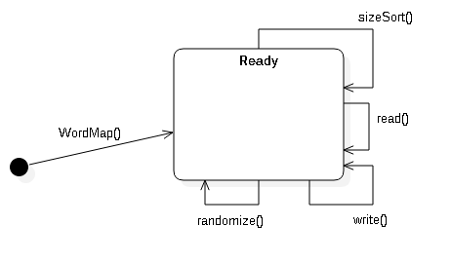

**Operations**

public void read(String inputFile) : Reads the map from a file. If the file does not exist, throw an exception.

public void write(String outputFile) : Writes out the map to file. If the file already exists, use filename(1).txt, else use filename(2), else use filename(3)…etc.

public void sizeSort() : Sorts the map by fontsize.

public void randomize() : Randomizes the order of the elements in the map.

MapItem

Holds a word and its associated fontsize, location, and size. Has getters, setters, and a to/fromString.

fontSize is a int representing the size of the font. Range 0-9.

|  |  |  |  |
| --- | --- | --- | --- |
| **Name** | **Signature[Parameters]** | **Signature[Return]** | **Description** |
| *getWord* | NA | *string* | Returns the value of *word*. |
| *getFontSize* | NA | *Int* | Returns the value of *fontSize.* |
| *getLocation* | NA | *Point\** | Returns the value of *location.* |
| *getSize* | NA | *Size\** | Returns the value of *Size*. |
| *setWord* | *std::string* | NA | Sets the value of *word*. |
| *setFontSize* | *Int* | NA | Sets the value of *fontSize.* |
| *setLocation* | *Point* | NA | Sets the value of *location.* |
| *setSize* | *Size* | NA | Sets the value of *Size*. |
| *MapItem* | NA | NA | Constructor creates an empty *MapItem.* |
| *~MapItem* | NA | NA | Destructor. |
| *toString* | NA | *string* | Returns *MapItem’s* values as a *string*. |
| *fromString* | *string* | NA | Sets MapItem’s values from inputted string. |

Point

Holds the X and Y coordinates for a MapItem.

X range: 0 <= X < 8500  
Y range: 0 <= Y < 11000

|  |  |  |  |
| --- | --- | --- | --- |
| **Name** | **Signature[Parameters]** | **Signature[Return]** | **Description** |
| *getX* | NA | *Int* | Returns the value of *X*. |
| *getY* | NA | *Int* | Returns the value of *Y*. |
| *setX* | *Int* | NA | Sets the value of *X*. |
| *SetY* | *Int* | NA | Sets the value of *Y*. |
| *Point* | NA | NA | Constructor creates an empty *Point.* |
| *~Point* | NA | NA | Destructor. |

Size

Holds the Height and Width of a *MapItem*.

Width range: 0 <= Width < 8500  
Height range: 0 <= Height < 11000

|  |  |  |  |
| --- | --- | --- | --- |
| **Name** | **Signature[Parameters]** | **Signature[Return]** | **Description** |
| *getHeight* | NA | *int* | Returns the value of *Height*. |
| *getWidth* | NA | *Int* | Returns the value of *Width*. |
| *setHeight* | *Int* | NA | Sets the value of *Height*. |
| *SetWidth* | *Int* | NA | Sets the value of *Width*. |
| *Size* | NA | NA | Constructor creates an empty *Size.* |
| *~Size* | NA | NA | Destructor. |

DocList

Contains a FreqList and the filename associated with it. Read and Write save and load from that file.

|  |  |  |  |
| --- | --- | --- | --- |
| **Name** | **Signature[Parameters]** | **Signature[Return]** | **Description** |
| read | string | N/A | Reads from the file |
| write | string | N/A | Writes to the file |
| getFilename | String | N/A | Calls fList.getFilename |
| setFreqList | N/A | fList | Calls fList.setFreqList |
| getMap | N/A | N/A | Calls fList.getMap |
| sortlist | N/A | fList | Calls fList.sortlist |
| remove | N/A | fList | Calls fList.remove |
| DocList | N/A | N/A | Constructor |
| ~DocList | N/A | N/A | Destructor |

