**ColumnLayout**

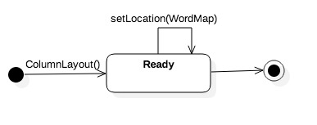Implements the method in ICloudLayout by setting with locations for each word. Words are chosen randomly, then laid out in columns. Make sure words don’t overlap.

|  |  |  |  |
| --- | --- | --- | --- |
| **Name** | **Signature(Parameters)** | **Signature(Return)** | **Description** |
| ICloudLayout::setLocation | WordMap | n/a | Implements the method in ICloudLayout by setting the locations for a column layout |
| ColumnLayout | n/a | n/a | Constructor |
| ~ColumnLayout | n/a | n/a | Destructor |

**FreqMaker**

Has a method that converts a StemmedList object to a DocList object. The first word following the stem is the one that should be chosen for the DocList entry, along with the total number of occurrences for that stem.

|  |  |  |  |
| --- | --- | --- | --- |
| Name | Signature(Parameters) | Signature(Return) | Description |
| stemToFreq | StemmedList* | FreqList* | Creates a FreqList from the StemmedList by pulling the total count and first word after stem from the StemmedList and putting them into FreqList |
| FreqMaker | n/a | n/a | Constructor |
| ~FreqMaker | n/a | n/a | Destructor |

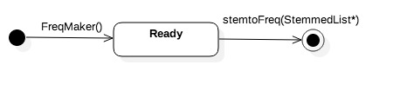

StemMaker

This StemMaker module reads in a stopList object and initializes it by using the readStopList function. After the stopList has been read in by the module, the function createStemmedList creates a stemmedList object that contains the initialized words that are grouped by their common stems. The parameter for the readStopList function contains a file. The function does not return a value. The parameter for the createStemmedList function includes a WordList object. The return value is a stemmedList object.

|  |  |  |  |
| --- | --- | --- | --- |
| Name | Signature(Parameters) | Signature(Return) | Description |
| stemMaker() | n/a | n/a | Constructor |
| ~stemMaker() | n/a | n/a | Destructor |
| readStopList() | Filename | n/a | Reads in the given file in order to initialize a stopList |
| createStemmedList() | Wordlist* | stemmedList* | Reads in a wordList object and returns a stemmedList object. The object contains the original words grouped by the common stem. |

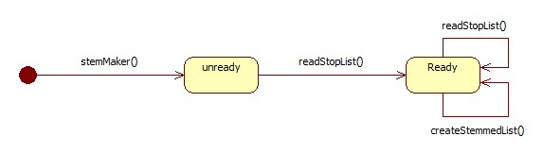

randomLayout

The randomLayout module sets the location for each word in the word cloud by randomly assigning coordinates that may or may not overlap. The parameters included in the module are a wordList object, Point, and Size. The module returns a cloud layout that assigns coordinates to each word.

|  |  |  |  |
| --- | --- | --- | --- |
| Name | Signature(Parameters) | Signature(Return) | Description |
| randomLayout() | n/a | n/a | Constructor |
| ~randomLayout() | n/a | n/a | Destructor |
| Randomize() |  |  |  |

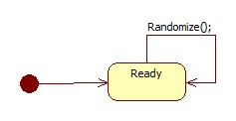

LatexMaker

Has a method that, given a WordMap, produces a latex document (with a .tex file extension). It will place this document in the current working directory, and give it the same name as the input file, with the extension changed to .tex. If the file already exists, the program will append a number, starting at 1 to filename, and try again.

|  |  |  |  |
| --- | --- | --- | --- |
| **Name** | **Input Type** | **Return Type** | **Description** |
| *generateDoc* | WordMap*  inputFileName.txt | *void* | Reads a WordMap, and creates a properly formatted Latex document.  This document is named inputFileName.tex, and placed in the current working directory.  If the output file already exists, a number, starting at 1. Then it tries again. |
| LatexMaker | NONE | NONE | Default Constructor |
| ~LatexMaker | NONE | NONE | Default Destructor |

LatexMaker State Chart Diagram

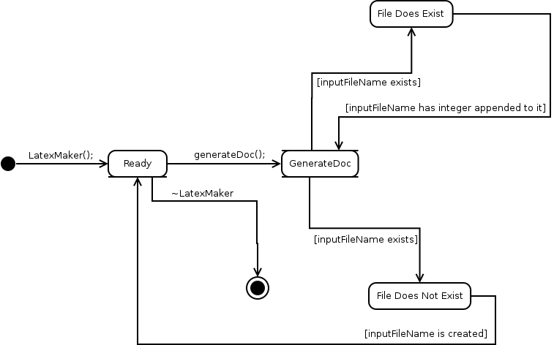

WordMapMaker

Converts a frequency list (DocList) to WordMap object.

|  |  |  |  |
| --- | --- | --- | --- |
| **Name** | **Signature[Parameters]** | **Signature[Return]** | **Description** |
| convertList | *DocList | WordMap | Makes a WordMap object of the frequency list. Mapped to 10 font sizes. |
| WordMapMaker | N/A | N/A | Constructor |
| ~WordMapMaker | N/A | N/A | Destructor |

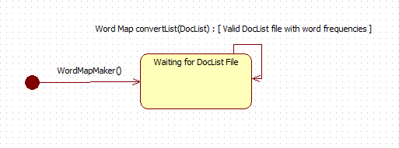

SquaresLayout

Implements ICloudLayout, randomly placing words. It organizes words in a square by rows and columns. The words don’t overlap

|  |  |  |  |
| --- | --- | --- | --- |
| **Name** | **Signature[Parameters]** | **Signature[Return]** | **Description** |
| setLocation | wordmap, Point | n/a | Sets the location for each word in a word map. Organized in a square |
| SquaresLayout | N/A | N/A | Constructor |
| ~SquaresLayout | N/A | N/A | Destructor |

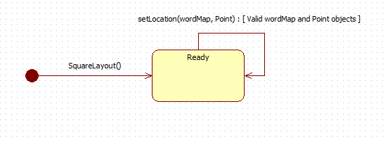

**ICloudLayout**

Specifies a method that will be implemented by the various layout classes. This method should update a WordMap by setting the locations (Point) for each word in the map.

|  |  |  |  |
| --- | --- | --- | --- |
| **Name** | **Signature[Parameters]** | **Signature[Return]** | **Description** |
| ICloudLayout | n/a | n/a | Constructor |
| ~ICloudLayout | n/a | n/a | Destructor |
| setLocation | wordmap, Point | n/a | Sets the location for each word in a word map |

**StackedLayout**

Implements the method in ICloudLayout by setting with locations for each word. Words are stacked from the bottom of the page upwards, with font size going from biggest (at the bottom) to smallest (at the top).

|  |  |  |  |
| --- | --- | --- | --- |
| **Name** | **Signature[Parameters]** | **Signature[Return]** | **Description** |
| ICloudLayout::setLocation | wordmap, Point | n/a | Implements the method in ICloudLayout by setting the locations for a stacked layout |
| StackedLayout | n/a | n/a | constructor |
| ~ StackedLayout | n/a | n/a | destructor |

**WordListParser**

Has a method that reads the input file (an ascii file), parses it into words, and strips out punctuation. The method returns a WordList object.

|  |  |  |  |
| --- | --- | --- | --- |
| **Name** | **Signature[Parameters]** | **Signature[Return]** | **Description** |
| parser | String (file location) | wordlist | Reads the input and parses into words |
| wordlistparser | n/a | n/a | constructor |
| ~wordlistparser | n/a | n/a | destructor |