# **Blender scene creation**

Once the scene is created, it is exported to the STL file.

Because the CONRAD framework requires the ASCII STL files, the exported STL file is converted from binary to ASCII via KitWare PARA App.



After writing the file name and click on button OK, the following window appears.

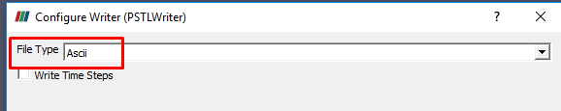

# **CONRAD App**

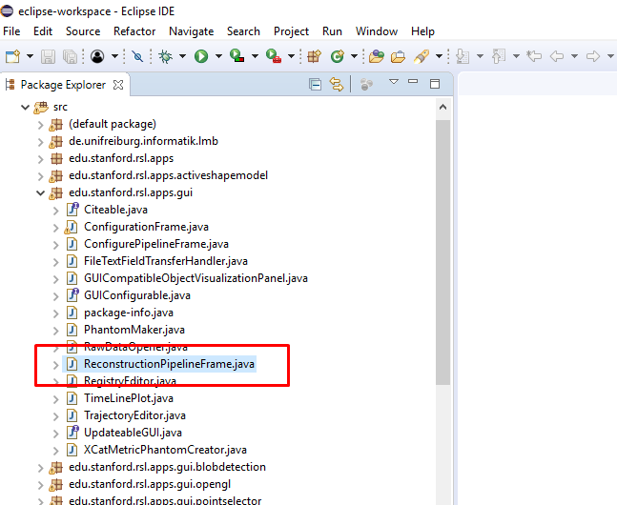

# **CONRAD Configuration Settings**

## Volume

Always perform center volume.

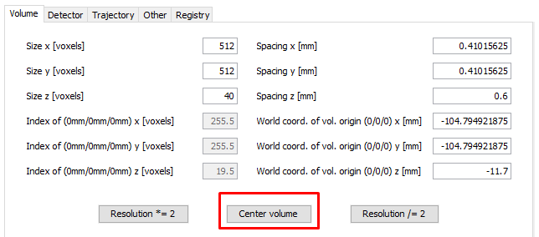

## Detector

Be careful to adjust the size of the detector to match the reconstruction dimensions, otherwise you may receive error that the size doesn’t correspond.

I was getting problems when setting too big resolution for the current reconstruction volume (e.g. 680x680).

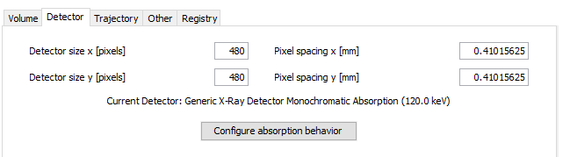

## Trajectory

Projection stack size – how many ‘average angular increment’ will be performed. Can be specified 360 with average angular increment of 1.0.

After editing the data always press ‘Define a trajectory’.

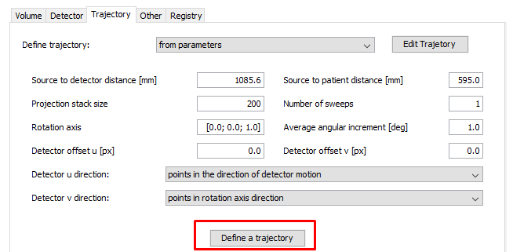

## Pipeline

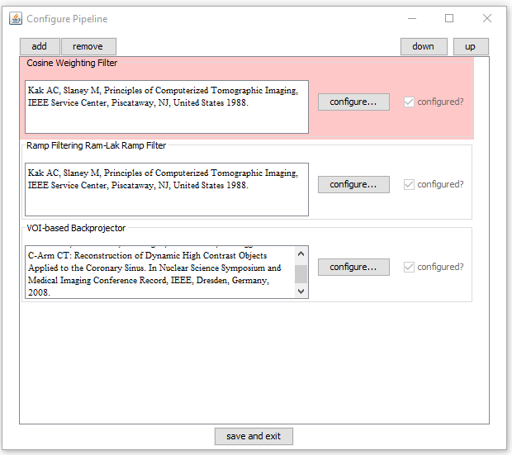

# **CONRAD Creating projection and reconstruction**

## Create a phantom

Note (01.06.2019): I had some issues with using Metric Phantom Projection. So better to stick with Projection Phantom.

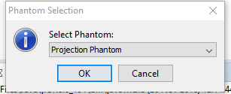

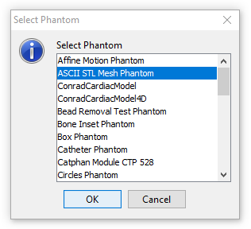

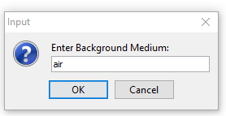

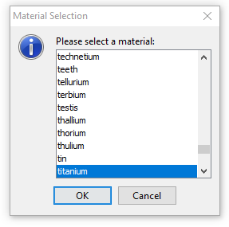

## Projection output

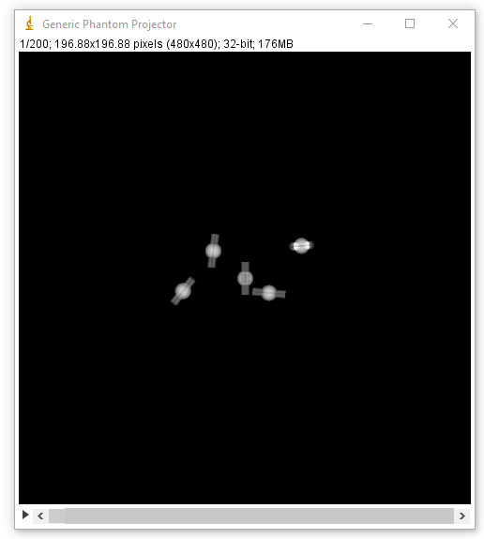

## Reconstruction

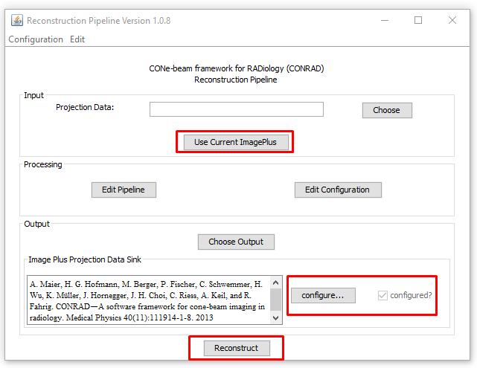

## Reconstruction output

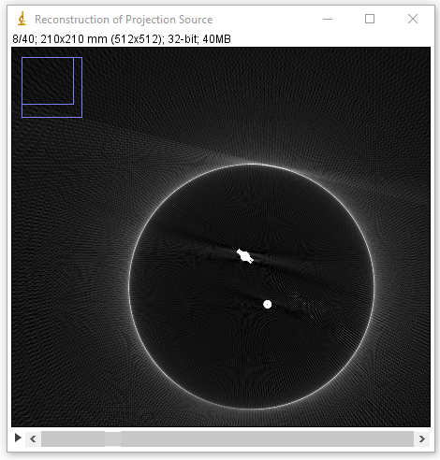

## Save reconstruction data

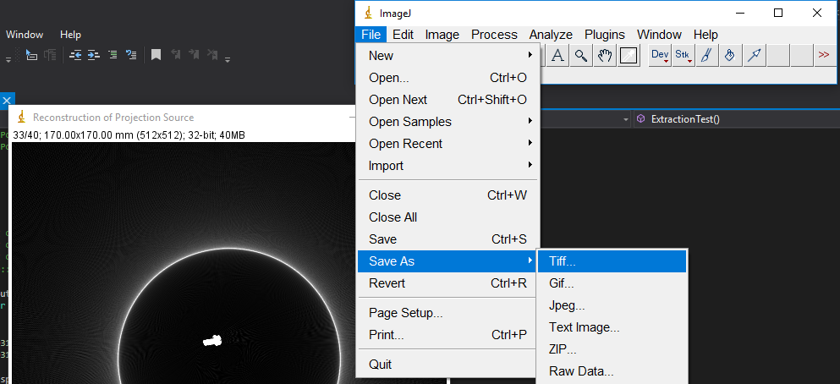

## Data modification

In order to read data with ITK or 3D Slicer: save the reconstruction output in the TIFF format in Image J.

After that, the file can be opened with 3D Slicer and converted to the .mhd format. The new .mhd file can be read by ITK and spacing should be adjusted. The TIFF file has default [1, 1, 1] spacing, which should be adjusted to spacing defined in the reconstruction VOLUME configuration.

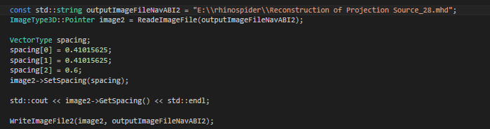

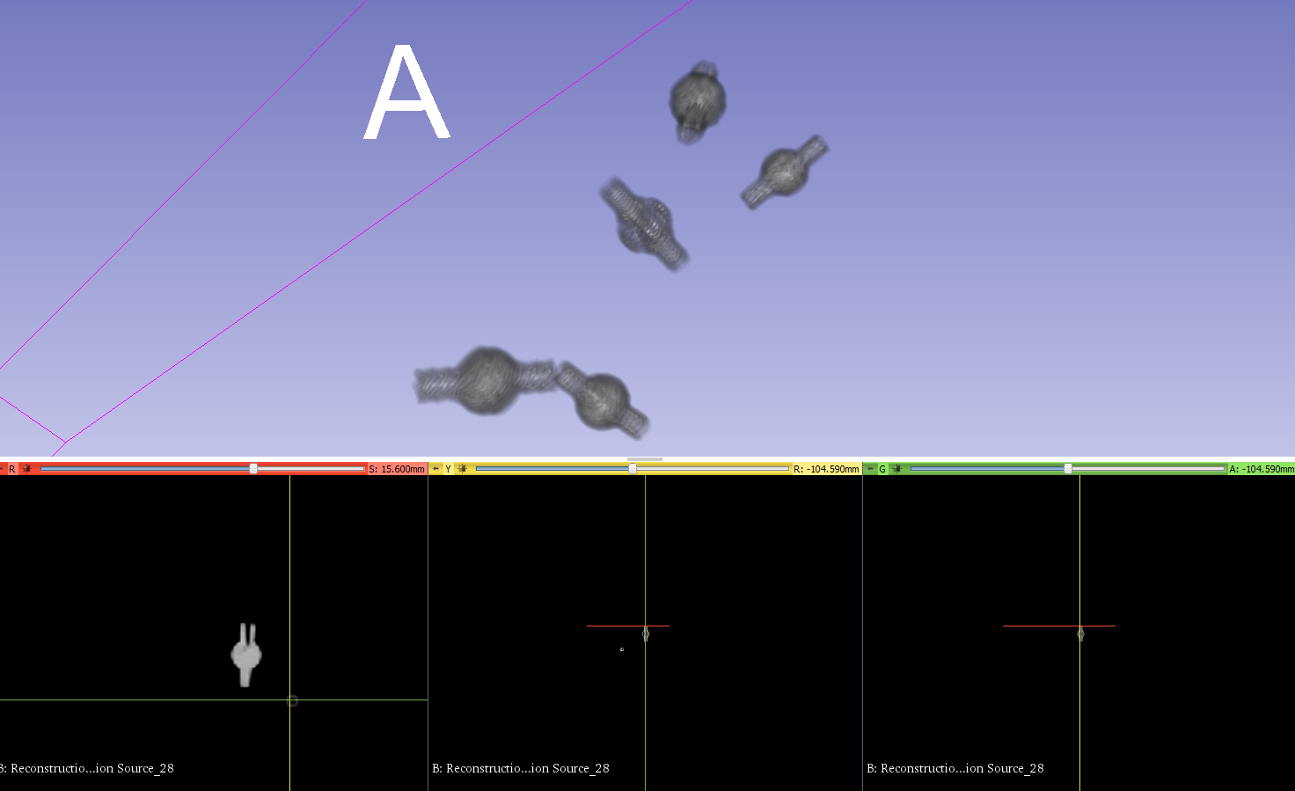

# Artifacts

## Apply thresholding

Sometimes it is necessary to perform thresholding of the .tiff file in 3D Slicer. The thresholding range is 0.01 (or 0.04 for better) to 1 (ThresholdImageFilter or BinaryThresholdImageFilter).

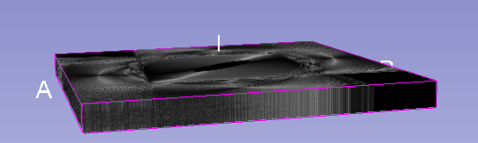

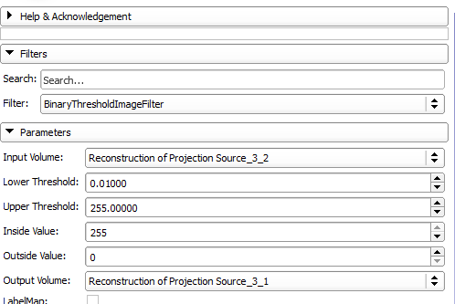

## Blurring

Settings 360 degree angle (Projecting stack size 720 and angle increase 0.5 – CONRAD Trajectory configuration). This is causing by applying 0.5 degree increase. I found out empirically that good is 1.

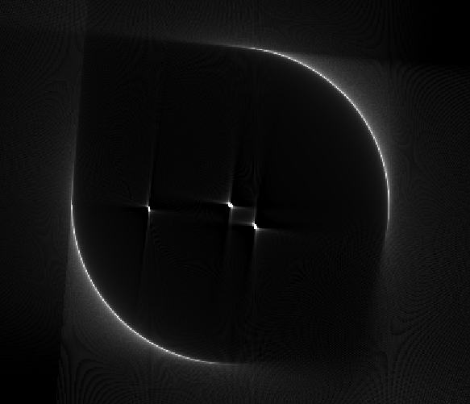

This artifact is caused by including default module Parker Redundancy Weighting Filter.

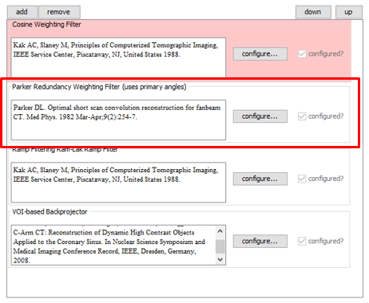

## Transparency of object at the origin (centre of the coordinate system)

It seems that the object that is at location [0, 0, 0] is less irradiated that the other objects. The consequences of that is that it looks transparent in the final reconstructed CT image.

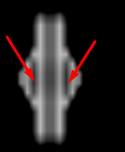

Figure from the 3D Slicer coronal slice

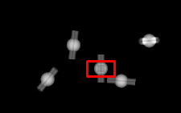

Figure from Image J projection output

## 3D Slicer – Scalar Opacity Mapping

Sometimes there is a black box that appears for CONRAD projected source in 3D Slicer Volume Rendering Panel.

And it cannot be removed by a threshold.

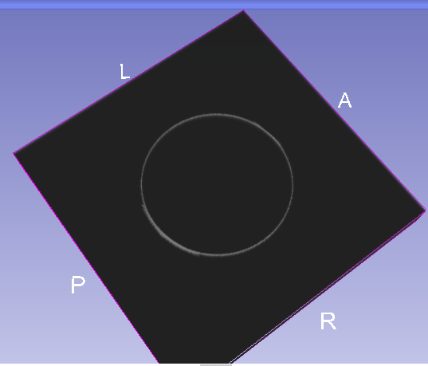

In order to remove it, it can be adjusted Scalar Opacity Mapping in the Volume Properties under Volume Rendering Panel.

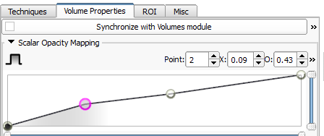

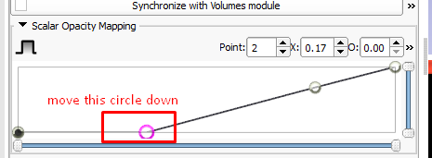

The box will magically disappear!



See also <https://discourse.slicer.org/t/volume-model-has-black-box-around-it/4054/5>

## Strange Reconstruction of a projected source

Projected source was done normally.

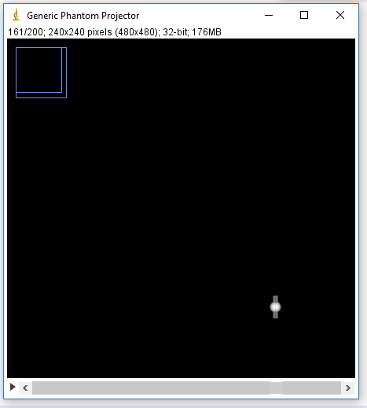

But then we get something like this as a reconstruction result:

|  |  |
| --- | --- |
|  |  |
|  | 3D Slicer of this projection source – does not look like a Rhinospider fiducial marker. |

I am not sure what is a cause of this, but it might be related to option:

## Not centered projection

For this case we had projection stack size at 200.



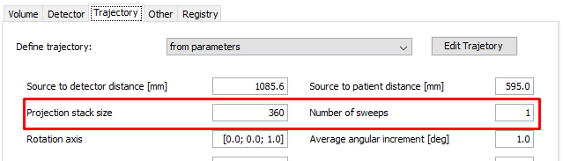

## Detector adjustment – Always press Define a Trajectory

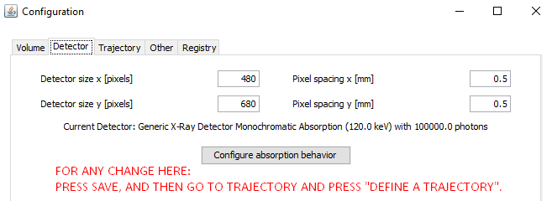

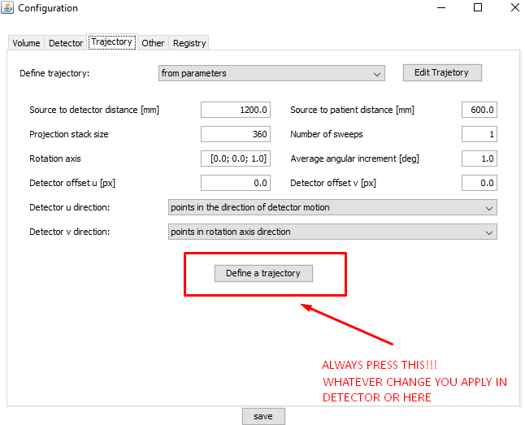

Extending