## Repository Clone Instructions and branch creation

Go to directory where you want repository cloned repository and run the following commands:

1. To clone repository

git clone [git@github.com:mregpala/project-national-park-performance.git](mailto:git@github.com:mregpala/project-national-park-performance.git)

1. Change directory to repository directory

cd project-national-park-performance/

1. Create new branch. Change mike to your name.

git branch developer-mike

1. To work in branch you must check it out.

git checkout developer-mike

1. Create local branch on remote server

git push --set-upstream origin developer-mike

The following is the link to remote repository: <https://github.com/mregpala/project-national-park-performance>

Make sure you work in your repository as you make changes (git checkout developer-mike). After you commit and push changes to branch create a pull request, so your changes can be reviewed before merged to main.

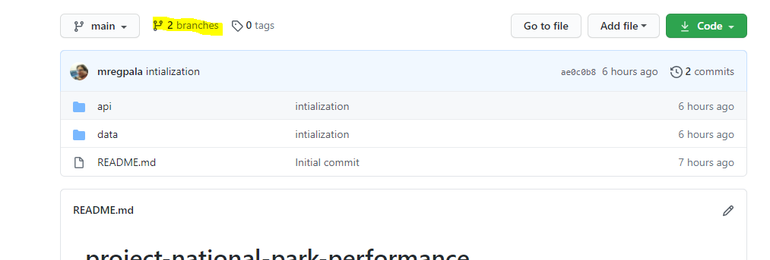

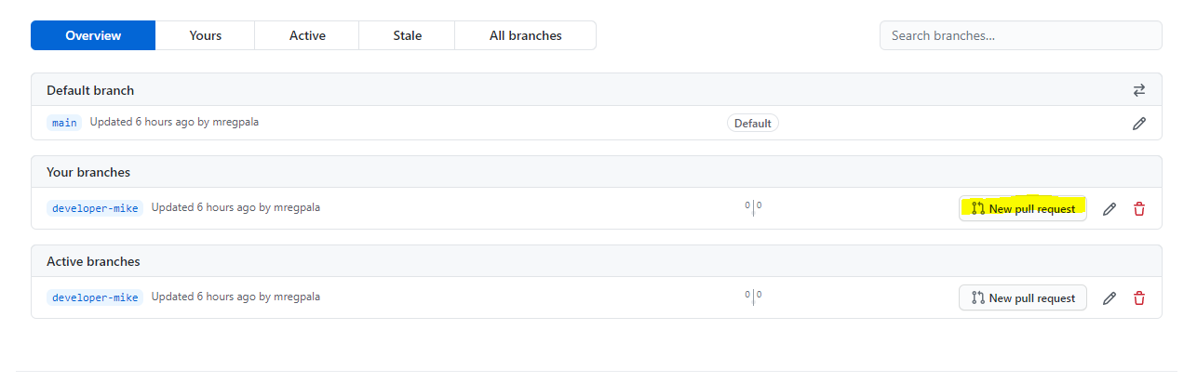

## Project tasks being recorded on GitHub Remote repository

