WHATSAPP AI ASSISTANT
Complete Project Documentation and Operating Guide
Purpose: A practical guide for operating, configuring, securing, and extending the multi-session WhatsApp assistant.

Version: Current local implementation
Prepared: 2026-08-19

Contents
- Project overview and scope
- Architecture and data isolation
- Installation and configuration
- WhatsApp registration and phone pairing
- Modes and message behavior
- Meeting, tasks, location, and Calendar automation
- AI, live information, and voice notes
- Operations, monitoring, and troubleshooting
- Security, privacy, and limitations
- Future web-platform roadmap

1. Project overview and scope
WhatsApp AI Assistant is a Node.js service built with Baileys and OpenRouter. It connects one or more WhatsApp accounts, receives incoming messages, and applies an assistant profile for each independent session.
Important: Baileys is an unofficial WhatsApp Web client. Use only WhatsApp accounts you own or are authorized to manage. Automated use can be restricted by WhatsApp and must comply with applicable laws and platform terms.

What the system does
- Runs separate WhatsApp sessions under sessions/<userId>/.
- Replies to incoming messages when Away Mode is enabled.
- Supports Advisor Mode for natural English and Roman Urdu conversations and supportive everyday advice.
- Answers current-information questions through OpenRouter web search when available.
- Transcribes push-to-talk voice notes through the configured transcription provider.
- Records eligible contact metadata and explicitly shared locations.
- Forwards meeting, time, and location alerts to the account owner self-chat.
- Stores extracted tasks and creates Google Calendar events for valid detected meetings when Calendar is connected.

2. Architecture and data isolation
Each userId has an independent Baileys authentication directory, local SQLite database, owner identity, reply-rate state, task list, and Google Calendar token. A connection or logout failure in one session does not stop the other sessions.
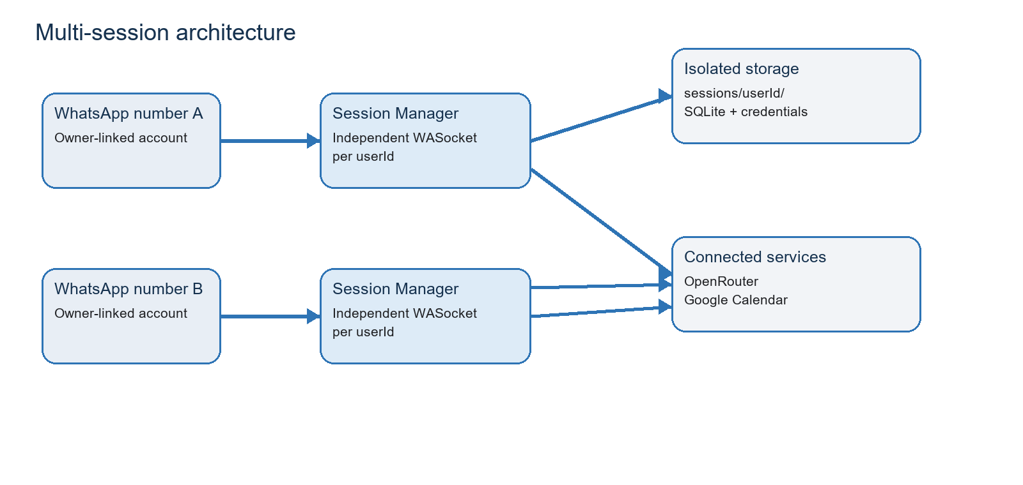
Figure 1. Each WhatsApp account has isolated session credentials, data, and integrations.
Component | Responsibility | Storage / boundary
index.js | Session manager, WhatsApp events, commands, reply flow, alerts | One WASocket per userId
src/openrouterClient.js | Structured AI replies, live web queries, voice transcription | Uses OpenRouter API key
src/dataStore.js | SQLite contacts, tasks, reply times, message dedupe, Calendar mappings | sessions/<userId>/assistant.sqlite
src/googleCalendar.js | Google OAuth and Calendar event creation | Per-user encrypted token
src/sessionStore.js | Session paths and session metadata | sessions/<userId>/session.json

3. Installation and configuration

Requirements
- Node.js 22.5 or later.
- A WhatsApp account for every session.
- An OpenRouter API key.
- OpenRouter balance for dependable web search and voice transcription.
- Google Cloud OAuth credentials only if Google Calendar automation is required.

Install
From the project directory:
Command: npm.cmd install
Copy-Item .env.example .env

Environment variables
Variable | Purpose | Recommended / notes
OPENROUTER_API_KEY | Authorizes AI, live search, and audio requests | Required. Never commit or share it.
OPENROUTER_MODEL | General replies and task extraction | Free models may be rate limited.
OPENROUTER_LIVE_MODEL | Current/live questions with web search | Requires model availability and usually credit.
OPENROUTER_FALLBACK_MODELS | Optional alternate models | Comma-separated model IDs.
OPENROUTER_TRANSCRIPTION_MODEL | Voice-note transcription model | Audio usage may require balance.
APP_TIME_ZONE | Timezone for task context and alerts | Asia/Karachi for this deployment.
MIN_REPLY_INTERVAL_MS | Per-chat flood guard | 15000 ms gives about four replies/minute/chat.
IGNORE_GROUPS | Ignore group chats | true is recommended.

Google Calendar configuration
Variable | Purpose
GOOGLE_CALENDAR_CLIENT_ID | OAuth client ID from the same Google Cloud project.
GOOGLE_CALENDAR_CLIENT_SECRET | OAuth client secret. Keep it private.
GOOGLE_CALENDAR_REDIRECT_PORT | Local callback port; default 3000.
GOOGLE_CALENDAR_REMINDER_MINUTES | Popup reminder before the created event; default 30.
CALENDAR_TOKEN_ENCRYPTION_KEY | Optional dedicated secret to encrypt Calendar tokens at rest.

Google OAuth note: For private testing, configure an External app in Testing status, add the Calendar owner Gmail as a Test user, enable Google Calendar API, and allow the calendar.events scope. The OAuth approval page must be completed in a browser on the same computer that runs the local callback server.

4. WhatsApp registration and phone pairing
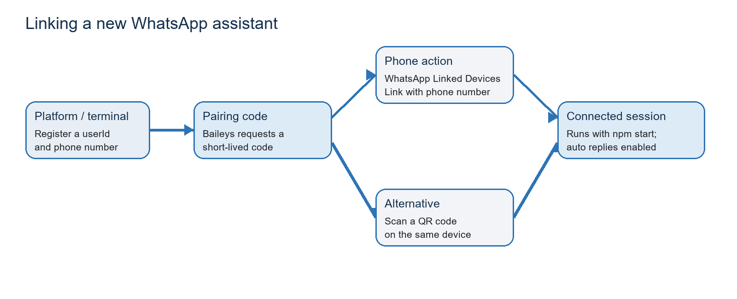
Figure 2. A new session can use a pairing code instead of a terminal QR code.

Existing session
Start all registered sessions:
Command: npm start

Register by QR code
Command: npm run register -- rehan

Scan the terminal QR using WhatsApp > Linked devices > Link a device.

Register by phone-number pairing code
Command: npm run register:pair -- advisor 923001234567

Use country code and digits only: no plus sign and no leading zero. On the target phone, open WhatsApp > Linked devices > Link a device > Link with phone number instead, then enter the code printed by the service.
Security: A pairing code gives access to a WhatsApp linked-device session. Show it only to the phone owner and do not store it in logs or screenshots.

5. Assistant modes and message behavior

Away Mode
Away Mode is intended for an owner who is unavailable. It sends quick greeting replies, answers general questions, and otherwise uses the configured assistant prompt to acknowledge messages and extract tasks.

Advisor Mode
Advisor Mode uses a dedicated prompt. It holds natural conversations, matches English or Roman Urdu, and offers supportive practical advice for everyday, relationship, study, and work topics. It must not present itself as an emergency, medical, legal, or financial professional.
Enable Advisor Mode: npm run profile:advisor -- rehan

Owner self-chat commands
Command | Effect
!away on | Enable automatic replies for this session.
!away off | Disable automatic replies while retaining logging and owner alerts.
!away status | Report whether automatic replies are enabled.
!tasks | List pending saved tasks for the current userId.
!calendar connect | Start Google OAuth and send the approval URL to owner self-chat.
!calendar status | Check whether the per-session Calendar token is working.
!calendar add 1 | Manually add an older pending task to Calendar.
!calendar disconnect | Remove the saved Google Calendar connection for this session.

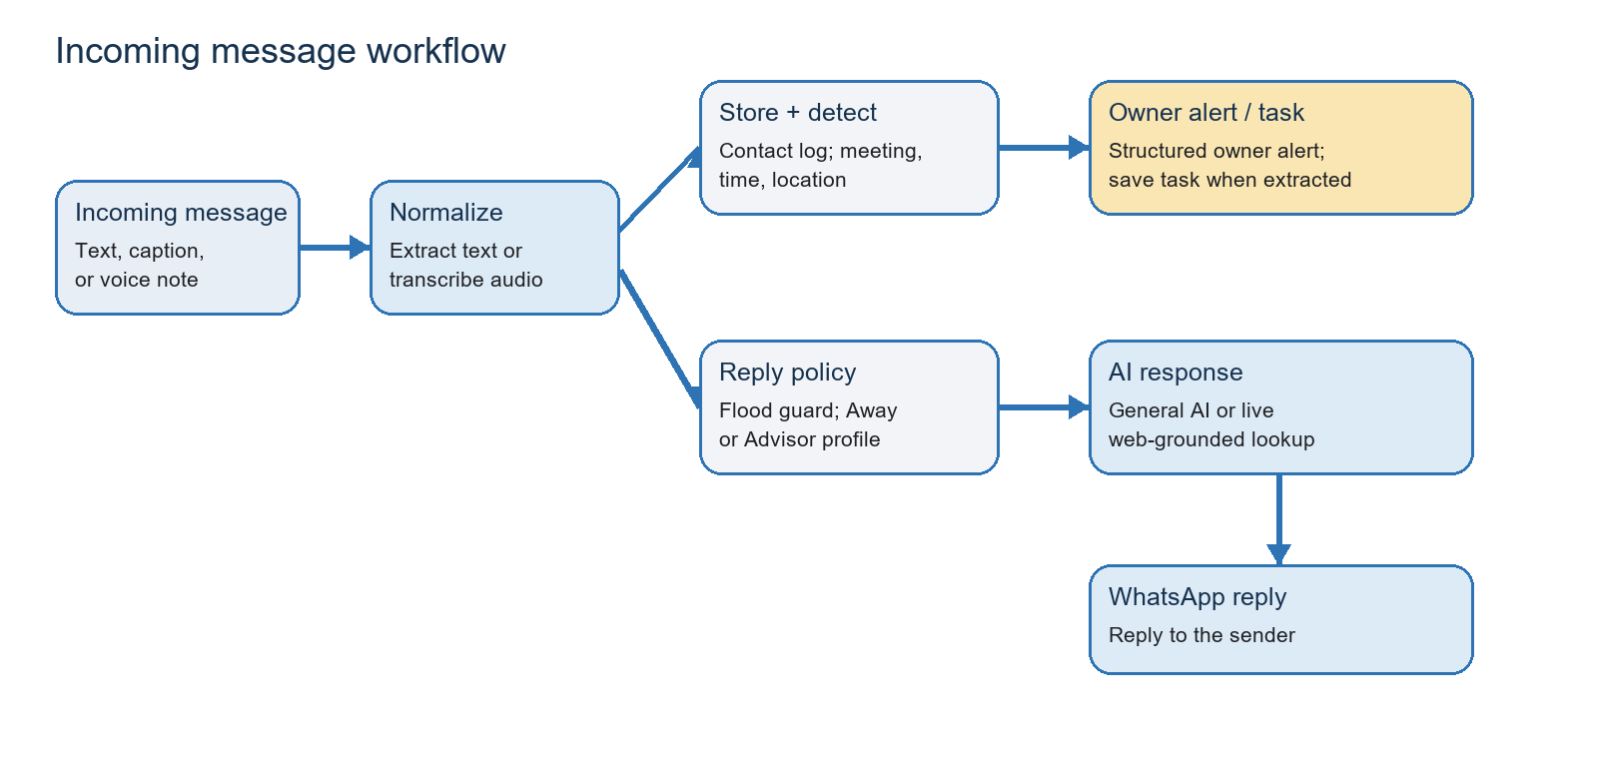
Figure 3. The standard incoming-message path, including logging, alerting, and reply selection.

6. Meeting, tasks, location, and Calendar automation
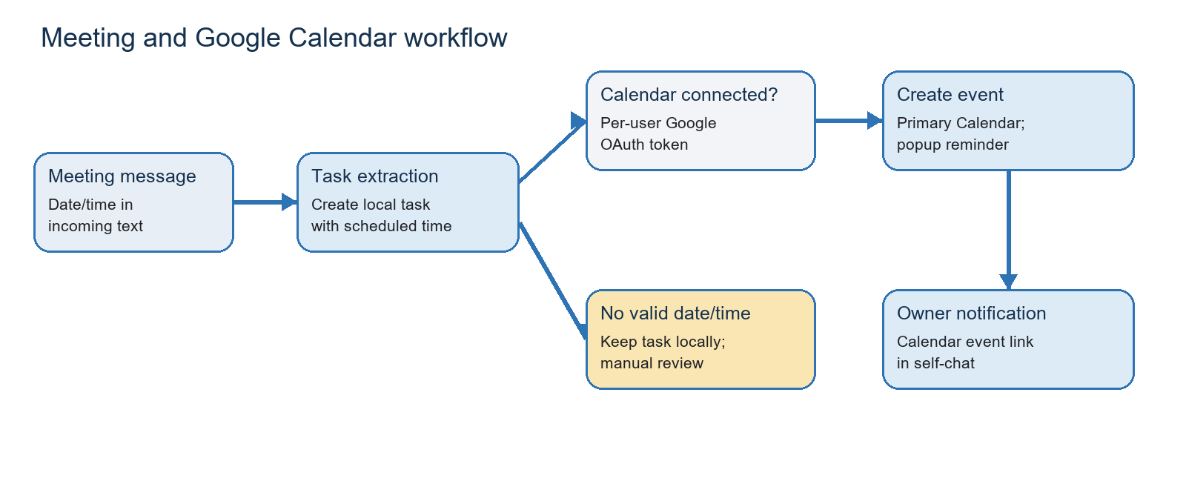
Figure 4. Valid extracted meetings are added to the connected primary Google Calendar.

Meeting alert contents
- Place or Google Maps link when the sender explicitly shared a location.
- Detected time/date reference.
- Venue when available.
- Sender display name and WhatsApp chat identifier.
- Task description, received timestamp, timezone, and original message.

Automatic Calendar event behavior
- The model extracts a task marked as a meeting with a valid scheduledFor date and time.
- The task is stored under the user session database and receives a unique task ID.
- The service checks that this user session has a Google Calendar token.
- An event is inserted into that user account primary Calendar with a one-hour duration and configured popup reminder.
- The event ID and link are stored to prevent re-adding the same saved task.
- The owner self-chat receives a Calendar confirmation and event link.
Important limitation: If the date/time is unclear, the task is kept locally for review. If the Calendar is disconnected, task saving and WhatsApp replies continue; Calendar creation is skipped and logged.

7. AI, live information, and voice notes

General and advice replies
OpenRouter is used for structured JSON replies and task extraction. The reply is sent only after the per-chat flood guard permits it. Common Salaam and "how are you" messages use immediate predefined replies without an AI request.

Live/current questions
Current questions such as weather, gold/silver price, exchange rates, news, sports scores, availability, and bank timings use the configured live model with web search. The service should not invent a current value; it returns a fallback if no verified answer is available.

Voice notes
A WhatsApp push-to-talk voice note is downloaded and sent to the transcription endpoint. Its transcript follows the same logging, alert, task, Calendar, and reply workflow as text.
Cost and availability: A 402 audio error means the OpenRouter account does not meet the required audio balance. A 429 error means a provider/model is temporarily rate limited. These are provider-account conditions rather than WhatsApp connection failures.

8. Operations, monitoring, and troubleshooting

Routine commands
Command | Use
npm start | Start every registered session.
npm run list-sessions | List registered user sessions.
npm run calendar:status -- rehan | Check Calendar configuration and connection for a user.
npm.cmd exec pm2 status | Check PM2 service state when deployed with PM2.
npm.cmd exec pm2 logs whatsapp-assistant | View bot logs.
npm.cmd exec pm2 restart whatsapp-assistant | Restart the PM2-managed process.
npm.cmd exec pm2 stop whatsapp-assistant | Stop the PM2-managed process.

Common problems
Symptom | Likely cause | Action
No AI reply | Away Mode off or flood guard active | Send !away status; wait 15 seconds between messages from the same chat.
Delayed / fallback reply | Free model 429 rate limit | Wait for retry, configure a fallback, or use a reliable paid model.
Voice note failed | OpenRouter audio 402 or transcription issue | Add account credit and check transcription model.
Calendar not connected | OAuth approval incomplete, test user missing, or callback opened on phone | Use browser on the bot computer; check !calendar status.
127.0.0.1 callback error on mobile | Phone cannot reach computer localhost | Open approval link on the same computer as npm start.
Session logged out | WhatsApp linked device revoked | Relink that session with QR or pairing code.

9. Security, privacy, and compliance

Data stored
- Contact WhatsApp JID, display name (pushName), and message timestamp.
- Latitude and longitude only when the contact explicitly sends a WhatsApp location message.
- Saved tasks, message deduplication IDs, and per-chat reply timestamps.
- Encrypted Google Calendar OAuth tokens and Calendar event mappings when Calendar is connected.

Data not collected by this project
- Device IP addresses.
- Contact device model details.
- Location that was not explicitly shared through a WhatsApp location message.

Required protections
- Never commit .env, sessions/, WhatsApp credentials, assistant.sqlite, or API keys.
- If a key was exposed, revoke it at the provider and create a replacement.
- Display a clear contact privacy notice and ensure you have a lawful basis for logging names, JIDs, timestamps, and shared locations.
- Use a dedicated CALENDAR_TOKEN_ENCRYPTION_KEY in production rather than relying on an API-key fallback.
- For a public dashboard, require user authentication, HTTPS, session ownership checks, rate limits, and audit logs.

10. Future web-platform roadmap
The current project is a service operated through terminal commands. To let many users link and manage assistants without terminal access, build a secure web platform around the existing session manager.
- Add an authenticated web backend with routes for users, sessions, pairing codes, QR display, status, tasks, and Calendar connections.
- Build a dashboard where each customer creates an assistant, enters a phone number, receives a pairing code, and sees status.
- Enforce ownership so a user can only access their own WhatsApp session, data, and Calendar token.
- Move multi-user metadata and logs from local-only storage to a managed database such as PostgreSQL for hosted deployments.
- Keep Baileys auth credentials encrypted at rest and use a background worker/process supervisor for every session.
- Deploy behind HTTPS with backups, monitoring, abuse controls, and reliable paid AI providers.
Platform boundary: A browser dashboard removes terminal access for customers, but the server must still run continuously in a protected environment. Pairing codes and WhatsApp credentials remain highly sensitive.

Appendix A. File and data layout
Path | Purpose
index.js | Application entry point and multi-session WhatsApp event handler.
src/config.js | Environment variable parsing and runtime configuration.
src/openrouterClient.js | AI, web-grounded live answers, and audio transcription.
src/dataStore.js | Per-user SQLite schema and persistent data access.
src/googleCalendar.js | Google OAuth token handling and Calendar events.
src/sessionStore.js | Session paths and per-user metadata.
sessions/<userId>/baileys_auth_info/ | WhatsApp linked-device credentials.
sessions/<userId>/assistant.sqlite | Per-user contacts, tasks, state, tokens, and event mappings.
.env | Private runtime configuration and secrets; never commit.
README.md | Quick-start and operator reference.

Appendix B. Operational checklist
- Verify .env includes a valid OpenRouter key and Asia/Karachi timezone if intended.
- Run npm.cmd install after pulling dependency changes.
- Run npm start and confirm each session logs "WhatsApp user session connected".
- For Calendar, complete !calendar connect from a browser on the service computer and confirm !calendar status.
- Test greeting, Advisor conversation, valid meeting, live question, and voice note separately.
- Review logs for 429 rate limits, 402 audio balance errors, and connection-close events.
- Back up session credentials and SQLite databases securely; do not expose them in Git or chat.

