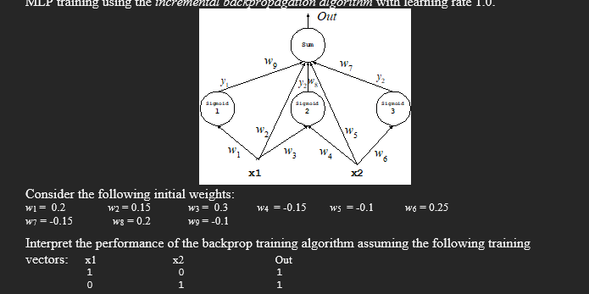

Training sample 1
X1 X2 Y
1 0 1

Oi1 = X1 = 1
Oi2 = X2 = 0

Forward propagate

Oj1 = sigmoid(Oi1 * w1 ) = sigmoid (1 * 0.2) = sigmoid (0.2) =0.549834
Oj2 = sigmoid(Oi1 * w3 + Oi2 * w4) = sigmoid (1 * 0.3 + 0 *-0.15) = sigmoid (0.3) =0.5744425
Oj3 = sigmoid(Oi2 * w6) = sigmoid (0 * 0.25) = sigmoid (0) =0.5
Ok = (Oj1 * w9 + Oi1 * w2 + Oj2 * w8 + Oi2 * w5 + Oj3 * w7) = (0.549834 * -0.1 + 1 * 0.15 + 0.5744425 * 0.2 + 0 * -0.1 + 0.5 * -0.15 = 0.1349051

Compute the benefit at the node k in the output layer

Bk = [yk – Ok] = [1 – 0.1349051] = 0.8650949

Compute the changes for weights j->k and i-k on connections to nodes in the output layer

w9_delta = n*Bk*Oj1 = 1*0.8650949*0.549834 =0.4756586
w2_delta = n*Bk*Oi1 = 1*0.8650949*1 =0.8650949
w8_delta = n*Bk * Oj2 = 1*0.8650949*0.5744425 =0.4969473
w5_delta = n*Bk * Oi2 = 1*0.8650949*0 =0
w7_delta = n*bk*Oj3 = 1*0.8650949*0.5 =0.4325474

Compute the benefit at nodes j

Bj1 = Oj1(1-Oj1) * (Bk * w9) = 0.549834(1-0.549834) * (0.8650949 * -0.1) = -0.0214125
Bj2 = Oj2(1-Oj2) * (Bk * w8) = 0.5744425(1-0.5744425) * (0.8650949 * 0.2) = 0.0422959
Bj3 = Oj3(1-Oj3) * (Bk *w7) = 0.5(1-0.5) * (0.8650949 *-0.15) = -0.0324411

Compute the changes for weights i->j

w1_delta = n *Bj1*Oi1 = 1 *-0.0214125*1 = -0.0214125
w3_delta = n * Bj2 * Oi2 = 1 * 0.0422959 * 1 = 0.0422959
w4_delta = n * Bj2 * Oi2 = 1 * 0.0422959 * 0 = 0
w6_delta = n * Bj3 * Oi3 = 1 * -0.0324411 * 0 = 0

Update the weights

w1 = w1 + w1_delta = 0.2 + -0.0214125 =0.1785875
w2 = w2 + w2_delta = 0.15 + 0.8650949 =1.0150949
w3 = w3 + w3_delta = 0.3 + 0.0422959 =0.3422959
w4 = w4 + w4_delta = -0.15 + 0 =-0.15
w5 = w5 + w5_delta = -0.1 + 0 =-0.1
w6 = w6 + w6_delta = 0.25 + 0 =0.25
w7 = w7 + w7_delta = -0.15 + 0.4325474 =0.2825474
w8 = w8 + w8_delta = 0.2 + 0.4969473 =0.6969473
w9 = w9 + w9_delta = -0.1 + 0.4756586 =0.3756586

Training sample 2

X1 X2 Y
0 1 1

Oi1 = X1 = 0
Oi2 = X2 = 1

Forward propagate

Oj1 = sigmoid(Oi1 * w1 ) = sigmoid (0 * 0.1785875) = sigmoid (0) =0.5
Oj2 = sigmoid(Oi1 * w3 + Oi2 * w4) = sigmoid (0 * 0.3422959 + 1 *-0.15) = sigmoid (-0.15) =0.4625702
Oj3 = sigmoid(Oi2 * w6) = sigmoid (1 * 0.25) = sigmoid (0.25) =0.5621765
Ok = (Oj1 * w9 + Oi1 * w2 + Oj2 * w8 + Oi2 * w5 + Oj3 * w7) = (0.5 * 0.3756586 + 0 * 1.0150949 + 0.4625702 * 0.6969473 + 1 * -0.1 + 0.5621765 * 0.2825474 = 0.5690579

Compute the benefit at the node k in the output layer

Bk = [yk – Ok] = [1 – 0.5690579] = 0.4309421

Compute the changes for weights j->k and i-k on connections to nodes in the output layer

w9_delta = n*Bk*Oj1 = 1*0.4309421*0.5 =0.215471
w7_delta = n*bk*Oj3 = 1*0.4309421*0.5621765 =0.2422655

Compute the benefit at nodes j

Bj1 = Oj1(1-Oj1) * (Bk * w9) = 0.5(1-0.5) * (0.4309421 * 0.3756586) = 0.0404718
Bj2 = Oj2(1-Oj2) * (Bk * w8) = 0.4625702(1-0.4625702) * (0.4309421 * 0.6969473) = 0.0746652
Bj3 = Oj3(1-Oj3) * (Bk *w7) = 0.5621765(1-0.5621765) * (0.4309421 *0.2825474) = 0.0299697

Compute the changes for weights i->j

w1_delta = n *Bj1*Oi1 = 1 *0.0404718*0 = 0
w3_delta = n * Bj2 * Oi2 = 1 * 0.0746652 * 0 = 0
w4_delta = n * Bj2 * Oi2 = 1 * 0.0746652 * 1 = 0.0746652
w6_delta = n * Bj3 * Oi3 = 1 * 0.0299697 * 1 = 0.0299697

Update the weights
(final weights rounded to 4dp)
w1 = w1 + w1_delta = 0.1785875 + 0 =0.1786
w2 = w2 + w2_delta = 1.0150949 + 0 =1.0151
w3 = w3 + w3_delta = 0.3422959 + 0 =0.3423
w4 = w4 + w4_delta = -0.15 + 0.0746652 =-0.0753
w5 = w5 + w5_delta = -0.1 + 0.4309421 =0.3309
w6 = w6 + w6_delta = 0.25 + 0.0299697 =0.2800
w7 = w7 + w7_delta = 0.2825474 + 0.2422655 =0.5248
w8 = w8 + w8_delta = 0.6969473 + 0.199341 =0.8963
w9 = w9 + w9_delta = 0.3756586 + 0.215471 =0.5911

