

INDINF10 – Debugging with eclipse

Microcontroller



15. Februar 2015

REILÄNDER Manuel

mreilaender@student.tgm.ac.at

X-Server 2

Cygwin 2

Installation 2

Configuration 3

Usage 3

Troubleshooting 3

# X-Server

## Cygwin

### Installation

<http://x.cygwin.com/>

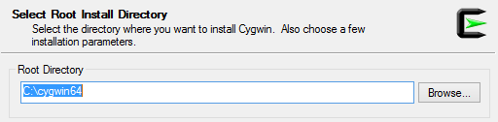

Root directory should be without spaces, e.g. C:\Program Files is NOT valid on the other side C:\cygwin is.

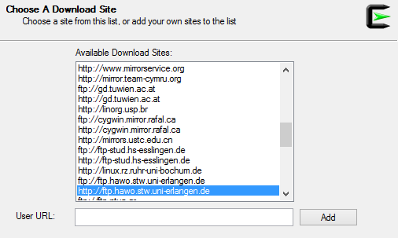

Use an ftp, which is as near as possible -> otherwise download will be very slow

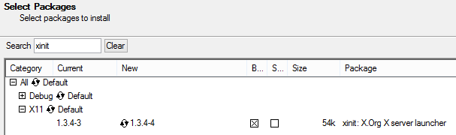

Install *xinit*

### Configuration

#### Enable X11 forwarding on the remote machine



Edit the *ssh_config* file in the root directory of your ssh-provider, and enable x11-forwarding e.g.



See this thread <http://superuser.com/questions/310197/how-do-i-fix-a-cannot-open-display-error-when-opening-an-x-program-after-sshi>

### Usage

Open the Cygwin terminal, which is usually in *Cygwin/bin/mintty*



Open it with the *–* argument as you can see above.

A terminal will open up and you may type in *startxwin*.

Another terminal will open up and you can now start your ssh-connection e.g. as follows.

* ssh –Y username@hostname

You can now start any GUI Application you want and it will be printed on your X-Server.

### Troubleshooting

#### Ssh fatal error

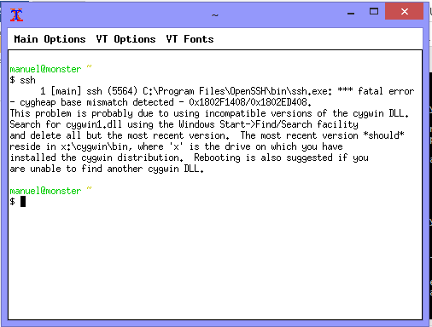

ATTENTION, backup your *ssh/bin/cygwin1.dll* before continuing.

Copy the *cygwin1.dll* from the bin directory of your Cygwin root directory (*Cygwin/bin*), to your ssh bin directory (*ssh/bin*).

#### Untrusted X11 forwarding

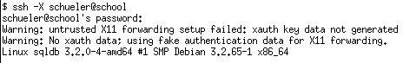

Use *–Y* instead of *–X*, because –Y uses trusted X11 forwarding, see this Thread <http://serverfault.com/questions/273847/what-does-warning-untrusted-x11-forwarding-setup-failed-xauth-key-data-not-ge>