

A12 Window Builder

SEW



11. Februar 2015

Reiländer manuel

mreilaender@student.tgm.ac.at

Inhaltsangabe

# Setup for eclipse

## Create a Window-Builder Project

In order to use the Window-Builder, which is already implemented in eclipse, you may have an existing project and a package.

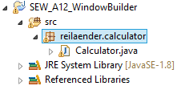

Now you can right click the package and choose *New -> Other*

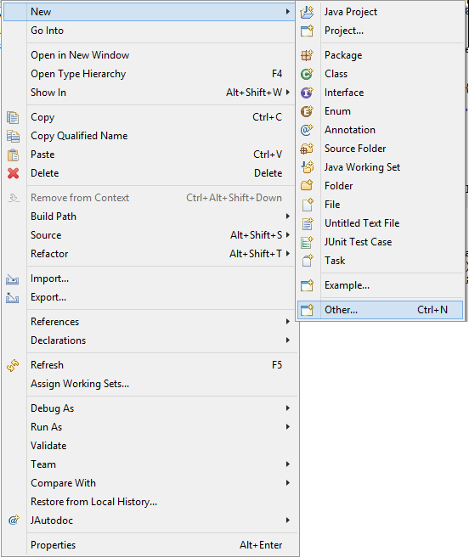

There are several folders, for example Java, Git, General etc. Choose *WindowBuilder -> Swing Designer -> Application Window*

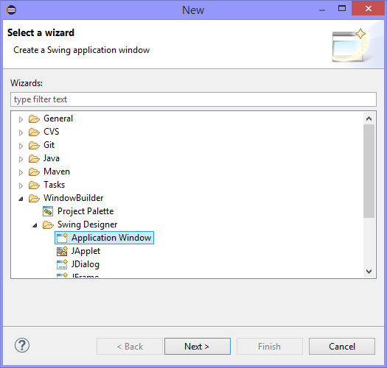

Choose a name for this class and press *Finish*.

A java-file will be created, where 2 tabs are. *Source* and *Design*.

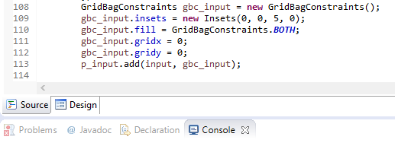

Choose Design and you will be able to customize your own JFrame via drag and drop.