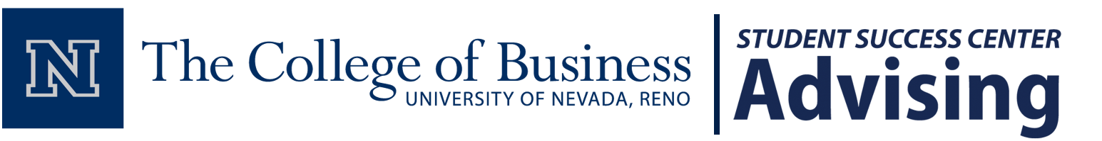

Wednesday, November 28, 2018

Congratulations! We have reviewed your College of Business Major Application, and it is with great pleasure that we are notifying you of your admission to the following degree program within the UNR College of Business for the Spring 2019 term.

**Marketing (B.S.)**

The paperwork you signed and submitted with your application is now en route to UNR’s Office of Admissions & Records for processing within the next 10-14 business days. Please check your “Academic Requirements” report in your MyNEVADA Student Center prior to next semester’s enrollment, to confirm that this is your newly-listed academic “Plan.”

Your next step is to attend our mandatory Declaration Day event, taking place on **Wednesday, October 10th, 2018 at 6:30-8:00pm** in **Davidson Math and Science Center (DMSC),** **Room 110**. At this event, you will learn more about the courses you will take moving forward, declaring a Business Minor, graduation requirements and reminders, and searching for internships/careers.

If you are unable to make this event, email us at [BusinessAdvising@unr.edu](mailto:BusinessAdvising@unr.edu) with your name, NSHE ID number, and the reason(s) why you are unable to attend. We will follow up with you separately.

If you have any questions, visit us in the Student Success Center in AB 409, call us at (775) 784-4912, or email us at [BusinessAdvising@unr.edu](mailto:BusinessAdvising@unr.edu).

On behalf of Dean Mosier, Associate Dean Ryan, and The College of Business faculty, we wish you continued success as you continue the rest of your academic career here at the University of Nevada, Reno.

Best wishes,

***The COB Student Success Center Advising Team***