# MOST WANTED Framework

## Introduction

You have been contracted to build a prototype for a person-searching application for a top-secret government project. You have been given access to an array of objects representing individuals. The prototype should just use window.prompt and window.alert for the User Interface (UI). Although this isn’t typical in production, you may use only three files for this project: an HTML file and two JavaScript files -- One JavaScript file for the application and one JavaScript file containing the data for the application.

💡 Do NOT change any code inside of the data.js file – all of your code will be written inside of the app.js file!

## Resources

**Lectures**

* Callbacks, Array Methods, and Objects
* Intermediate Git & GitHub

**Documents**

* Starter Code: [most-wanted-documentation.zip](https://devcodecamp-my.sharepoint.com/:u:/p/michael/EXoEQZ7HS_JIugE0StzZ8-QBR_-v7Ip_8aiVjcQykgdstA?e=gEJRp5)

**Relevant Projects**

* Day Trip Generator

## Tasks

1. Create and setup GitHub repository with the starter code provided (see Setup Steps below).
2. Using the paired programming methodology if you are part of a team, begin tackling features for the application based on the provided user stories.

## Setup Steps

1. Select a person on your team to create the GitHub repository for the project. Call it MostWanted_JavaScript
   1. Add other team members as collaborators

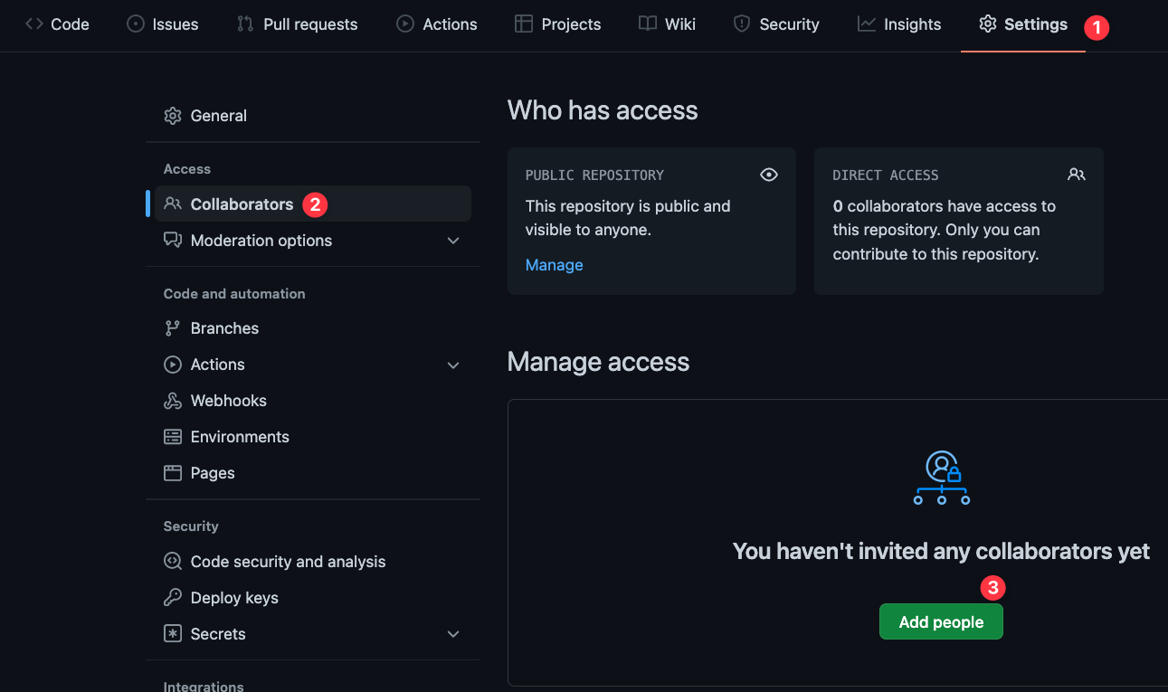

1. Make sure your team members check their email associated with their GitHub accounts for the invitation.
2. Now, the creator of the repository should clone down the starter code for the project (link above). Also clone down the project repository you created, and move the index.html, app.js, and data.js files over to that folder.
3. Add, commit, and push those files up to the repository then have your collaborators pull the updated code. Make sure everyone can open their code as normal.
4. Begin by stepping through the code using the debugger and trying to search for a single person by name, then displaying information about that person.
5. Once you’ve tested the existing searchByName function, begin working on the Search by Traits features.

## End Result

Please see “Project Walkthrough – Most Wanted” for what the end result should look and behave like!