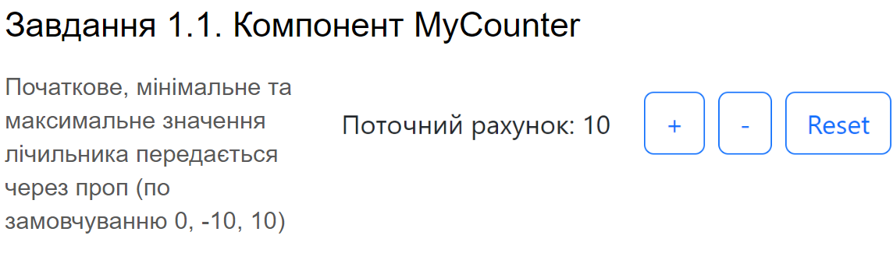

Рішення:



import ***React***, {useState} from "react";  
import {***Button***} from "react-bootstrap";  
  
export default function MyCounter(countStandart = 0, min = -10, max = 10) {  
 let [count, setCount] = useState(countStandart)  
 const changeCountPlus = ()=>{  
 if(max >= count + 1) {  
 setCount(count + 1)  
 } else {  
 alert(`Max is ${max}`)  
 }  
 }  
 const changeCountMinus = () =>{  
 if(min <= count - 1) {  
 setCount(count - 1)  
 } else {  
 alert(`Min is ${min}`)  
 }  
 }  
 const resetCounter = () =>{  
 setCount(0)  
 }  
  
 return <div className={"d-flex justify-content-around"} style={{maxWidth: "20vw"}}>  
 <span>поточний рахунок {count}</span> <Button variant="primary" onClick={changeCountPlus}> + </Button> <Button  
 variant="secondary" onClick={changeCountMinus}> - </Button> <Button  
 variant="danger" onClick={resetCounter}> reset </Button>  
 </div>  
}

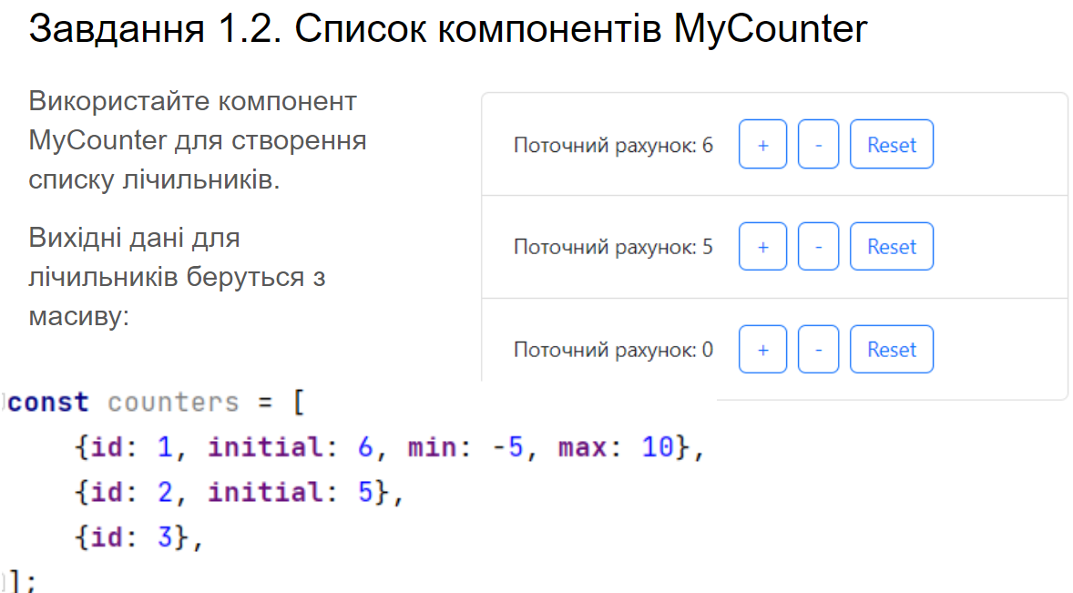

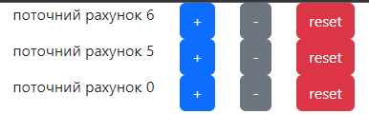

import ***React*** from "react";  
import MyCounter from "./counter";  
  
export default function fewCounter(counters) {  
 return <div className={"d-flex flex-column"}>  
 {counters.map(el => {  
 return MyCounter(el.initial,el.min, el.max)  
 })}  
 </div>  
}

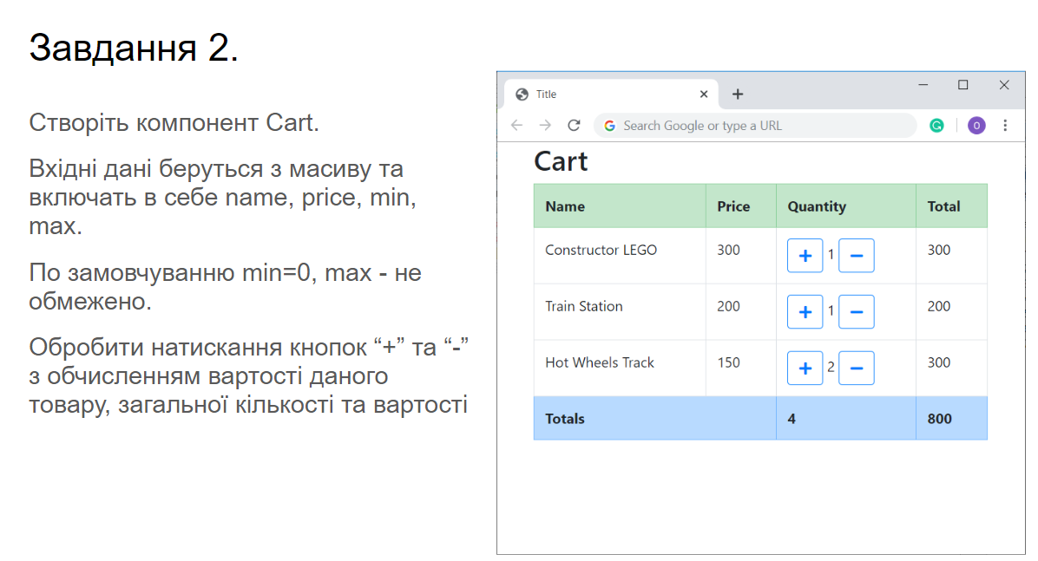

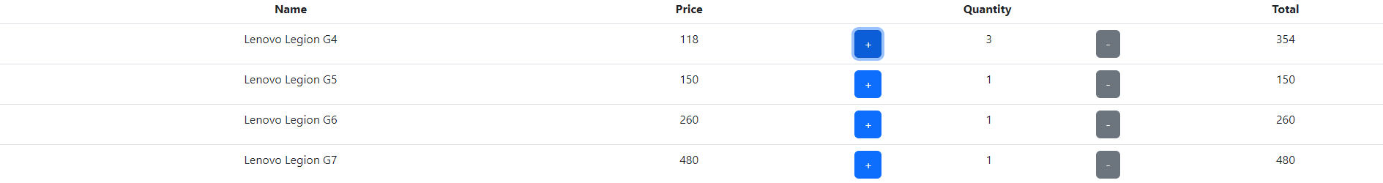

import ***React***, {useRef, useState} from "react";  
import ***Table*** from 'react-bootstrap/Table';  
import MyCounter from "./counter";  
import {***Button***} from "react-bootstrap";  
  
export default function Cart(product) {  
 return <Table>  
 <thead>  
 <tr>  
 <th>Name</th>  
 <th>Price</th>  
 <th>Quantity</th>  
 <th>Total</th>  
 </tr>  
 </thead>  
 <tbody>  
 {product.map(el => {  
 const [count, setCount] = useState(1)  
 const [total, setTotal] = useState(el.price)  
 const changeCountPlusCart = () => {  
 setCount(count + 1)  
 increaseTotal()  
 }  
 const increaseTotal = () => {  
 setTotal(count*el.price)  
 }  
 const changeCountMinusCart = () => {  
 if(count-1 > 0){  
 setCount(count-1)  
 increaseTotal()  
 }  
 }  
 return (<tr>  
 <td>  
 {el.name}  
 </td>  
 <td>  
 {el.price}  
 </td>  
 <td>  
 <div className={"d-flex justify-content-around"}>  
 <Button variant="primary" onClick={changeCountPlusCart}> + </Button>  
 <span>{count}</span>  
 <Button variant="secondary" onClick={changeCountMinusCart}> - </Button>  
 </div>  
 </td>  
 <td>  
 {total}  
 </td>  
 </tr>  
 )  
 })}  
 </tbody>  
 </Table>  
}

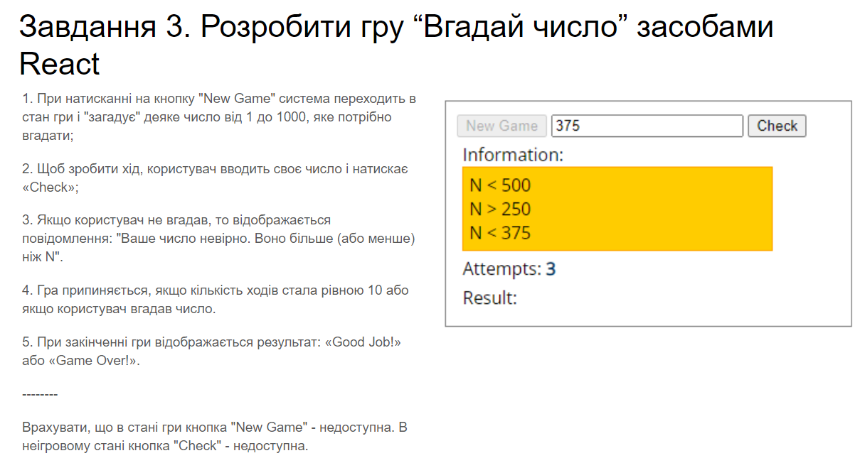

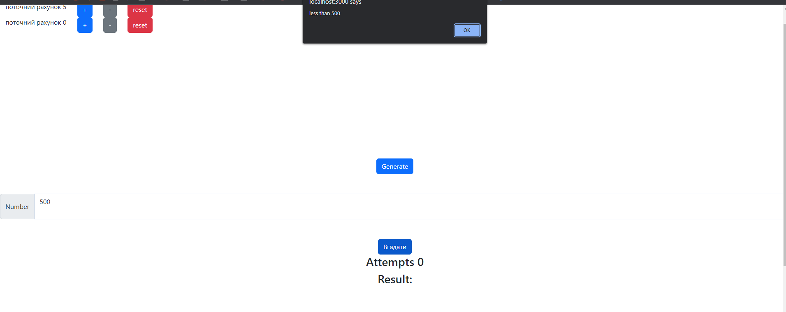

import ***React***, {useState} from "react"  
import {***Button***} from 'react-bootstrap';  
import ***InputGroup*** from 'react-bootstrap/InputGroup';  
import ***Form*** from 'react-bootstrap/Form';  
  
  
export default function Game() {  
 function getRandomInt(max) {  
 return ***Math***.floor(***Math***.random() * max);  
 }  
 const [randomNumber, setRandomNumber] = useState(getRandomInt(1000))  
 let generateRandomNumber = () => {  
  
 setRandomNumber(getRandomInt(1000))  
 setTrys(0)  
 setuserGuess("")  
 }  
  
 const [trys, setTrys] = useState(0)  
 let result = ""  
 const [userGuess, setuserGuess] = useState("")  
 const handlerValueChanger = (e) => {  
 let current = e.target.value;  
 setuserGuess(current)  
 }  
 const submit_hendler = () => {  
  
 setTrys(trys + 1)  
 if (userGuess == randomNumber) {  
 alert("You Win")  
 generateRandomNumber()  
 }else {  
 if(userGuess < randomNumber){  
 alert(`bigger than ${userGuess}`)  
 }  
 else {  
 alert(`less than ${userGuess}`)  
 }  
 }  
 }  
 return <div  
 style={{display: "flex", flexDirection:"column" , alignItems: "center", justifyContent: "center", width: "100vw", height: "100vh"}}>  
 <Button variant="primary" onClick={generateRandomNumber}>Generate</Button>{' '}  
 <InputGroup className={"my-5"}>  
 <InputGroup.Text>Number</InputGroup.Text>  
 <Form.Control as="textarea" aria-label="Number" value={userGuess} onChange={handlerValueChanger}/>  
 </InputGroup>  
 <Button variant="primary" onClick={submit_hendler}>Вгадати</Button>{' '}  
 <h3>Attempts {trys}</h3>  
 <h3>Result: {result}</h3>  
 </div>  
}