DARA AI PLATFORM
Architecture & Delivery Roadmap

AI-Powered Analytics, NLP, and Compliance Intelligence

Document Type | Architecture & Roadmap
Version | 1.0
Date | February 14, 2026
Classification | Internal – Confidential

1. Executive Summary
This document outlines the architecture, current state, and delivery roadmap for the DARA AI Platform initiative. The platform leverages Claude, Google Vertex AI, and Model Context Protocol (MCP) integrations to deliver AI-powered analytics, natural language processing, regulatory compliance intelligence, and automated workflow capabilities for the DARA ecosystem.
The initiative targets two critical milestones: a Rocket Demo on April 1, 2026, and the Ignite presentation on May 9, 2026. This document serves as the authoritative reference for technical architecture decisions, capability status, and prioritized deliverables.

2. Current State Assessment
The following table summarizes the capabilities established to date, including their integration points, current maturity, and status.
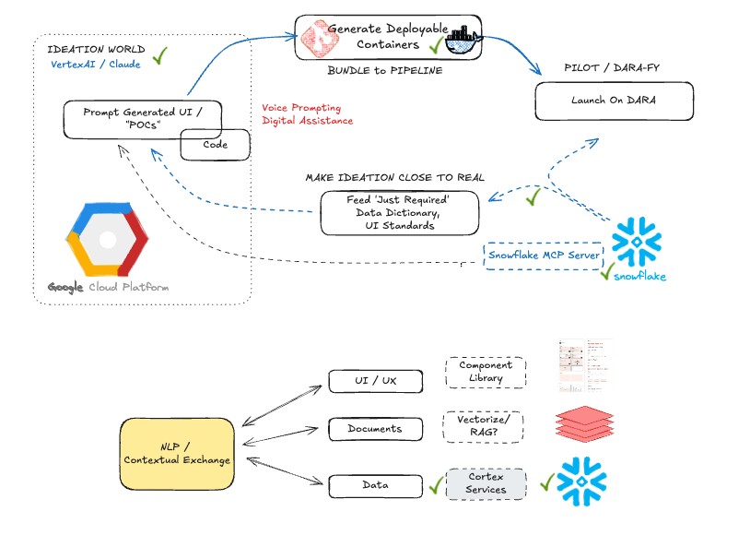
Capability | Description | Integration | Status
Prompt-to-Ideation | Generative AI tooling enabling prompt-driven ideation workflows using Claude and Vertex AI | Claude / Vertex AI | Completed
Ideation based on OLAP Data | Providing limited OLAP Dictionary to Vertex and Claude, produced REAL DARA analytics panels | OLAP / Analytics | Completed
Snowflake MCP Server | Validated connectivity pipeline from Snowflake OLAP data sources to Vertex AI via MCP server and Agent framework | Snowflake MCP | Completed
Storybook MCP Server | MCP server integration with Storybook to generate code aligned with DARA UI standards and component library | Storybook MCP | In Progress
RAG / Document Agent | GCP Document Agent for vectorization and retrieval-augmented generation across DARA User Guides, compliance documents, and regulatory materials | GCP Doc AI | In Progress
NLP Layer | Voice / Digital Assistant :: natural language processing layer on top of vectorized document stores for semantic query and response generation | Vertex AI | In Progress

3. Technical Architecture

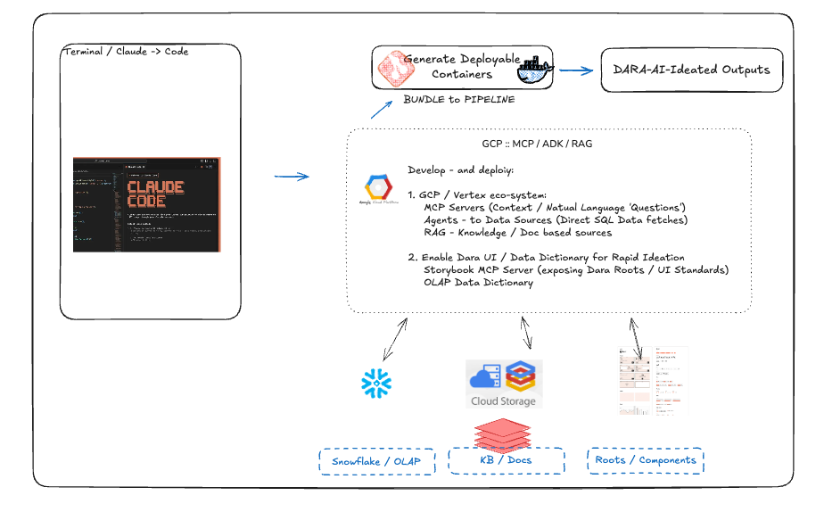

3.1 Platform Components
The DARA AI Platform is built on a modular architecture that integrates multiple AI services and data sources through the Model Context Protocol (MCP) layer. The core components are organized into four tiers: the Data Layer (Snowflake OLAP/Aggregate Marts), the AI Services Layer (Vertex AI, Claude, GCP Document AI), the Integration Layer (MCP Servers, Agents), and the Presentation Layer (DARA UI, Voice/Digital Assistant).

3.2 Data Layer
The data layer provides the foundational data infrastructure for all AI-driven capabilities. Snowflake serves as the primary OLAP data warehouse, hosting Aggregate Marts that power analytics and compliance reporting. Connectivity to the AI Services Layer is established through a validated Snowflake MCP server, enabling direct data retrieval in response to natural language queries.

3.3 AI Services Layer
The AI Services Layer encompasses three primary functions. First, generative analytics powered by Claude and Vertex AI provide prompt-driven insights derived from live data. Second, the RAG pipeline leverages GCP Document AI to vectorize internal documentation (DARA User Guides) and external regulatory/compliance documents, enabling retrieval-augmented generation for contextual, evidence-based responses. Third, the NLP engine provides natural language understanding across data queries, document retrieval, and voice/digital assistant interactions.

3.4 Integration Layer
The MCP (Model Context Protocol) framework serves as the integration backbone, connecting AI services to data sources and UI components. Active MCP servers include the Snowflake MCP for data retrieval, the Storybook MCP for UI code generation aligned with DARA design standards, and the GCP Document Agent for document vectorization and retrieval.

4. Delivery Roadmap & Priority Deliverables
The following deliverables are organized against two key milestones: the Rocket Demo (April 1, 2026) and the Ignite presentation (May 9, 2026).

Workstream | Deliverable | Target
DARA Insights – Analytics | Prompt-generated analytics fetching data directly from OLAP / Aggregate Marts, enabling self-service analytical insights | May 9
NLP – Data Queries | Natural language querying over Snowflake data via MCP, returning structured and conversational responses | May 9
NLP – Document Intelligence | Semantic search and response generation across vectorized DARA and regulatory documents | May 9
NLP – Voice & Digital Assistant | Voice and conversational interface enabling hands-free interaction with platform capabilities | May 9
Compliance Dashboard – Rule Capture | Centralized capture and cataloging of all regulatory rules applicable to the portfolio | May 9
Compliance Dashboard – Test Generation | AI-generated actionable compliance tests derived from regulatory rules | May 9
Compliance Dashboard – Portfolio Analysis | Automated analysis of current portfolio for compliance impact assessment | May 9
Workflow Integration | Intercept call detail anomalies, trigger AI-generated workflow/communication events, and track resolution to closure | April 1

5. Milestone Detail

5.1 Rocket Demo – April 1, 2026
The Rocket Demo is the near-term priority milestone, focusing on demonstrating workflow integration capabilities. The demonstration will showcase the platform’s ability to detect a call detail anomaly in real time, automatically trigger an AI-generated workflow or communication event in response, and provide end-to-end tracking and reporting on the anomaly resolution lifecycle. This demo serves as proof-of-concept for the platform’s operational automation capabilities.

5.2 Ignite – May 9, 2026
The Ignite presentation is the strategic milestone targeting the full breadth of platform capabilities. All workstreams listed in Section 4 are targeted for this date. The presentation will demonstrate DARA Insights analytics, NLP across data and documents, the Regulatory and Compliance Dashboard, and the voice/digital assistant interface.

6. RAG & Document Intelligence Architecture
The Retrieval-Augmented Generation (RAG) pipeline is a critical component underpinning both the NLP and Compliance workstreams. The architecture follows a three-stage process.

6.1 Document Ingestion & Vectorization
Source documents are ingested from two primary corpuses: the DARA User Guide and associated operational documentation, and the Compliance/Regulatory document library. The GCP Document AI Agent processes these documents, extracting text and structural metadata, then generating vector embeddings stored in a vector database for efficient semantic retrieval.

6.2 Retrieval & Response Generation
When a user submits a natural language query, the system performs semantic similarity search against the vector store, retrieves the most relevant document chunks, and passes them as context to the language model for grounded response generation. This ensures that all responses are evidence-based and traceable to source documentation.

6.3 Compliance Application
The Regulatory and Compliance Dashboard leverages this RAG infrastructure to capture regulatory rules, generate compliance tests, and assess portfolio impact. By vectorizing the complete regulatory corpus, the platform enables natural language querying of compliance requirements and automated identification of portfolio exposure to regulatory changes.

7. Risks & Dependencies

Risk / Dependency | Description | Mitigation
Storybook MCP Maturity | MCP server for DARA UI code generation is still under active development | Parallel manual component development as fallback
RAG Vectorization Quality | Quality of vectorized embeddings directly impacts NLP accuracy and compliance coverage | Iterative tuning of chunking strategy and embedding models
April 1 Timeline | Workflow integration demo requires end-to-end anomaly detection, event triggering, and tracking | Early integration testing; scoped demo scenario
Data Access & Governance | Snowflake OLAP access patterns must comply with data governance and security policies | Collaborate with data governance team for access review

8. Next Steps
- Finalize Workflow Integration demo scenario and begin end-to-end integration testing for the April 1 Rocket Demo.
- Complete Storybook MCP server configuration to achieve DARA UI Standards compliance in generated code.
- Expand RAG document corpus to include full regulatory library and validate vectorization quality.
- Build and validate the Regulatory and Compliance Dashboard with rule capture, test generation, and portfolio analysis workflows.
- Prepare integrated demonstration materials for Ignite (May 9) covering all four workstreams.

