Class: pesanKamar

1. Method lamaNginap():

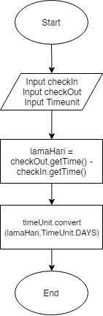

VG = 0+1=1

Path:

1. Method insertPesananDB():

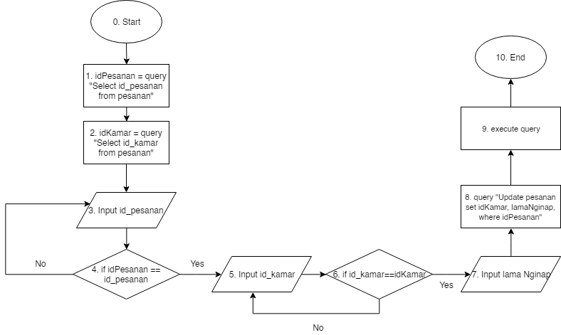

VG: 1+1+1=3

Path:

1. Method updatePesananDB():

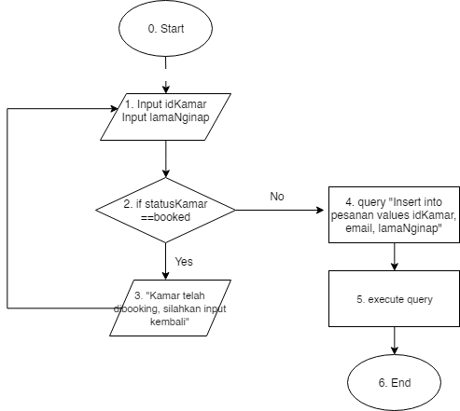

VG: 1 + 1=2

Path:

1. Method hapusPesananDB():

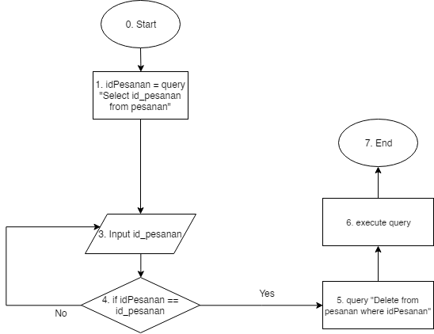

VG: 1 + 1=2

Path: