
IT-SIMPLERA INSTITUTE
Network Administration Internship Program
Week 1 Report — Networking Fundamentals & Network Simulation Tools

Prepared By | Muhammad Fahad Khan
Assigned To | Network Administration Interns
Company | IT-SIMPLERA Institute
Department | Network Administration
Supervisor | Jawad Qayum (Senior Network Administrator)
Submission Date | 2 July 2026

1. Introduction
This report documents the work completed during Week 1 of the Network Administration Internship Program at IT-SIMPLERA Institute. The objective of this week's task was to build a foundational understanding of computer networking concepts and gain hands-on experience with two industry-standard network simulation tools: Cisco Packet Tracer and GNS3. In this assignment I designed and implemented in both Cisco Packet Tracer and GNS3 with static IP addressing and also verified the connectivity using ping command.

2. Networking Concepts Learned
During this task of the week, several networking concepts were studied and applied in practice:
- Network Devices: A switch connects multiple devices within the same local network and forwards data based on MAC addresses, I only used switch in this task but we can also use routers. End devices such as PCs communicate through these devices to reach other hosts.
- IP Addressing: Every device on a network requires a unique IP address to communicate. A subnet mask (e.g. 255.255.255.0) defines which portion of the address identifies the network and which portion identifies the host. I used 192.168.1.20 IP address for PC 1 and 192.168.1.30 for PC 2.
- Static vs Dynamic Addressing: Static IP addressing means manually assigning a fixed IP address to a device, which is useful for servers and network infrastructure. Dynamic addressing, typically via DHCP, assigns addresses automatically.
- Connectivity Testing: The ping command uses ICMP echo requests to verify whether one device can successfully reach another over the network, and reports packet loss and round-trip time, and in my task no data was lost in the process.

3. Cisco Packet Tracer — Interface Overview
Cisco Packet Tracer provides a graphical workspace for building and simulating network topologies. Key areas of the interface during this task included:
- Device panel: a categorized library of network devices (routers, switches, end devices, and connection cables) that can be dragged onto the workspace.
- Workspace / logical topology view: the main canvas where devices are placed and connected to build the network.
- Physical vs Logical workspace toggle: allows switching between a logical diagram view and a physical/rack-style view.
- Device configuration windows: accessed by clicking a device, offering both a GUI-based configuration tab and a CLI (command-line) tab for IOS-style configuration.
- Simulation mode: allows sending test packets between devices and visually tracing how they travel through the topology.

4. GNS3 — Interface Overview
GNS3 was new for me so I did take a litle bit of help for ChatGPT. GNS3 is a network emulation platform that runs real device images/software, making it more advanced than Packet Tracer for realistic network behavior. Key parts of the interface included:
- Project workspace: the canvas where routers, switches, and end devices are placed and cabled together, similar in concept to Packet Tracer.
- Device/appliance panel: a list of available device templates (routers, switches, cloud/VM nodes) that can be dragged into the topology.
- GNS3 VM: the virtual machine that runs the actual device images in the background so that emulated devices behave like real hardware.
- Console access: right-clicking a device and selecting 'Console' opens a terminal (via PuTTY) for direct command-line configuration. I was not familiar with console and how to assign IP addresses so I asked this from ChatGPT.
- Topology summary panel: shows the status (started/stopped) of every device in the project.

5. Screenshots of Both Topologies
The following screenshots show the LAN topology implemented in each tool.
Cisco Packet Tracer Interface:
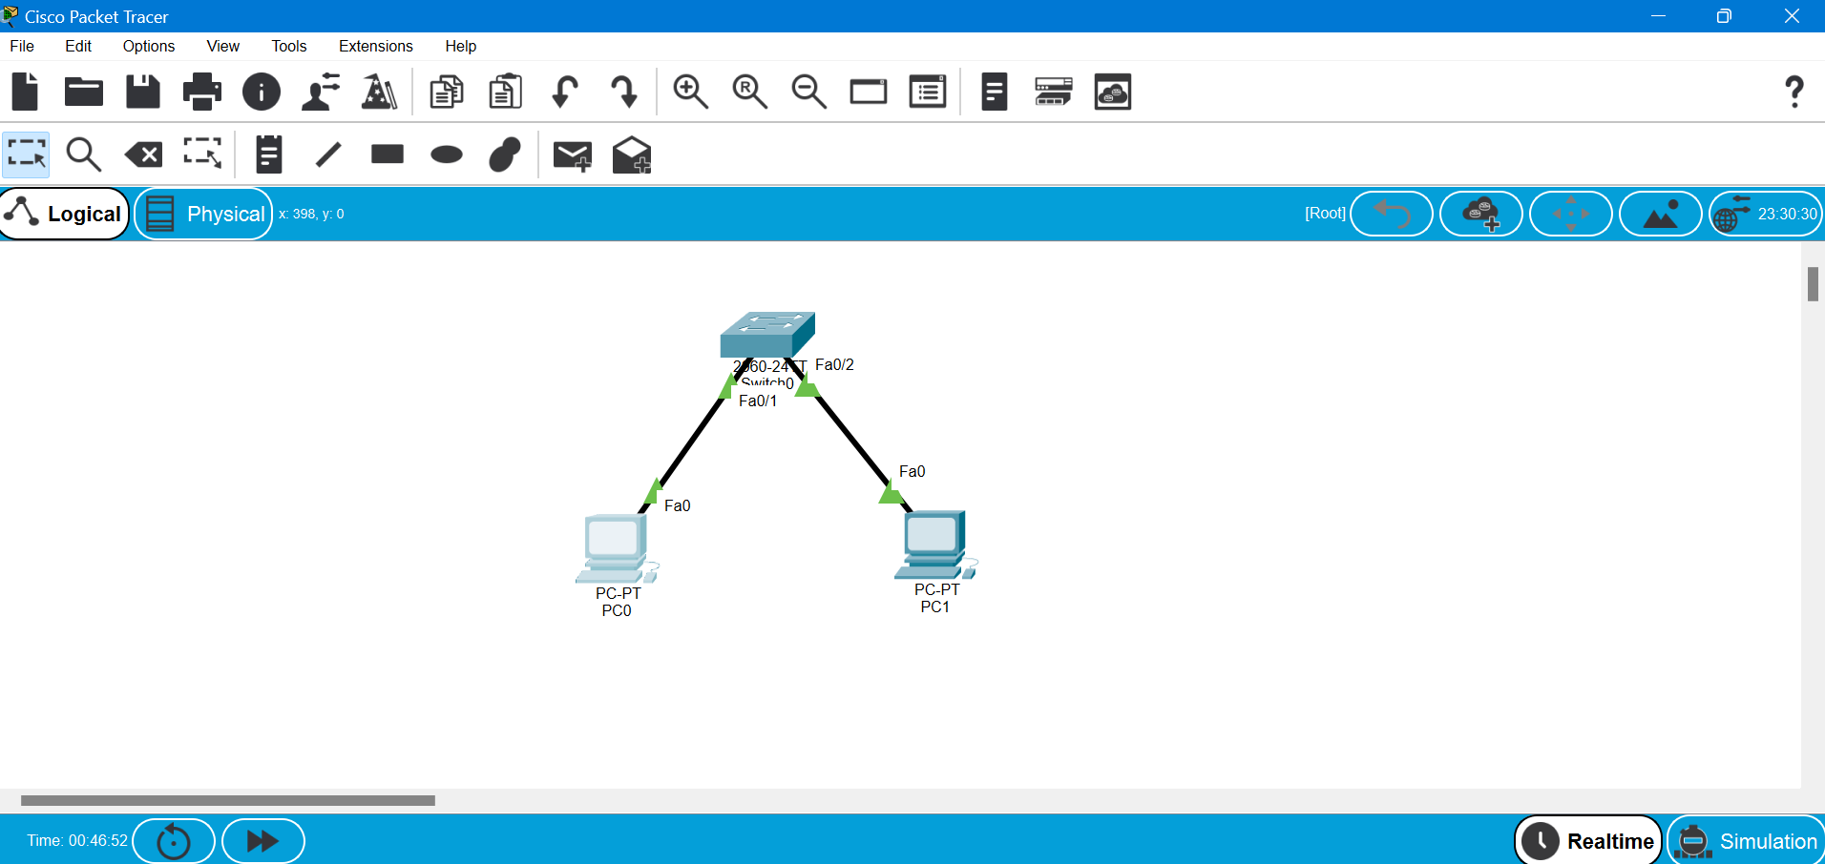
Cisco Packet Tracer PC1 IP:
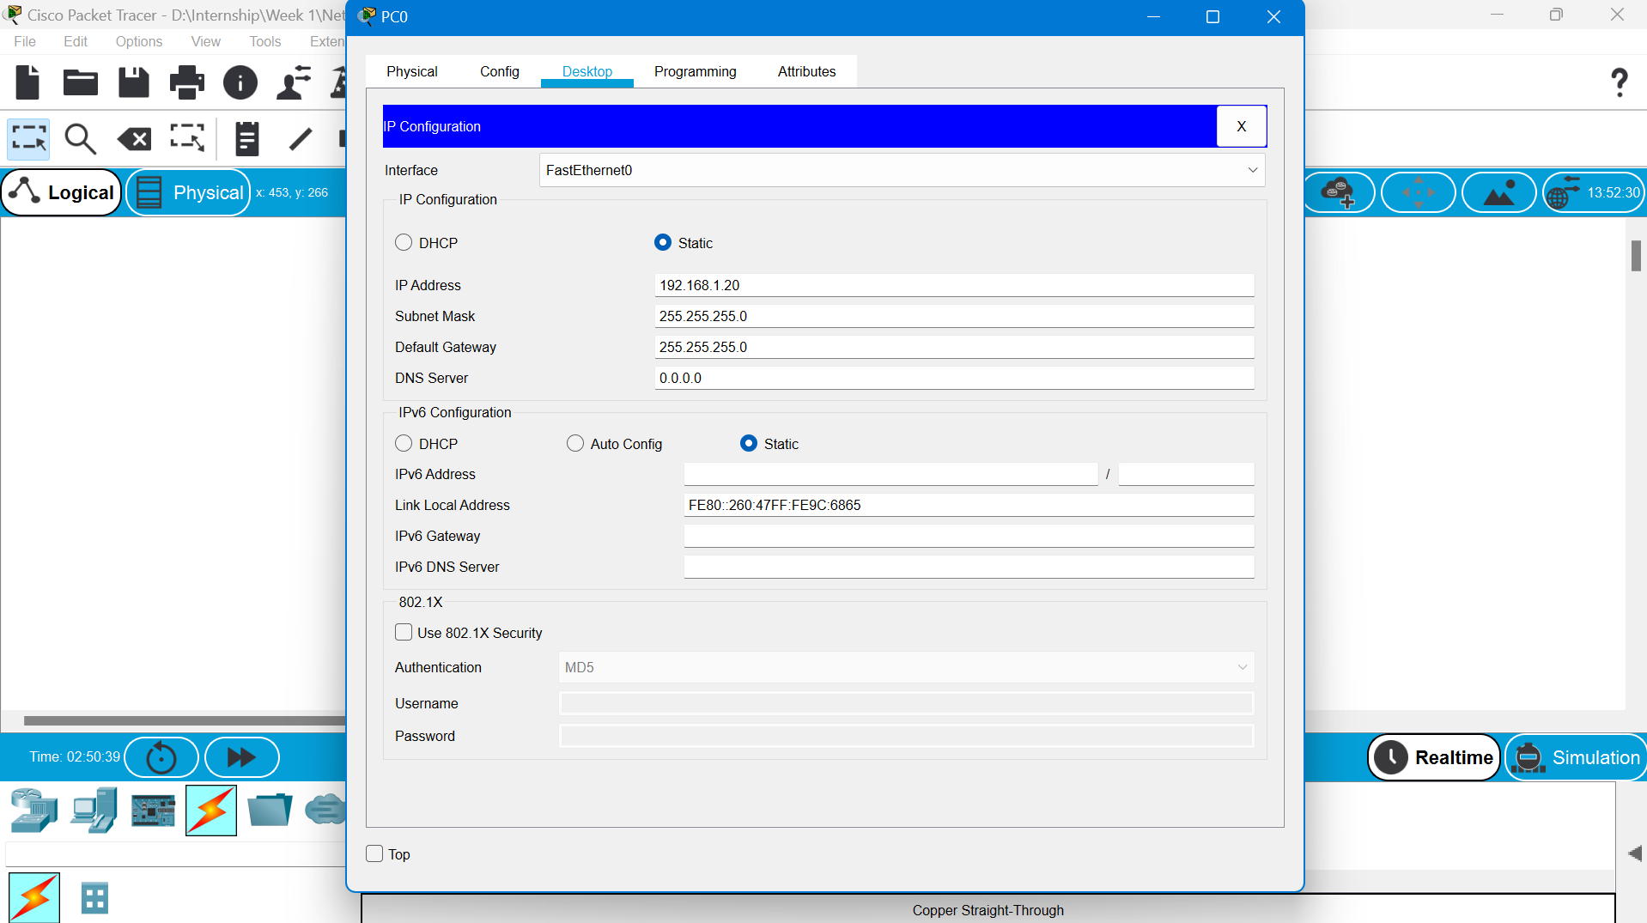
Cisco Packet Tracer PC2 IP:
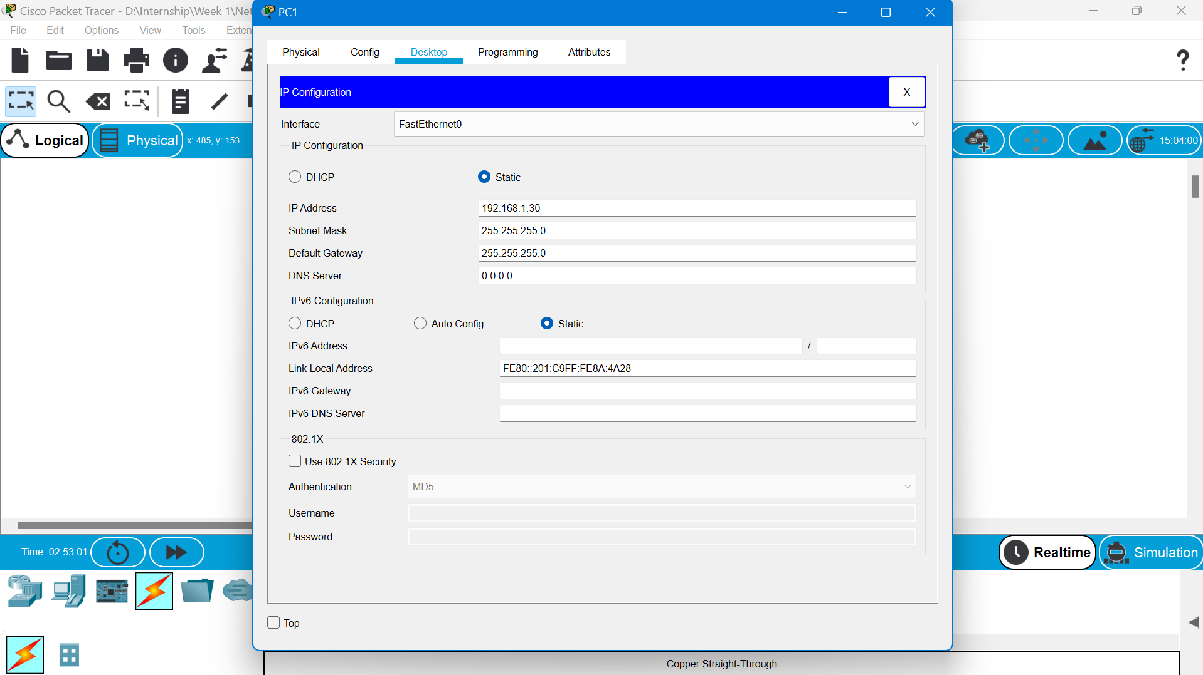
GNS3 Interface:
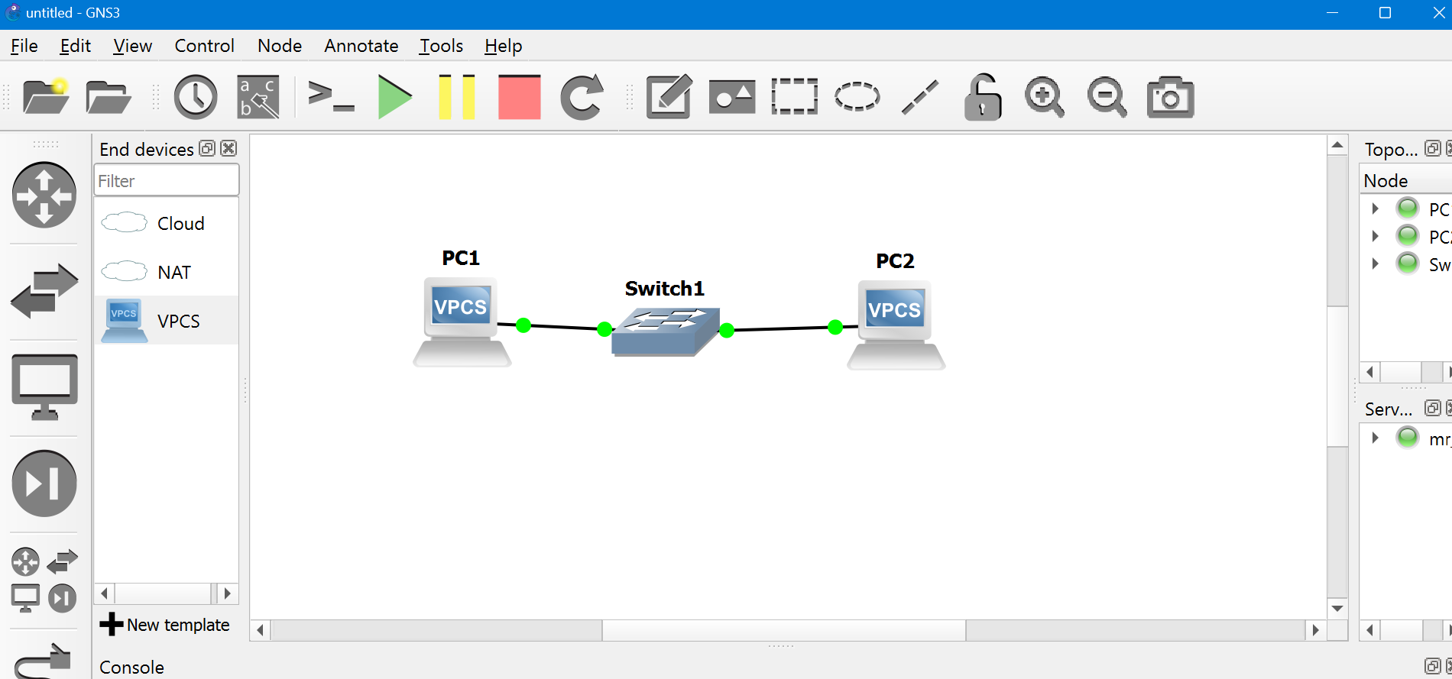
GNS3 PC1 IP:
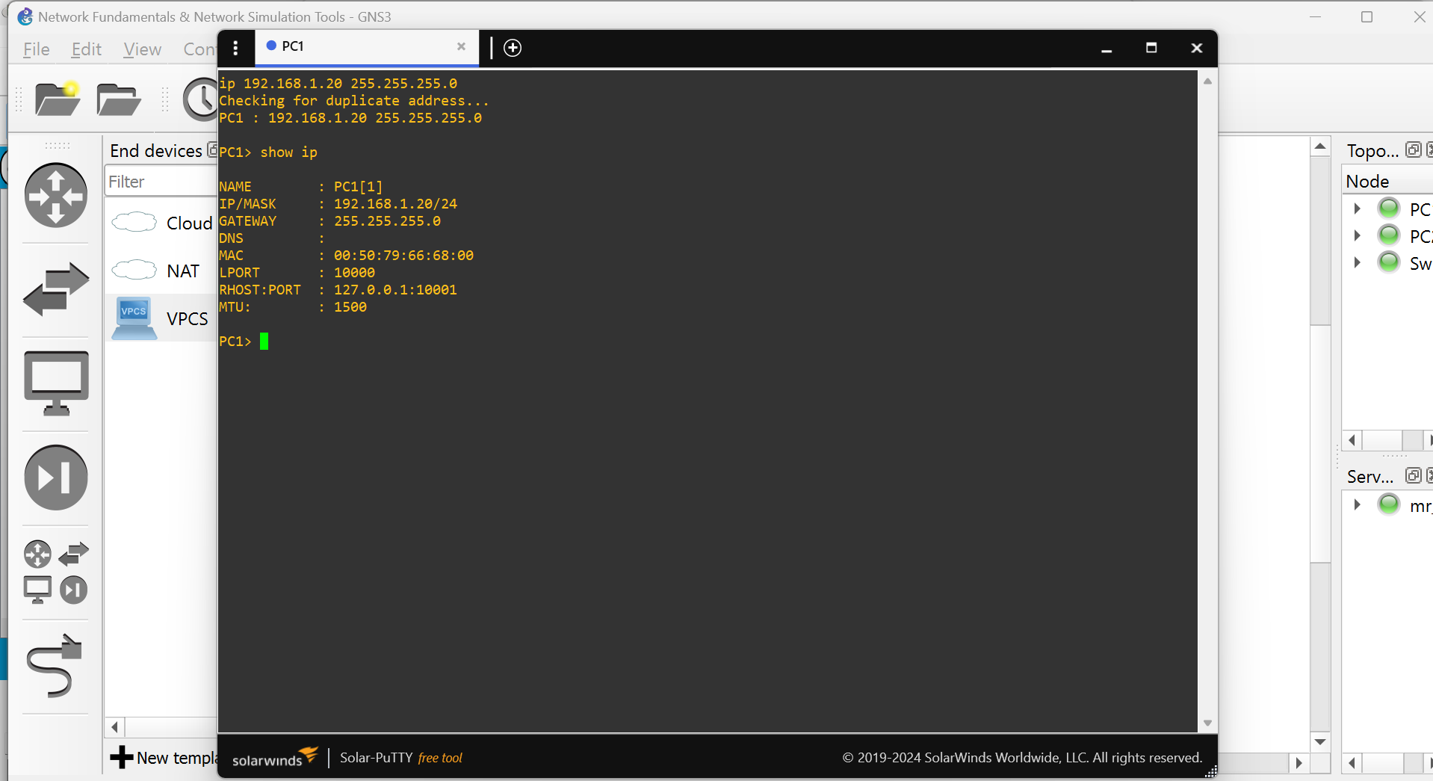

GNS3 PC2 IP:
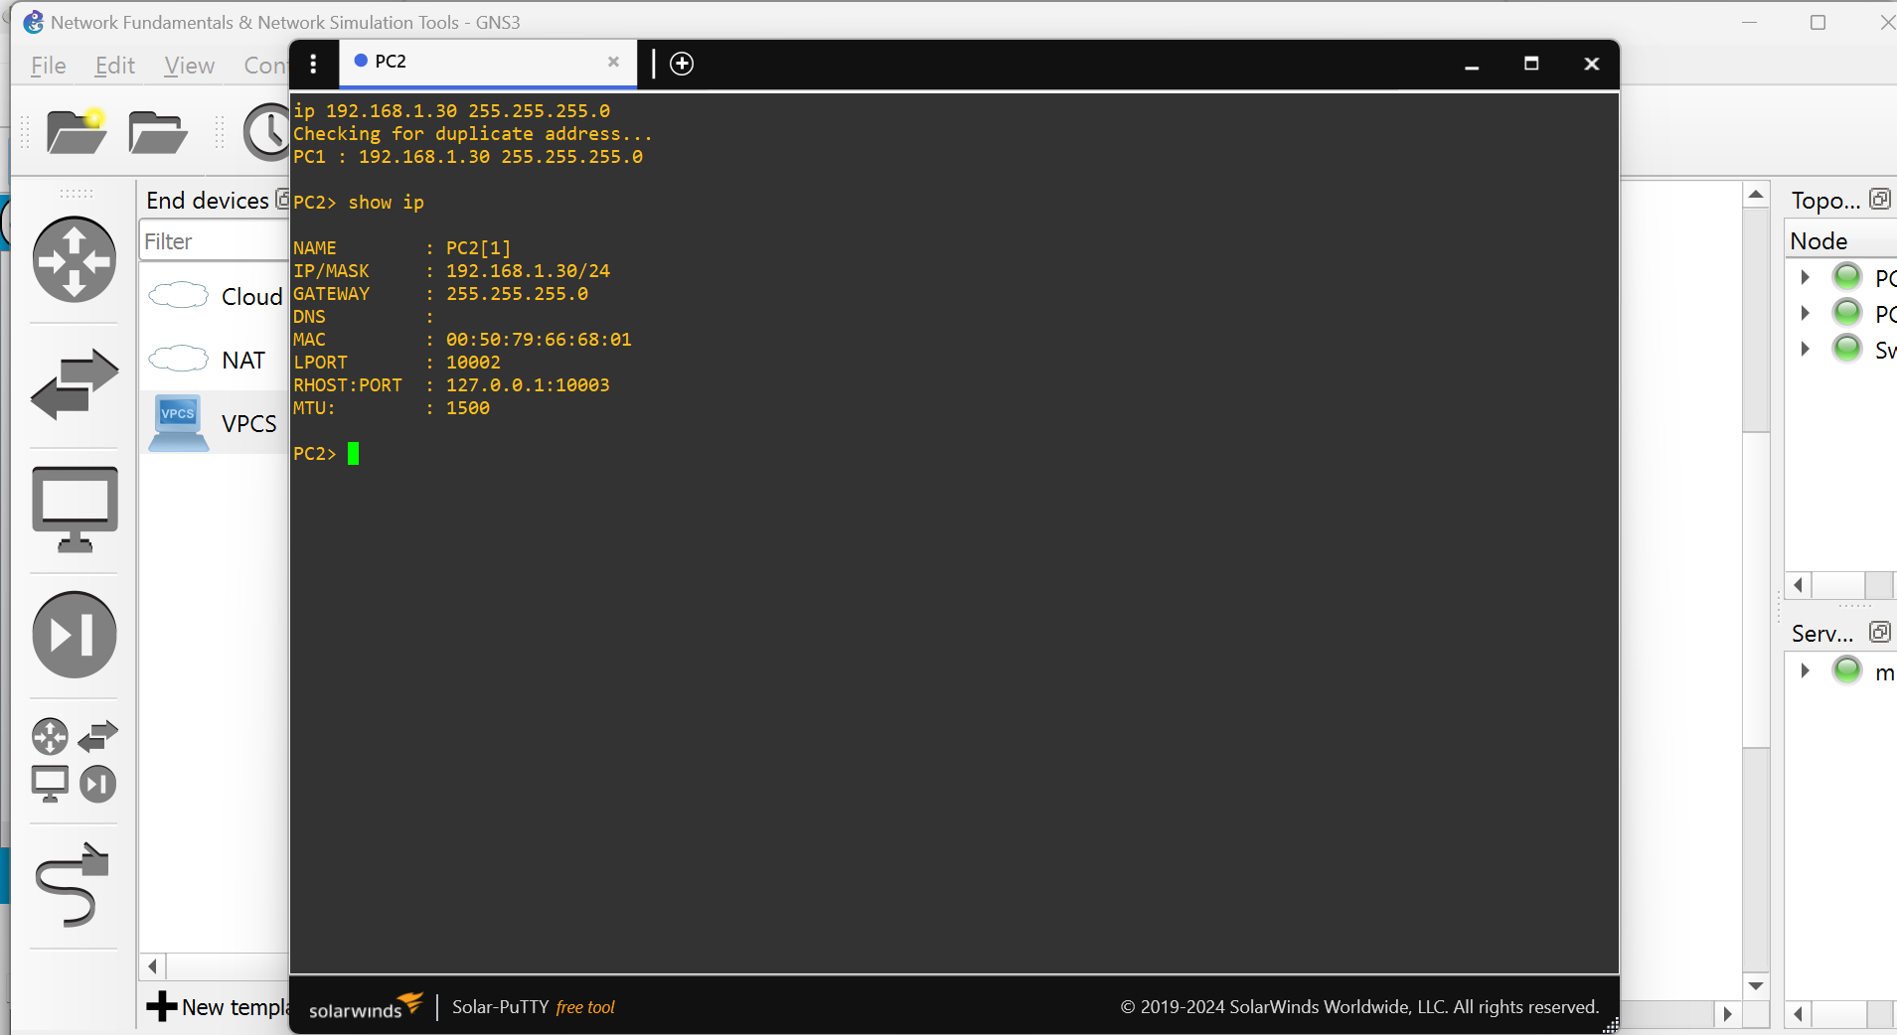

6. Ping Test Results
Connectivity between devices was verified using the ping command after static IP addresses were assigned. The command was ping 192.168.1.30 and the PC1 pings with PC2 with zero packet loss.
Cisco Packet Tracer PC1 Ping:
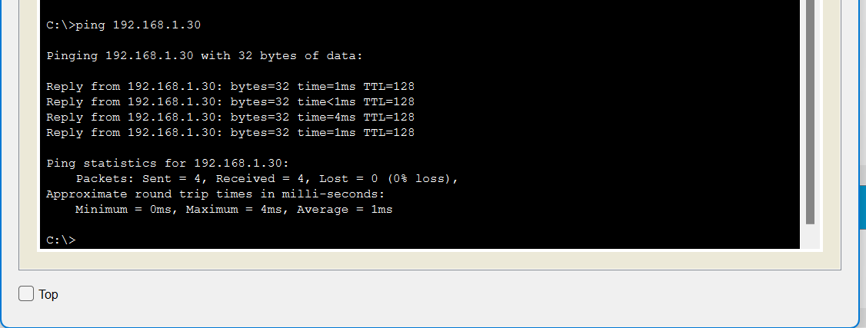
Cisco Packet Tracer PC2 Ping:
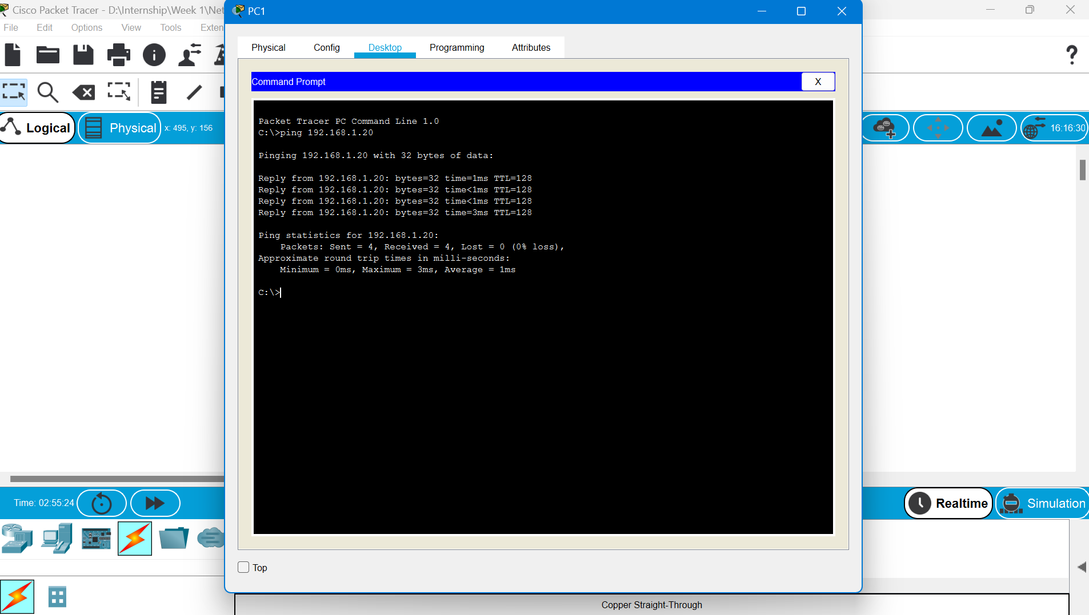
Both the Pcs in Cisco Packet Tracer ping with one another perfectly without any packet loss.

GNS3 PC1 Ping:
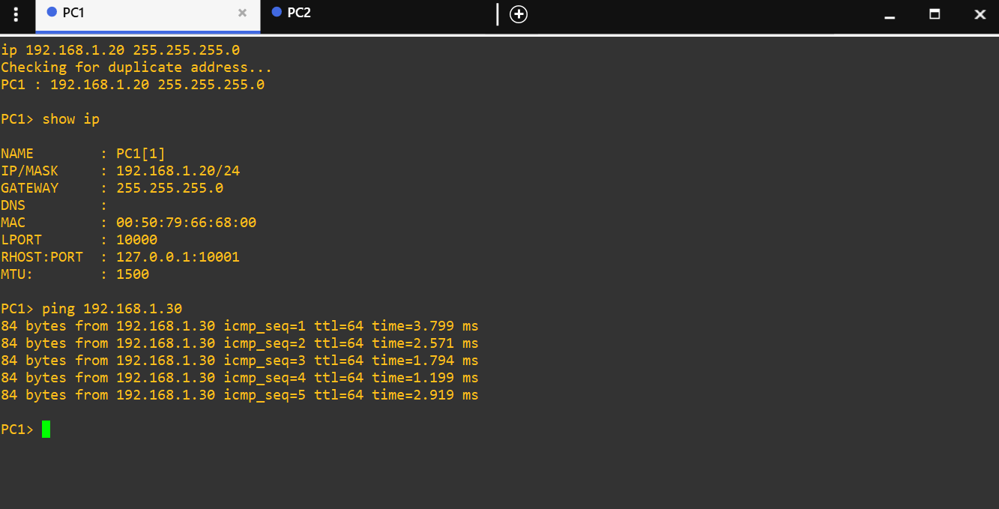
GNS3 PC2 Ping:
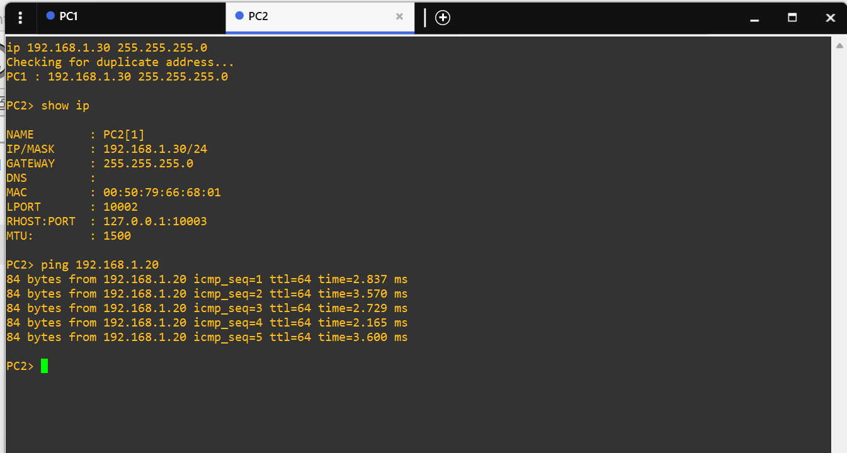
Both the PCs in GNS3 ping with one another perfectly without any packet loss.

7. Challenges Faced
I’m new to GNS3 so I did face some challenges, I was trying to connect both the PCs and switch through wires but was facing some issue so I asked it from ChatGPT and it give me a solution with that I was able to complete my assignment without any difficulties. While I was already familiar with Cisco Packet Tracer so I did not face any difficulties completing the assignment.

8. Conclusion
In this week’s task a practical introduction to core networking was provided with two widely used network simulation tools. Build same LAN topology in both Cisco Packet Tracer and GNS3 helped the difference between a simple simulation environment and more realistic emulation platform. Configuring static IP addressing and verifying connectivity through ping test gives the fundamentals of how devices comunicates on a local network. With this task completion It will be easy to complete the upcoming week’s task.

