IT-SIMPLERA INSTITUTE 
Network Administration Internship Program
WEEKLY REPORT — WEEK 02
IP Addressing (FLSM & VLSM) and VLAN Configuration
Field | Detail
Intern | Muhammad Fahad Khan
Supervisor | Jawad Qayum (Senior Network Administrator)
Company / Department | IT-SIMPLERA Institute — Network Administration
Week | 02
Submission date | 10 July 2026
Tools used | Cisco Packet Tracer, GNS3

FLSM subnetting:

FLSM (Fixed Length Subnet Masking) is a subnetting technique in which all subnets have the same subnet mask and the same number of IP addresses. It is suitable when every department or network requires approximately the same number of hosts.
Formula Used
Number of Subnets
$$2^{n}≥\text{Required Subnets}$$Where:
n = Number of borrowed bits
$$2^{h}-2$$Where:
h = Number of host bits
(-2 because one IP is the Network Address and one is the Broadcast Address.)
FLSM Problem 1
Network: 192.168.10.0/24 → 4 Subnets (/26)
Subnet | Network Address | Subnet Mask / CIDR | First Host | Last Host | Broadcast Address
1 | 192.168.10.0 | 255.255.255.192 (/26) | 192.168.10.1 | 192.168.10.62 | 192.168.10.63
2 | 192.168.10.64 | 255.255.255.192 (/26) | 192.168.10.65 | 192.168.10.126 | 192.168.10.127
3 | 192.168.10.128 | 255.255.255.192 (/26) | 192.168.10.129 | 192.168.10.190 | 192.168.10.191
4 | 192.168.10.192 | 255.255.255.192 (/26) | 192.168.10.193 | 192.168.10.254 | 192.168.10.255

FLSM Problem 2
Network: 192.168.20.0/24 → 8 Subnets (/27)
Subnet | Network Address | Subnet Mask / CIDR | First Host | Last Host | Broadcast Address
1 | 192.168.20.0 | 255.255.255.224 (/27) | 192.168.20.1 | 192.168.20.30 | 192.168.20.31
2 | 192.168.20.32 | 255.255.255.224 (/27) | 192.168.20.33 | 192.168.20.62 | 192.168.20.63
3 | 192.168.20.64 | 255.255.255.224 (/27) | 192.168.20.65 | 192.168.20.94 | 192.168.20.95
4 | 192.168.20.96 | 255.255.255.224 (/27) | 192.168.20.97 | 192.168.20.126 | 192.168.20.127
5 | 192.168.20.128 | 255.255.255.224 (/27) | 192.168.20.129 | 192.168.20.158 | 192.168.20.159
6 | 192.168.20.160 | 255.255.255.224 (/27) | 192.168.20.161 | 192.168.20.190 | 192.168.20.191
7 | 192.168.20.192 | 255.255.255.224 (/27) | 192.168.20.193 | 192.168.20.222 | 192.168.20.223
8 | 192.168.20.224 | 255.255.255.224 (/27) | 192.168.20.225 | 192.168.20.254 | 192.168.20.255

FLSM Problem 3
Network: 10.0.0.0/24 → 2 Subnets (/25)
Subnet | Network Address | Subnet Mask / CIDR | First Host | Last Host | Broadcast Address
1 | 10.0.0.0 | 255.255.255.128 (/25) | 10.0.0.1 | 10.0.0.126 | 10.0.0.127
2 | 10.0.0.128 | 255.255.255.128 (/25) | 10.0.0.129 | 10.0.0.254 | 10.0.0.255

FLSM Problem 4
Network: 172.16.10.0/24 → 16 Subnets (/28)
Subnet | Network Address | Subnet Mask / CIDR | First Host | Last Host | Broadcast Address
1 | 172.16.10.0 | 255.255.255.240 (/28) | 172.16.10.1 | 172.16.10.14 | 172.16.10.15
2 | 172.16.10.16 | 255.255.255.240 (/28) | 172.16.10.17 | 172.16.10.30 | 172.16.10.31
3 | 172.16.10.32 | 255.255.255.240 (/28) | 172.16.10.33 | 172.16.10.46 | 172.16.10.47
4 | 172.16.10.48 | 255.255.255.240 (/28) | 172.16.10.49 | 172.16.10.62 | 172.16.10.63

FLSM Problem 5
Network: 192.168.30.0/24 → 32 Subnets (/29)
Subnet | Network Address | Subnet Mask / CIDR | First Host | Last Host | Broadcast Address
1 | 192.168.30.0 | 255.255.255.248 (/29) | 192.168.30.1 | 192.168.30.6 | 192.168.30.7
2 | 192.168.30.8 | 255.255.255.248 (/29) | 192.168.30.9 | 192.168.30.14 | 192.168.30.15
3 | 192.168.30.16 | 255.255.255.248 (/29) | 192.168.30.17 | 192.168.30.22 | 192.168.30.23
4 | 192.168.30.24 | 255.255.255.248 (/29) | 192.168.30.25 | 192.168.30.30 | 192.168.30.31

FLSM Problem 6
Network: 172.20.5.0/24 → 4 Subnets (/26)
Subnet | Network Address | Subnet Mask / CIDR | First Host | Last Host | Broadcast Address
1 | 172.20.5.0 | 255.255.255.192 (/26) | 172.20.5.1 | 172.20.5.62 | 172.20.5.63
2 | 172.20.5.64 | 255.255.255.192 (/26) | 172.20.5.65 | 172.20.5.126 | 172.20.5.127
3 | 172.20.5.128 | 255.255.255.192 (/26) | 172.20.5.129 | 172.20.5.190 | 172.20.5.191
4 | 172.20.5.192 | 255.255.255.192 (/26) | 172.20.5.193 | 172.20.5.254 | 172.20.5.255

FLSM Problem 7
Network: 192.168.100.0/24 → 8 Subnets (/27)
Subnet | Network Address | Subnet Mask / CIDR | First Host | Last Host | Broadcast Address
1 | 192.168.100.0 | 255.255.255.224 (/27) | 192.168.100.1 | 192.168.100.30 | 192.168.100.31
2 | 192.168.100.32 | 255.255.255.224 (/27) | 192.168.100.33 | 192.168.100.62 | 192.168.100.63
3 | 192.168.100.64 | 255.255.255.224 (/27) | 192.168.100.65 | 192.168.100.94 | 192.168.100.95
4 | 192.168.100.96 | 255.255.255.224 (/27) | 192.168.100.97 | 192.168.100.126 | 192.168.100.127

FLSM Problem 8
Network: 10.10.10.0/24 → 16 Subnets (/28)
Subnet | Network Address | Subnet Mask / CIDR | First Host | Last Host | Broadcast Address
1 | 10.10.10.0 | 255.255.255.240 (/28) | 10.10.10.1 | 10.10.10.14 | 10.10.10.15
2 | 10.10.10.16 | 255.255.255.240 (/28) | 10.10.10.17 | 10.10.10.30 | 10.10.10.31
3 | 10.10.10.32 | 255.255.255.240 (/28) | 10.10.10.33 | 10.10.10.46 | 10.10.10.47
4 | 10.10.10.48 | 255.255.255.240 (/28) | 10.10.10.49 | 10.10.10.62 | 10.10.10.63

FLSM Problem 9
Network: 172.31.1.0/24 → 2 Subnets (/25)
Subnet | Network Address | Subnet Mask / CIDR | First Host | Last Host | Broadcast Address
1 | 172.31.1.0 | 255.255.255.128 (/25) | 172.31.1.1 | 172.31.1.126 | 172.31.1.127
2 | 172.31.1.128 | 255.255.255.128 (/25) | 172.31.1.129 | 172.31.1.254 | 172.31.1.255

FLSM Problem 10
Network: 192.168.200.0/24 → 8 Subnets (/27)
Subnet | Network Address | Subnet Mask / CIDR | First Host | Last Host | Broadcast Address
1 | 192.168.200.0 | 255.255.255.224 (/27) | 192.168.200.1 | 192.168.200.30 | 192.168.200.31
2 | 192.168.200.32 | 255.255.255.224 (/27) | 192.168.200.33 | 192.168.200.62 | 192.168.200.63
3 | 192.168.200.64 | 255.255.255.224 (/27) | 192.168.200.65 | 192.168.200.94 | 192.168.200.95
4 | 192.168.200.96 | 255.255.255.224 (/27) | 192.168.200.97 | 192.168.200.126 | 192.168.200.127

VLSM subnetting:

Five VLSM (Variable length subnet mask) scenarios were designed by allocating address blocks largest-requirement-first, so each department or link receives only the addresses it needs rather than a fixed equal share.
VLSM Design Scenario 1
Given Network:
192.168.10.0/24
Requirements
Department | Hosts Required
Sales | 100
HR | 50
IT | 25
Server Room | 10
IP Allocation
Department | Network Address | Subnet Mask / CIDR | First Host | Last Host | Broadcast
Sales | 192.168.10.0 | 255.255.255.128 (/25) | 192.168.10.1 | 192.168.10.126 | 192.168.10.127
HR | 192.168.10.128 | 255.255.255.192 (/26) | 192.168.10.129 | 192.168.10.190 | 192.168.10.191
IT | 192.168.10.192 | 255.255.255.224 (/27) | 192.168.10.193 | 192.168.10.222 | 192.168.10.223
Server Room | 192.168.10.224 | 255.255.255.240 (/28) | 192.168.10.225 | 192.168.10.238 | 192.168.10.239

VLSM Design Scenario 2
Given Network:
172.16.20.0/24
Requirements
Department | Hosts Required
Engineering | 120
Finance | 60
Management | 30
Printers | 12

IP Allocation
Department | Network Address | Subnet Mask / CIDR | First Host | Last Host | Broadcast
Engineering | 172.16.20.0 | 255.255.255.128 (/25) | 172.16.20.1 | 172.16.20.126 | 172.16.20.127
Finance | 172.16.20.128 | 255.255.255.192 (/26) | 172.16.20.129 | 172.16.20.190 | 172.16.20.191
Management | 172.16.20.192 | 255.255.255.224 (/27) | 172.16.20.193 | 172.16.20.222 | 172.16.20.223
Printers | 172.16.20.224 | 255.255.255.240 (/28) | 172.16.20.225 | 172.16.20.238 | 172.16.20.239

VLSM Design Scenario 3
Given Network:
10.10.0.0/24
Requirements
Department | Hosts Required
Production | 80
Accounts | 40
Admin | 20
CCTV | 5
IP Allocation
Department | Network Address | Subnet Mask / CIDR | First Host | Last Host | Broadcast
Production | 10.10.0.0 | 255.255.255.128 (/25) | 10.10.0.1 | 10.10.0.126 | 10.10.0.127
Accounts | 10.10.0.128 | 255.255.255.192 (/26) | 10.10.0.129 | 10.10.0.190 | 10.10.0.191
Admin | 10.10.0.192 | 255.255.255.224 (/27) | 10.10.0.193 | 10.10.0.222 | 10.10.0.223
CCTV | 10.10.0.224 | 255.255.255.248 (/29) | 10.10.0.225 | 10.10.0.230 | 10.10.0.231

VLSM Design Scenario 4
Given Network:
192.168.50.0/24
Requirements
Department | Hosts Required
Office | 60
Lab | 30
Security | 12
Router Link | 2

IP Allocation
Department | Network Address | Subnet Mask / CIDR | First Host | Last Host | Broadcast
Office | 192.168.50.0 | 255.255.255.192 (/26) | 192.168.50.1 | 192.168.50.62 | 192.168.50.63
Lab | 192.168.50.64 | 255.255.255.224 (/27) | 192.168.50.65 | 192.168.50.94 | 192.168.50.95
Security | 192.168.50.96 | 255.255.255.240 (/28) | 192.168.50.97 | 192.168.50.110 | 192.168.50.111
Router Link | 192.168.50.112 | 255.255.255.252 (/30) | 192.168.50.113 | 192.168.50.114 | 192.168.50.115

VLSM Design Scenario 5
Given Network:
172.31.100.0/24
Requirements
Department | Hosts Required
Students | 100
Teachers | 50
Administration | 20
ISP Link | 2
IP Allocation
Department | Network Address | Subnet Mask / CIDR | First Host | Last Host | Broadcast
Students | 172.31.100.0 | 255.255.255.128 (/25) | 172.31.100.1 | 172.31.100.126 | 172.31.100.127
Teachers | 172.31.100.128 | 255.255.255.192 (/26) | 172.31.100.129 | 172.31.100.190 | 172.31.100.191
Administration | 172.31.100.192 | 255.255.255.224 (/27) | 172.31.100.193 | 172.31.100.222 | 172.31.100.223
ISP Link | 172.31.100.224 | 255.255.255.252 (/30) | 172.31.100.225 | 172.31.100.226 | 172.31.100.227

VLAN topology design:

The purpose of this task is to divide one physical network into two separate VLANs. Two switches are connected with a trunk link so devices in the same VLAN can communicate with eachother when they are on different switches.

Three VLANs were create for each department having its own subnet.
VLAN | Name | Subnet | Assigned Devices
10 | HR | 192.168.10.0/24 | PC1, PC2, SW1
20 | SALES | 192.168.20.0/24 | PC3, PC4, SW2

Network Topology:
The topology shows Switch1 and Switch2 connected by a trunk link, each switch has two PCs split across two VLANs.
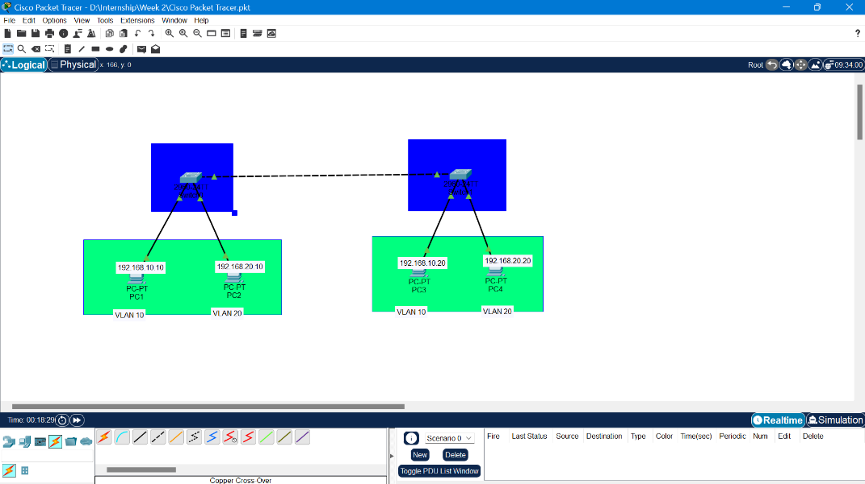
Figure 1: VLAN topology showing Switch1 and Switch2 connected by a trunk link In Cisco

Switch Configuration:

Cisco Packet Tracer
Some steps were carried out on Switch1 through the CLI:
- Created VLAN 10 with a name HR
- Created VLAN 20 with a name SALES
- Select FastEthernet 0/24 as a trunk link and connect it Switch2
The same method was used on Switch2 so that devices in matching VLANs can reach other across the trunk link.
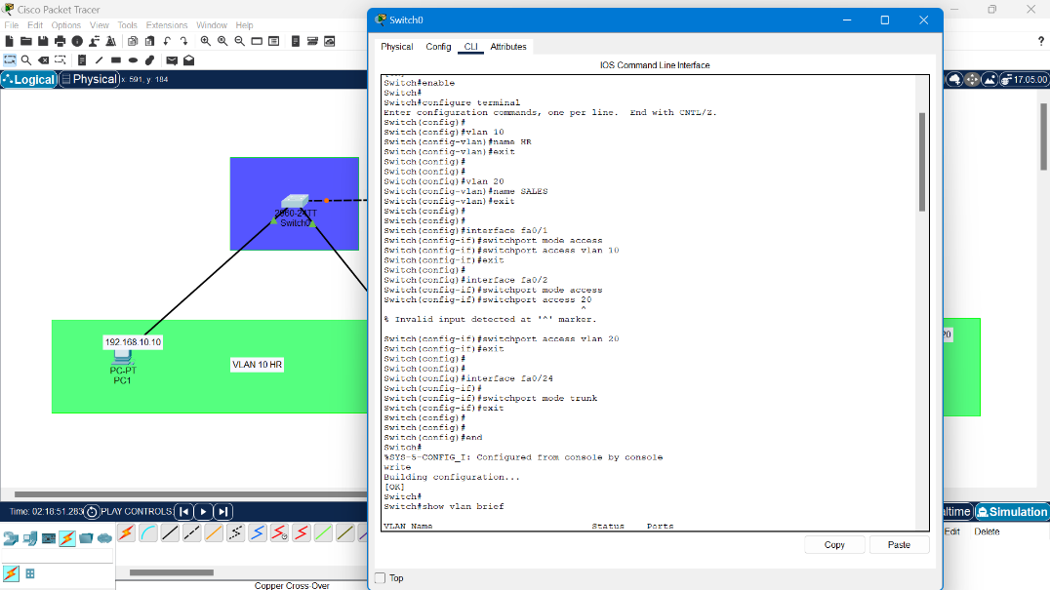
Figure 2: CLI commands used to create VLANs, configure the trunk port, and assign access ports on Switch1
Verification:

When the configuration was done, the following commands were used on Switch1 to confirm the VLANs and trunk link were working correctly.
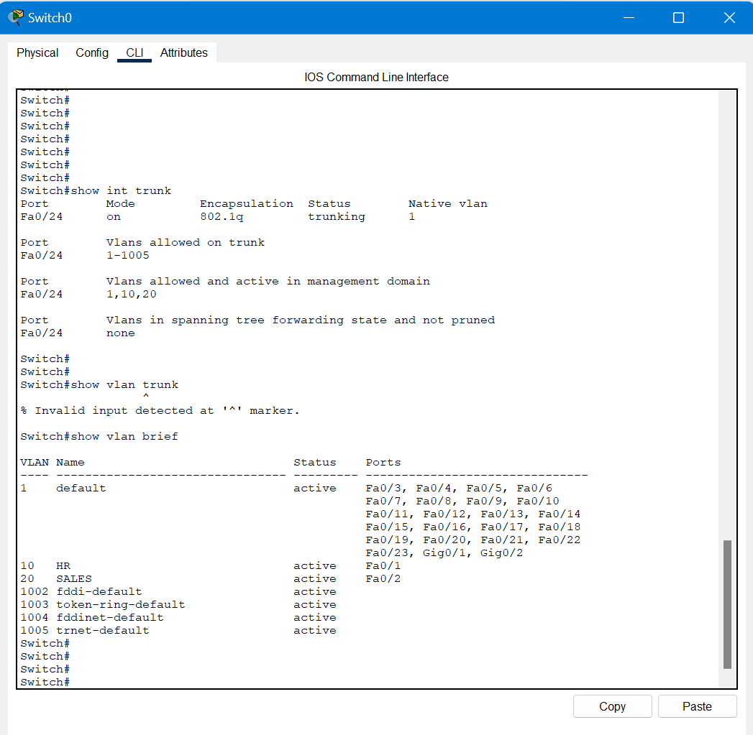
Figure 4: Output of show interface trunk and show vlan brief on Switch1

PING Test Results:

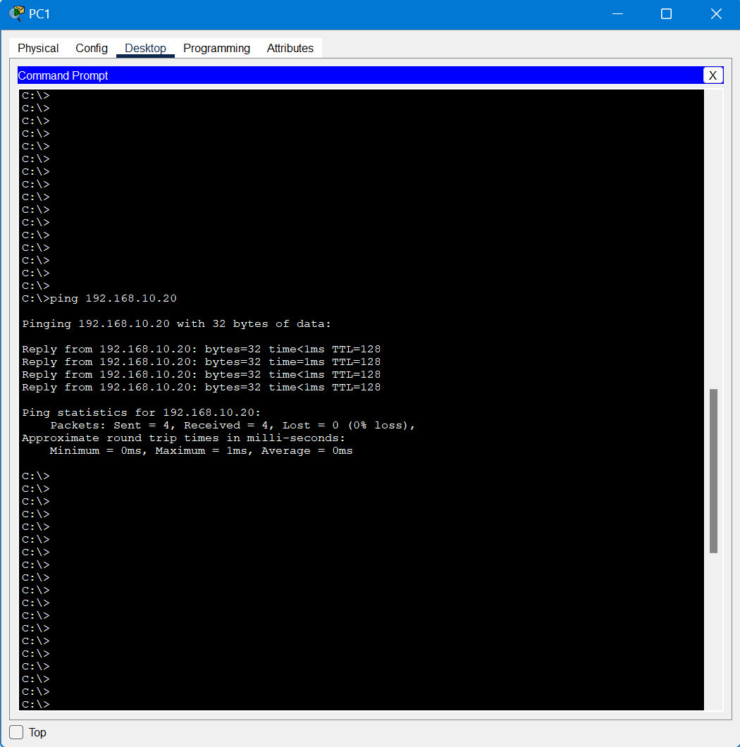
Figure 5: PC1 successfully pinging PC3

Challenges Faced and Solutions:

The challenge I faced in Cisco was I was not able to connect both the switches because I was using the wrong cables so when I searched for the solution and then applied it, it worked perfectly.

Conclusion:

The task was about IP addressing, VLSM, FLSM and to applied that addressing to a working VLAN topology both in Cisco Packet Tracer and GNS3.
Two VLANs (HR, SALES) were created and assigned to different access port on two switches connected through a trunk link.
Then by configuring the trunk port and assign access port on both the switches and by using command show int trunk and show vlan brief verified the VLAN setup.
All the tests was successful and was showing a correctly working trunk layer and proper VLAN segmentation across network.

