Name Faizan Anjum

Roll Number 00382183

Slot Friday 9am to 12pm

## Completed Features

The following features have been successfully implemented and are now live:

- **Order Placement:** Users can now place orders seamlessly and enjoy an improved shopping experience.

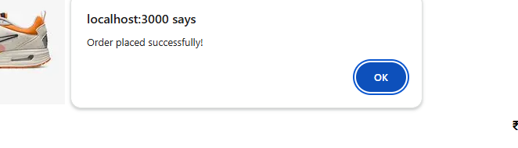

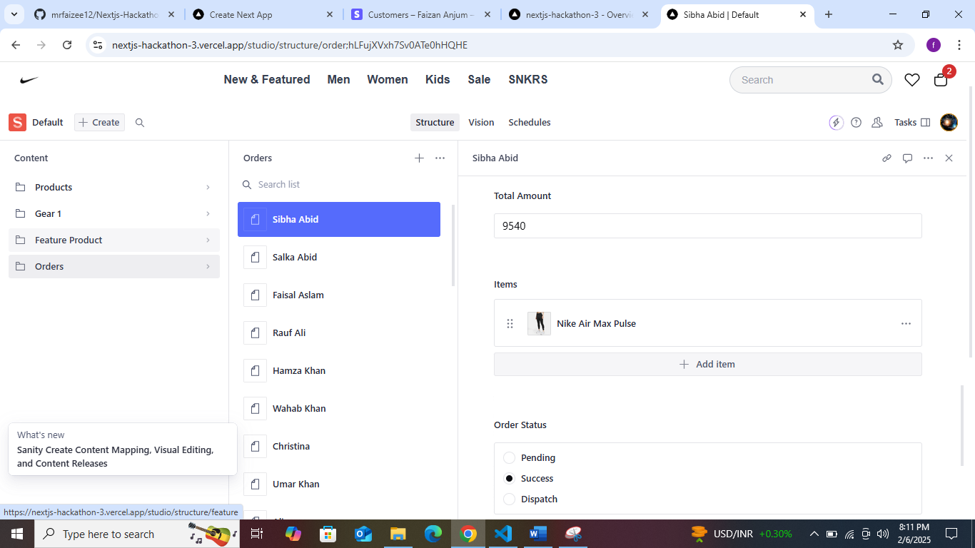

**Admin Dashboard**

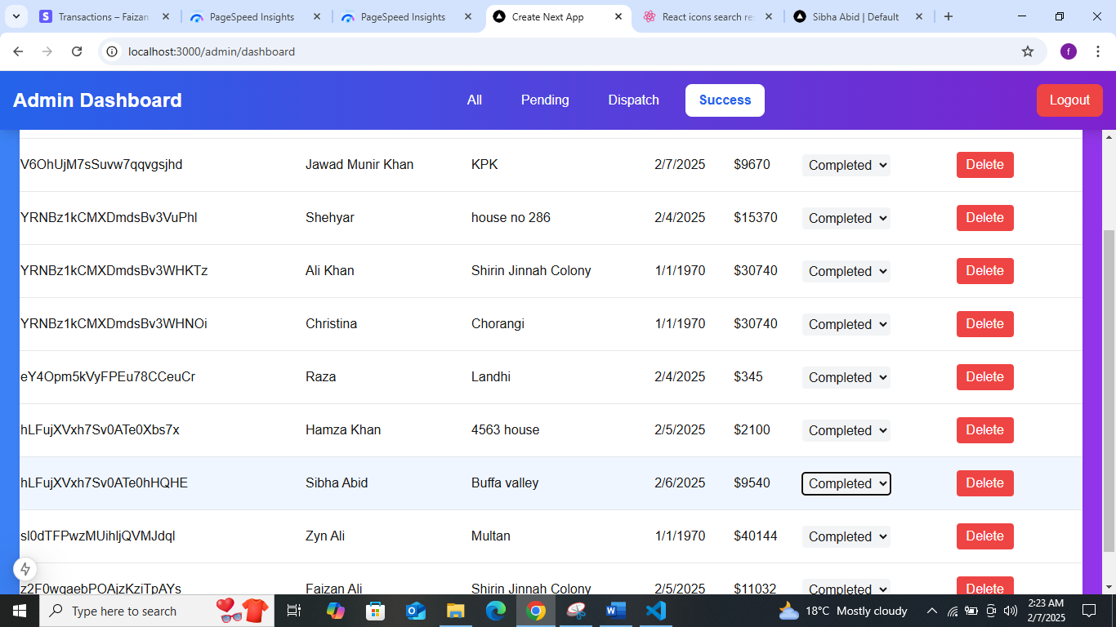

- **Filtering and Searching:** Users can efficiently filter and search for products, enhancing the overall user experience.

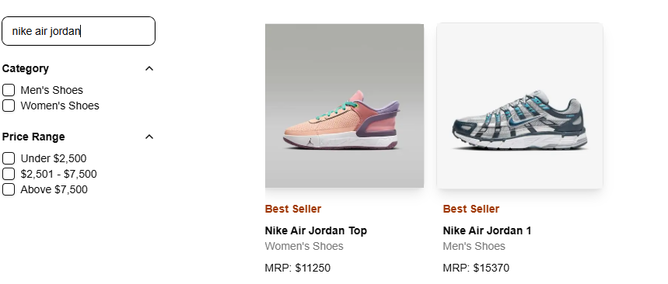

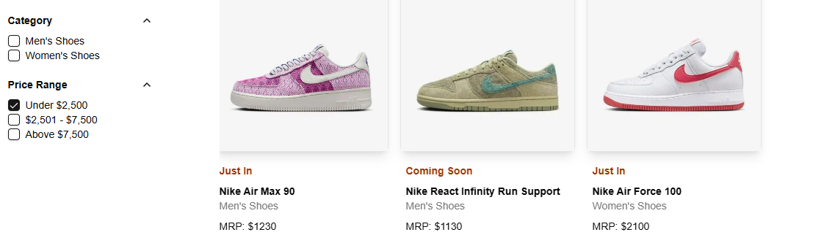

- **Dynamic Routing with 'Add to Cart' Functionality:** Users can navigate seamlessly between pages and add products to their cart.

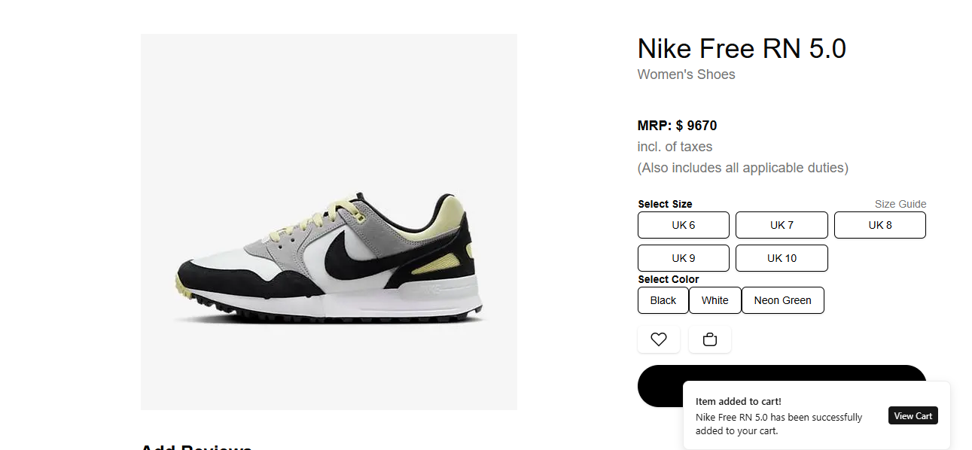

- **Wishlist Integration:** Users can save their favorite items for later purchase.

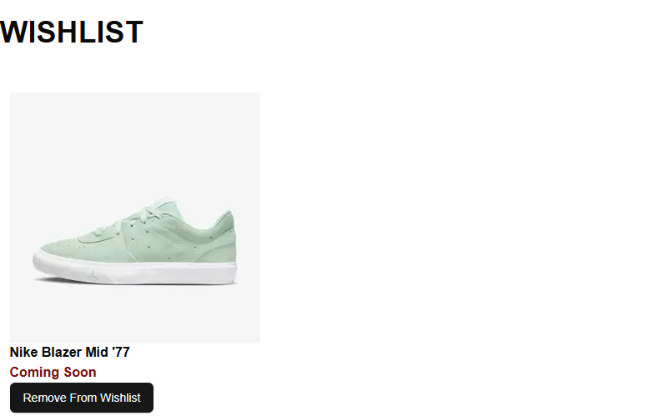

- **User Feedback and Review System:** Customers can rate products and leave feedback based on their experience.

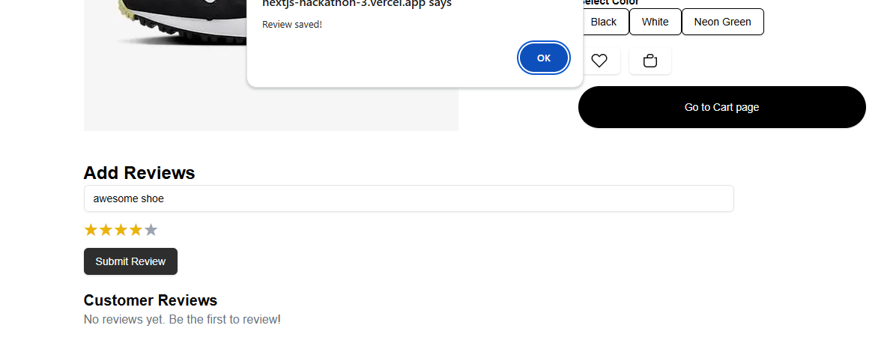

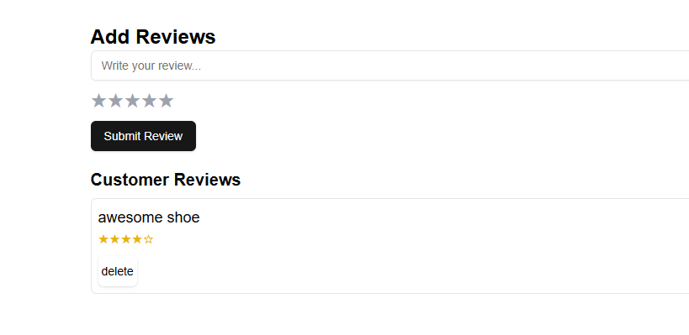

- **Secure Payment Integration:** Users can complete purchases using a secure payment method, providing a streamlined and trustworthy transaction experience.

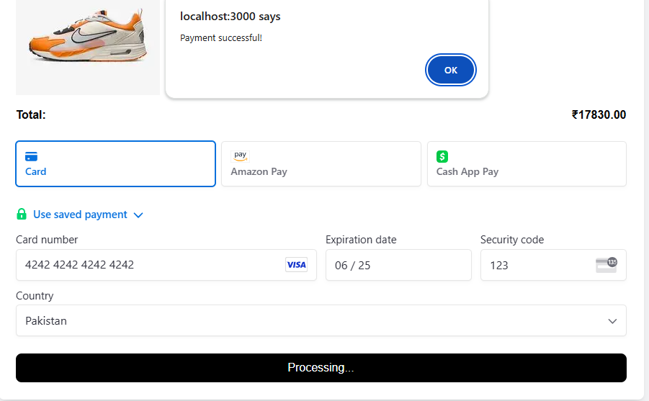

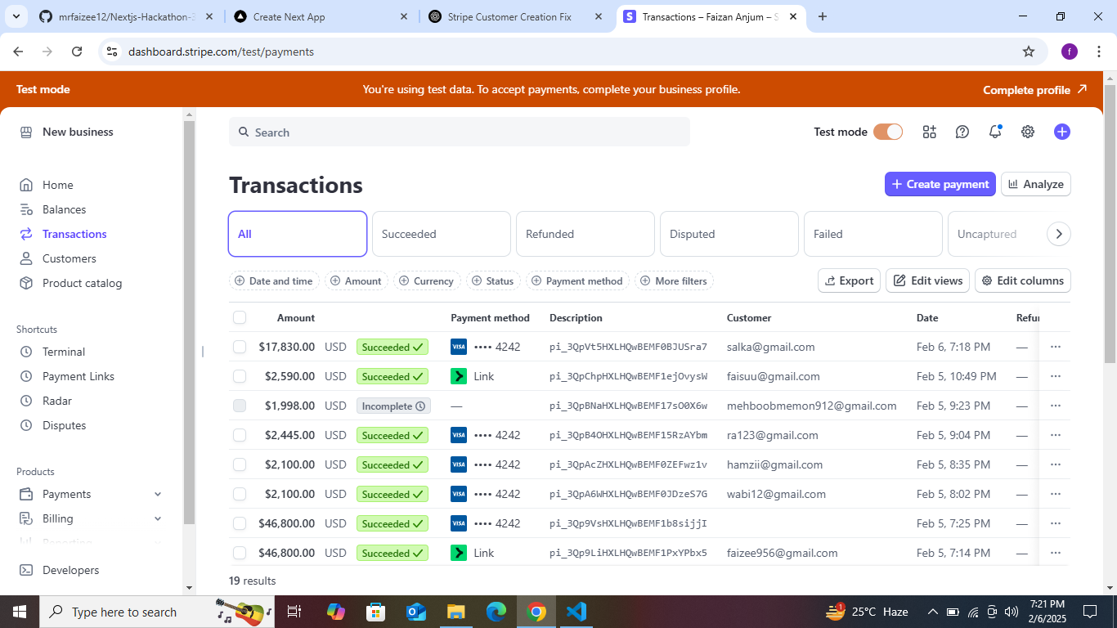

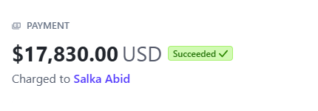

## Pending Features

Due to the project deadline, the following functionality is still under development:

- **Shipment Tracking:** Work is ongoing to implement a shipment tracking system, which will help users easily track their orders. Updates will be shared soon after this feature is integrated.