Preliminary project – Bus Reservation System

By Filip Tomasz Stolarczuk

# Aim of the project

This project’s aim is to manage a bus reservation system, where clients can book bus trips.

# Restrictions

1. Trip can have only 1 bus assigned to it.
2. Bus can be assigned to only 1 trip.
3. There can be no more passengers than places in the bus.
4. Bus cannot start another trip before finishing the previous one.
5. Buses cannot have 0 capacity.
6. Client cannot book trips if they overlap.

# Functionality

* Client:
  + Has a name (set when adding a client) and ID (set automatically)
  + Can book trips.
  + Can cancel reservation.
  + Name can be changed.
* Trip:
  + Has following parameters:
    - ID
    - Starting place
    - Destination
    - Distance
    - Departure time
    - Duration
    - Assigned bus
    - List of enrolled clients
  + Time can be changed.
  + Bus can be changed.
  + Can print enrolled clients.
* Bus:
  + Has ID, capacity and assigned trip.
  + Its assigned trip can be changed.
* Program can print the timetable.
* There’s a *Time* class, which helps with time management (months, days, hours, minutes).

# Class declarations

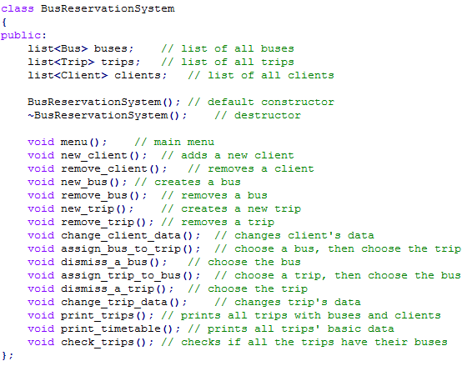

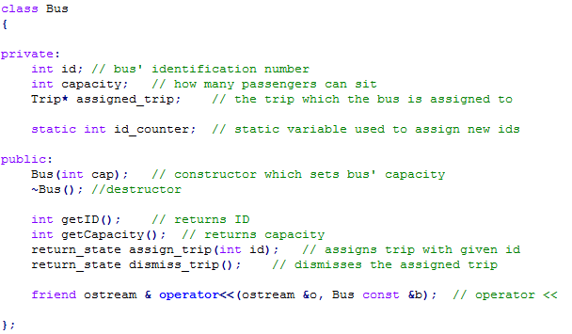

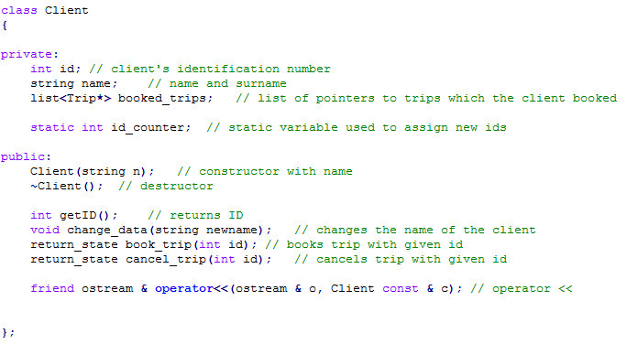

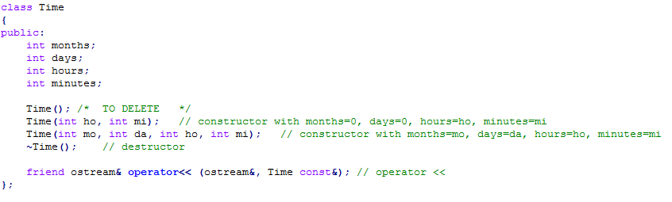

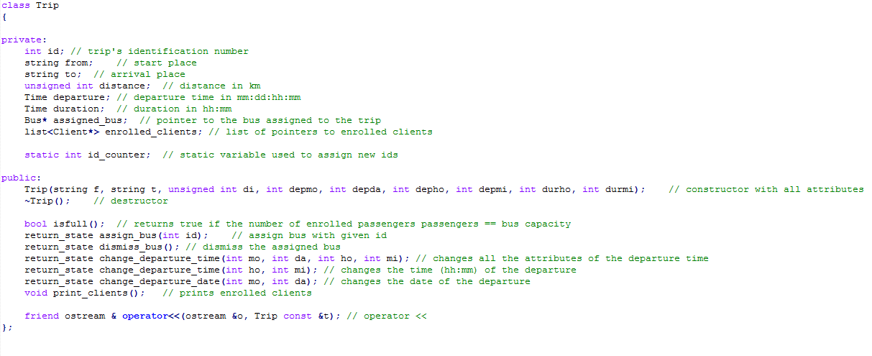



# Test scenarios

1. Testing adding and removing objects:
   * Try to remove from empty list.
   * Add some clients/buses/trips.
   * Print the list.
   * Remove a client from front, middle, back.
   * Test passed if the list is printed again properly.
2. Testing single functions:
   * Change client data:
     + Print client’s data.
     + change_client_data()
     + Test passed if the client is printed again properly and with new data.
   * Assign bus to a trip:
     + assign_bus_to_trip()
     + Print bus data (should have the trip assigned)
     + Print trip data (should have the bus assigned)
     + assign_bus_to_trip() shouldn’t let choose this bus
   * Dismiss a bus from a trip
     + dismiss_a_bus() (should print only buses with assigned trips)
     + Print bus data (should have no trip assigned)
     + Print trip data (should have no bus assigned)
   * Assign trip to a bus
     + assign_trip_to_bus()
     + Print bus data (should have the trip assigned)
     + Print trip data (should have the bus assigned)
     + assign_trip_to_bus () shouldn’t let choose this trip
   * Dismiss a trip from a bus
     + dismiss_a_trip() (should print only trips with assigned buses)
     + Print bus data (should have no trip assigned)
     + Print trip data (should have no bus assigned)
   * Change trip data:
     + Print trip’s data.
     + change_trip_data()
     + Test passed if the trip is printed again properly and with new data.
   * Printing:
     + Try to use every print function when it has nothing to print.
   * << operators:
     + Use operator<< on single objects to see how beautiful the output is.