PRG282 Milestone 1
Zacharias Pretorius
Kyle Knoetze
Janco Bester

Presentation layer

In the presentation layer I will Firstly create a login form This will contain 2 labels 2 buttons and a 2 textboxes.
Labels will be username and password with 2 textboxes for user to write in their details
Button 1 will be register Button 2 will be login if user has a password and username in the current database it will prompt him to the next window(detail window) When he clicks login. If he does not have a Username and password it will give him a error that his account does not have an account, Then he has to click on the Register button. This will add his username and password to the Database after that he can then click login and continue.

In the next window we will have Textbox labels and a picture box for student image for the following
Student Number
▪Student Name and Surname
▪Student Image
▪DOB
▪Gender
▪Phone
▪Address
▪Module Codes
With 4 buttons Search insert Update delete
Search will search for student by Student Number insert will allow you to add a new student update will allow you to update current students details Delete will let you delete the student.

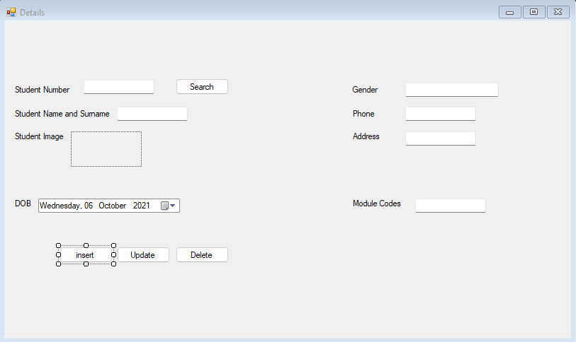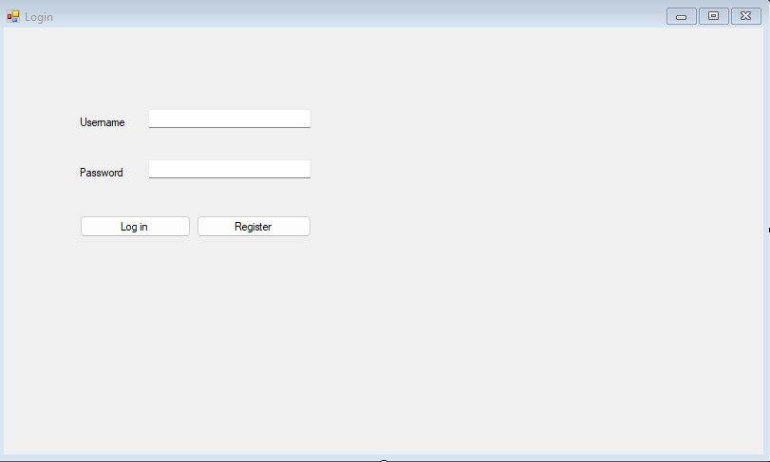

Business Logic Layer

The business Logic Layer will consist of 2 Objects “Students” and “Modules” these Objects will have there respected atrebutes.

Students
- StudentName String
- StudentSurName String
- StudentNumber String
- StudentImage Image
- DateOfBurth Date
- Gender String
- StudentPhoneNumber String
- StudentAddress String
- ModuleCodes String
Modules
- ModuleCode
- ModuleName
- ModuleDescription
- ModuleResources

There will also be classes with functions

Login
- Get the username and password from the user
- pull the username and password from the database
- decript the password
- send user to the corrects form
Regester
- Get new username and password from user
- incript password
- send username and encripted password to database
- send user back to login screen
AddData
- Get all the needed data from the user (
Student Number,
Student Name and Surname,
Student Image,
DOB,
Gender,
Phone,
Address
Module Codes)
- Save all the data in to the database

Data access layer
First I will add Using System.Data and system.data.sqlclient This will make it possible to use SQLconnection function After this
I will make 4 methods which will be
Insert
Update
Delete
Search

These methods will run SQL commands on the Database so we can delete a user update details search and insert a new user if we wanted
The Database will have SQL server Database connected to it With students table and in that table will be
▪Student Number
▪Student Name and Surname
▪Student Image
▪DOB
▪Gender
▪Phone
▪Address
▪Module Codes
Using this we can run queries on the Database like delete and update.

Data Layer

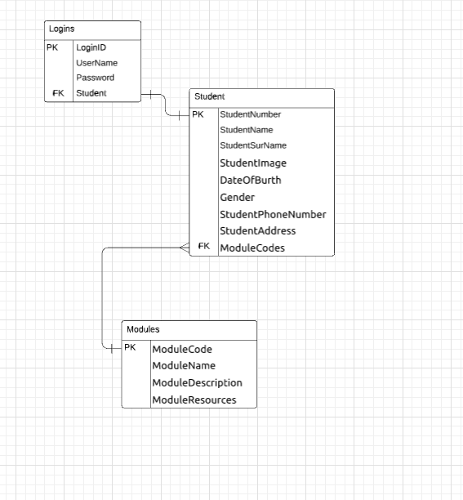
The Data will be stored based on a per user basus the user can only acces the data that his/her username and password coresponds to and the student can see the modules ha/she has access to.

