Data Layer

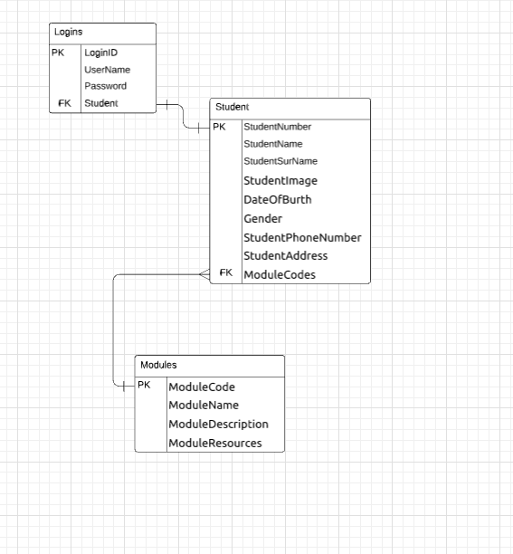
The Data will be stored based on a per user basus the user can only acces the data that his/her username and password coresponds to and the student can see the modules ha/she has access to.

