RESPIRATION SYSTEM
The processes in living organisms such as growth cell repair and reproduction requires a lot of energy. Energy stored in the food we eat, but our body cannot use it directly .Food is first digested and the nutrients are taken up in the blood stream. This energy must first be released before our cells can make use of the energy. This process of setting energy free from nutrients to be used in the body’s cells is called cellular respiration
Cellular respiration is the process of setting energy free from nutrients to be used in the cells of an organism.
The word equation for cellular respiration is: Glucose + Oxygen Carbon dioxide + water + energy
During cellular respiration Oxygen (O₂) inhaled enters into the lungs and then diffuses into the blood where it is taken to the muscle cells .Carbon dioxide (CO₂) which is a waste product is then taken by the blood from the cells to the lungs and then expelled out of the body during exhalation.
When seeds germinate, they make use of the food stored in the cotyledons (seed leaves) to provide energy to start growing. This means cellular respiration takes place.
Investigating if carbon dioxide is produced and energy are produced during cellular respiration
Aim: To demonstrate that carbon dioxide is a product of cellular respiration.
Materials: 2 similar flasks with lids or conical flasks with cotton lagging, seeds (beans or mealies), two beakers with lime water, thermometers
Procedure
- Take half of the seeds the day before the experiment and soak them to start the process of germination. Keep these seeds in a damp cloth until the next day.
- On the day of the experiment, place a beaker of lime water inside one of the flasks and place the germinating seeds around it.Seal the flask.
- Also place a beaker of lime water in the second flask and place the dry or boiled disinfected seeds around it.Seal the flask. (if you have used dry seeds, make sure this flask is completely dry so that the seeds will not start to germinate
- Place both flasks in a dark place in the class room. Observe what happens over the next two or so days.
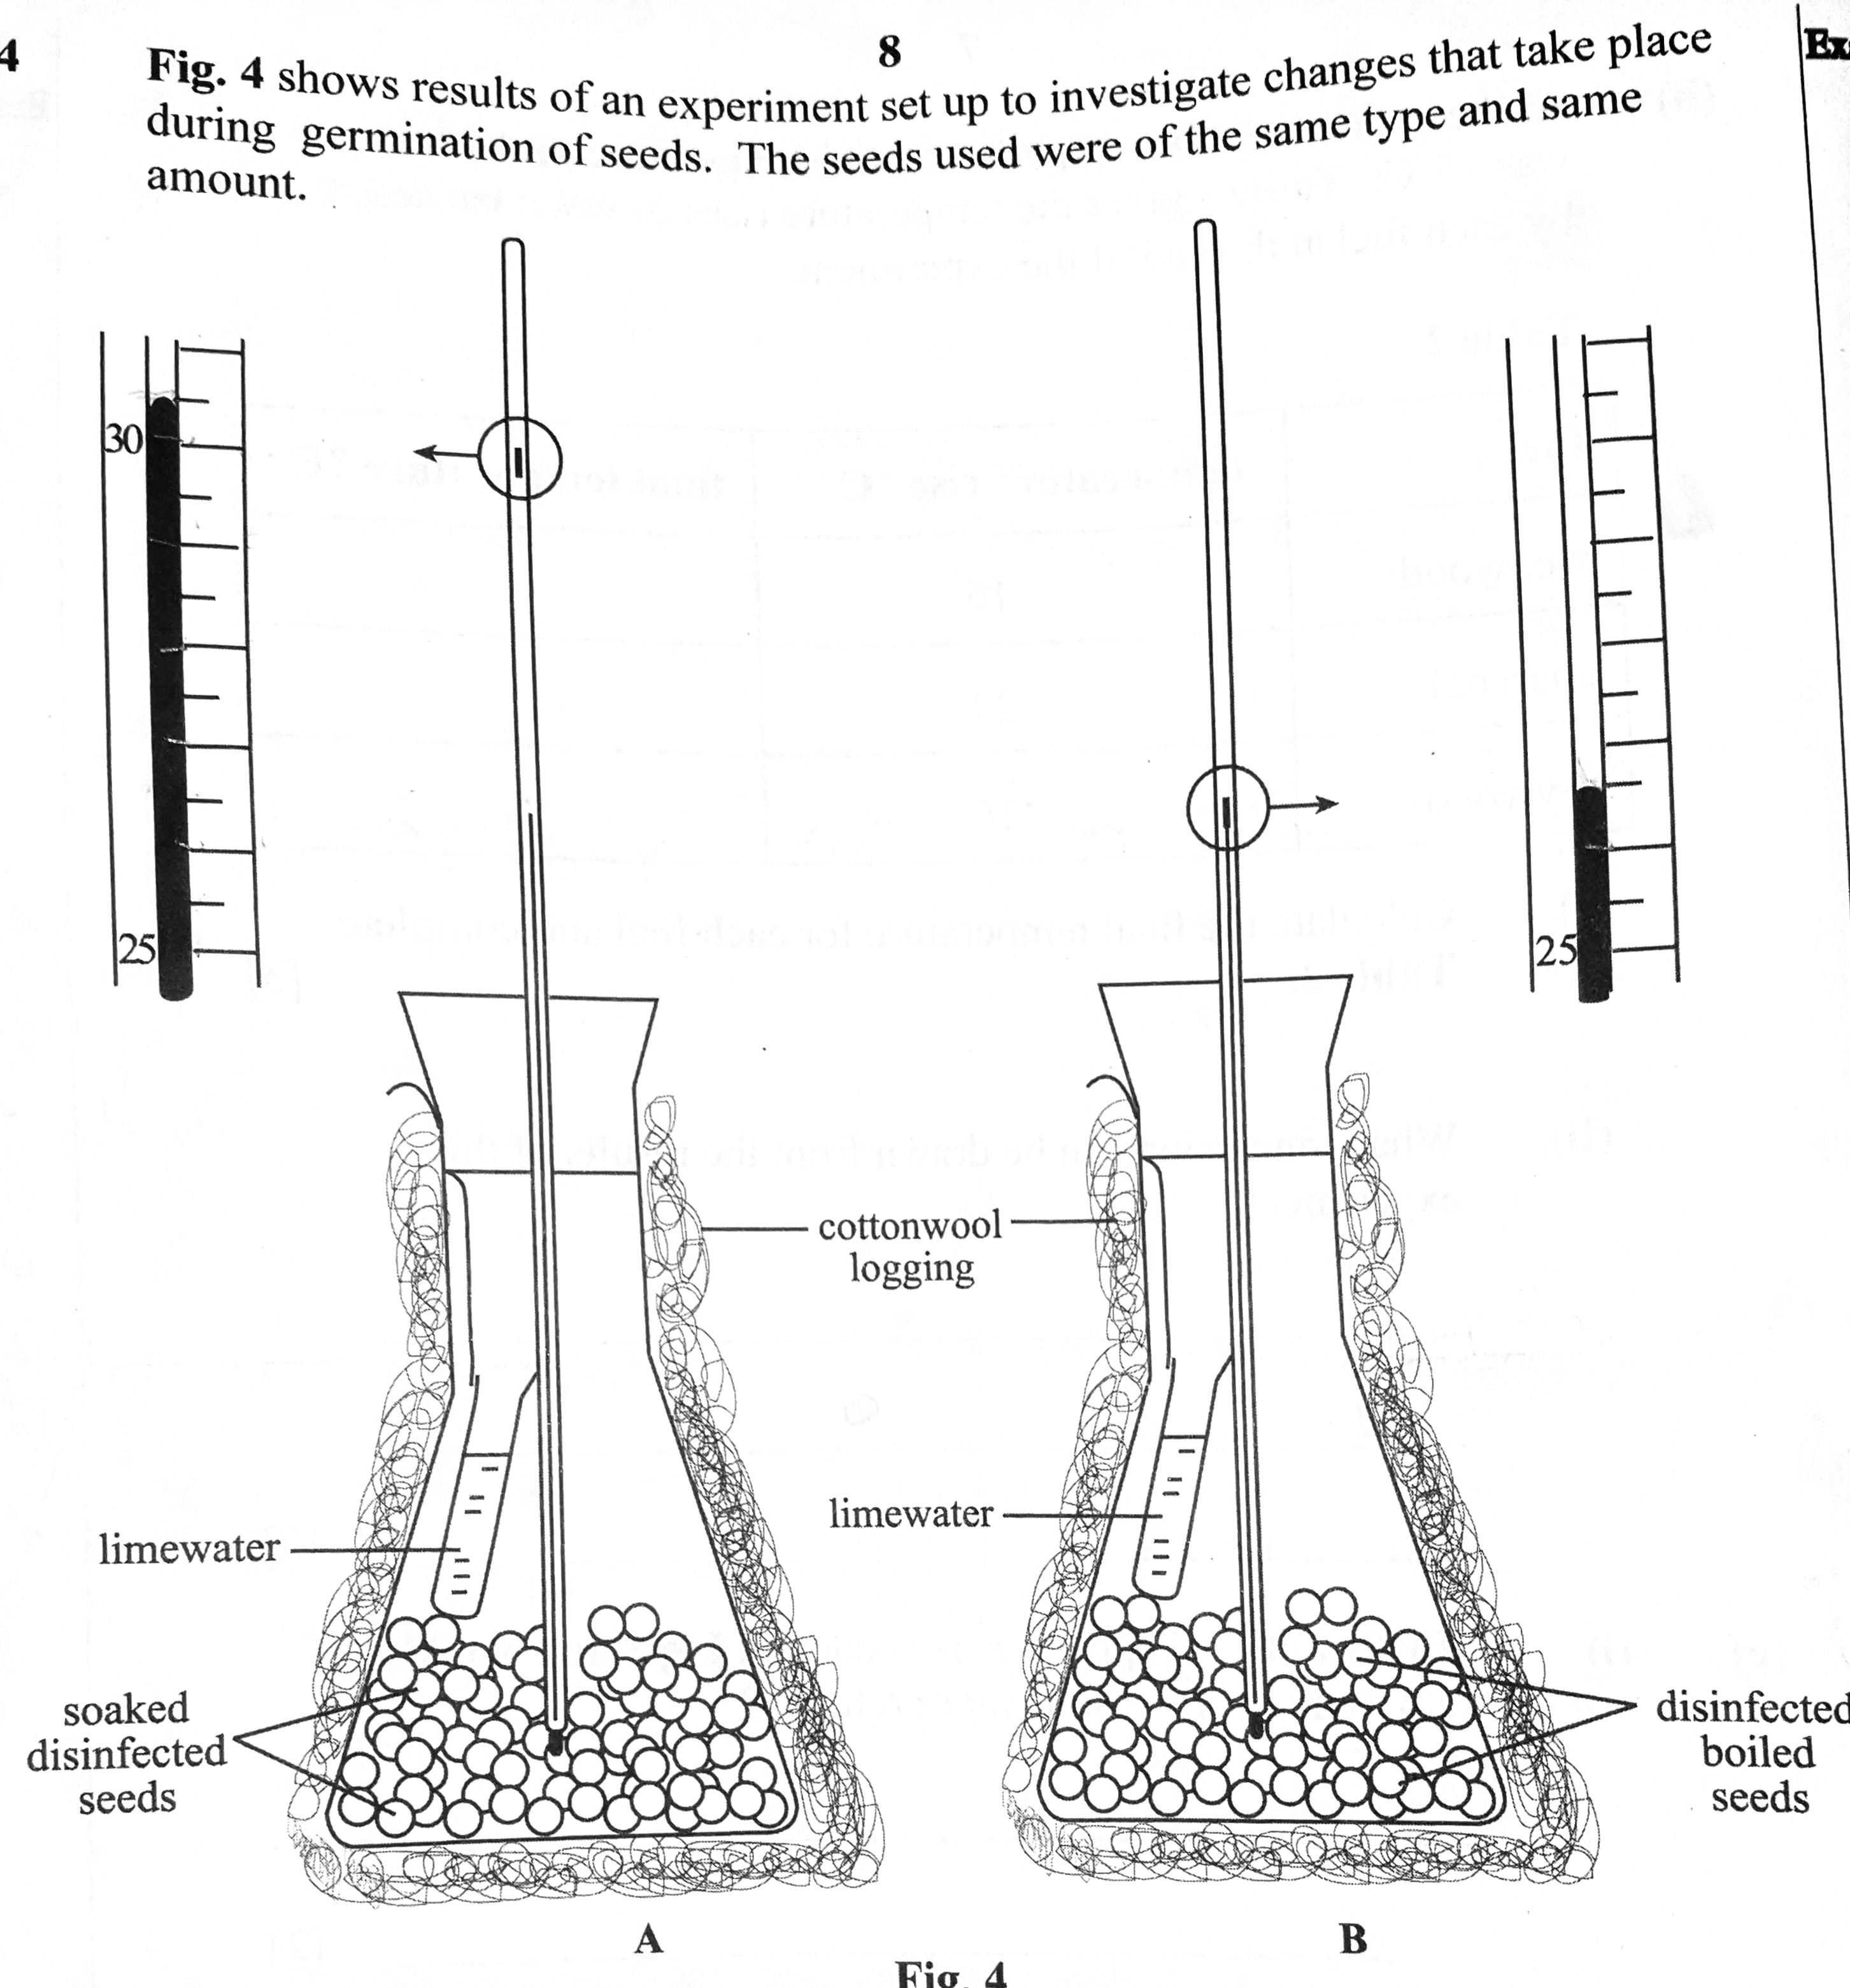

Questions and answers
1. What is the purpose of using germinating seeds in this experiment?
2. Why did you prepare a second flask boiled seeds instead of germinating seeds?
3. What is the purpose of placing a beaker of lime water inside the two flasks?
4. Record the temperatures in A and B.
5. Explain the differences in temperatures in A and B
6. What is the purpose of the cotton lagging?
7. Besides lime water what can be used to test for the presence of carbon dioxide and identify the colour change.
8. How can the experiment be made more reliable.
9. Why were the seeds disinfected?
Answers
- Germinating seeds respire and produce carbon dioxide as a product
- To demonstrate that only germinating seeds and not boiled or dry seeds do respire and produce carbon dioxide as a product
- To test for the presence of Carbon dioxide as lime water turns from colourless to milky in the presence of carbon dioxide
- A is 30.5⁰ and B is 26.5⁰.
- In A the temperature rose because respiration took place as the seeds were germinating and heat energy was produced. There was no temperature change in B as only germinating seeds respire and produce heat energy
- To prevent heat exchange between the inside of the flask and the outside environment.
- Bicarbonate indicator which changes from red to yellow.
- Make sure that the initial temperatures are equal; having the same amount of seeds in each flask; making sure that the tip of the thermometers are surrounded by the seeds.
- To prevent them from rotting
Investigating energy release during the burning of food
Aim: To investigate energy release when burning sugars (food)
Materials: retort stand and clamp, Bunsen burner, beaker with water, thermometer, evaporating dish, glucose powder or mealie meal, gauze mat, tripod.
Procedure
Set up the apparatus as shown in the diagram
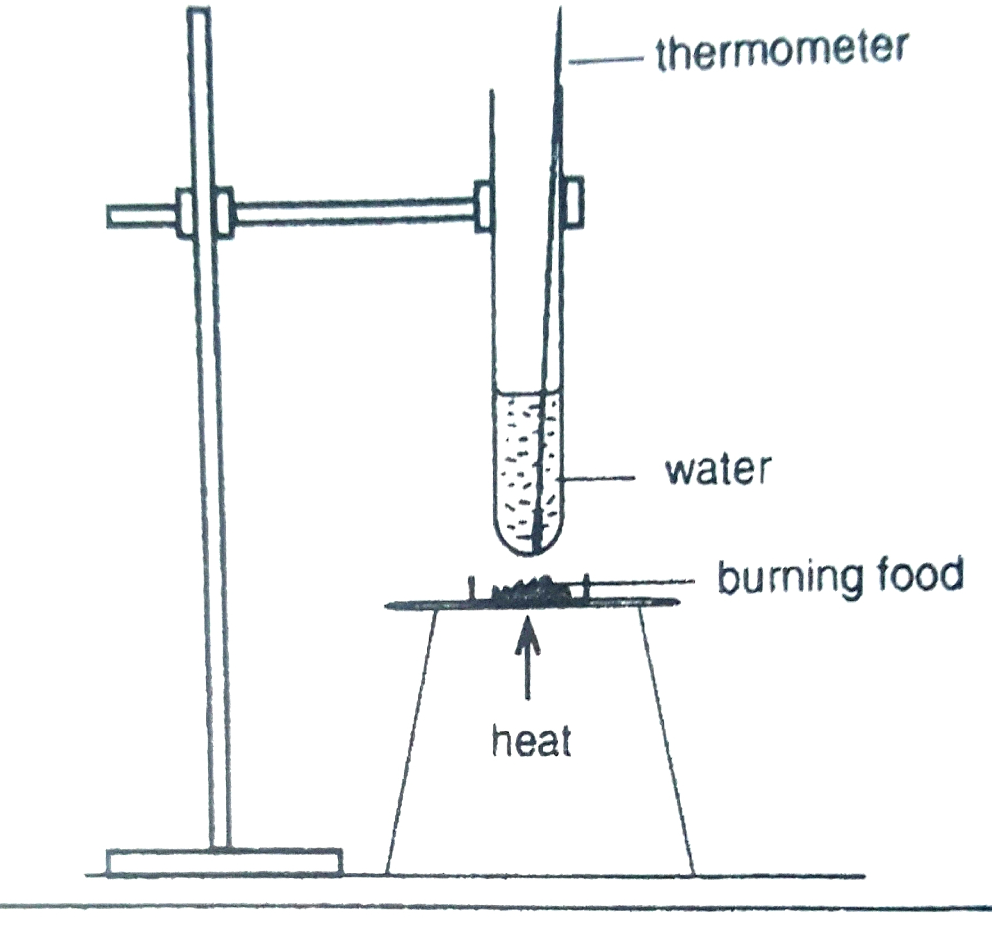
- Record the temperature in the beaker of water before
you start the experiment.
- Heat the evaporating dish with a Bunsen burner until
the glucose catches fire.
- Immediately remove the Bunsen burner.
- Measure the increase in temperature of the water
once burning has stopped.
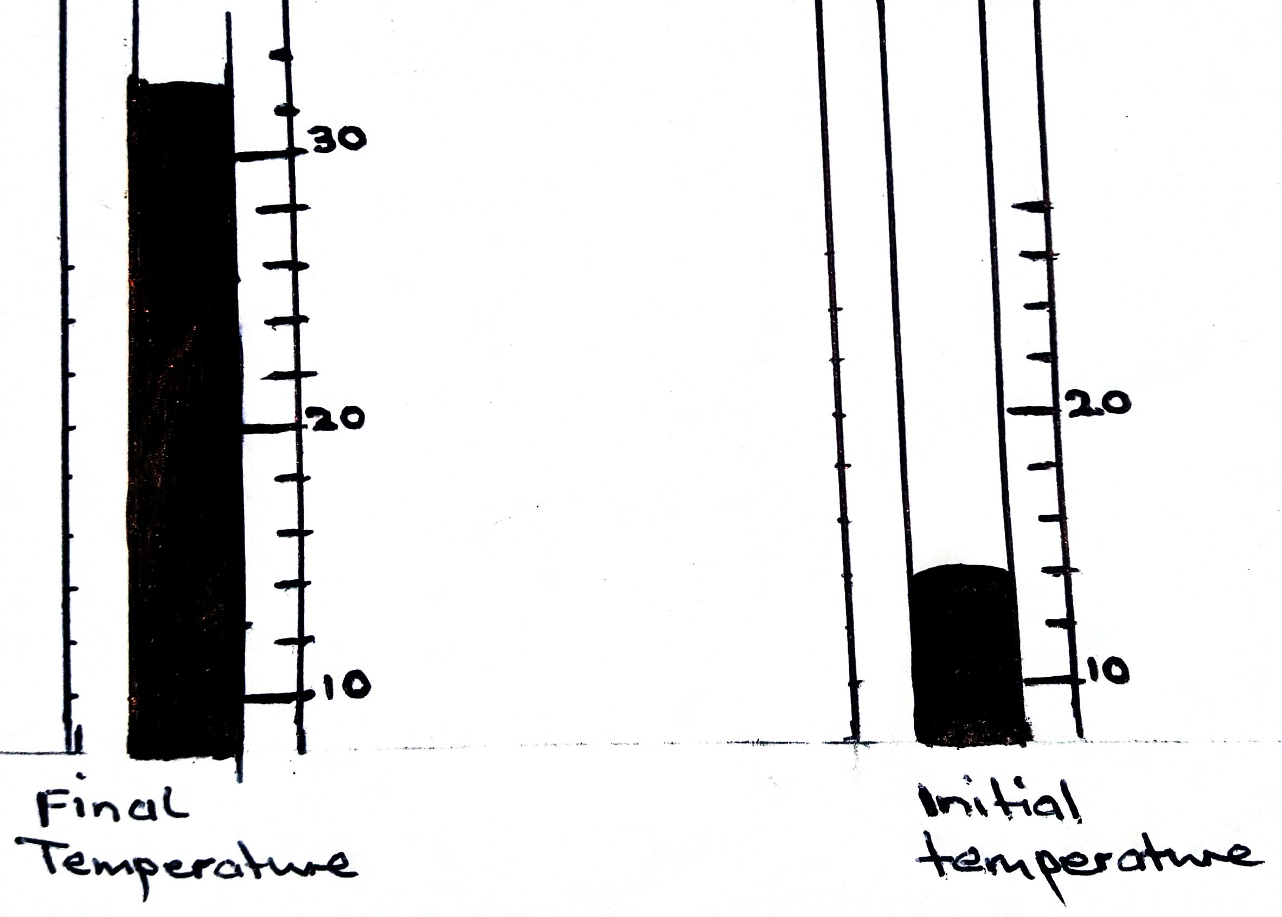

Questions
- Calculate the increase in temperature of the water.
- What does the increase in water temperature suggests about the energy in the glucose powder or mealie meal?
- What does a substance react with when it is burnt?
- What other observations did you make?
- What precautions did you take in this experiment?
Answers
- 26 – 14 = 12 ⁰C
- It shows that
- Oxygen

The energy produced during cellular respiration is used by the cells to perform their functions. Some energy is lost as heat energy. Carbon dioxide and water are the waste products of cellular respiration. There is a chemical cycling between photosynthesis and cellular respiration as the products of photosynthesis are the reactants for the respiration process.
THE HUMAN RESPIRATORY SYSTEM
The human circulatory system is made up of the following:
The air passage; two lungs; the respiratory muscles; the respiratory control system in the brain.
The human transport system makes the external gaseous exchange and internal gaseous exchange possible
-External gaseous exchange takes place in the alveoli when gases diffuses into and out of the bloodstream.
-Internal gaseous exchange happens in the cells and makes cellular respiration possible.
-The respiratory control centre in the brain controls the breathing rate .The breathing rate and heart rate are closely linked to maintain the correct levels of gases in the body.
The air passage
The air passage allow free movement of air into and out of the lungs. They include:
The nasal cavity; the pharynx(throat); the glottis (opening to the voice box); the larynx( voice box); the trachea (wind pipe); the bronchi (singular bronchus); the bronchiole (singular bronchiolus).
THE AIR PASSAGES
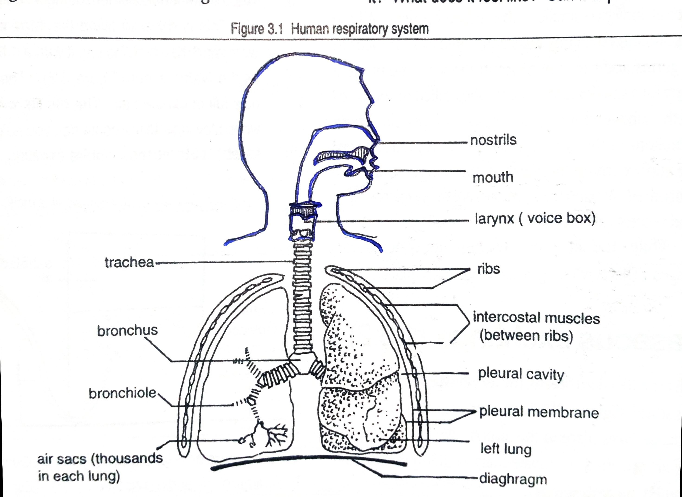

The nasal cavities – when we breathe in through the nostrils, the hair and cilia inside acts s a screening device, trapping dust and other small particles. Irritation of the nasal lining can make a person sneeze, which also helps to keep the air passage clean. The lining is supplied with blood capillaries which warms the air we inhale. There are also mucous glands to moisten the air before it reaches the lungs. The mucus is antiseptic and helps to prevent the spread of germs.
The pharynx, the glottis and the voice box
The air and food passages meet in the pharynx. This means that food can enter the air passages to the lungs, but it also allows you to breathe through your mouth when you exercise very hard or when your noise is blocked. You are prevented from choking when you swallow due to the upward movement of the trachea and the larynx, making the epiglottis close over the glottis.at the same time, the soft palate moves backwards, covering the entrance to the nose, and the food passes down the oesophagus. When you breathe, the air passes freely through the glottis into the larynx, where your vocal cords are and then into the trachea.
The trachea
The wall of the trachea is strengthened and held open at all times by a series of C-shaped cartilage rings. You can feel these rings very clearly when you tilt your head backwards and run your fingers up and down your neck. The Adam’s apple is one of these rings and is clearly visible in adult men. The trachea forks into the left and right bronchus
The bronchi and bronchiole
The left bronchus enters the left lung and the right bronchus enters the right lung. In the lungs, both left and right bronchi branch out into a network of fine tubes called the bronchioli. The system of air tubes looks like a tree turned upside down. The system of air tubes looks like a tree turned upside down.
THE LUNGS
External structure
The lungs are located inside the chest (thoracic) cavity, where they are well protected by the rib cage. They consists of spongy tissue, are very elastic and have a rich supply of blood capillaries. They are shaped like cones and are pinkish –grey in colour.The heart is situated in the space in between the lungs.
Internal structure
The bronchiole branch into smaller and smaller tubes deep into the lungs. Each bronchioles ends in a cluster of tiny air sacs called alveoli. Each alveolus has an extremely thin wall and is surrounded by a network of tiny blood capillaries. Gaseous exchange takes place between the air in the alveoli. There are millions of alveoli in each lung and together have a surface area about fifty times of that of the skin.
The internal and external structure of the lungs
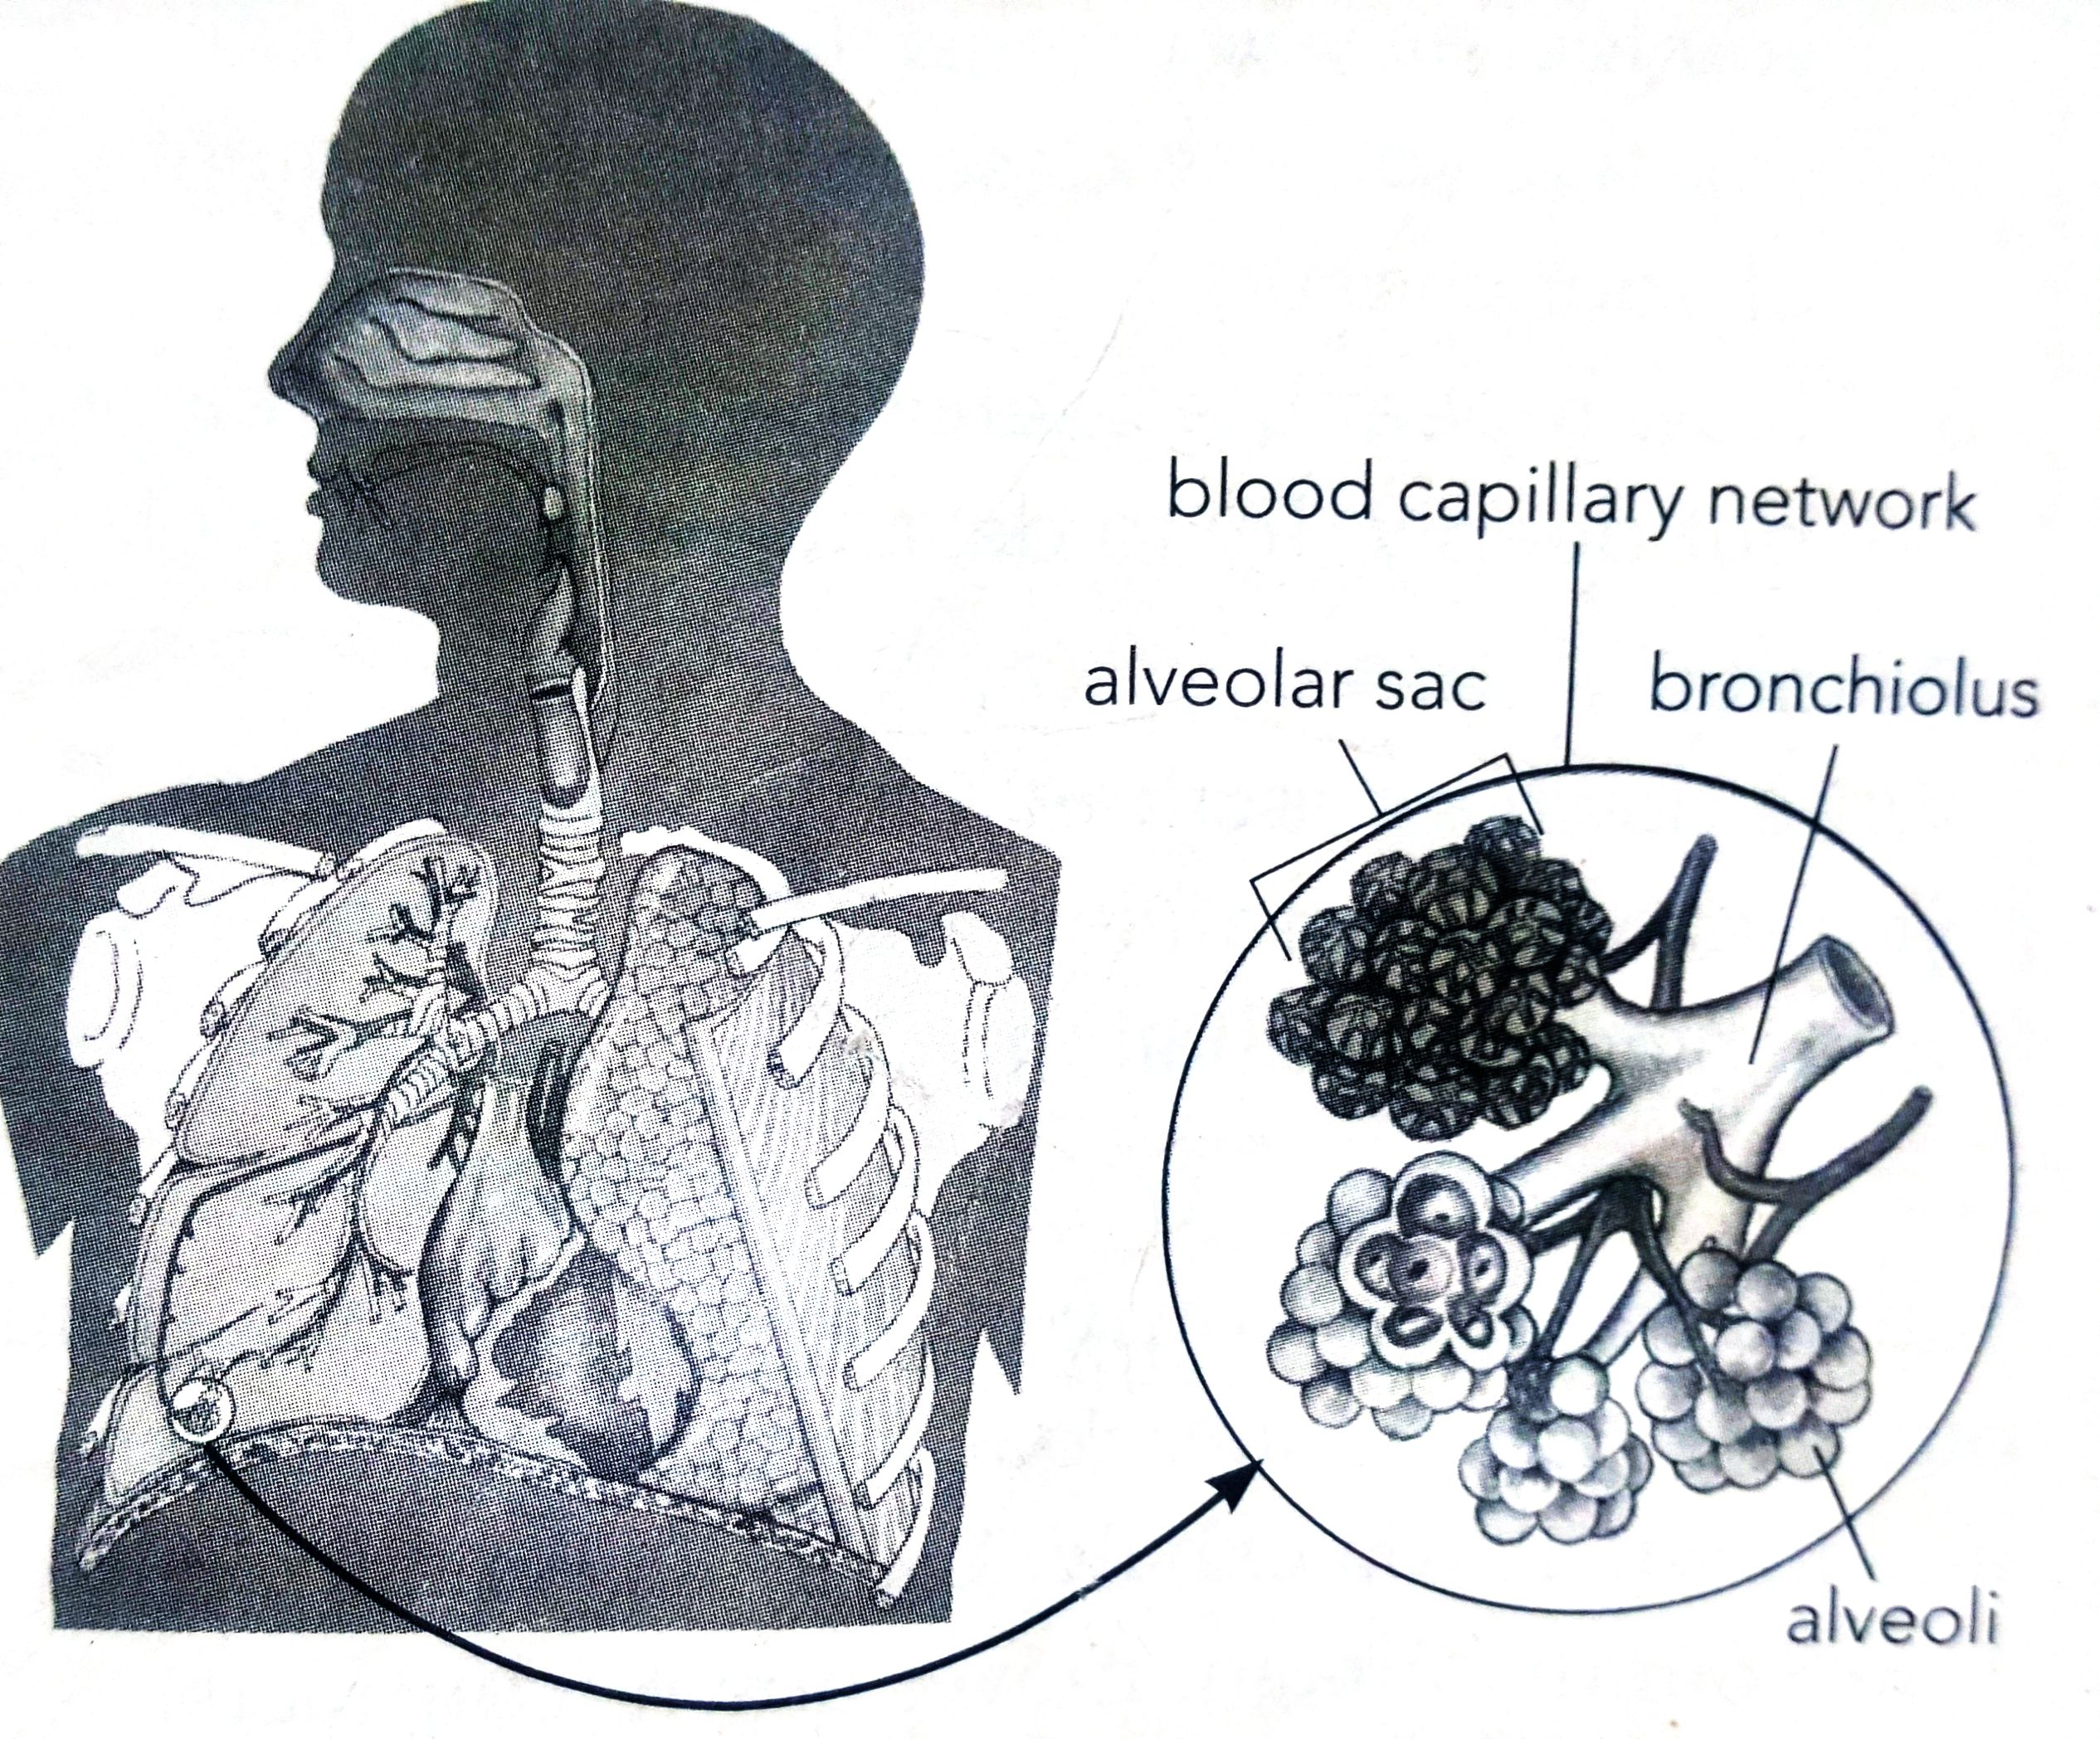

Gaseous exchange in the alveoli
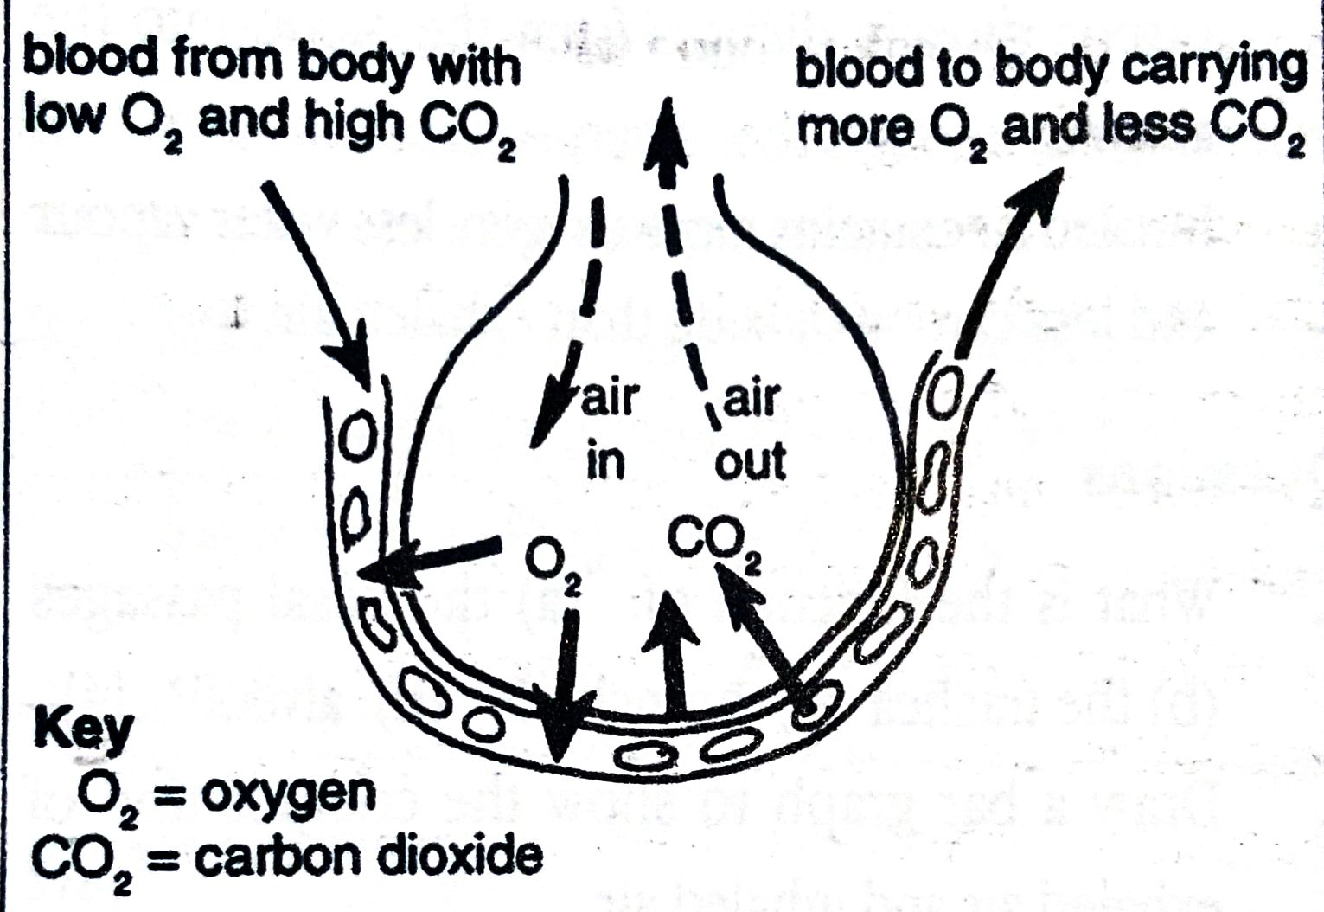

The role of alveoli in gaseous exchange
Gaseous exchange occurs in the alveolis.They are numerous and their large surface area is large enough for the intake of plenty of oxygen and expulsion of carbon dioxide. They are always moist, they are thin walled to allow rapid gaseous exchange and they are surrounded by numerous blood vessels called capillaries.
Capillaries surrounded the alveolus contain less oxygen than that is contained in the air sac (alveolus) oxygen therefore enters into the blood in the blood capillaries through a process called diffusion and is then carried by the blood to all parts of the body, to respiring cell.
The blood in the capillaries contains a higher concentration of carbon dioxide than the air in the alveolus. So, by diffusion, carbon dioxide moves into the air sacs and is expelled through the bronchiole, and up the trachea until it is breathed out through the nose/mouth.
Path followed by air during inhalation (breathing in)
Nose Trachea (wind pipe) bronchi bronchiole Alveoli (air sac)
The respiratory system
The muscles used for breathing are the diaphragm at the base of the chest cavity and the muscles between the ribs. These muscles are used when you inhale and exhale.
The mechanism for breathing
-Ribcage moves up and out during inhalation.
-Ribcage moves down and in during exhalation
Diaphragm moves down (contracts) during inhalation and moves up (relaxes) during exhalation.
Inhalation is the active phase of breathing. The diaphragm contracts and moves down .The external muscles between the ribs contract so that the ribcage moves out and up.The chest cavity increases in volume .The pressure in the lungs decreases so that air from outside flows in .
The respiratory control Centre
Although you can decide to hold your breathe or to breathe faster or slower, you are, most of the time, unaware of the fact that you are breathing.This is because you do not have to concentrate to do it.
Breathing is controlled automatically by the respiratory control centre at the base of the brain .We say it is involuntary action.Breathing control is only effective in keeping the correct levels of oxygen and carbon dioxide in the body if there is coordination with blood flow.
Breathing model
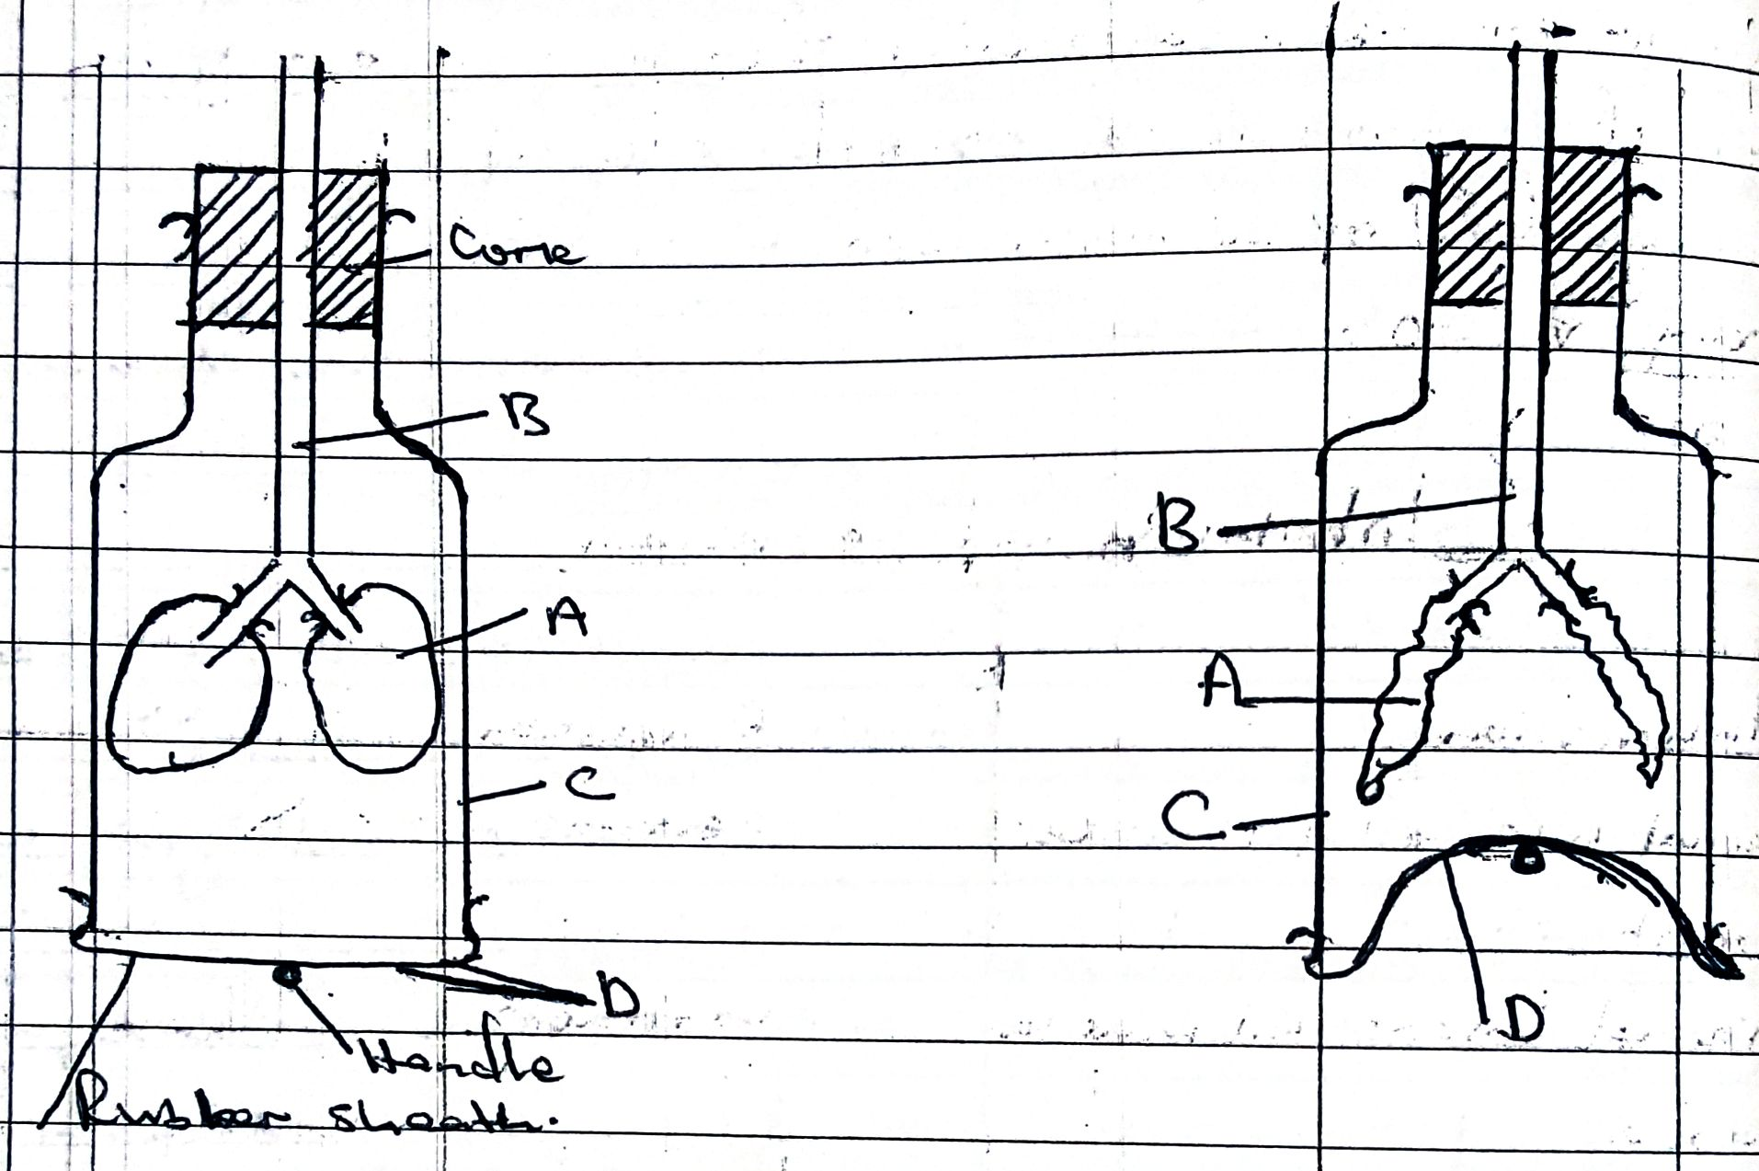

Inhalation exhalation
Relationship between heart rate and breathing rate
Breathing rate and heart rate are given per minute. You can take the counts over 30 seconds and multiply them by two. A normal breathing rate at rest is between 16 and 20 per minute. A normal pulse rate at rest is between 60 and 100 per minute.
After exercising pulse rate and heart beat rate increases because
Chemical cycling is a process during which chemical substances are used and produced in a continuous cycle
REVISION EXERCISE
- State the word equation for cellular respiration. [3]
- Complete: Cellular respiration and -------------------------------- are related through chemical cycling [2]
- A learner made a model shown below
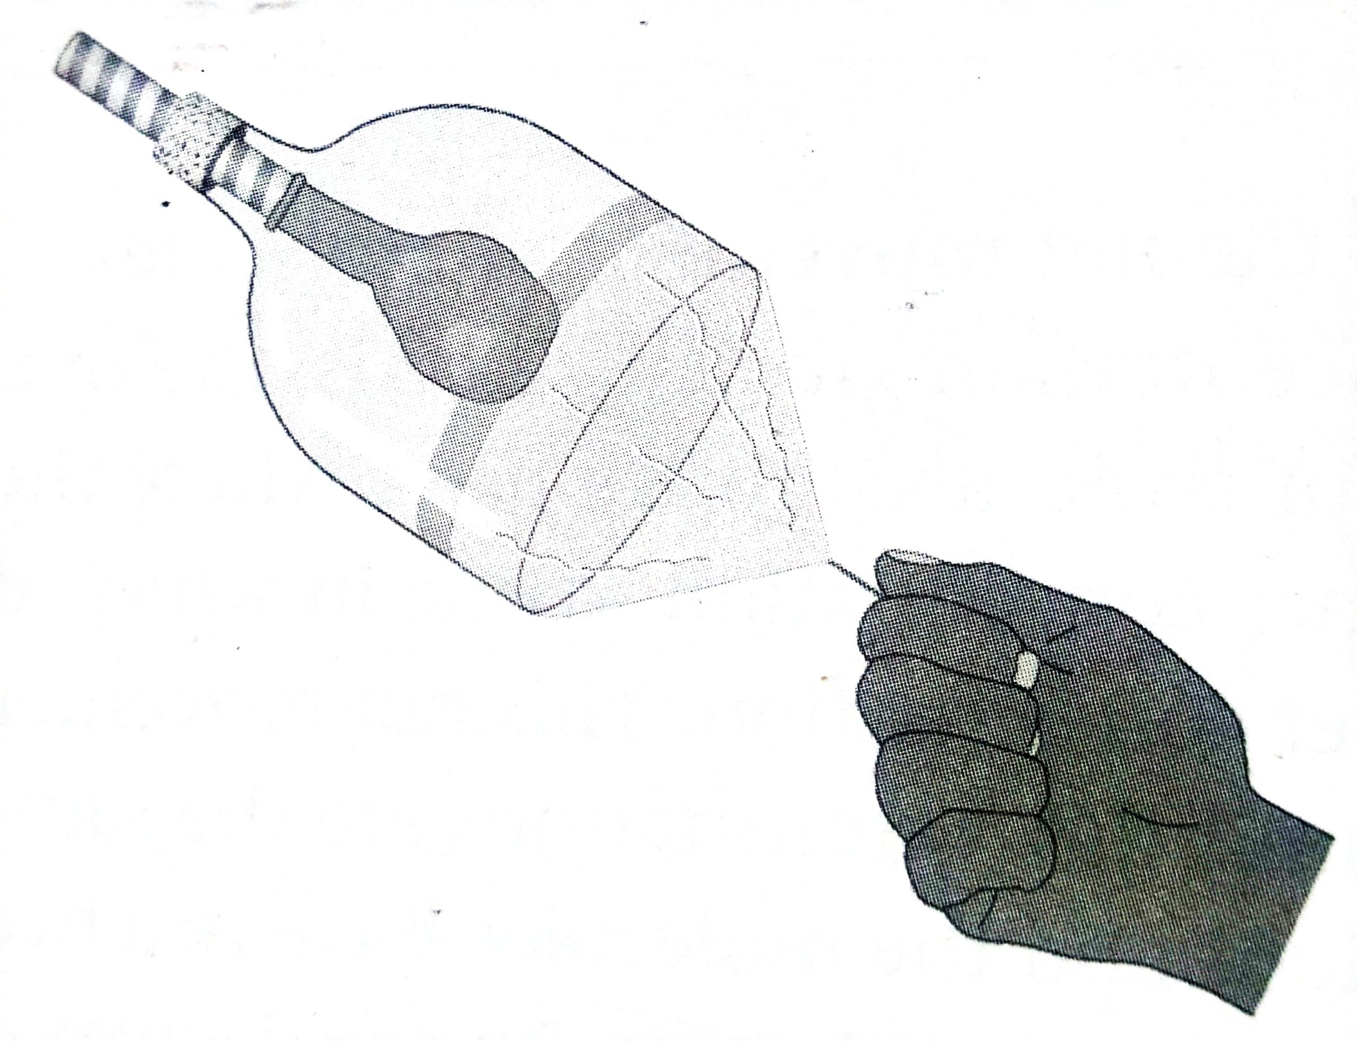

- State the aim of the experiment. [2]
- What parts are represented by the straw, the plastic bottle, the balloon and the plastic sheeting? [4]
- State two limitations of this model. [2]
- Describe the process in the Human body that is shown by pulling the elastic band [6]
- What is the function of the respiratory control centre in the brain? [2]
- Choose the correct option : There is a direct / indirect relationship between breathing rate and pulse rate [1]

