Candidate Name : Mutsvairo Amasiah
Candidate Number : 5036
Center Name : Mufakose 1 Secondary School
Center Number : 010142
Level : Advanced Level
Project Title : Using DC motors as DC Generators as an Innovative
Solution to Power Shortages During Winter
Learning Area : Physics
Syllabus Topic : Electromagnetic induction
Year : 2025

Objectives
- Investigate how varying revolutions per minute impacts motor power output.
- Optimize the motor-generator system for cost effectiveness and sustainability.
- Evaluate the performance and effectiveness of the system.

Stage 1: Problem identification
Problem statement.
During winter, in my area there is a significant increase in energy demand due to the need for heating, lighting, and longer indoor activities. This surge in demand often exceeds the electricity supply capacity, leading to frequent power shortages and load-shedding. Power shortages have led people to seek alternative energy sources for their daily needs. For activities like cooking and studying, which require reliable lighting, solar systems have become popular. However, during winter months, the reduced sunlight and shorter daylight hours hinder the batteries' ability to fully charge, resulting in decreased efficiency and shorter battery life. This limitation affects the overall performance and reliability of these solar systems.
Statement of Intent.
The intention of this project is to develop a system that will employ the principle of electromagnetic induction from a rotating dc motor to charge rechargeable torch batteries. The goal is to improve comfort, safety, and energy efficiency during winter seasons
Design Specifications.
The proposed solution must:
- Be sustainable and environmentally friendly.
- Be cost-effective for implementation and maintenance.
- Operate efficiently during extreme winter conditions.
- Require minimal manual intervention once installed.

Stage 2: Investigation of related ideas
Research Methodology
A research study was conducted through observation and in-person interviews with Mufakose residents to gather information on their coping mechanisms with power outages in winter. Specifically, the study aimed to identify the methods residents use for lighting purposes when there is no electricity.

1.Use of Fossil fuel based-Generators

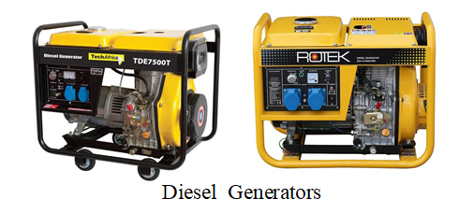
Some residents use diesel generator for lighting in homes.
Strengths:
- There are very effective as they supply more power enough to power even other household appliances

Weaknesses
- Expensive to run and maintain
- They are very noisy
- Not environmentally sustainable as it produces gases
2.Installing a solar system with more solar panels and battery backup
More Solar panels generate more electricity during the day then batteries store extra power for night-time or cloudy days.
Strengths
- Provides a reliable energy as more energy from the sun is captured and stored in batteries.
Weaknesses
- More solar panels can be insignificant relative to increased time of no sunlight
- It is associated with High initial installation cost
- Battery storage capacity may not be enough for long periods without sun
Recommendation
Encourage community solar programs to reduce costs by allowing multiple households to share one solar system.
3.Relying on Candles from stores
Use of candles for lighting in homes
Strengths
- Low cost
- Readily available
Weakness
- Light produced in not much effective
- Can causes eye problems.
- Poor managing of them can cause fires
- They have limited duration
- Produce dangerous fumes
Recommendation:
Discourage long-term reliance on candles due to safety risks. Encourage households to explore safer alternatives like LED lights powered by rechargeable batteries or small solar systems.
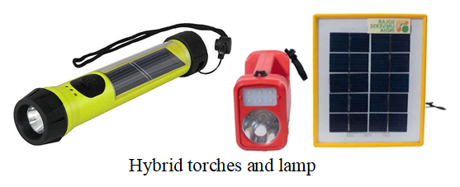
4.Relying on hybrid rechargeable torches
Strengths
- Readily available in stores
- Portable.
- Can be charged using electricity (if available) in case of cloudy days
Weaknesses
- Can be difficult to achieve full charge in cases of no electricity and cloudy days
- Might not be affordable to everyone
Recommendation
Manufacturers of hybrid torches could focus on developing more efficient solar panels that enable faster and more effective charging, even on cloudy days

Stage 3: generation of ideas
1.Developing Homemade Batteries Using Domestic Materials as electrolytes such as lemons, vinegar and potatoes so as to convert Chemical energy to Electrical Energy.
An experiment was conducted to test the performance of different electrolytes in a homemade battery setup using zinc and copper electrodes. The voltage produced by each electrolyte was measured and recorded. The results were presented in the table below:
Electrolyte type | PD across 1kΩ resistor/V | Load current/mA | Power delivered/W
Lemon | 0.8 | 0.8 | 6.4x10⁻⁴
Potato | 0.7 | 0.7 | 4.9x10⁻⁴
Vinegar | 0.5 | 0.5 | 2.5x10⁻⁴
Comment
The table clearly illustrates that lemon is the most effective electrolyte for generating electrical energy, as indicated by its higher PD and power output. The consistent relationship between PD, load current, and power emphasizes the efficiency of using different electrolytes in generating electricity.
Advantages
- Uses inexpensive and easily obtainable materials.
- Demonstrates fundamental electrochemical principles.
- Potentially reduces reliance on commercially produced batteries (if materials are recycled).
- Can explore different material combinations to optimize performance.
Challenges:
- Typically produces very low voltage and current, insufficient for powering most devices directly.
- Batteries may degrade quickly.
- Performance is highly dependent on the purity and consistency of materials.
- Potential for leakage of corrosive materials.

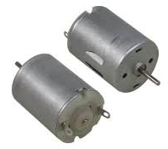
2.Using DC Motors as DC Generators, employing the concept of electromagnetic Induction
Description: Using a DC motor in reverse as a generator, mechanical energy (e.g., from hand-cranking, wind, or water flow) is converted into electrical energy through electromagnetic induction. This electricity can then be used to charge a battery.
An experiment to investigate the voltage and current produced by a rotating motor used as DC generator was conducted at different revolutions per minute (RPM). The results were measured and recorded in the table below
Revolutions per minute | PD across the motor when connected to a 1kΩ resistor/V | Load current/mA | Power Delivered/W
1000 | 4.96 | 4.96 | 2.460x10⁻²
2000 | 8.91 | 8.91 | 7.939x10⁻²
3000 | 15.84 | 15.84 | 2.509x10⁻¹
4000 | 20.79 | 20.79 | 4.322x10⁻¹
5000 | 26.73 | 26.73 | 7.145x10⁻¹
Comment
The data shows a positive correlation between RPM, PD, and power delivered. As the motor speeds up, both voltage and power output increase, suggesting that optimizing RPM can enhance the motor's performance and efficiency in generating electrical energy.
Advantages:
- Can harness kinetic energy from various sources.
- DC motors are relatively easy to find and adapt.
- Can be scaled up by using larger motors or multiple motors.
Challenges:
- DC motors are not optimized for generator use, resulting in lower efficiency compared to dedicated generators.
- The output voltage may fluctuate depending on the speed of rotation.
- Requires a charge controller to prevent overcharging the battery.
3.Making Homemade Candles to produce Light Energy from them
Description: Producing candles from wax from any of the wax type (paraffin wax, beeswax, soy wax)
An experiment to compare the burn times of beeswax and paraffin wax candle wax conducted to identify which wax is good to make candles from. 100g of each wax type was melted at 70°C and solidified into candles. The candles were lit, and burn times were recorded.
Wax type | Burn time
Paraffin wax | 8 hours
Bee wax | 11 hours
Soy wax | 10 hours
Comment
The beeswax candle burned for a longer duration compared to other types of candles, providing sustained light.
Advantages
- Candle making is a straightforward process with readily available materials.
- Provides a reliable source of light during power outage
Challenges
- Candles provide relatively low light compared to electric lights.
- Requires careful handling to prevent fires.
- Burning candles can release soot and other pollutants.
- Wax Consumption: Candles have a limited lifespan due to wax consumption.
4.Using Piezoelectric Modules that convert Stress to Electrical Energy
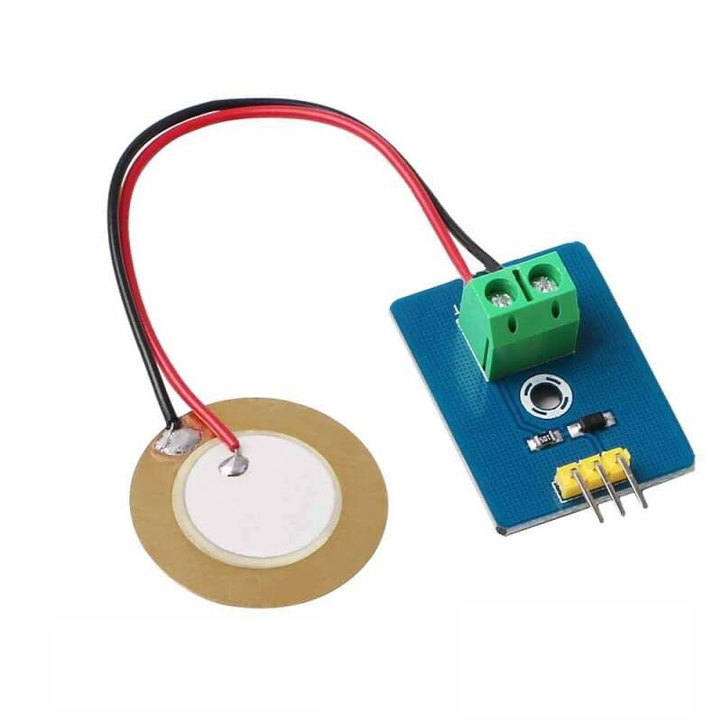
Description: Piezoelectric modules convert mechanical stress (e.g., from footsteps, vibrations, or pressure) into electrical energy.
Piezoelectric modules can harness electrical energy from various stress sources, including footsteps, vibrations, mechanical pressure, and oscillations. However, due to their limited availability and high cost, experimenting with these modules proved impractical, rendering them unsuitable as a viable solution for addressing the problem at hand.

Advantages
- Can harness energy from otherwise wasted mechanical stress.
- Piezoelectric modules are generally durable and require little maintenance.
- Can be scaled up by using more modules.
Challenges:
- Piezoelectric modules typically produce very low voltage and current.
- Requires a significant amount of force to generate a usable amount of energy.
- Piezoelectric modules can be relatively expensive
Stage 4: development OF idea
The idea chosen is Using DC Motors as DC Generators, employing the concept of electromagnetic Induction to produce Direct current.
Justification of the chosen idea
- Self-sustaining power generation: Capable of generating sufficient electricity to charge batteries.
- Environmentally friendly: No emission of harmful gases.
- Cost-effective: Affordable due to the ease of obtaining DC motors.
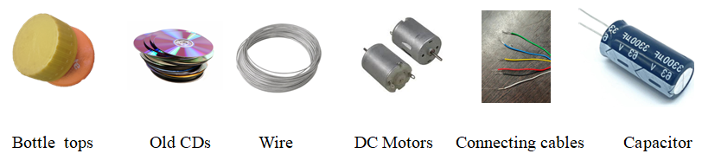
- Scalability: Can be scaled up to some extent by configuring DC motors in series or parallel.
Materials and equipment to be used

Refining the idea
In stage 3, the exact revolutions were made possible by motor speed controller so as to identify the how varying RPM varies potential difference and load current produced
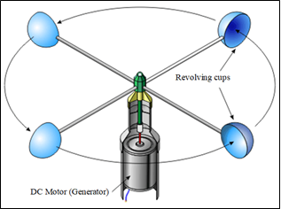
A design was then made such that the motor is rotated by wind velocities as shown in the diagram below:
Experimentation and Data Collection
To determine if wind speeds can generate sufficient RPMs to produce electricity for charging a 3.7V battery, experiments were conducted on different days. Key measurements were recorded:
- Wind Speed: Measured using a cup anemometer.
- RPM: Calculated by analyzing video footage of the rotating motor using Tracker software.
- Voltage (PD) and Current: Measured using a multimeter.
Each experiment started with a battery voltage of 1.0V. The collected data is presented in the table below.
 | Wind speed/ms-¹ | RPM | Load current/A | Battery voltage after 1 Hour/V
Day 1 | 5.50 | 867 | 4.37 | 3.06
Day 2 | 6.20 | 891 | 4.50 | 3.11
Day 3 | 4.92 | 723 | 3.65 | 2.28
Day 4 | 6.80 | 1115 | 5.63 | 3.44
Day 4 | 7.02 | 1253 | 6.32 | 3.57
Comment
The data illustrates a positive relationship between wind speed and RPM, while the load current fluctuates based on demand.
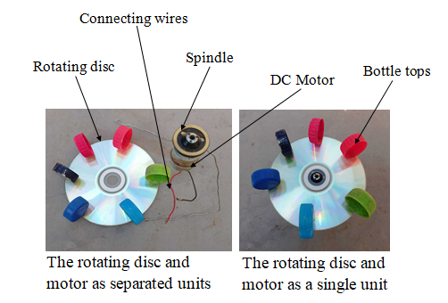
Stage 5: Presentation of results
For the final solution, my project presents a self-sustaining power generation system of DC motors as DC generators, powered by wind energy. This solution was demonstrated through a functional prototype that uses wind to rotate a motor, generating electricity through electromagnetic induction
How the system works
1. Air Collection: Bottle tops collect air to rotate a rotating disc.
2. Rotating Disc: The disc spins as air accumulates in bottle tops, turning a spindle.
3. Spindle: Holds the rotating disc in place during it's spinning.
4. DC Motor (Generator): The rotating disc's motion turns the motor's shaft, inducing electromagnetic current through coil rotation between magnets.
5. Connecting Cables: Transmit the generated current to an external load.
6. Capacitor (not shown in the diagram): Filters the DC output, compensating for fluctuations due to varying wind speeds.
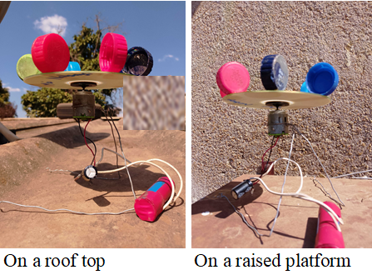
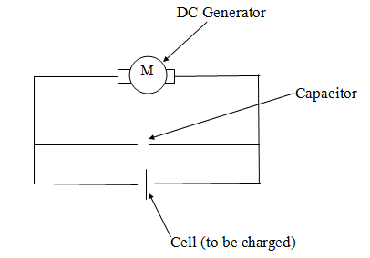
The system in action The circuit diagram

Stage 6: Evaluation and Recommendation
For evaluation purposes on the performance of the motor-generator system, the system was given to one Mufakose resident and was asked to provide feedback on the following aspects after using it for a week
- Charging time
- Low wind performance
- Mechanical durability

Feedback received

1. Charging time: The charging time varies a lot depending on the wind speed. On windy days, it charges relatively quickly, but on calm days, it takes forever.
2. Low wind performance: Yeah, I've noticed that when the wind speed is below 5 km/h, the generator barely produces any electricity. It's like it's not even spinning.
3. Mechanical durability: So far, so good. The generator seems sturdy, but I'm a bit worried about the blades. They seem to be vibrating quite a bit when the wind picks up. Not sure how long they'll last.
Achievements
The project successfully:
- Generated electricity using wind energy and a DC motor.
- Demonstrated the impact of wind speed on power production.
- Proved that the system can charge a 3.7V battery.
- Showed potential for household use by harnessing natural wind.
- Met the project goals by providing an affordable and community-friendly solution to wind power shortages.
Challenges encountered
- Accurate measurement of RPM and wind speed was difficult.
- Ensuring secure connections without loose wires was tricky.
- Inconsistent wind speeds affected output.
- Voltage output fluctuated without a voltage regulator.
Recommendations
- Designing a sturdy stand or case to hold components steady.
- Adding multiple motors to generate more power for larger applications.
- Incorporating a voltage regulator to stabilize power output before charging devices.

