**Explore the Mystery of the Ghost Town Misnebalam**

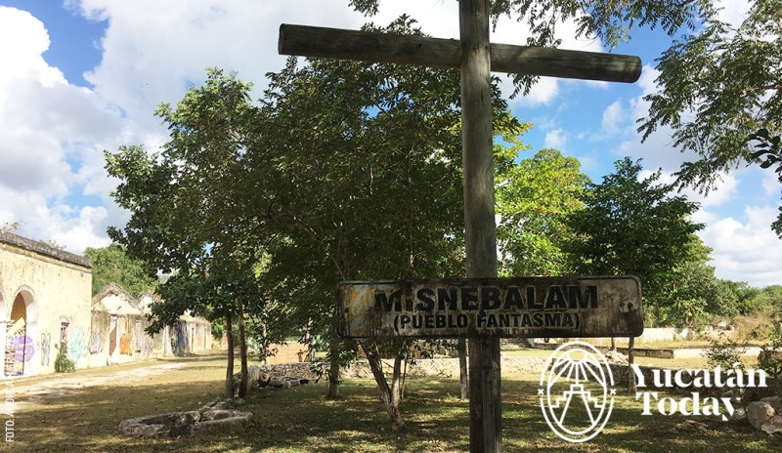

Are you daring and want to explore a place full of mystery? Would you like a day of adventure, hunting for ghosts? If you answered yes to these questions, then you’re ready to visit the ghost town Misnebalam. Best of all, it’s very close to Mérida!

Yes, Yucatán has a ghost town! It’s a place that combines adventure, mystery, and ghosts: Misnebalam, a former henequén farm located in the precinct of Santa María Yaxché just off the Mérida – Progreso highway. It had a prosperous past and is now famous for the appearance of spirits, particularly the child “Juliancito”, among other supernatural phenomena.

Link : <https://yucatantoday.com/ghost-town-misnebalam/?lang=en>