Colorimeter

**INDEX**

|  |  |  |
| --- | --- | --- |
| **Sr. No.** | **Contents** | **Page No.** |
| **1** | **ABSTRACT** | **3** |
| **2** | **OBJECTIVES** | **4** |
| **3** | **INTRODUCTION AND THEORY** | **5** |
| **4** | **EXPERIMENTAL METHODS or THEORETICAL CONTENT** | **6** |
| **5** | **RESULTS** | **7** |
| **6** | **CONCLUSION** | **8** |
| **7** | **Limitations and future scope** | **9** |
| **8** | **REFERENCES** | **10** |

**ABSTRACT**

The visible light spectrum consists of a range of frequencies, each of which corresponds to a specific color. Any visible light that strikes an object and becomes reflected (or transmitted to our eyes) will contribute to the color appearance of that in the same way, the color of a solution is a direct result of the wavelengths of light absorbed. So, if a solution absorbs all of the frequencies of visible light except for the frequency associated with green light, then the object will appear green.

A colorimeter is any instrument a chemist uses to determine or specify colors. One type of colorimeter can find the concentration of a substance in solution, based on the intensity of color of the solution. If you are testing a colorless solution, you add a reagent that reacts with the substance, producing a color. This type of colorimeter has a wide range of applications, including laboratory research, environmental analysis of water quality, analysis of soil components, monitoring of hemoglobin content in blood and analysis of chemicals used in various industrial settings.

**Objective**

1. **To find the concentration of a solution by measuring its absorbance of a specific wavelength of light.**
2. **A Modern Approach of Using LED Light of the respective Wavelength instead of using the Color Filters.**

**INTODUCTION AND THEORY:-**

When it comes to the appearance of products, the most important aspect of appearance is the color of the product. The color contributes a major portion of the appearance and hence it is essential to ensure that the color of the products is of the best quality and level. To ensure that the color of the products is of the best quality and level, a colorimeter is used. The colorimeter is a device that is mainly used in industries and laboratories for analyzing the color quality of the products along with color measurement.

## What is Colorimeter?

The colorimeters are highly sensitive devices that can measure the concentration and intensity of a particular color that is used in a product. There are mainly two different types of colorimeters that are used in industries that are color densitometers and color photometers. The color densitometers measure the color density of primary colors in a color combination in a test sample. The color photometers are used for measuring the reflectance of a color as well as the transmission.

## Working Principle of Colorimeter:-

The working of colorimeters is mainly based on the Beer-Lambert’s Law. This law states that the light absorption when passes through a medium are directly proportional to the concentration of the medium. When a colorimeter is used, there is a ray of light with a certain wavelength is directed towards a solution. Before reaching the solution the ray of light passes through a series of different lenses. These lenses are used for navigation of the colored light in the colorimeter. The colorimeter analyzes the reflected light and compares with a predetermined standard. Then a microprocessor installed in the device is used for calculation of the absorbance of the light by the solution. If the absorption of the solution is higher than there will be more light absorbed by the solution and if the concentration of the solution is low then more lights will be transmitted through the solution.

**EXPERIMENTAL METHODS or THEORITICAL CONTENTS:-**

A specific reagent are used which react with the specific components and form a coloured complex. The concentration of the coloured complex is directly proportional to the concentration of the component in the specimen. That colour density absorbed specific spectrum of light and reset of light transmitted from specimen. That transmitted light is detected by colorimeter detector. According to following formula, Optical density is calculated.

Optical Density= 2-log%T

Optical density is directly proportional to concentration of substance.

## How Colours can be analysed using Colorimeters?

To analyse the concentration of an unknown sample, there are several specimen prepared from the test sample and then tested using an efficient colorimeter. After analysis, the transmittance and concentration of the tested specimen are plotted on a graph to obtain a graphical representation of the concentration creating a calibration curve. This curve is then compared with the curve of a known sample, and the concentration is measured.

**Results:**

Some of the Observations of the Designed Colorimeter are: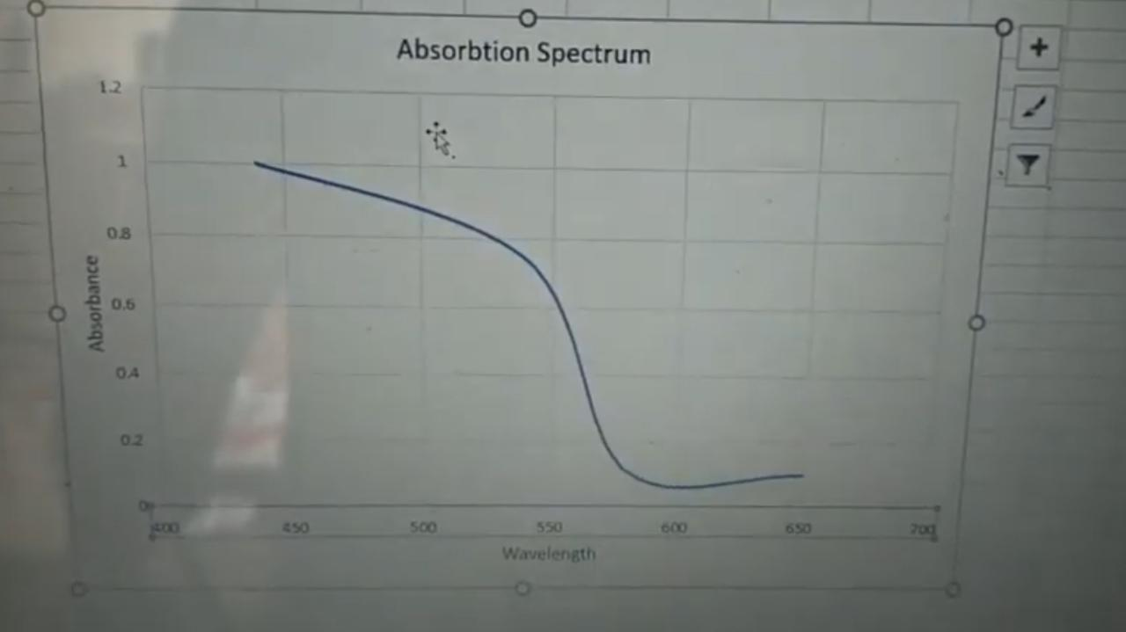

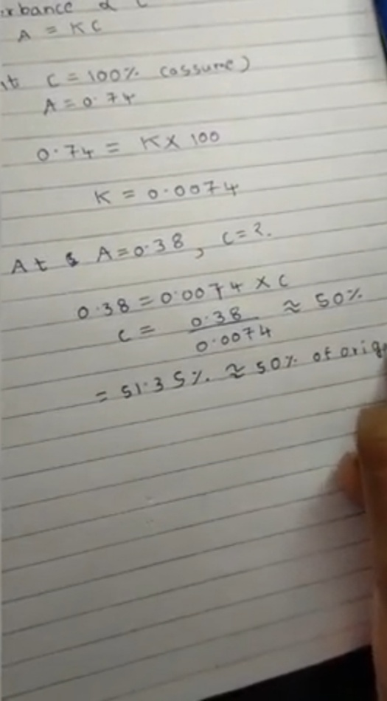

**CONCLUSION**

1. The project taught about beer’s and Lambert’s law.

2. And also about changing the intensity to absorbance to find unknown concentration of solution.

3. We can also plot absorption spectra by measuring absorption of solution for particular wavelength.

**Limitations And Future Scope:**

## Limitation:

1. Accuracy is not upto two decimal points.
2. And this Device can showcase upto Four Wavelenghts of Light Only, which is short than that in the Traditional Lab Instrument.

## Future Scope:

* The global colorimeter market size is estimated to be valued at ~US$ 635 Mn in 2019.
* The colorimeter market is estimated to grow at a CAGR of ~8% during the forecast period of 2019-2029.
* Expanding water utilities and food & beverage industries are majorly boosting the growth of the colorimeter market.
* Collectively, North America and Europe are expected to account for about ~55% of the revenue share in the colorimeter industry by the end of 2029.
* Rapid growth in water utilities & pharmaceutical industries is fuelling the colorimeter market growth.
* Moreover, rapidly growing industries such as food & beverages, water utilities, and pharmaceuticals are creating significant demand for colorimeters.
* With a conventional colorimeter, you will need to calibrate the instrument and use it to determine the absorbance values of several standard solutions containing a solute at known concentrations. Choose the light filter or LED that gives the highest absorbance values. Plot the data to obtain a graph of absorbance versus concentration. Then use the instrument to find the absorbance of the test solution, and use the graph to find the concentration of the solute in the test solution. Modern digital colorimeters may directly show the concentration of the solute, eliminating the need for most of the above steps.

**References:**

1. [**https://**](https://www.allaboutcircuits.com/projects/design-a-luxmeter-using-a-light-dependent-resistor/)[**www.allaboutcircuits.com/projects/design-a-luxmeter-using-a-light-dependent-resistor/**](http://www.allaboutcircuits.com/projects/design-a-luxmeter-using-a-light-dependent-resistor/)
2. [**https://www.google.com/url?sa=t&source=web&rct=j&url=https://www.azosensors.com/amp/article.aspx%3FArticleID%3D324&ved=2ahUKEwicn8XSyPnoAhXbZCsKHQeGBE8QFjAQegQICxAi&usg=AOvVaw00-PLPS3j8j6HzwNO**](https://www.google.com/url?sa=t&source=web&rct=j&url=https://www.azosensors.com/amp/article.aspx?ArticleID=324&ved=2ahUKEwicn8XSyPnoAhXbZCsKHQeGBE8QFjAQegQICxAi&usg=AOvVaw00-PLPS3j8j6HzwNO)
3. [**http://www.testronixinstruments.com/blog/working-principle-applications-of-colorimeters/**](http://www.testronixinstruments.com/blog/working-principle-applications-of-colorimeters/)[**rZx8_&ampcf=1**](https://www.google.com/url?sa=t&source=web&rct=j&url=https://www.azosensors.com/amp/article.aspx?ArticleID=324&ved=2ahUKEwicn8XSyPnoAhXbZCsKHQeGBE8QFjAQegQICxAi&usg=AOvVaw00-PLPS3j8j6HzwNOrZx8_&ampcf=1)