MCA-29 Kolhe Gaurav Krushna

Assignment No:1 Demonstrate fundamental concepts of Java

- Write a program to calculate perimeter and area of rectangle. (hint : area = length * breadth , perimeter=2*(length+breadth))
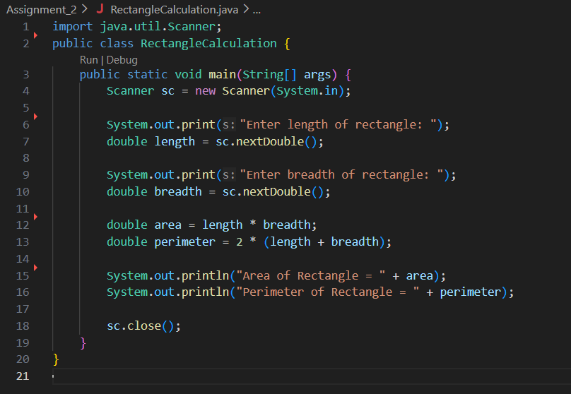
Output:-
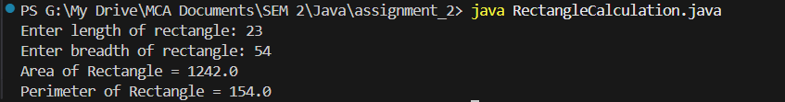

- Write a menu driven program to perform the following operations
  - Calculate the volume of cylinder. (hint : Volume: π × r² × h)
  - Find the factorial of given number.
  - Check the number is Armstrong or not.
  - Exit
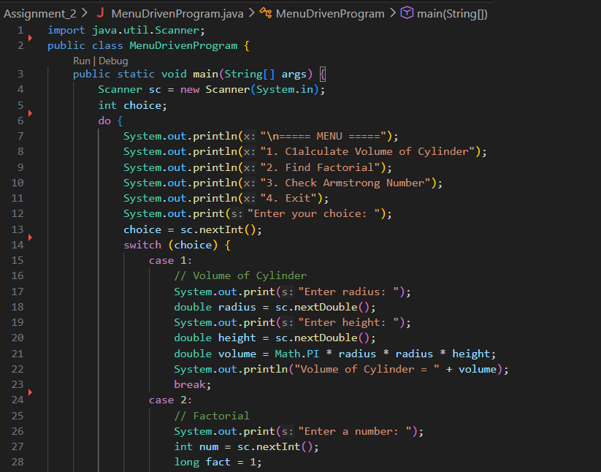
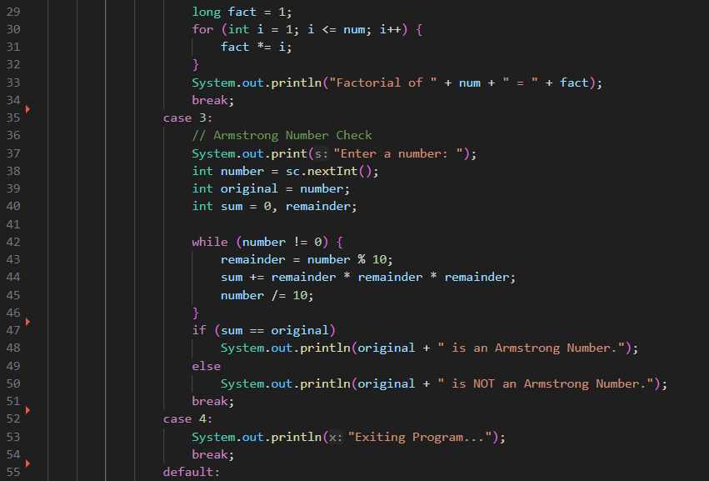
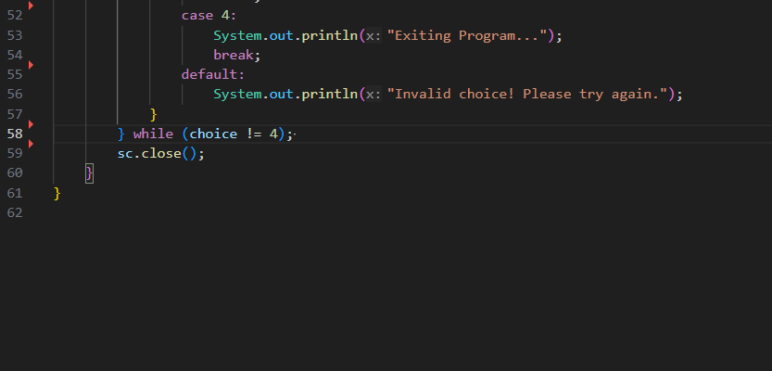
Output:-
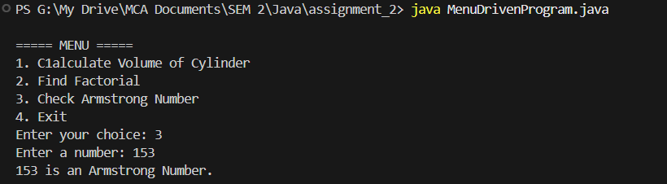

- Write a program to accept the array element and display in reverse order.
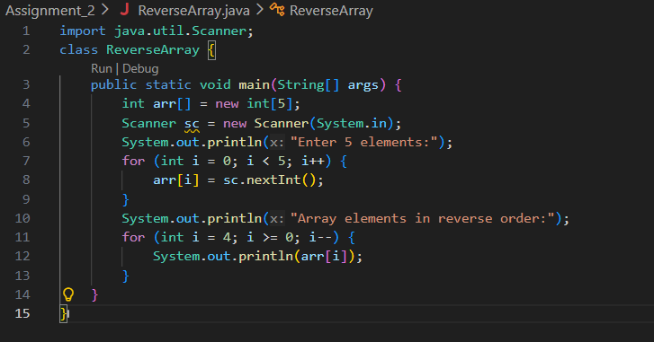
Output:-
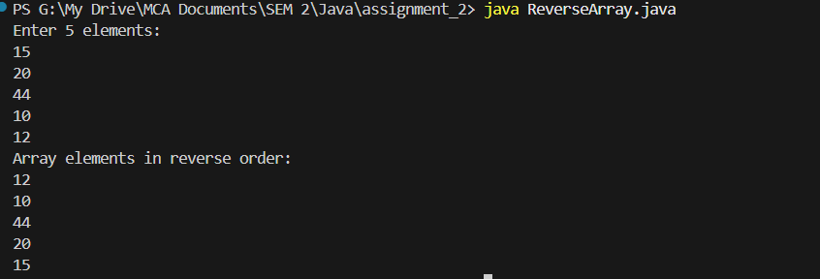

- Write a menu driven program to perform the following operations on multidimensional array ie matrix :
i. Addition
ii. Multiplication
iii. Transpose of any matrix.
iv. Exit
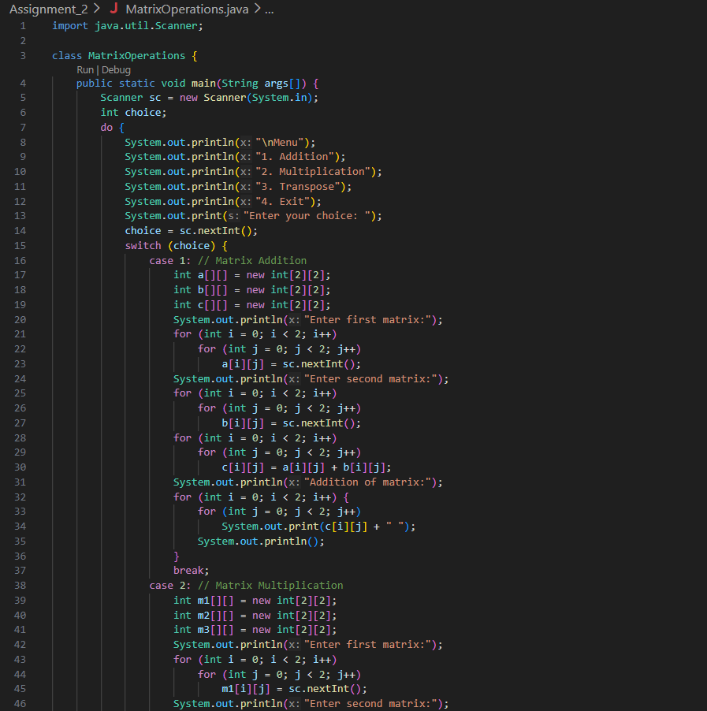
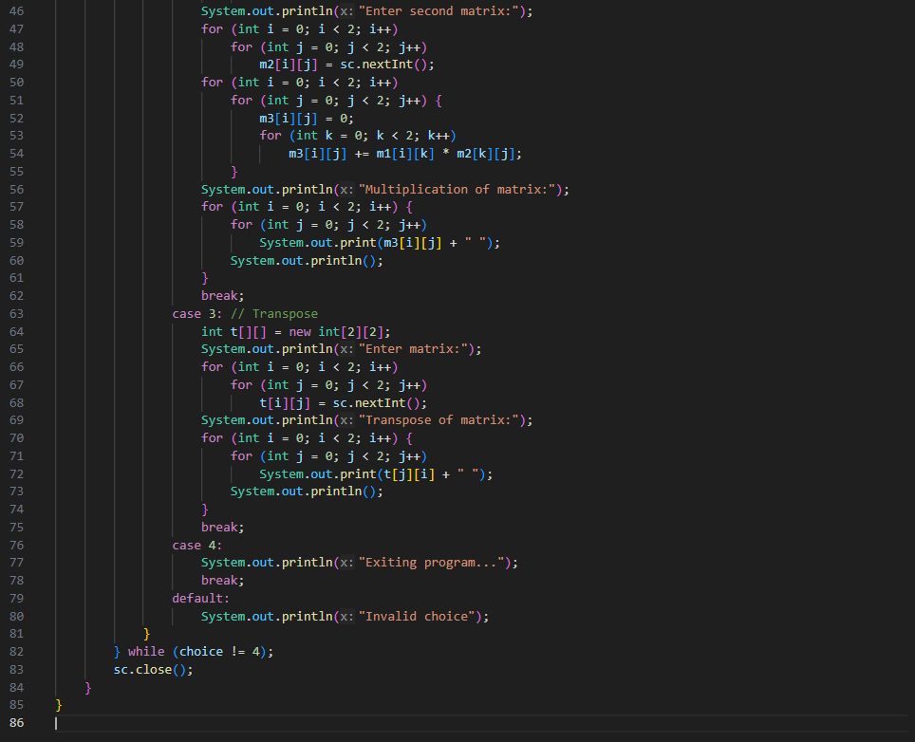
Output:-
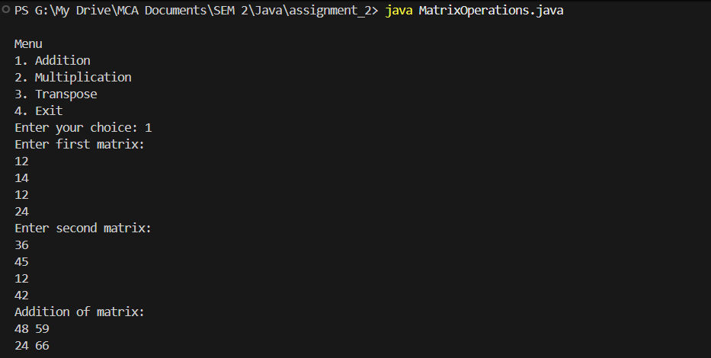

- Write a program to accept n names of country and display them in descending order.
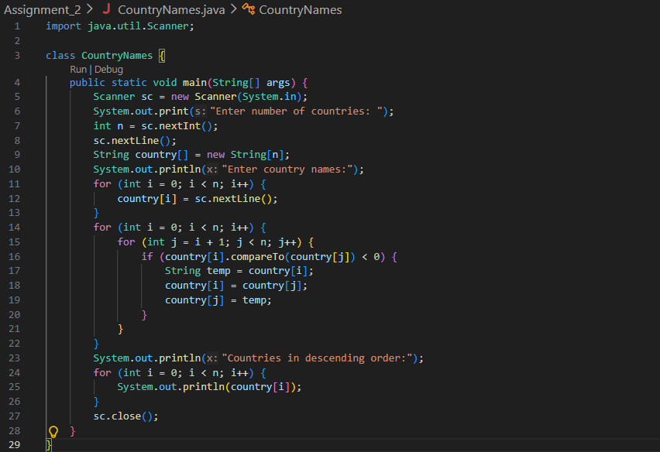
Output:-
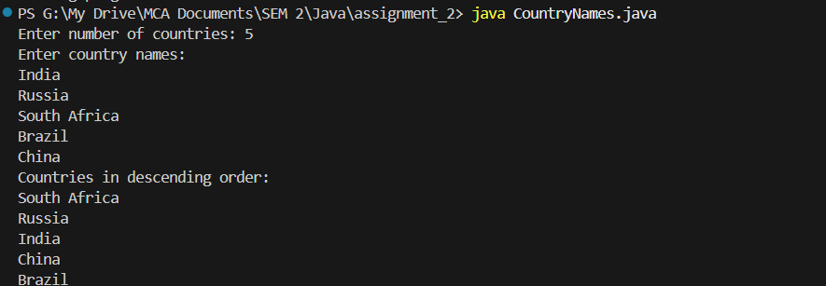

- Write a menu driven program to perform the following operations on 2D array:
i. Sum of diagonal elements
ii. Sum of upper diagonal elements
iii. Sum of lower diagonal elements
iv. Exit
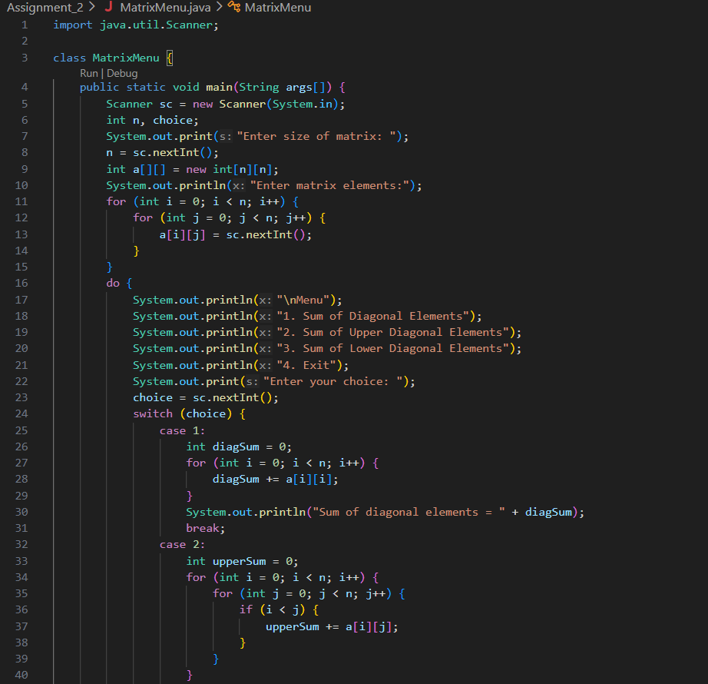
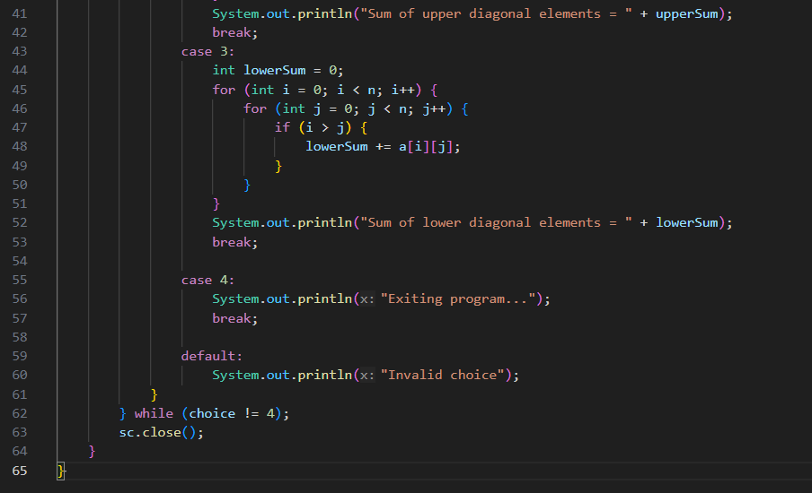
Output:-
