Practical Machine Learning - Project

Gito

2024-11-08

# PRACTICAL MACHINE LEARNING PREDICTION ASSIGNMENT - JHU - COURSERA

This Project is part of JHU - Coursera Project on Practical Machine Learning. Using devices such as Jawbone Up, Nike FuelBand, and Fitbit it is now possible to collect a large amount of data about personal activity relatively inexpensively. These type of devices are part of the quantified self movement – a group of enthusiasts who take measurements about themselves regularly to improve their health, to find patterns in their behavior, or because they are tech geeks. One thing that people regularly do is quantify how much of a particular activity they do, but they rarely quantify how well they do it. In this project, your goal will be to use data from accelerometers on the belt, forearm, arm, and dumbell of 6 participants.

Data

The training data for this project are available here: <https://d396qusza40orc.cloudfront.net/predmachlearn/pml-training.csv>

The test data are available here: <https://d396qusza40orc.cloudfront.net/predmachlearn/pml-testing.csv>

# Required Result

Your submission for the Peer Review portion should consist of a link to a Github repo with your R markdown and compiled HTML file describing your analysis. Please constrain the text of the writeup to < 2000 words and the number of figures to be less than 5. It will make it easier for the graders if you submit a repo with a gh-pages branch so the HTML page can be viewed online (and you always want to make it easy on graders :-).

# Importing Data and load necessary library

Import data from local directory and consider “NA”,““, and”#DIV/0!” as NA strings

library(caret)

## Loading required package: ggplot2

## Loading required package: lattice

library(tidyverse)

## ── Attaching core tidyverse packages ──────────────────────── tidyverse 2.0.0 ──  
## ✔ dplyr 1.1.4 ✔ readr 2.1.5  
## ✔ forcats 1.0.0 ✔ stringr 1.5.1  
## ✔ lubridate 1.9.3 ✔ tibble 3.2.1  
## ✔ purrr 1.0.2 ✔ tidyr 1.3.1

## ── Conflicts ────────────────────────────────────────── tidyverse_conflicts() ──  
## ✖ dplyr::filter() masks stats::filter()  
## ✖ dplyr::lag() masks stats::lag()  
## ✖ purrr::lift() masks caret::lift()  
## ℹ Use the conflicted package (<http://conflicted.r-lib.org/>) to force all conflicts to become errors

library(dplyr)  
library(GGally)

## Registered S3 method overwritten by 'GGally':  
## method from   
## +.gg ggplot2

library(rpart)  
library(randomForest)

## Warning: package 'randomForest' was built under R version 4.4.2

## randomForest 4.7-1.2  
## Type rfNews() to see new features/changes/bug fixes.  
##   
## Attaching package: 'randomForest'  
##   
## The following object is masked from 'package:dplyr':  
##   
## combine  
##   
## The following object is masked from 'package:ggplot2':  
##   
## margin

# library(cor)  
rawdata_training <- read.csv("pml-training.csv",header = TRUE,na.strings = c("NA","","#DIV/0!"))  
rawdata_testing <- read.csv("pml-testing.csv",header = TRUE,na.strings = c("NA","","#DIV/0!"))  
dim(rawdata_training)

## [1] 19622 160

dim(rawdata_testing)

## [1] 20 160

# Clean Data

By Analyzing the data, we can see many NA strings and we might need to analyze which variables are not important to the model. Below are my methodologies to remove unnecessary data 1. Low variability data 2. NA values will be removed –> By recognizing sum of NA for each variable, if sum is 0 then its considered as NA column 3. Remove time variable, window variable, name and 1st columns

# Removing NAs  
rawdata_training <- rawdata_training[,colSums(is.na(rawdata_training)) == 0]  
rawdata_testing <- rawdata_testing[,colSums(is.na(rawdata_testing)) == 0]  
dim(rawdata_training)

## [1] 19622 60

dim(rawdata_testing)

## [1] 20 60

rawdata_training_clean <- rawdata_training[,8:60]  
rawdata_testing_clean <- rawdata_testing[,8:60]

We will split our training to 70% to generate model & 30% to validate model to quantify the performance before passing to data testing set

set.seed(123)  
train_sample <- createDataPartition(rawdata_training_clean$classe,p=0.7,list = FALSE)  
train <- rawdata_training_clean[train_sample,]  
validate <- rawdata_training_clean[-train_sample,]

# Data Modelling

## 1. 1st Model, Basic Decision Tree

### 1.1 Decision Tree Model

model1 <- rpart(classe~.,data = train,method = "class")  
par(cex=0.7)  
plot(model1)  
text(model1)

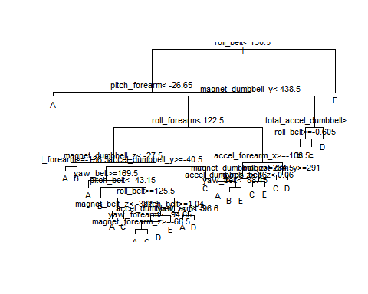

### 1.2 Decision Tree Model Prediction Performance

predict_validate_tree <- predict(model1,validate,type = "class")  
CF_DTree <- confusionMatrix(as.factor(validate$classe),predict_validate_tree)  
CF_DTree

## Confusion Matrix and Statistics  
##   
## Reference  
## Prediction A B C D E  
## A 1552 48 39 24 11  
## B 174 588 220 83 74  
## C 18 43 888 75 2  
## D 60 63 100 651 90  
## E 6 64 148 86 778  
##   
## Overall Statistics  
##   
## Accuracy : 0.7573   
## 95% CI : (0.7462, 0.7683)  
## No Information Rate : 0.3076   
## P-Value [Acc > NIR] : < 2.2e-16   
##   
## Kappa : 0.6926   
##   
## Mcnemar's Test P-Value : < 2.2e-16   
##   
## Statistics by Class:  
##   
## Class: A Class: B Class: C Class: D Class: E  
## Sensitivity 0.8575 0.72953 0.6366 0.7084 0.8147  
## Specificity 0.9701 0.89151 0.9693 0.9370 0.9383  
## Pos Pred Value 0.9271 0.51624 0.8655 0.6753 0.7190  
## Neg Pred Value 0.9387 0.95407 0.8957 0.9455 0.9631  
## Prevalence 0.3076 0.13696 0.2370 0.1562 0.1623  
## Detection Rate 0.2637 0.09992 0.1509 0.1106 0.1322  
## Detection Prevalence 0.2845 0.19354 0.1743 0.1638 0.1839  
## Balanced Accuracy 0.9138 0.81052 0.8029 0.8227 0.8765

## 2. 2nd Model, Random Forest with Cross Validation

### 2.1 Random Forest Model with Cross Validation

set.seed(321)  
model2 <- train(classe~.,data = train,method = "rf", trcontrol = trainControl(method = "cv",10),ntree = 100)  
model2

## Random Forest   
##   
## 13737 samples  
## 52 predictor  
## 5 classes: 'A', 'B', 'C', 'D', 'E'   
##   
## No pre-processing  
## Resampling: Bootstrapped (25 reps)   
## Summary of sample sizes: 13737, 13737, 13737, 13737, 13737, 13737, ...   
## Resampling results across tuning parameters:  
##   
## mtry Accuracy Kappa   
## 2 0.9869305 0.9834603  
## 27 0.9877731 0.9845271  
## 52 0.9799382 0.9746101  
##   
## Accuracy was used to select the optimal model using the largest value.  
## The final value used for the model was mtry = 27.

plot(model2)

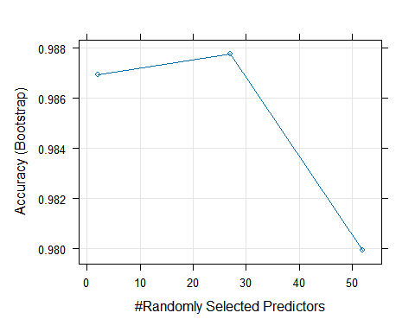

### 2.2 Random Forest with Cross Validation Prediction Performance

predict_validate_rforest <- predict(model2,validate)  
CF_RFCV <- confusionMatrix(as.factor(validate$classe),predict_validate_rforest)  
CF_RFCV

## Confusion Matrix and Statistics  
##   
## Reference  
## Prediction A B C D E  
## A 1674 0 0 0 0  
## B 8 1126 5 0 0  
## C 0 5 1017 4 0  
## D 0 0 10 954 0  
## E 0 0 4 5 1073  
##   
## Overall Statistics  
##   
## Accuracy : 0.993   
## 95% CI : (0.9906, 0.995)  
## No Information Rate : 0.2858   
## P-Value [Acc > NIR] : < 2.2e-16   
##   
## Kappa : 0.9912   
##   
## Mcnemar's Test P-Value : NA   
##   
## Statistics by Class:  
##   
## Class: A Class: B Class: C Class: D Class: E  
## Sensitivity 0.9952 0.9956 0.9817 0.9907 1.0000  
## Specificity 1.0000 0.9973 0.9981 0.9980 0.9981  
## Pos Pred Value 1.0000 0.9886 0.9912 0.9896 0.9917  
## Neg Pred Value 0.9981 0.9989 0.9961 0.9982 1.0000  
## Prevalence 0.2858 0.1922 0.1760 0.1636 0.1823  
## Detection Rate 0.2845 0.1913 0.1728 0.1621 0.1823  
## Detection Prevalence 0.2845 0.1935 0.1743 0.1638 0.1839  
## Balanced Accuracy 0.9976 0.9964 0.9899 0.9943 0.9991

## 3. 3rd Model, Random Forest without Cross Validation

### 3.1 Random Forest Model without Cross Validation

set.seed(31)  
model3 <- train(classe~.,data = train,method = "rf", ntree = 100)  
model3

## Random Forest   
##   
## 13737 samples  
## 52 predictor  
## 5 classes: 'A', 'B', 'C', 'D', 'E'   
##   
## No pre-processing  
## Resampling: Bootstrapped (25 reps)   
## Summary of sample sizes: 13737, 13737, 13737, 13737, 13737, 13737, ...   
## Resampling results across tuning parameters:  
##   
## mtry Accuracy Kappa   
## 2 0.9876212 0.9843417  
## 27 0.9893441 0.9865233  
## 52 0.9810035 0.9759734  
##   
## Accuracy was used to select the optimal model using the largest value.  
## The final value used for the model was mtry = 27.

plot(model3)

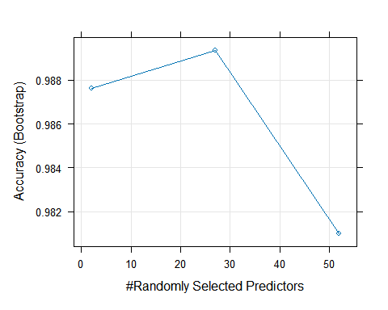

### 3.2 Random Forest Prediction Performance

predict_validate_rforest_noCV <- predict(model3,validate)  
CF_RF <- confusionMatrix(as.factor(validate$classe),predict_validate_rforest_noCV)  
CF_RF

## Confusion Matrix and Statistics  
##   
## Reference  
## Prediction A B C D E  
## A 1672 1 0 0 1  
## B 7 1123 9 0 0  
## C 0 5 1019 2 0  
## D 0 0 9 955 0  
## E 0 0 4 4 1074  
##   
## Overall Statistics  
##   
## Accuracy : 0.9929   
## 95% CI : (0.9904, 0.9949)  
## No Information Rate : 0.2853   
## P-Value [Acc > NIR] : < 2.2e-16   
##   
## Kappa : 0.991   
##   
## Mcnemar's Test P-Value : NA   
##   
## Statistics by Class:  
##   
## Class: A Class: B Class: C Class: D Class: E  
## Sensitivity 0.9958 0.9947 0.9789 0.9938 0.9991  
## Specificity 0.9995 0.9966 0.9986 0.9982 0.9983  
## Pos Pred Value 0.9988 0.9860 0.9932 0.9907 0.9926  
## Neg Pred Value 0.9983 0.9987 0.9955 0.9988 0.9998  
## Prevalence 0.2853 0.1918 0.1769 0.1633 0.1827  
## Detection Rate 0.2841 0.1908 0.1732 0.1623 0.1825  
## Detection Prevalence 0.2845 0.1935 0.1743 0.1638 0.1839  
## Balanced Accuracy 0.9977 0.9957 0.9887 0.9960 0.9987

## Performance Benchmark Chart Random Forest with Cross Validation and Without Cross validataion

plot(model2$results[,1],model2$results[,2],type = "l",col = "blue",xlab = "Predictors",ylab = "Accuracy", main = "Random Forest with CV & Without CV Performance Benchmark")  
# lines(model2$results[,1],model2$results[,2],col = "blue",xlab = "Predictors",ylab = "Accuracy", main = "Random Forest with CV & Without CV Performance Benchmark")  
lines(model3$results[,1],model3$results[,2],col = "green")  
legend("topright", legend = c("R Forest with CV","R Forest without CV"), col = c("blue","green"),lty = 1)

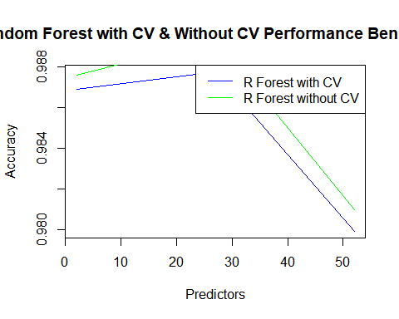

# CONCLUSION, Prediction on Test Data

## 1. Prediction with Test Data Result

predict1_test <- predict(model1,rawdata_testing_clean[,1:52],type = "class")  
predict2_test <- predict(model2,rawdata_testing_clean[,1:52])  
predict3_test <- predict(model3,rawdata_testing_clean[,1:52])  
print(data.frame("problem" = rawdata_testing_clean$problem_id,"Decision Tree Prediction" = predict1_test,"Random Forest with CV Prediction" = predict2_test, "Random Forest w/o CV" = predict3_test))

## problem Decision.Tree.Prediction Random.Forest.with.CV.Prediction  
## 1 1 C B  
## 2 2 A A  
## 3 3 A B  
## 4 4 A A  
## 5 5 A A  
## 6 6 C E  
## 7 7 D D  
## 8 8 A B  
## 9 9 A A  
## 10 10 A A  
## 11 11 C B  
## 12 12 C C  
## 13 13 B B  
## 14 14 A A  
## 15 15 C E  
## 16 16 E E  
## 17 17 A A  
## 18 18 B B  
## 19 19 B B  
## 20 20 B B  
## Random.Forest.w.o.CV  
## 1 B  
## 2 A  
## 3 B  
## 4 A  
## 5 A  
## 6 E  
## 7 D  
## 8 B  
## 9 A  
## 10 A  
## 11 B  
## 12 C  
## 13 B  
## 14 A  
## 15 E  
## 16 E  
## 17 A  
## 18 B  
## 19 B  
## 20 B

## 2. Model Accuracy Benchmark

print(data.frame("Decision Tree" = CF_DTree$overall[1], "Random Forest with CV" = CF_RFCV$overall[1],"Random Forest w/o CV" = CF_RF$overall[1]))

## Decision.Tree Random.Forest.with.CV Random.Forest.w.o.CV  
## Accuracy 0.7573492 0.9930331 0.9928632