Reproducible Research JHU Project 01

Gito

2024-10-05

# Reproducible Research Project 01 on COursera

## Introduction

It is now possible to collect a large amount of data about personal movement using activity monitoring devices such as a Fitbit, Nike Fuelband, or Jawbone Up.

These type of devices are part of the “quantified self” movement – a group of enthusiasts who take measurements about themselves regularly to improve their health, to find patterns in their behavior, or because they are tech geeks.

This assignment makes use of data from a personal activity monitoring device. This device collects data at 5 minute intervals through out the day. The data consists of two months of data from an anonymous individual collected during the months of October and November, 2012 and include the number of steps taken in 5 minute intervals each day.

The data for this assignment can be downloaded from the course web site: - Dataset: [Activity Monitoring Data] (<https://d396qusza40orc.cloudfront.net/repdata%2Fdata%2Factivity.zip>) The variables included in this dataset are: - Steps: Number of steps taking in a 5-minute interval (missing values are coded as NA) - Date: The date on which the measurement was taken in YYYY-MM-DD format - Interval: Identifier for the 5-minute interval in which measurement was taken

# Below are the project task and step

## Loading and preprocessing the data

### Import csv file from local directory

#### Import all necessary library and transform dataset

# Import Dataset and store to variable activity  
library(ggplot2)  
library(tidyverse)

## ── Attaching core tidyverse packages ──────────────────────── tidyverse 2.0.0 ──  
## ✔ dplyr 1.1.4 ✔ readr 2.1.5  
## ✔ forcats 1.0.0 ✔ stringr 1.5.1  
## ✔ lubridate 1.9.3 ✔ tibble 3.2.1  
## ✔ purrr 1.0.2 ✔ tidyr 1.3.1  
## ── Conflicts ────────────────────────────────────────── tidyverse_conflicts() ──  
## ✖ dplyr::filter() masks stats::filter()  
## ✖ dplyr::lag() masks stats::lag()  
## ℹ Use the conflicted package (<http://conflicted.r-lib.org/>) to force all conflicts to become errors

library(dplyr)

#### Read csv from local directory and transform data

activity <- read.csv("activity.csv", header = TRUE, sep = ",")  
activity$date <- as.Date(activity$date,"%Y-%m-%d")

## What is mean total number of steps taken per day?

1. Calculate the total number of steps taken per day

# Summarize steps and group by date as sum and exclude NA from calculation  
step_summary <- activity|> group_by(date)|> summarise(sum(steps,na.rm = TRUE))  
names(step_summary) <- c("Date","Total_Steps")  
head(step_summary)

## # A tibble: 6 × 2  
## Date Total_Steps  
## <date> <int>  
## 1 2012-10-01 0  
## 2 2012-10-02 126  
## 3 2012-10-03 11352  
## 4 2012-10-04 12116  
## 5 2012-10-05 13294  
## 6 2012-10-06 15420

1. If you do not understand the difference between a histogram and a barplot, research the difference between them. Make a histogram of the total number of steps taken each day

ggplot(step_summary,aes(x=Total_Steps)) +   
 geom_histogram(fill = "gray")+  
 theme_bw()+   
 labs(x="Total Steps",y="Frequency",title = "Total Steps Daily")

## `stat_bin()` using `bins = 30`. Pick better value with `binwidth`.

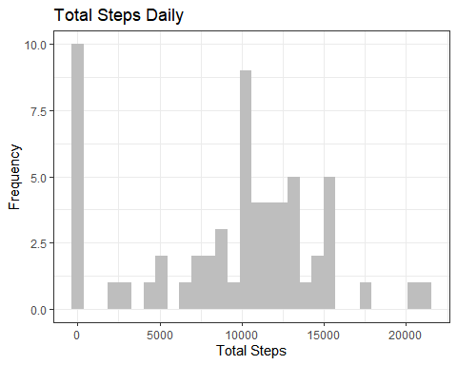

1. Calculate and report the mean and median of the total number of steps taken per day

Mean_Median <- list(avg_step = mean(step_summary$Total_Steps),  
 median_step = median(step_summary$Total_Steps))  
Mean_Median

## $avg_step  
## [1] 9354.23  
##   
## $median_step  
## [1] 10395

## What is the average daily activity pattern?

1. Make a time series plot (i.e. type = “l”type = “l”) of the 5-minute interval (x-axis) and the average number of steps taken, averaged across all days (y-axis)

interval_summary <- activity|> group_by(interval)|> summarise(mean(steps,na.rm = TRUE))  
names(interval_summary) <- c("Interval","Steps")  
ggplot(interval_summary,aes(x=Interval,y=Steps))+  
 geom_line(linewidth = 1)+theme_bw()+  
 labs(x= "Interval",y = "Total Steps",title = "Total Steps per Interval")

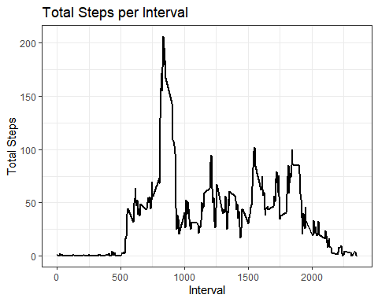

1. Which 5-minute interval, on average across all the days in the dataset, contains the maximum number of steps?

## filter top max steps value and select 1st column (which is interval)  
head(interval_summary|>arrange(desc(Steps)),1)[,1]

## # A tibble: 1 × 1  
## Interval  
## <int>  
## 1 835

## Imputing missing values

1. Calculate and report the total number of missing values in the dataset (i.e. the total number of rows with NA)

sum(is.na(activity$steps) == "TRUE")

## [1] 2304

1. Devise a strategy for filling in all of the missing values in the dataset. The strategy does not need to be sophisticated. For example, you could use the mean/median for that day, or the mean for that 5-minute interval, etc.

## We will replace NA with mean of whole data   
activity$steps[is.na(activity$steps)] <- mean(activity$steps,na.rm = TRUE)

1. Create a new dataset that is equal to the original dataset but with the missing data filled in.

# export cleaned dataset to csv format and save to local directory  
write.csv(activity,file = "activitytidy.csv",row.names = FALSE)

1. Make a histogram of the total number of steps taken each day and Calculate and report the mean and median total number of steps taken per day. Do these values differ from the estimates from the first part of the assignment? What is the impact of imputing missing data on the estimates of the total daily number of steps?

step_summary <- activity|> group_by(date)|> summarise(sum(steps))  
names(step_summary) <- c("Date","Total_Steps")  
ggplot(step_summary,aes(x=Total_Steps)) +   
 geom_histogram(fill = "gray")+  
 theme_bw()+   
 labs(x="Total Steps",y="Frequency",title = "Total Steps Daily")

## `stat_bin()` using `bins = 30`. Pick better value with `binwidth`.

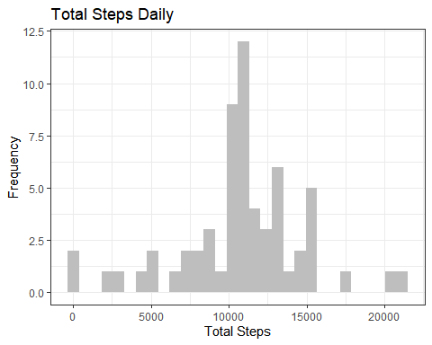

Mean_Median <- list(avg_step = mean(step_summary$Total_Steps),  
 median_step = median(step_summary$Total_Steps))  
  
# New Mean and Median after NA cleaning  
Mean_Median

## $avg_step  
## [1] 10766.19  
##   
## $median_step  
## [1] 10766.19

# Previous Mean and Median prior to NA cleaning   
## $avg_step  
## [1] 9354.23  
##   
## $median_step  
## [1] 10395

### We can see difference in mean and median after NA cleaning

## Are there differences in activity patterns between weekdays and weekends?

For this part the weekdays() weekdays() function may be of some help here. Use the dataset with the filled-in missing values for this part.

1. Create a new factor variable in the dataset with two levels – “weekday” and “weekend” indicating whether a given date is a weekday or weekend day.

## Create new factor variable weekend and weekdays  
## Reimport dataset  
activity <- read.csv("activity.csv", header = TRUE, sep = ",")  
activity$date <- as.Date(activity$date,"%Y-%m-%d")  
names(step_summary) <- c("Date","Total_Steps")  
activity$Dayname <- weekdays(activity$date)  
## Create new variable Wend_Wday with value "Weekday" and we ll replace Saturday and Sunday with mutate function  
activity$Wend_Wday <- "Weekday"  
activity <- activity |> mutate(Wend_Wday = ifelse(Dayname == "Saturday" | Dayname == "Sunday","Weekend",Wend_Wday))  
head(activity)

## steps date interval Dayname Wend_Wday  
## 1 NA 2012-10-01 0 Monday Weekday  
## 2 NA 2012-10-01 5 Monday Weekday  
## 3 NA 2012-10-01 10 Monday Weekday  
## 4 NA 2012-10-01 15 Monday Weekday  
## 5 NA 2012-10-01 20 Monday Weekday  
## 6 NA 2012-10-01 25 Monday Weekday

1. Make a panel plot containing a time series plot (i.e. type = “l” of the 5-minute interval (x-axis) and the average number of steps taken, averaged across all weekday days or weekend days (y-axis). See the README file in the GitHub repository to see an example of what this plot should look like using simulated data.

interval_summary <- activity|> group_by(interval,Wend_Wday)|> mutate(avg_step = mean(steps,na.rm = TRUE))  
ggplot(interval_summary,aes(x=interval,y=avg_step,colour = Wend_Wday)) +   
 geom_line(linewidth = 0.8)+  
 facet_wrap(~Wend_Wday,ncol=1,nrow=2) +   
 labs(x="Interval",y="Mean Steps", title = "Mean of Steps for Weekday and Weekend Comparison",color = "Status")+  
 theme_bw()

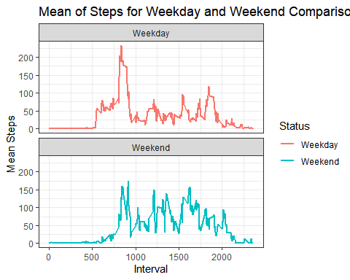

### We can see the pattern difference between weedays and weekend